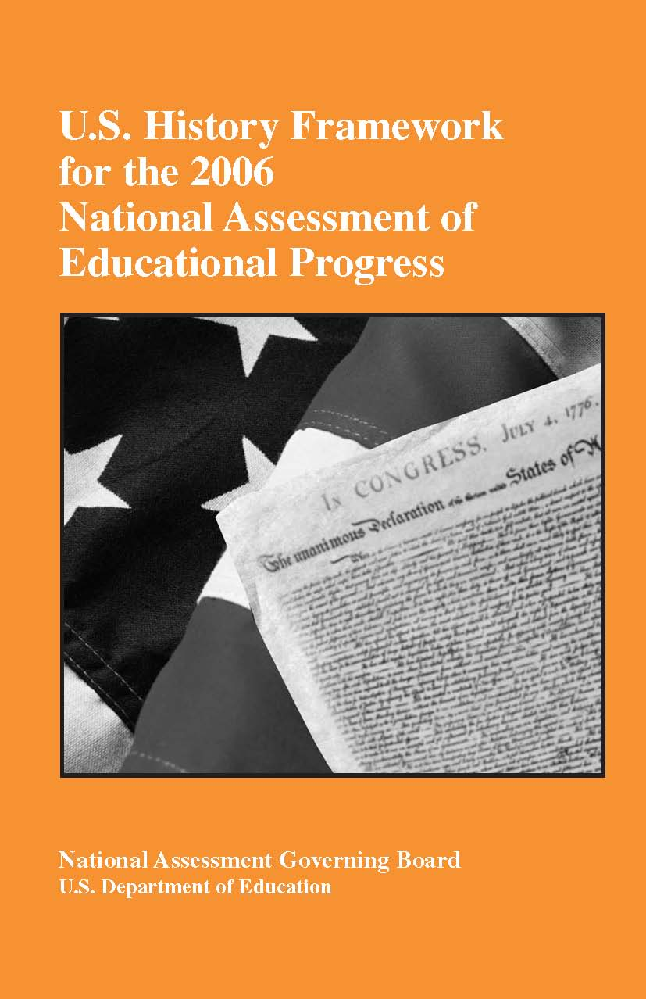
The National Assessment Governing Board
The National Assessment Governing Board (NAGB) was created by Congress to formulate policy for the National Assessment of Educational Progress (NAEP). Among the Board’s responsibilities are developing objectives and test specifications, and designing the assessment methodology for NAEP.

Members

Darvin M. Winick, Chair
President
Winick & Associates
Dickinson, Texas
Sheila M. Ford, Vice Chair
Former Principal Horace
Mann Elementary School
Washington, D.C.
Francie Alexander
Chief Academic Officer, Scholastic, Inc.
Senior Vice President, Scholastic Education
New York, New York
David J. Alukonis
Chairman
Hudson School Board
Hudson, New Hampshire
Amanda P. Avallone
Assistant Principal and Eighth-Grade Teacher Summit Middle School
Boulder, Colorado
Honorable Jeb Bush
Governor of Florida
Tallahassee, Florida
Barbara Byrd-Bennett
Chief Executive Officer
Cleveland Municipal School District
Cleveland, Ohio
Carl A. Cohn
Superintendent
San Diego City Schools
San Diego, California
Shirley V. Dickson
Educational Consultant
Laguna Niguel, California
John Q. Easton
Executive Director
Consortium on Chicago School Research
Chicago, Illinois
Honorable Dwight Evans
Member
Pennsylvania House of Representatives
Philadelphia, Pennsylvania
David W. Gordon
Sacramento County
Superintendent of Schools
Sacramento County Office of Education
Sacramento, California
Kathi M. King
Twelfth-Grade Teacher
Messalonskee High School
Oakland, Maine
Honorable Keith King
Member
Colorado House of Representatives
Colorado Springs, Colorado
Kim Kozbial-Hess
Fourth-Grade Teacher
Fall-Meyer Elementary School
Toledo, Ohio
Andrew C. Porter
Director, Learning Sciences Institute
Peabody Institute
Vanderbilt University
Nashville, Tennessee
Luis A. Ramos
Community Relations Manager
PPL Susquehanna
Berwick, Pennsylvania
Mark D. Reckase
Professor Measurement and
Quantitative Methods
Michigan State University
East Lansing, Michigan
John H. Stevens
Executive Director
Texas Business and Education Coalition
Austin, Texas
Mary Frances Taymans
Executive Director
National Catholic Educational Association
Washington, D.C.
Oscar A. Troncoso
Principal
Socorro High School
Socorro Independent School District
El Paso, Texas
Honorable Thomas J. Vilsack
Governor of Iowa
Des Moines, Iowa
Michael E. Ward
Former State Superintendent of Public Instruction
North Carolina Public Schools
Jackson, Mississippi
Eileen L. Weiser
Member, State Board of Education
Michigan Department of Education
Lansing, Michigan
Grover (Russ) Whitehurst (Ex Officio)
Director
Institute of Education Sciences
U.S. Department of Education
Washington, D.C.
Charles E. Smith
Executive Director NAGB Washington, D.C.

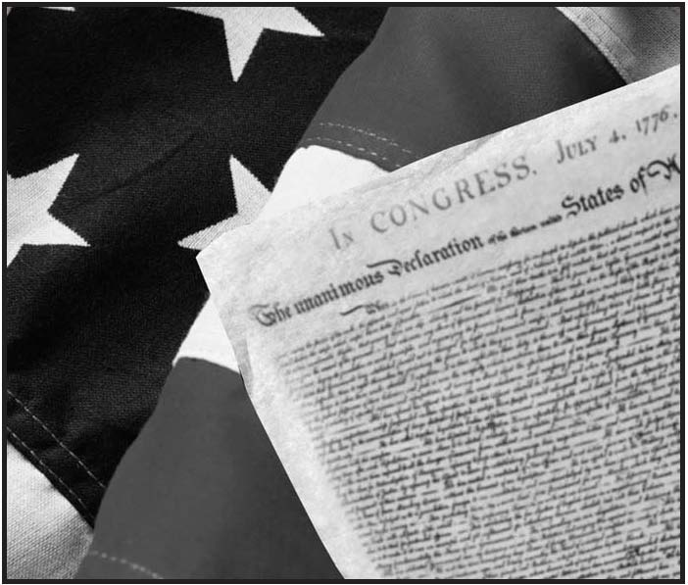
U.S. History Framework for the 2006 National Assessment of Educational Progress
Developed Under Contract Number RN 91072001 by the Council of Chief State School Officers with the American Historical Association, the American Institutes for Research, the National Council for History Education, and the National Council for the Social Studies for the National Assessment Governing Board
National Assessment Governing Board
Darvin Winick
Chair
Sheila M. Ford
Vice Chair
Charles Smith
Executive Director
Sharif Shakrani
Deputy Executive Director
Mary Crovo
Project Officer
U.S. History Project
Ramsay Selden
Director
Thomas G. Ward
Framework Coordinator
U.S. History Assessment Framework for the National Assessment of Educational Progress
Developed for the National Assessment Governing Board under contract number RN 91072001 by the Council of Chief State School Officers with the American Historical Association, American Institutes for Research, National Council for History Education, and National Council for the Social Studies.
For further information, contact the National Assessment
Governing Board: 800 North Capitol Street NW.
Suite 825
Washington, DC 20002
www.nagb.org

Table of Contents
Executive Summary v
Introduction 1
Chapter One: U.S. History in Elementary, Middle, and
High Schools 3
Nature of U.S. History 3
Chapter Two: The Framework for the 2006 NAEP U.S. History Assessment 7

Purpose of the Framework 7
Elements of the Framework 7
Content Matrix Outline 7
Themes of U.S. History 8
Periods of U.S. History 14
Ways of Knowing and Thinking About U.S. History 32

Chapter Three: Desired Attributes of the Assessment and Its Exercises and Items 37
Achievement Levels in U.S. History 39
Appendix A: NAEP U.S. History Framework Project 43
Appendix B: Released Items From the NAEP
U.S. History Assessment 49
Executive Summary
In a democratic country such as the United States, the study of history is vital. All students need to know and understand the origins and evolution of their nation. They also need to understand the development of our democratic institutions and ideals so that they are prepared to take part knowledgeably, as citizens and voters, in shaping America’s future.
The framework in U.S. history for the 1994 and 2001 National Assessment of Educational Progress (NAEP) was developed by the National Assessment Governing Board (NAGB) under contract to the Council of Chief State School Officers in 1991–92. The original framework project committees included a broad range of historians, educators, policymakers, business representatives, and other interested citizens. In addition, comments were received from several hundred individuals, including state and local educators, public officials, and parents.
In 2003, the Governing Board revised and updated the framework for the 2006 U.S. history assessment. The framework document was revised to make it more useful to the general public, to delete outdated and extraneous information, and to include released NAEP questions to illustrate more clearly the content and format of the assessment. These relatively minor revisions to the framework will ensure that NAEP can maintain the U.S. history trendline of student achievement for grades 4, 8, and 12 in 1994, 2001, and 2006. The revisions in 2003 were made by the Board’s Assessment Development Committee in consultation with an external panel of historians and teachers. The updated U.S. history framework was then approved by NAGB at its August 2003 meeting.
The framework reflects the conviction of the National Assessment Governing Board (NAGB) that any broadly acceptable examination in this field must be a careful balance of:
- what is commonly taught and learned and what ought to be grasped by our students;
- the common and diverse strands that formed one nation from many groups and gave life to its motto, E Pluribus Unum;
- accomplishments and failings in achieving the nation’s goals and ideals;
- specific names, dates, and facts that students need to know to master concepts, generalizations, and intellectual skills.

This framework identifies the main ideas, major events, key individuals, and unifying themes of American history as a basis for preparing the 2006 assessment. The framework recognizes that U.S. history includes powerful ideas, common and diverse traditions, economic developments, technological and scientific innovations, philosophical debates, religious movements, and the interconnection of all these forces.
The teaching of history should introduce students to the process of historical inquiry. This process requires critical examination of evidence, thoughtful consideration of conflicting claims, and careful weighing of facts and hypotheses. Historical inquiry provides experience in the kind of reasoned and informed decisionmaking that should characterize each citizen’s participation in our American democracy.
The framework organizes U.S. history into four central themes. Each theme is described briefly below and more fully in chapter two of the framework:
1. Change and Continuity in American Democracy: Ideas, Institutions, Events, Key Figures, and Controversies. The development of American political democracy from colonial times to the present. This includes basic principles and core civic ideas developed through the American Revolution, the U.S. Constitution, the Civil War, and the struggles over slavery and civil rights.
2. The Gathering and Interactions of Peoples, Cultures, and Ideas. The gathering of people and cultures of many countries, races, and religious traditions that have contributed to the development of the American heritage and American society.
3. Economic and Technological Changes and Their Relationship to Society, Ideas, and the Environment. The transformation of the American economy from rural frontier to industrial superpower and its impact on society, ideas, and the environment. This includes the influence of geography; the development of business and labor; and the impact of science and technology, a market economy, and urbanization.
4. The Changing Role of America in the World. The movement from isolation to worldwide responsibility. The evolution of relationships between the United States and other nations, including American foreign policy and the nation’s participation in world and regional wars. Students will consider the influence of geography, economic interests, and democratic ideals in evaluating the role of the United States in foreign affairs.
The framework divides U.S. history into eight chronological periods:
- Beginnings to 1607
- Colonization, Settlement, and Communities (1607–1763)
- The Revolution and the New Nation (1763–1815)
- Expansion and Reform (1801–1861)
- Crisis of the Union: Civil War and Reconstruction
(1850–1877)
- The Development of Modern America (1865–1920)
- Modern America and the World Wars (1914–1945)
- Contemporary America (1945 to the present)

As schools teach U.S. history, we hope they will foster a sense of excitement and pride that students will gain a sense of who Americans are and of what the idea of America is. Indeed, this nation was founded on a core of ideals—liberty, equality of opportunity, freedom of religion, self-government under law, and respect for individual worth—that continues to draw millions to our shores.
In order to understand these core democratic ideals, students should be familiar with the nation’s founding documents as well as major documents such as Lincoln’s Gettysburg Address and Second Inaugural Address, Franklin D. Roosevelt’s Four Freedoms, and Martin Luther King’s speech at the Lincoln Memorial. These documents and the ideals they express serve as a force for unity and continue to stimulate reform.
Introduction
Since 1969, NAEP has been the sole, ongoing national indicator of what American students know and can do in major academic subjects. Over the years, NAEP has measured students’ achievement in many subjects including reading, mathematics, science, writing, geography, civics, and the arts. NAEP is a congressionally authorized project administered by the U.S. Department of Education’s National Center for Education Statistics. The National Assessment Governing Board sets policy for NAEP. Among the Board’s congressionally mandated responsibilities are selecting subject areas to be assessed, developing assessment objectives and specifications, determining appropriate student achievement levels, and other duties.
Under provisions of the No Child Left Behind (NCLB) Act of 2001 (P.L. 107–110), Congress authorized the Governing Board to continue its mandate for determining the content and format of NAEP assessments. While NCLB requires NAEP to assess reading and mathematics every 2 years in grades 4 and 8, the legislation permits the assessment of other subjects such as science, writing,
U.S. history, civics, geography, and other areas, to the extent time and resources allow.
In May 2003, the Governing Board revised the NAEP assessment schedule to move the planned 2010 U.S. history assessment forward to 2006. The assessment will be conducted at the national level, in public and nonpublic schools, at grades 4, 8, and 12.
The following table describes NAEP assessments in history and the social sciences since 1969.
Table 1. NAEP assessments in history and the social sciences
Subjects | Years | Notes
Civics U.S. History Economics | 2006 | Civics—national data for grades 4, 8, and 12; continues trendline from 1998 U.S. History—national data for grades 4, 8, and 12; continues trendline from 1994 and 2001 Economics—national data for grade 12 only; first economics assessment for NAEP
U.S. History Geography | 2001 | National data at grades 4, 8, and 12
Civics | 1998 | National data at grades 4, 8, and 12 Beginning of new trendline for civics assessment Special study on subsample of students at grades 4, 8, and 12 using questions from 1988 civics assessment
U.S. History Geography | 1994 | National data at grades 4, 8, and 12 Beginning of new trendlines for these two assessments
Geography | 1988 | Special assessment at grade 12 and age 17, conducted with support from the National Geographic Society
Civics: U.S. Government and Politics | 1988 | Grade 4 and age 9; grade 8 and age 13; and grade 12 and age 17, with links back to parts of the 1976 and 1982 citizenship assessments at ages 13 and 17
U.S. History | 1988 | Grade 4 and age 9; grade 8 and age 13; and grade 12 and age 17, with a special study linking results to those from 1986
U.S. History and Literature | 1986 | Grade 11 and age 17; conducted with the Educational Excellence Network and with support from the National Endowment for the Humanities
Citizenship and Social Studies | 1981–82 | Ages 9, 13, and 17
Social Studies | 1975–76 | Ages 9, 13, and 17
Citizenship | 1975–76 | Ages 9, 13, and 17
Social Studies | 1971–72 | Ages 9, 13, and 17

Publications related to previous NAEP assessments can be found at nces.ed.gov/nationsreportcard.
Chapter One
U.S. History in Elementary, Middle, and High Schools
Nature of U.S. History
As young people study U.S. history, they gain insight into the American experience over time and discover how the past influences the present. They encounter new (and sometimes conflicting) ideas, compelling stories of people and events, diverse traditions, economic booms and busts, technological and scientific innovations, philosophical and political debates, religious movements and influences, and the complex interactions among these various forces. Most of all, they study people—individually and in groups—in their complex settings and in their complex reactions to the world around them.
The framework for the assessment of U.S. history in elementary, middle, and high schools is based on seven basic assumptions:
- First, historical study must strive to connect people and events across time and to establish a context that includes the political, social, cultural, economic, technological, philosophical, and religious dimensions of human activities.
- Second, the study of U.S. history must analyze change and continuity over time, explore the range of choices that have been available to people, and examine the events, people, and ideas that have been most significant in our nation’s development. History introduces students to people from all walks of life and to key events, major turning points, and significant records that reveal the American people’s beliefs, hopes, and ideas.
- Third, to illuminate the range and depth of the human experience, as well as differing perspectives, historical study must include famous people and ordinary individuals and events on the grand scale and in everyday life to convey the ideas and experiences that have shaped U.S. history. It must be informed by the humanities and social sciences, and it must draw upon many forms of documentation such as original documents, speeches, cartoons, artifacts, photos, art, music, architecture, literature, drama, dance, popular culture, biographies, journals, folklore, historic sites and places, and oral histories.
- Fourth, history must include the analytical study of the nation’s political ideals of individual dignity, individual rights, civic virtue, democracy, the rule of law, equality of opportunity, liberty, popular sovereignty, justice, and the right to dissent. The study of U.S. history must show how and why these core civic ideas have influenced American society, while recognizing historical moments such as the Civil War, when these ideals were challenged or violated. The study of American history will (1) address the conflict between the founding proposition that “all men are created equal” in possession of certain rights and the reality that enormous inequalities in legal protection and in political and economic opportunity were common and accepted practice throughout the world at the outset of the American experiment, (2) show how individuals and groups have worked since the founding to make the nation’s civic ideals real for all people, and (3) identify the institutions and laws that establish equality under law for everyone.
- Fifth, history has a spatial dimension—the places where human actions occur. The study of history must examine how events were influenced by geography, such as the locations of places and relationships within places. Aspects of the natural environment, such as climate and terrain, influence human behavior, and people affect the places they inhabit.
- Sixth, it is necessary to identify enduring themes that link people and events across time and space. People and events in history are not isolated and discrete; they are linked in many ways. The linkages are not static but are continuously evolving, and later generations will certainly perceive new relationships that are not evident today. Among the many possible themes of U.S. history, four have been selected for emphasis in the assessment:
1. Change and Continuity in American Democracy: Ideas, Institutions, Events, Key Figures, and Controversies
2. The Gathering and Interactions of Peoples, Cultures, and Ideas
3. Economic and Technological Changes and Their Relationship to Society, Ideas, and the Environment
4. The Changing Role of America in the World

- Seventh, students need historical reasoning skills to enable them to examine evidence, analyze cause and effect, and appreciate how complex and sometimes ambiguous the explanation of historical events can be. Historical study must encourage students to think and judge evidence responsibly, independently, imaginatively, and critically. In developing critical thinking skills, students should engage in debates and consider alternative viewpoints or possibilities of historical movements and their causes.
In sum, students must know the specific facts of American history, be able to evaluate historical evidence, and understand change and continuity over time. For them, the nation’s past should be a body of knowledge as well as a source for understanding America’s promise, achievements, and shortcomings. They must be prepared to examine the influence of past upon present and to weigh evidence in order to reach generalizations and conclusions about how change and continuity have occurred.
Chapter Two
The Framework for the 2006 NAEP
U.S. History Assessment
Purpose of the Framework
The National Assessment Governing Board is responsible for developing an assessment framework for each NAEP subject area. A framework defines the scope of the domain to be measured by delineating the knowledge and skills to be tested at each grade, the format of the NAEP assessment, and achievement level descriptions. The framework will provide information to the public and test developers on three key aspects of the assessment:
- what should be measured at grades 4, 8, and 12
- how the domain of content is most appropriately measured in a large-scale assessment
- how much of the content domain, in terms of knowledge and skills, should students know and be able to do at the Basic, Proficient, and Advanced levels

Elements of the Framework
This assessment framework has three components: Themes in
U.S. History, Periods of U.S. History, and Ways of Knowing and Thinking About U.S. History. The themes and periods that structure the assessment are illustrated in the content matrix (table 2) and explained in the section that follows the matrix. The final section of the chapter, Ways of Knowing and Thinking About U.S. History, defines the cognitive dimensions of the assessment.

Content Matrix Outline
The framework is defined by a “content matrix outline.” This matrix consists of the four major themes, as observed in each of the eight chronological periods of American history. The four themes form the horizontal axis of the content matrix, while the eight periods of U.S. history form its vertical axis. The periods are a useful way to divide history into manageable segments. The themes establish important emphases within periods and ensure continuity from one era to another. While the framework is based on one set of historical periods and issues, other perspectives, other issues, and other chronologies could easily have been identified.
The general questions posed for each theme and the specific questions developed for each period define a conceptual approach to U.S. history. The questions provide a way to think about U.S. history in elementary and secondary school and to define content and interpretive approaches to be used in creating assessment exercises for grades 4, 8, and 12. Appendix B provides publicly released test questions from the 1994 and 2001 NAEP U.S. history assessments. Additional NAEP questions, performance results, scoring criteria, and sample student responses can be found on the NAEP Web site at www.nces.ed.gov/naep.

Themes of U.S. History
The four themes that will be the central focus of the assessment are defined through general questions. The theme questions establish the context for the people, events, ideas, movements, issues, and sources to be addressed in each historical period. Not all themes, however, will be examined in equal depth in all periods or all grade levels because the thematic emphasis in any given period will depend upon the major historical issues and developments of that period.
Theme 1. Change and Continuity in American Democracy:
Ideas, Institutions, Events, Key Figures, and
Controversies
Defining Questions
- What political, legal, philosophical, and religious traditions did Americans draw upon for their conceptions of democracy? Who were the leaders, what were their contributions, and what political and legal institutions developed? In what significant ways have these institutions continued? In what ways have they changed? What individuals and groups have been important in maintaining, testing, and changing these institutions?

Table 2. NAEP U.S. history content matrix outline
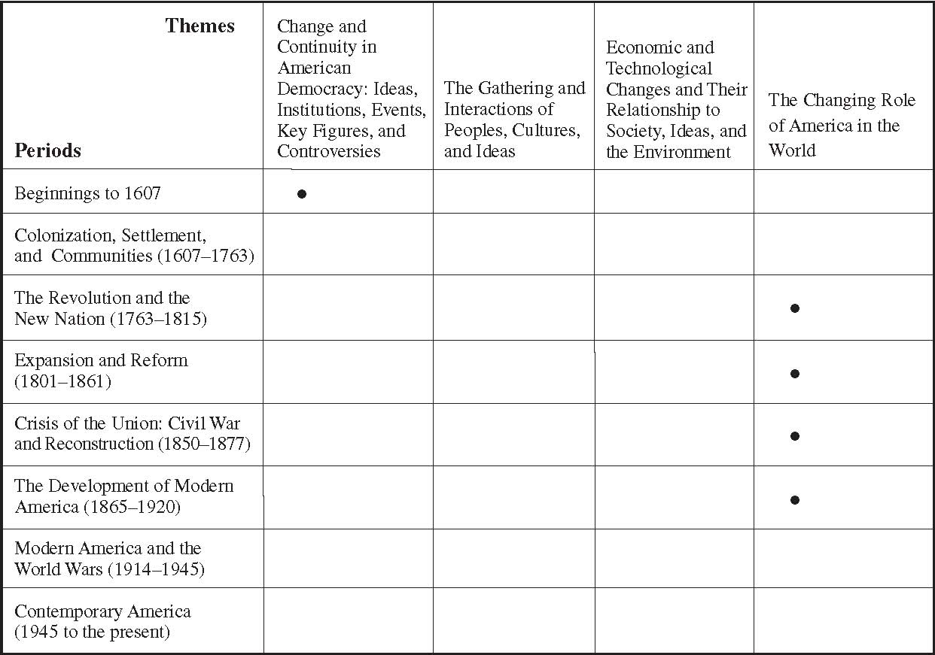
Note: Not all of the themes will be addressed equally in every period.
*These themes will not be tested at grade 4 for each designated period.

- Which democratic institutions and procedures made change possible? How does the Constitution permit compromise, continuity, and change? What landmark documents reflect change and continuity?
- What are the basic principles and critical assumptions of American constitutional government about the sources of political power and the rights of individuals? What core civic ideas (e.g., individual rights and popular sovereignty) have influenced American society? What individuals and groups have maintained, tested, and influenced the evolution of these ideas? What primary documents include these commonly held civic ideas (e.g., Mayflower Compact, Declaration of Independence, The Federalist Papers, Constitution, Bill of Rights, Seneca Falls Declaration of Sentiments, and “I Have a Dream” speech)? What landmark Supreme Court cases have had an important influence on our nation (e.g., Brown v. Board of Education, Plessy v. Ferguson, Marbury v. Madison)? Why has the Constitution survived, and why has it become a model political framework? How have Americans responded to inherent tensions and conflicts of constitutional democracy, such as reconciling the desire for liberty with the need for order, majority rule with minority rights, and liberty with equality?
- How has the cultural diversity of American society shaped the nation’s civic culture, political institutions, and political practices? What individuals and groups played important roles in raising and responding to issues about diversity and unity in the American body politic? What major political controversies arose about the issues? Which controversies have been resolved? Which controversies have remained or reemerged under other circumstances?

Theme 2. The Gathering and Interactions of Peoples, Cultures, and Ideas
Defining Questions
- What racial, ethnic, religious, and national groups formed this nation? Why have people immigrated to the land that became the United States and why has the country continued to attract so many immigrants? What have been the patterns and conditions of this immigration (e.g., voluntarily in search of economic opportunity, religious freedom, and political refuge; involuntarily in bondage as slaves, or in a “nonfree” status such as indentured servants and contract laborers)? How has the racial, ethnic, and religious composition of the nation changed over time? What racial, ethnic, and religious tensions arose? What issues have been resolved? What issues remain? What were the patterns of settlement? How and why have these settlement patterns changed?
● What common and diverse cultural traditions did Americans develop? How did racial, ethnic, religious, and national groups contribute to the creation of American culture? What individuals and defining events contributed to these developments? What primary documents and historical sources—such as original documents, speeches, cartoons, artifacts, photos, art, music, architecture, literature, drama, dance, popular culture, biographies, journals, folklore, historic sites and places, and oral histories—reflect the development of American culture?
- What have been the roles of men and women in American society? How and why have gender roles changed over time?
Theme 3. Economic and Technological Changes and Their Relationship to Society, Ideas, and the Environment
Defining Questions
- How did the United States develop from a rural, agricultural economy to an urban, industrialized superpower? What were the human and environmental benefits and costs of this development? How and why has the standard of living for most Americans changed over time? How have state and national governments responded to issues raised by economic developments and how have they participated in the economy?
- What ideas, values, and practices (e.g., individual entrepreneurship, private ownership of property, laissez-faire economics, free enterprise, monopolies, and government regulation) contributed to the development of the American economic system? What types of labor systems developed and how did they influence society and the economy? How has the economic system, including its ideas and values, adapted to changing conditions and changing demands? What forms of prosperity and opportunity resulted? How have the work lives and economic opportunities of various groups differed (e.g., men and women, racial groups, and people in different regions)?
- How have geography and economic and technological developments influenced society? How have these developments influenced how Americans make a living, where they live, their quality of life, and their natural environment?
- What have been the major American achievements and developments in science and technology? Who played key roles? What caused these developments? How have these developments influenced the economy, the environment, and the rest of the world? What have been the most important economic, scientific, and technological issues? How have these scientific and technological developments affected other areas of American society?

Theme 4. The Changing Role of America in the World
Defining Questions
- What were the causes and consequences of key events that marked American involvement in world affairs? Spanish-American War? World War I? World War II? Marshall Plan? The Cold War? Globalization?
- How have the geographical location and resources of the United States, its ideals, its interests, and its power influenced its role in the world? How and why has that role changed? Who played significant roles in international affairs at critical moments in American history? What is the role of public opinion in shaping foreign policy in a democracy? What primary documents and historical sources record the key developments?
- How have the interests, institutions, ideologies, individuals, power, and activities of other nations affected the United States?
- How have the interests, institutions, ideologies, individuals, power, and activities of the United States affected other nations?
- How has life inside the United States been affected by the nation’s role in the world?

The distribution of the assessment exercise pool across historical themes for grades 4, 8, and 12 follows in table 3.
Table 3. Distribution of the test questions across historical themes: grades 4, 8, and 12
Grade Levels | Themes | Change and Continuity in American Democracy: Ideas, Institutions, Events, Key Figures, and Controversies | The Gathering and Interactions of Peoples, Cultures, and Ideas | Economic and Technological Changes and Their Relationship to Society, Ideas, and the Environment | The Changing Role of America in the World
4th Grade |  | 25% | 35% | 25% | 15%
8th Grade |  | 30% | 30% | 20% | 20%
12th Grade |  | 25% | 25% | 25% | 25%

Periods of U.S. History
Because history is concerned with the experiences of people over time, it is critical to establish a basic chronological structure to organize it. Eight periods structure the assessment. A series of questions directly related to the four historical themes establishes the content and interpretive emphasis for each period. The questions set the parameters of U.S. history for the assessment and will guide the development of assessment exercises.
Period 1: Beginnings to 1607
Theme 1
- What were some of the political ideas, institutions, and practices of Native Americans, Western Europeans, and West Africans before 1607? How did these ideas influence colonial American settlements?
Theme 2
- What were the family patterns, religious practices, political institutions, and artistic traditions of Western Europeans that principally influenced and shaped colonial American settlements? How did Native American and West African traditions contribute to creating a new and uniquely American culture in the 17th and 18th centuries?
- What was “the Columbian exchange”? How did it affect societies and cultures worldwide?
- Why did Europeans explore and settle in the Western Hemisphere? Who were the explorers? What were their motivations? How did geographical factors influence their routes?
- What historical sources provide insights into the exchange?

Theme 3
- How did Europeans, Native Americans, and West Africans live and make a living on the eve of Columbus’ voyage?
- What were the economic and trading relationships among Europe, Asia, and Africa before Columbus’ voyage? How did these relationships change with the beginning of transatlantic trade?
- How did European inventions and technological developments (particularly in navigation and armament) lead to exploration and early conquest? What role did education and literacy play in spreading these technological developments? What individuals and groups contributed to these developments?
- What was the role of economic factors in exploration and the search for resources in the Western Hemisphere? What impact did exploration have on the economies of Europe, West Africa, and North America?
- What labor systems emerged? Why did the practice of slavery develop in the Western Hemisphere? How did it compare to other forms of slavery that existed historically in Africa and other parts of the world?

Theme 4
- How did the quest for political and economic power among European nations cause rivalries in the Western Hemisphere?
- How did Europeans’ efforts to gain control in the Western Hemisphere affect the people of West Africa and the North American continent? How did these people respond?

Period 2: Colonization, Settlement, and Communities (1607–1763)
Theme 1
- How did various European colonists reshape their political, legal, and philosophical traditions to fit their circumstances in North America? What new political traditions evolved? In the English colonies, what practices of self-government and law developed?
- How did various Native American groups view and respond to European colonization?
- How did ideas about individual rights, popular sovereignty, and law develop in different parts of the British, Spanish, Dutch, and French colonies?
- What conceptions of law, government, literacy, education, and human nature did English colonists bring with them? What was the significance of the Mayflower Compact?

Theme 2
- Who were the colonists? What were the reasons they came? Where did they settle? What social and cultural organizations did they create? What were the conflicts and cooperative efforts between and within these groups? What was the impact on Native Americans?
- What motives did the colonists’ financial backers have in settling North America? How did the English, French, Dutch, and Spanish colonies differ?
- What was daily life like in colonial America for the yeoman farmers, merchants, artisans, planters, indentured servants, slaves, and Native Americans? How was life different and how was it similar in New England, the mid-Atlantic, the South, the West, the Spanish Southwest, and French Louisiana?
- How did diverse religious beliefs and practices affect life in the English colonies and lead to denominationalism and religious freedom?

Theme 3
- What ideas, individuals, motives, practices, and values influenced economic development in the different regions of colonial North America and the West Indies?
- What were the roles of private property, communal landholding, the fur trade, the “Protestant work ethic,” the plantation system, merchants, small farmers, indentured servants, and slaves in the economies that arose in the European colonies?
- What roles did women play in colonial economies?
- How did indentured servitude differ from chattel slavery? Why did slavery come to mean racial or black slavery?
- In what ways did slavery in the Americas differ from slavery in Africa, ancient Greece and Rome, or in other places and times?

Theme 4
- Why did European nations contend for control of North America? What were the trade routes? What was the extent of each nation’s empire by 1763?
- What kinds of relationships, alliances, and conflicts developed among Native American societies, European countries, and settlers?
- What were the causes and results of the French and Indian War of 1754–63? What was its counterpart in Europe?
- Why did English language, culture, ideas, and institutions become dominant in the colonies?

Period 3: The Revolution and the New Nation (1763–1815)
Theme 1
- What ideas about the nature of liberty, power, and “natural rights” contributed to the colonists’ decision to declare their independence? What were the sources of these ideas?
- What British policies led to the revolt? What was the American response to these events? What were the most important turning points in the Revolution? Why was the Revolution successful?
- In what ways have the ideas embodied in the Declaration of Independence served as fundamental and enduring ideas of American political life?
- What were the political debates regarding independence and the creation of new state governments and a national government? Who supported what positions?
- Who were the leaders of the American Revolution? What was the role and what was the importance of George Washington, Thomas Jefferson, Benjamin Franklin, and others in the revolutionary generation? What ideas about government, sources of political power, rights of individuals, and political participation are specified in the Declaration of Independence, the Articles of Confederation, the Northwest Ordinance, the Constitution, and the Bill of Rights? How did the ideas in these documents contribute to a common civic culture?
- What factors and events, such as problems of the Articles of Confederation and Shays’ Rebellion, led to the Constitutional Convention? Who were the participants? What key issues did they debate? What major compromises did they make to create the Constitution of 1787?
- What are the most important features of the Constitution? How did it differ from the Articles of Confederation? How have its core civic ideas of individual rights, equal justice under law, and popular sovereignty become the basis for the nation’s common political culture? Why did it become recognized as a model political framework? How has it sustained aspirations for individual freedom and dignity, here and in other nations, for more than 200 years?
- How does the ratification of the Bill of Rights illustrate the idea of compromise and change that has been a basic principle of American constitutional government?
- What political and legal institutions were created by the Constitution? How was power distributed among the branches of the federal government and between federal and state governments?
- How and why did issues such as slavery, the rights of individuals, the power of the states, and the nature of federalism and republicanism divide Americans? How did the Constitution provide avenues for addressing these issues?
- Why did political parties arise (e.g., Federalists, Democrats, and Republicans)? How did the party system influence the development of democracy? What was the role and importance of George Washington? Why was the peaceful transfer of power following Jefferson’s election such a landmark event in history?
- How did John Marshall establish as a principle of constitutional government the judicial review by the Supreme Court of acts of state and federal governments? What does this mean today?

Theme 2
- What were the various roles of Native Americans, African Americans, and men and women from different social and economic levels in the Revolution? What role did Loyalists play in the Revolution?
- How did revolutionary rhetoric about equality and civic virtue produce rising expectations for women, slaves, free blacks, and nonproperty-owning men?
- What ideas, beliefs, and values emerged to create a national culture? How did that culture compare and contrast to regional cultures in the United States and to the cultural traditions of the Spanish borderlands (Texas, Arizona, New Mexico, California, and Florida)?
- What reforms and improvements were sought for women, African Americans, and Native Americans in the new nation in response to new concepts of liberty as they emerged during the American Revolution? How did their lack of political power influence the strategies and successes of reformers?

Theme 3
- How did colonial economic growth interact with the British mercantile and Native American economic systems?
- What economic factors contributed to the colonists’ decision to declare their independence?
- What were the effects of the Revolution on economic development and institutions?
- What ideas, values, and practices caused the Hamiltonian-Jeffersonian debate over the formation and direction of the nation’s economy? What were the results?

Theme 4
- What were the contributions of other nations to America’s victory in the Revolution?
- In what ways did the American Revolution and the establishment of the United States influence people in other nations? How did these events reshape the image of America in other countries? What was the significance of George Washington’s farewell address?
- How did the French Revolution affect American domestic and foreign policy?

Period 4: Expansion and Reform (1801–1861)
Theme 1
- Why did the nation expand across the Appalachian Mountains to the Pacific Coast? What ideas about democracy emerged? Why did the nation decide to add states and give them equal standing instead of creating colonies? What controversies arose about organizing territories and adding states to the union? How and to what extent were these controversies resolved?
- How did the American political culture develop? What procedures emerged for managing controversy and responding to changing political and social needs? Who played important roles in this process?
- How did Jefferson and Jackson change the power and practices of the presidency? What caused the rise of interest-group politics?
- How did the right to vote expand?
- How did reform movements challenge assumptions about slavery, women’s rights, qualifications for citizenship and the right to vote, and the rights of Native Americans?
- How did reform movements change political practices, the rights of individuals, and the meaning of American constitutional democracy?
- How did landmark Supreme Court decisions affect the development of the legal system and constitutional government (e.g., Marbury v. Madison, McCulloch v. Maryland)?
- What were the positions of the political parties and their leaders on economic development, territorial expansion, political participation, individual rights, states’ rights, slavery, and social reforms? What was the significance of the Lincoln-Douglas debates?

Theme 2
- What was distinctive about the new American culture? Who were the principal artistic and intellectual figures (e.g., Ralph Waldo Emerson, Nathaniel Hawthorne, Henry David Thoreau, Edgar Allan Poe)? What were their contributions? How did the new culture draw on, reject, and compare to European and British culture?
- What ideas, traditions, and traits (such as individualism and the belief in the human capacity to solve problems) came to define the American character?
- What were the characteristics of Native American and Southwest-Hispanic cultures? How did African Americans develop unique cultures in response to slavery? How did free African Americans, especially in the North, develop their own institutions and actively seek the abolition of slavery? How did the cultures of Native Americans, Hispanics, and African Americans adapt and survive?
- What groups (such as the Germans and Irish) immigrated to the United States during this period? Why did they come? Where did they settle? What impact did they have on the national culture as they adapted to the American lifestyle?
- How did religious revivalism and the idea of human perfectibility contribute to many reform movements? What was the role of women in revivalism and reform?
- What ideas about education emerged, what institutions were created, and how did the increased emphasis on education influence society?

Theme 3
- How did geographical factors, technological innovations, individual inventors, and entrepreneurialism contribute to rapid economic growth and important economic developments such as the specialization and division of labor, the manufacturing system, the westward movement, “King Cotton,” and the expansion of slavery? What were the costs and benefits of these economic developments?
- Why did many people experience growing prosperity? How did their prosperity influence society?
- How did the growth of the factory system affect living conditions, working conditions, and where people lived?
- How did government subsidies, the growth of a national transportation system, tariffs, immigrant labor, and foreign investments influence economic development?

Theme 4
- How and why did the United States expand its boundaries? What was the Monroe Doctrine? Who were the chief advocates of territorial expansion? What were the major events in territorial expansion? What was the idea of Manifest Destiny? Who were its supporters and opponents?
- How did the United States influence revolutionary movements in the Caribbean and Latin America? How did those movements affect the United States?
- How did the United States attempt to prevent European nations from regaining control of Latin America? Who were the leaders?

Period 5: Crisis of the Union: Civil War and Reconstruction (1850–1877)
Theme 1
- What role did the process of compromise play in the disputes about slavery, the nature of the Union, individual rights, states’ rights, and the power of the federal government? What caused the outbreak of the Civil War? What were the roles of Webster, Clay, Calhoun, Douglas, Lincoln, and Seward? What were Abraham Lincoln’s positions on key issues during this period?
- How did the major political parties and leaders deal with controversies about abolition of slavery, constitutional rights, and economic development?
- What were the major events and turning points in the Civil War? What was the influence of civilian and military leaders (e.g., Lincoln, Davis, Grant, and Lee)?
- What actions did African Americans take before, during, and after the war to secure their freedom and rights as citizens?
- How did the Civil War and Reconstruction change conceptions of the Union and the power of the federal government? What were the influences of Lincoln’s presidency?
- What primary sources exemplify the key ideas and issues of this period (e.g., Gettysburg Address, Emancipation Proclamation, Lincoln’s second inaugural address, “Battle Hymn of the Republic,” “Bonnie Blue Flag,” and “Dixie”)?
- How was the U.S. Constitution changed after the Civil War (e.g., 13th, 14th, and 15th amendments)? How did the changes affect democratic ideas and practices and contribute to achieving democratic ideals? How did decisions by the Supreme Court undermine the effectiveness of these amendments?
- What were the goals of radical and moderate reconstructionists? How and why did they succeed and fail?

Theme 2
- How did the social and cultural traditions of the prewar North and South differ?
- What was the role of religion in the debate over slavery?
- In what ways did the Civil War and Reconstruction challenge earlier ideas and alter relations between races, classes, and genders?
- What individuals and groups played significant roles in the Civil War and Reconstruction?
- How did postbellum black communities differ from slave and antebellum free black communities?

Theme 3
- How did slavery as an economic system affect the economy and the social and class systems in the North, the South, and the West?
- How did the economic strengths and weaknesses of each side affect the outcome of the Civil War?
- What scientific and technological developments affected the economy, the Civil War, and Reconstruction?
- How did Reconstruction change the economic life of the
South?
Theme 4
- How did Union and Confederate diplomacy affect the Civil War?
- In what ways did other nations influence the course and outcome of the Civil War?
- How did the Civil War affect Europe, Latin America, and Native American nations?
- How did the Civil War and Reconstruction influence the
nation’s image in other countries?

Period 6: The Development of Modern America (1865–1920)
Theme 1
- How did the movements of Populism and Progressivism lead to changes in basic assumptions about the practice of democracy? What led to the 16th amendment?
- Who were the leaders in these reform efforts? How did they affect events?
- What gains and losses in individual rights resulted (e.g., suffrage)? How did these changes relate to other reform efforts? Who was left out of these reform efforts?
- How did the role of government change in relation to business and labor? What were the issues and how were they resolved?
- What groups came to the United States (Italians, Jews, Russians, Poles, etc.)? Why did they come?
- What was the debate over American ownership of colonies after the Spanish-American War and what was the influence of this debate on the nature of American government?

Theme 2
- What was the concept of Social Darwinism? How was it used by both liberals and conservatives?
- How did westward expansion and the 19th-century belief in progress affect American ideas and society? Who advocated westward expansion? Who advocated social change and what changes did they advocate?
- What was the impact of westward expansion on Native American and Hispanic societies? How did these groups respond?
- What was the influence of Mexican culture on the southwest?
- What factors influenced immigration? How did the image of America as a land of opportunity develop? How did European immigration patterns change? What was the experience of newly arriving groups such as the Swedes, Norwegians, Jews, Poles, Russians, and Italians? What was the influence of European immigrants on the United States?
- Why did Asians immigrate to the United States? What were their experiences after their arrival?
- How did the forces of industrialization, immigration, technology, and urbanization change popular culture, the definitions of “What is American?,” and family life?
- Why and how did public education develop and expand?
- How did women respond to the opportunities and problems produced by urbanization and industrialization?

Theme 3
- What accounts for the surging growth of the American economy in this era? What were the main features of industrialization, and what were the benefits and costs of this economic development?
- What basic assumptions define socialism and communism? What were their followers’ critiques of the industrial economy? What was the economic critique of these approaches to economic organization? What influence did these philosophies have on the American economy?
- Who were the leaders of industrialization? What were their roles? What was their impact on society?
- How did American industrial achievements and developments influence the rest of the world? How did industrialization in other countries affect the United States?
- How did the American labor movement develop? Who were its leaders? What were its goals?
- What were major conflicts between big business and labor? What was the role of the federal government in resolving such disputes?
- What was the influence of increased regulation on business?
- Who were the innovators? What major scientific and technological achievements and developments influenced industrialization? Discuss the importance of Thomas Alva Edison, the Wright brothers, and other inventors and pioneers of technology.
- How were Americans’ work habits, living conditions, and attitudes shaped by industrialization and urbanization?
- How did economic growth and industrialization affect the environment? What were the goals of the early environmentalists?
- How was agriculture affected by technological development? How did it contribute to industrialization and urbanization?

Theme 4
- Why did the United States expand its role in world affairs in the late 19th and early 20th centuries?
- Who were the champions and critics of expansion?
- In what ways did the United States expand its territory, its diplomatic importance, and its military power?
- In what ways did other nations respond to the expanding
American role in world affairs?
Period 7: Modern America and the World Wars (1914–1945)
Theme 1
- Why did the United States decide to enter the First World War? What were the major turning points in this war? Who were the leaders (Woodrow Wilson, Kaiser Wilhelm II, etc.)? What happened in the First World War?
- How did politics in the 1920s reflect both the advancement and the retreat of important democratic practices?
- Why was the Constitution amended to ban the sale/consump-tion of alcohol? Who supported Prohibition? Why was the amendment repealed?
- How did women’s suffrage become enacted as an amendment to the Constitution? Who were the leaders of the women’s suffrage movement (Susan B. Anthony, Elizabeth Cady Stanton, Carrie Chapman Catt)? Why did some people oppose women’s suffrage?
- How did the Depression affect American politics? How did the Depression change assumptions about the nature of federalism and the role of government?
- How did Franklin Roosevelt’s New Deal legislation change the role of the federal government in relation to social welfare and individual rights? Which new agencies were created and which of them became a lasting part of American government?
- What were the key events in the Second World War (Pearl Harbor, the rise of Nazism/Hitler, concentration camps/ Holocaust, atomic bomb, etc.)? Who were the leaders (Hitler, Stalin, Tojo, Mussolini, Churchill, Roosevelt, MacArthur, Eisenhower)? Why did the United States get involved in the Second World War?
- How did landmark Supreme Court decisions reflect changes in the nature of federalism, the rights of individuals, and the power and duties of government (e.g., Gitlow v. New York, Near v. Minnesota, and NLRB v. Jones & Laughlin)? Why did Franklin Roosevelt try to “pack” the Supreme Court?

Theme 2
- Who were the artistic and literary figures (e.g., Ernest Hemingway, Sinclair Lewis, John Steinbeck, Langston Hughes, F. Scott Fitzgerald) that contributed to national culture and to distinct ethnic and regional cultures? How did World War I, the Depression, the Dust Bowl, and World War II affect writers and artists?
- Why were restrictive immigration policies enacted? What groups were restricted and what groups were allowed? Why did large numbers of people continue to seek opportunities to immigrate to the United States?
- What were the social and cultural consequences of the immigration policies and internal migration? What developments defined the “Roaring Twenties,” the “Harlem Renaissance,” and the Depression era?
- What was the controversy over scientific views of evolution? What was the Scopes trial?
- What is the importance of the New Deal in American social reform? What were the key policies? Who developed the policies and who were the critics?
- How did technological innovations such as the radio, movies, and automobiles affect the lives of ordinary Americans?
- What was the immediate and long-range impact of World War II on the homefront?

Theme 3
- What effect did wartime economies have on the composition of the American workforce and on the shift from a rural society to an urban society?
- How did wartime economic innovation and technological developments change the American economy and American society? Who were the innovators?
- What factors led to the growth of the American economy in the 1920s? To what extent was growing prosperity a reality for Americans from various levels of society?
- What caused the Depression? How did Herbert Hoover and Franklin Roosevelt respond? How did it alter ideas, values, and practices of the American economic system? What was its impact on the lives of ordinary Americans?
- How did the Depression and the New Deal influence economic theory and practice and the role of the government in the economy?
- How did workers and labor leaders shape the discussion of economic theory and employer policies and practices?

Theme 4
- How did events in Europe and Asia, such as the outbreak of the First World War, the Russian Revolution, the Nazis’ rise to power, the Axis alliance, the Nazi-Soviet pact, and Japanese territorial expansion, influence U.S. history?
- How was life in the United States affected by expansion and participation in the First World War?
- What was the role of American democratic ideals in the nation’s entry into the First World War?
- What was the role of American democratic ideals in the nation’s entry into the Second World War? What was the relationship between the United States and the U.S.S.R. during the war? Why did this relationship end after the war?
- How did isolationism influence American foreign policy between 1914 and 1945?
- What roles did national leaders (e.g., Kaiser Wilhelm II, Woodrow Wilson, Joseph Stalin, Adolf Hitler, Neville Chamberlin, Winston Churchill, Franklin Roosevelt, Dwight Eisenhower, and Tojo) play in shaping military and foreign policy?
- Why did some Americans oppose involvement in the First and Second World Wars?
- How did U.S. policy and activities in the peacemaking process compare after each war? Why did the failure to solve problems after the First World War lay the groundwork for another war? How did U.S. policy after the Second World War differ from its policy after the First World War?
- What international alliances and agreements resulted from the wars? What were the goals of the League of Nations and the United Nations? Why did the League of Nations fail?

Period 8: Contemporary America (1945 to the present)
Theme 1
- How have the ideas of the founding period about the nature of the government, liberty, and sources of political power been maintained and changed? Why do the important core civic ideas of individual rights, equal rights under law, and popular sovereignty continue to be forces in American society?
- How did the Second World War affect the movement for racial equality?
- What political issues have been most significant in contemporary America (e.g., abortion; affirmative action; antiwar protests; civil liberties; civil rights for minorities, women, and the disabled; environmentalism; national security; reducing government regulation and taxes; terrorism)? How have issues and controversies been resolved in the American democratic political system?
- How did Harry Truman respond to Soviet military challenges in Europe and Greece? How did Dwight Eisenhower respond to McCarthyism and the Brown decision? How did John F. Kennedy respond to the Cuban missile crisis and to the civil rights movement? How did Lyndon B. Johnson attempt to balance the “Great Society” domestic reforms while expanding American involvement in the Vietnam War? How did Richard Nixon change the nation’s relations with China but lose his presidency because of Watergate? How did Ronald Reagan hasten the collapse of the Soviet Union? What caused George H.W. Bush to initiate Operation Desert Storm? What was the impact of welfare reform under the Clinton administration? What were the policies of George W. Bush following the September 11, 2001, terrorist attacks?
- How have landmark Supreme Court decisions affected constitutional rights, political controversies, and the relationships of individuals and groups (e.g., Brown v. Board of Education, Gideon v. Wainwright, Abington School District v. Schempp, Reynolds v. Sims, Miranda v. Arizona, and Roe v. Wade)?
- What is the role of political leadership in contemporary politics? What individuals or groups have taken leadership roles? What strategies and political philosophies have they pursued to achieve power and resolve political issues?

Theme 2
- How has immigration policy changed in the contemporary United States? What groups (Hispanics, Asians) are immigrating in large numbers? Why?
- How has cultural diversity affected education, media, and popular culture?
- How have the structures of families changed in contemporary American society?
- What has been the role of the media in contemporary America?
- How have the civil rights movement and the women’s movement affected individuals and American society?
- What is the influence of literary figures in contemporary
America?

Theme 3
- What caused the general economic boom and growing prosperity in the post-Second World War era?
- What have been key technological innovations (e.g., transistors, television, computers, jet airplanes, penicillin, plastics, the hydrogen bomb, and space exploration)? Who were the innovators? How have these innovations influenced society?
- How has the labor movement influenced the economy and society?
- How has technological change influenced work habits, the composition of the workforce, and economic productivity?
- How have mass production, the consumer economy, entrepreneurship, and changing economic conditions affected American society?

Theme 4
- How and why did the United States become the preeminent economic and military power in the world? How did U.S. participation in the First and Second World Wars influence the rest of the world? How and why did the Soviet Union collapse?
- What combination of ideology, economics, historical circumstances, individual viewpoints, and other factors shaped the history of the Cold War? What factors led to its end?
- What were the foreign policy objectives of the major world powers after the Second World War? What were the major events and conflicts (Hungarian Revolution of _956, Berlin Airlift, Marshall Plan, Suez crisis, collapse of the U.S.S.R., etc.)? What led to these policies? What influence did domestic and foreign leaders have on these policies (e.g., Harry Truman, John Foster Dulles, Joseph Stalin, Mao Zedong, Dwight Eisenhower, John Kennedy, Fidel Castro, Nikita Khrushchev, Richard Nixon, Jimmy Carter, Golda Meir, Anwar Sadat, Margaret Thatcher, Lyndon Johnson, Ronald Reagan, Mikhail Gorbachev, George H.W. Bush, Bill Clinton, Colin Powell, George W. Bush)?
- What were the main features of U.S. foreign policy during the Cold War era? Who advanced specific proposals?
- How did policies toward nations in Europe, Asia, Africa, Latin America, and the Middle East change during the Cold War era? What were the causes and results of the Korean War and the Vietnam War? In what ways did the Cold War strengthen or weaken American democracy, the American economy, and American military practices?
- What role has public opinion and public protest played in shaping American foreign policy?
- How have the end of the Cold War, the dissolution of the Soviet Union, the democratic revolution in certain countries of Eastern Europe, and conflicts in the Middle East reshaped American foreign policy?
- What is the significance of the United Nations in the world today?

The distribution of the test questions across historical periods for grades 4, 8, and 12 appears in Table 4.

Ways of Knowing and Thinking About U.S. History
The study of United States history engages students’ minds with the facts and complexities that give insight into the development of the nation. Historical study requires specialized ways of knowing and thinking, habits of mind, and cognitive processes that typify historians’ approaches to the past. These habits of mind require almost simultaneous exercise of lower and higher order cognitive skills such as recall, analysis, judgment, application, and evaluation. This assessment identifies and defines the cognitive processes of historical knowing and thinking as follows:
- Historical Knowledge and Perspective—knowing and understanding people, events, concepts, themes, movements, contexts, and historical sources; sequencing events; recognizing multiple perspectives and seeing an era or movement through the eyes of different groups; and developing a general conceptualization of U.S. history.
- Historical Analysis and Interpretation—explaining issues, identifying historical patterns, establishing cause-and-effect relationships, finding value statements, establishing significance, applying historical knowledge, weighing evidence to draw sound conclusions, making defensible generalizations, and rendering insightful accounts of the past.

Table 4. Distribution of the exercise pool across historical periods: grades 4, 8, and 12
Periods  Grade Levels | Beginnings–1607 | 1607–1763 | 1763–1815 | 1801–1861 | 1850–1877 | 1865–1920 | 1914–1945 | 1945 to Present
4th Grade | 20% | 15% | 15% | 15% | 10% | 5% | 5% | 15%
8th Grade | 5% | 10% | 20% | 15% | 20% | 10% | 10% | 10%
12th Grade | 5% | 10% | 15% | 10% | 10% | 15% | 15% | 20%

Perspective
The following diagram illustrates the interaction of these two domains in the process of knowing and thinking about history:
The NAEP U.S. history assessment will include a variety of items in both cognitive domains. Following is a description of the types of exercises developed to assess the cognitive domains. It is important to note that assessing higher order thinking processes will require students to demonstrate that they have a fund of knowledge and understanding of historical periods and themes. Such higher order questions will assess more than just skillful reading and fact finding.
1. Exercises assessing Historical Knowledge and Perspective will examine students’ ability to identify and define specific factual information, themes, movements, and general principles operating in U.S. history; to deduce meaning; and to comprehend patterns. These exercises will test students’ ability to:
- Name, recognize, list, identify, and give examples of people, places, events, concepts, and movements.
- Place specifics in a chronological framework and construct and label historical periods.
- Define historical themes and give examples of the ways themes relate to specific factual information.
- Describe the past from the perspectives of various men and women of the time. Explain the perspective of an author of a primary source document. Describe different perspectives related to a historical issue or event.
- Summarize the contributions of individuals and groups to U.S. history; summarize the meaning of historical sources, such as original documents, speeches, cartoons, artifacts, photos, art, music, architecture, literature, drama, dance, popular culture, biographies, journals, folklore, historic sites and places, and oral history narratives; and link these people and sources to general themes.

2. Exercises assessing Historical Analysis and Interpretation will examine students’ ability to distinguish value judgments in historical information, weigh evidence, synthesize information, apply knowledge, make judgments, formulate generalizations, and draw conclusions. Therefore, these exercises should ensure that the assessment tasks will address the whole range of historical thinking. These exercises will probe students’ ability to:
- Specify and explain cause-and-effect relationships and connect contemporary events to their origins in the past.
- Categorize information and develop strategies for organizing a large body of facts.
- Examine multiple causes of historical developments.
- Explain points of view, biases, and value statements in historical sources.
- Determine the significance of people, events, and historical sources.
- Weigh and judge different views of the past as advanced by historical figures themselves, historians, and present-day commentators and public figures.
- Demonstrate that the interpretation and meaning of the past are open to change as new information and perspectives emerge.
- Develop sound generalizations and defend these generalizations with persuasive arguments.
- Make comparisons and recognize the limitations of generalizations.
- Apply knowledge, draw conclusions, and support those conclusions with convincing evidence.

The distribution of the assessment exercise pool across the cognitive domains for grades 4, 8, and 12 appears in table 5.
Table 5. Distribution of the exercise pool across cognitive domains: grades 4, 8, and 12
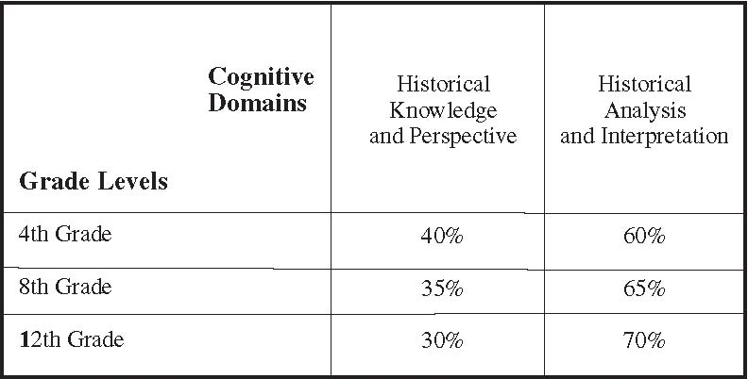
Chapter Three
Desired Attributes of the Assessment and Its Exercises and Items
Too often history has been perceived as dull memorization of an endless series of facts, events, and people long-since dead. By including thoughtful and profound questions, the committees hope to bring an aura of intellectual excitement to the assessment process. The assessment is intended to present a variety of questions that provide opportunities for students to demonstrate their grasp of specific detail, while showing a deep understanding of the context of events and an ability to employ logical historical thought processes. The development of assessment items will take into account issues of fairness and the need to avoid cultural and socioeconomic biases.
- New assessment options are available for use in the assessment. NAEP assessments in the 1980s were confined largely to multiple-choice exercises, but more recent assessments have introduced open-ended and performance exercises. Therefore, the U.S. history assessment should include both the traditional multiple-choice and the newer open-ended questions. In addition, special studies should examine various types of innovative assessment approaches, including portfolios and cooperative learning activities.
- Multiple-choice questions should constitute no more than 50 percent of the assessment. Such questions are desirable because they take up a relatively brief amount of assessment time, are easy to score, and allow for broad content coverage. The multiple-choice items on the assessment should include not only recall and comprehension questions but also a large proportion of questions that require higher level thinking skills.
- Open-ended questions, the other portion of the test, should concentrate on measuring students’ depth of learning in U.S. history. Both short-answer and extended-response exercises should require students to marshal a body of facts and organize and express their thoughts. Recognizing that many students do not perform well on test items requiring long written responses, the item development committee should strive to construct the questions so that students can demonstrate performance on some items without writing extensively.
- The study of history requires the use of a variety of resources. To reflect the richness of history and historical sources, the assessment should use a variety of stimulus materials appropriate to U.S. history. In both the multiple-choice and open-ended exercises, the stimulus materials should include copies of primary documents, graphs, political cartoons, charts, photographs, pictures, maps, and timelines. The types and complexity of materials should be appropriate for students at each grade level, but a variety of types should be used in varying grades. Stimulus materials and documents must be chosen with the understanding that many resources are not equally available to all schools in all areas.
Students will be asked to respond to stimulus materials in a variety of ways:
- Short answers—Responses to short-answer items may require lists, phrases, or sentences.
- Extended responses—Extended responses call upon students to generate more developed arguments, analyses, or explanations and may require the creation of nontextual components such as charts, maps, graphs, and timelines.

Open-ended exercises should be scored according to rubrics that allow students to receive partial credit. Rubrics used to score extended-response exercises should be constructed to evaluate students’ historical knowledge and historical understanding, as well as analytical skills. Careful reading and clever thinking alone will not be sufficient to answer the extended-response questions. The item development panel should develop the scoring criteria prior to the pilot test of the assessment. Extensive training of skilled raters will be essential to ensure that the criteria are applied consistently and do not confound students’ historical knowledge and thinking with the ways in which they express themselves.
In constructing the assessment exercises, the item developers must ensure that the items are congruent with the framework and correspond to the NAEP achievement levels described below.

Achievement Levels in U.S. History
The assessment should be constructed to measure and report student performance according to three levels of achievement—Basic, Proficient, and Advanced—as required by NAEP policy.
The following are the Board-approved achievement levels for students participating in the 1994, 2001, and 2006 NAEP U.S. history assessment in grades 4, 8, and 12. Within each grade, it is assumed that every higher achievement level incorporates and builds upon the preceding levels. Note that the levels suggested for 4th grade are based on the assumption that most students will not have had a formal course in U.S. history. Note: Depending on the nature of the framework changes, we will review the descriptions of the achievement levels. However, the specific changes to the framework should not affect the more general descriptions of achievement levels.
Grade 4
Basic—Fourth-grade students performing at the Basic level should be able to identify and describe a few of the most familiar people, places, events, ideas, and documents in American history. They should be able to explain the reasons for celebrating most national holidays, have some familiarity with the geography of their own state and the United States, and be able to express in writing a few ideas about a familiar theme in American history.
Proficient—Fourth-grade students performing at the Proficient level should be able to identify, describe, and comment on the significance of many historical people, places, ideas, events, and documents. They should be able to interpret information from a variety of sources, including texts, maps, pictures, and timelines. They should be able to construct a simple timeline from data. These students should recognize the role of invention and technological change in history. They should also recognize the ways in which geographic and environmental factors have influenced life and work.
Advanced—Fourth-grade students performing at the Advanced level should have a beginning understanding of the relationships between people, places, ideas, events, and documents. They should know where to look for information, including reference books, maps, local museums, interviews with family and neighbors, and other sources. They should be able to use historical themes to organize and interpret historical topics and to incorporate insights from beyond the classroom into their understanding of history. These students should understand and be able to explain the role of invention and technological change in history. They should also understand and be able to explain the ways in which geographic and environmental factors have influenced life and work.
Grade 8
Basic—Eighth-grade students performing at the Basic level should be able to identify and place in context a range of historical people, places, events, ideas, and documents. They should be able to distinguish between primary and secondary sources. They should have a beginning understanding of the diversity of the American people and the ways in which people from a wide variety of national and cultural heritages have become part of a single nation. Eighth-grade students at the Basic level should also have a beginning understanding of the fundamental political ideas and institutions of American life and their historical origins. They should be able to explain the significance of some major historical events.
Proficient—Eighth-grade students performing at the Proficient level should be able to explain the significance of people, places, events, ideas, and documents, and to recognize the connection between people and events within historical contexts. They should understand and be able to explain the opportunities, perspectives, and challenges associated with a diverse cultural population. They should incorporate geographic, technological, and other considerations in their understanding of events and should have knowledge of significant political ideas and institutions. They should be able to communicate ideas about historical themes while citing evidence from primary and secondary sources to support their conclusions.
Advanced—Eighth-grade students performing at the Advanced level should recognize significant themes and movements in history and begin to understand particular events in light of these themes and movements. They should have an awareness of continuity and change over time and be able to draw relevant analogies between past events and present-day situations. They should be able to frame questions about historical topics and use multiple sources to develop historical generalizations and interpretations. They should be able to explain the importance of historical themes, including some awareness of their political, social, and economic dimensions.
Grade 12
Basic—Twelfth-grade students performing at the Basic level should be able to identify the significance of many people, places, events, dates, ideas, and documents in U.S. history. They should also recognize the importance of unity and diversity in the social and cultural history of the United States and have an awareness of America’s changing relationships with the rest of the world. They should have a sense of continuity and change in history and be able to relate relevant experience from the past to their understanding of contemporary issues. They should recognize that history is subject to interpretation and should understand the role of evidence in making a historical argument.
Proficient—Twelfth-grade students performing at the Proficient level should understand particular people, places, events, ideas, and documents in historical context, with some awareness of the political, economic, geographic, social, religious, technological, and ideological factors that shape historical settings. They should be able to communicate reasoned interpretations of past events, using historical evidence effectively to support their positions. Their written arguments should reflect some indepth grasp of issues and should refer to both primary and secondary sources.
Advanced—Twelfth-grade students achieving at the Advanced level should demonstrate a comprehensive understanding of events and sources of U.S. history. Recognizing that history is subject to interpretation, they should be able to evaluate historical claims critically in light of the evidence. They should understand that important issues and themes have been addressed differently at different times and that America’s political, social, and cultural traditions have changed over time. They should be able to write well-reasoned arguments on complex historical topics and draw upon a wide range of sources to inform their conclusions.

Appendix A
NAEP U.S. History Framework Project
Staff
Ramsay Selden, Director
Student Education Assessment Center
Council of Chief State School Officers (CCSSO)
Thomas Gregory Ward
Consensus Coordinator
CCSSO
Bonnie L. Verrico
Administrative Assistant CCSSO

Steering Committee Members
Marjorie Bingham
Teacher of U.S. History St. Louis Park Senior High School
Minnetonka, Minnesota
Austin Creel
Professor of Religion
University of Florida Department of Religion
Gainesville, Florida
Thomas S. Dickinson
Editor
Middle School Journal National Middle School
Association
Columbus, Ohio
Tom Dunthorn
Social Studies Consultant
Florida Department of Education
Tallahassee, Florida
Gerald M. Eads II
Division Chief
Department of Assessment and Testing
Virginia State Department of Education
Richmond, Virginia
William Everdell
Dean of Humanities and Teacher of Grades 4–12
Saint Ann’s School
Brooklyn Heights, New York
Elizabeth Fox-Genovese
Elenore Raoul Professor of the Humanities
Institute for Women’s Studies Emory University
Atlanta, Georgia
Sandra French
Parent
National PTA
Ellicott City, Maryland
Art Gosling
Superintendent
Arlington County Schools
Arlington, Virginia
Byron Hollinshead
Chairman Americana Magazine, Inc.
New York, New York
Bill Honig
Superintendent
California State Department of Education
Sacramento, California
Arnita A. Jones
Executive Secretary
Organization of American Historians
Bloomington, Indiana
Leon Litwack
Professor of History
University of California
Berkeley, California
Ruth Wattenberg
Coordinator, AFT Education for Democracy Project
American Federation of Teachers
Washington, D.C.
Robert D. Reynolds, Jr.
Archivist
The George Meany Memorial Archives
Silver Spring, Maryland
Armstead L. Robinson
Associate Professor of History
Director of the Carter
Woodson Institute University of Virginia
Charlottesville, Virginia
Everett V. Samuelson
Professor of Educational
Administration
College of Education
University of Idaho
Moscow, Idaho
Diane Stallings
Supervisory Park Ranger
Colonial National Historical Park
Newport News, Virginia
August Steinhilber
General Counsel
National School Boards Association
Alexandria, Virginia
Kathleen Hunter
National Trust for Historic Preservation
Washington, D.C.
Carolyn Yoder
Editor in Chief
Cobblestone Magazine
Peterborough, New Hampshire
Sandra Harp
Member
Minneapolis Board of Education
Minneapolis, Minnesota
Karol Wolgemuth
4th Grade Teacher
Greenview Knolls Elementary School
Great Mills, Maryland
James B. Gardner (Ex Officio)
Deputy Executive Director
American Historical Association
Washington, D.C.
Frances Haley (Ex Officio)
Executive Director
National Council for the Social Studies
Washington, D.C.
Elaine Reed (Ex Officio*)
Executive Secretary
National Council for History Education
Westlake, Ohio
(*Replaced Paul Gagnon on 12/2/91)
Planning Committee Members
Carol Berkin
Professor of History
Baruch College
Department of History
New York, New York
William Branch
Teacher of U.S. History and Political Science
Evanston Township High School #202
Bellwood, Illinois
Stewart Caffey
Teacher of U.S. History
Jefferies Junior High
Comanche Independent School District
Comanche, Texas
Pedro Castillo
Associate Professor of History
University of California, Santa Cruz
Oakes College
Santa Cruz, California
Charlotte Crabtree*
Director, National Center for History in the Schools
University of California, Los Angeles
Los Angeles, California
(*Served on Planning Committee from September 1991–March 1992. Appointed to National Assessment Governing Board on 3/5/92.)
Alberta Sebolt George
Executive Vice President and Chief Operating Officer
Sturbridge Village
Sturbridge, Massachusetts
George M. Gregory
Supervisor of Educational Programs
New York State Education Department
Albany, New York
Claudia Hoone
Teacher of 4th Grade Elementary School #58
Indianapolis, Indiana
Jean Jamgochian
Teacher of Upper Elementary Grades
Haycock Gifted and Talented Center
Falls Church, Virginia
Richard Kirkendall
Bullitt Professor of History
University of Washington
History Department
Seattle, Washington
Linda Levstik
Professor of Education
University of Kentucky
Lexington, Kentucky
Tedd Levy
Teacher of U.S. History
Nathan Hale Middle School
Norwalk, Connecticut
Earl Lewis
Associate Professor of History and Afro-American Studies
Center for Afro-American and African Studies University of Michigan
Ann Arbor, Michigan
Glenabah Martinez
8th Grade Teacher of U.S. History
Rio Grande High School
Albuquerque, New Mexico
John Patrick
Director of the Social Studies Development Center
Indiana University
Bloomington, Indiana
Joyce Stevos
Director of Program and Staff Development
Providence School Department
Providence, Rhode Island
Robert Summerville
Curriculum Consultant for Social Studies
Alabama State Department of Education
Secondary Instructional Services
Montgomery, Alabama
Stephan Thernstrom
Winthrop Professor of History
Harvard University
Cambridge, Massachusetts
Lawana Trout
Professor of English Emeritus
Central State University
Chicago, Illinois
Reed Ueda
Associate Professor of History
Tufts University
Medford, Massachusetts
Jon Wakelyn
Professor of History
Catholic University
Washington, D.C.
Ronald G. Walters
Professor of History
Johns Hopkins University
Baltimore, Maryland
Subcontractors
American Institutes for Research
Judy Mitchell
Associate Research Scientist
Palo Alto, California
American Historical Association
Noralee Frankel (Task Force Chair)
Assistant Director for Women’s and Minority Interests
Washington, D.C.
National Council for History Education
Theodore Rabb (Task Force
Chair)
Professor of History
Princeton University
Princeton, New Jersey
National Council for the Social Studies
Fay Metcalf (Task Force Chair)
Consultant for Social Studies Education
Mesa, Arizona

Appendix B
Released Items From the NAEP U.S. History Assessment
Note: Scoring guides and other information can be found at nces.ed.gov/nationsreportcard under NAEP Questions. In the sample items below, correct answers to multiple-choice questions are indicated by a ●.
Grade 4
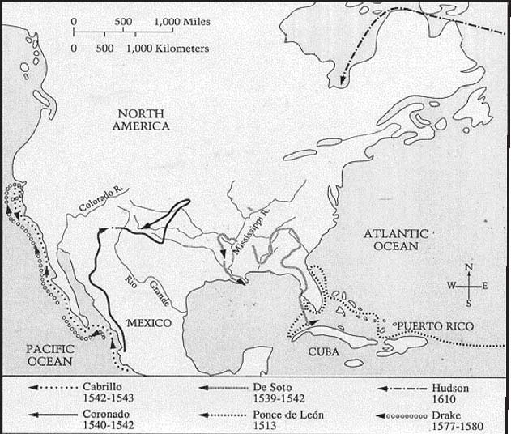
- Suppose that you are traveling with ONE of the explorers whose route is shown on the map.
Write the name of the explorer that you are traveling with. What is the area you are exploring?
Explain why your explorations were important.
[Percent essential: 11% Partial: 39%]
Questions 2–3 refer to the picture below.
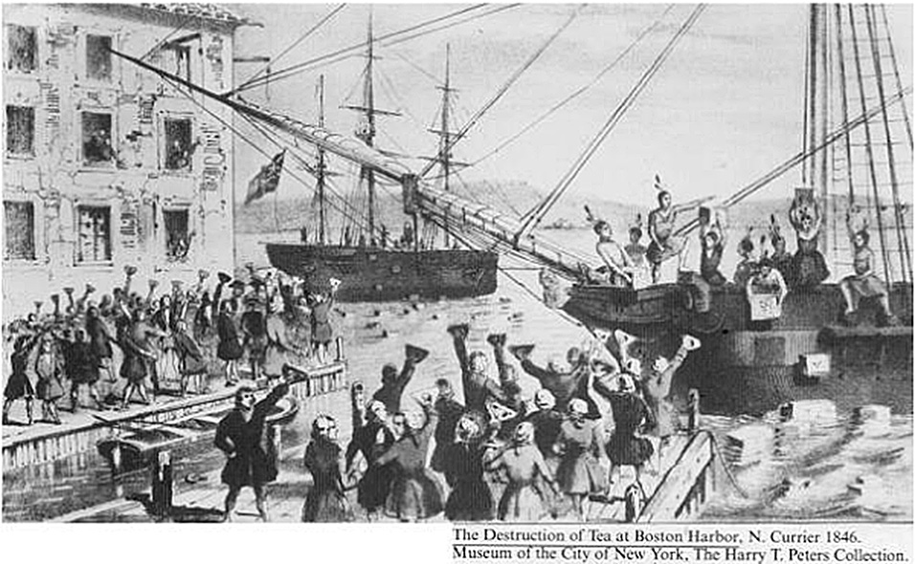
2. What are the people in the picture protesting against?
a. French fur trade with American Indians
b. Colonial treatment of American Indians
c. British control of colonial shipping companies
● British taxation of the colonists
[Percent correct: 21%]
3. The event shown in the picture helped lead directly to the
a. adoption of the Bill of Rights
● American Revolution
c. Great Compromise
d. French and Indian War

[Percent correct: 35%]
4. The document that contains the basic rules used to run the United States government is
a. the Declaration of Independence
b. Magna Carta
c. the Mayflower Compact
● the Constitution
[Percent correct: 27%]
Questions 5–6 refer to the part of the song below.
Follow the Drinkin’ Gourd
Follow the drinkin’ gourd;
Follow the drinkin’ gourd,
For the old man is awaitin’ for to carry you to freedom
If you follow the drinkin’ gourd.
The river bank will make a mighty good road,
The dead trees will show you the way,
Left foot, peg foot travellin’ on;
Follow the drinkin’ gourd.
5. In the song, “following the drinkin’ gourd” means to
● use a group of stars (the Big Dipper) as a guide
b. never go out at night
c. never travel long distances alone
d. share your food and drink with others

[Percent correct: 47%]
6. Why did African Americans originally sing this song?
a. It helped teach children to read and write.
b. It celebrated American independence.
● It gave directions about how to escape from slavery.
d. It was written by slaves in Africa.
[Percent correct: 42%]
These pictures show three common forms of transportation in the United States 100 years ago.
7. Name one form of transportation that is common now in the United States, and explain how it is different from the forms of transportation shown above.
[Percent essential: 24% Partial: 9%]
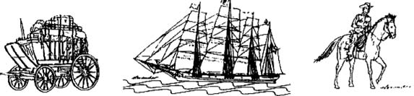
8. What is the purpose of the Bill of Rights?
a. To say how much Americans should pay in taxes
● To protect freedoms like freedom of speech
c. To describe the jobs of the President and Congress
d. To make Washington, D.C., the capital of the United States
[Percent correct: 45%]
9. “That’s one small step for a man, one giant leap for mankind.” This statement was first made when
a. Columbus arrived in the Americas
b. Thomas Edison invented the light bulb
c. Lewis and Clark saw the Pacific
● Neil Armstrong first stepped on the moon
[Percent correct: 61%]
10. You are writing a history report about an old town. What kinds of historical things could you learn about the old town from its cemetery?
Name two historical things you could learn.
[Percent partial: 16% Inappropriate: 28%]
11. Imagine you could use a time machine to visit the past. You have landed in Philadelphia in the summer of 1776. Describe an important event that is happening.
[Percent partial: 28% Inappropriate: 46%]

Questions 12–13 refer to the statement below.
“The house divided against itself cannot stand. I believe this government cannot endure permanently half slave and half free. I do not expect the Union to be dissolved—I do not expect the house to fall—but I do expect it will cease to be divided.”
12. The statement was made by
a. George Washington
b. Thomas Jefferson
● Abraham Lincoln
d. Theodore Roosevelt
[Percent correct: 39%]
13. What war broke out soon after the statement was made?
a. American Revolution
b. War of 1812
c. Mexican-American War
● Civil War
[Percent correct: 54%]
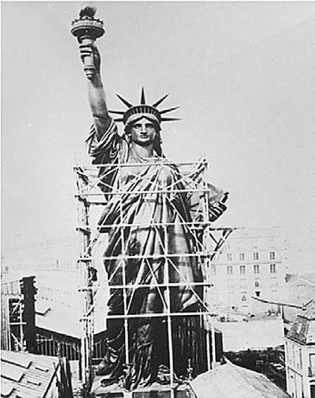
14. What best describes this monument?
a. For many Americans, it has been a symbol of the power of the President.
b. For many people moving west in covered wagons, it has been a symbol of bravery.
c. For many soldiers, it has been a symbol of the United States Army.
● For many immigrants, it has been a symbol of the freedom they hoped to find in the United States.
[Percent correct: 68%]
15. Give TWO reasons why the people we call “pioneers” moved west across the United States.
[Percent partial: 29% Inappropriate: 48%]
Grade 8
1. Over the years, many people have immigrated to the United States. Give two reasons why people have come. Name a group of immigrants who came for each reason you have given.
[Partial: 54% Inappropriate percent: 17%]
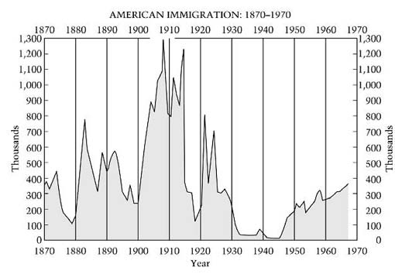
2. The graph above traces “peaks” and “valleys” in immigration to the United States from 1890 to 1970. Choose two valleys on the graph. Using your knowledge of United States history, explain one major reason for each of the valleys you selected.
[Percent essential: 21% Partial: 26%]
3. One major consequence of the Seven Years’ War (French and Indian War) was that the
a. colonists’ decision to side with France led Britain to retaliate against them
● expense of fighting the war led Britain to tax the colonies directly for the first time
c. loyalty of the colonists to the British side led Britain to grant them a high degree of self-government
d. elimination of the French threat in North America led Britain to concentrate on conquering all of the remaining Spanish colonies

[Percent correct: 47%]

4. Many people opposed ratification of the Constitution without a bill of rights because they
a. were afraid that states would be too powerful without a bill of rights
b. thought that a bill of rights would strengthen the President’s power
c. did not want the national government to have an army
● feared that the new national government would deny people their rights
[Percent correct: 54%]
5. What was the most significant factor that led the American colonists to form the First Continental Congress in 1774?
a. Religious conflict inside the colonies
b. The desire of the colonists to write a Constitution to replace the Articles of Confederation
● Colonial frustration with laws passed by the British Parliament
d. The desire of the colonists to stop the war between Britain and the colonies

[Percent correct: 39%]
6. List two issues that were important in causing the Civil War. On the chart below, list the Northern and Southern positions on each of these issues.
MANY NORTHERNERS MANY SOUTHERNERS
BELIEVED BELIEVED
1. 1.
2. 2.

[Percent partial: 48% Inappropriate: 28%]

7. The phonograph was invented by
a. Samuel Morse
b. Benjamin Franklin
● Thomas Edison
d. Cyrus McCormick

[Percent correct: 48%]
8. What goal was most important in shaping United States foreign policy between 1945 and 1990?
● Preventing the spread of communism to new areas and weakening it where it already existed
b. Encouraging trained scientists and other skilled workers who lived in foreign countries to immigrate to the United States
c. Strengthening the United States industrial and agricultural sectors to help them compete against the British and the French
d. Providing foreign aid to all poor countries to help them develop economically and technologically

[Percent correct: 26%]
9. The Lend-Lease Act, the Yalta Conference, and the dropping of the atomic bomb on Hiroshima are all associated with the
a. First World War
● Second World War
c. Korean War
d. Vietnam War

[Percent correct: 41%]
Questions 10–12 refer to the passage below.
“We hold these truths to be self-evident: That all men are created equal; that they are endowed by their Creator with certain unalienable rights; that among these are life, liberty, and the pursuit of happiness. That, to secure these rights, governments are instituted among men, deriving their just powers from the consent of the governed; that, whenever any form of government becomes destructive of these ends, it is the right of the people to alter or to abolish it, and to institute a new government.”
—1776
10. The quotation is from the
a. Articles of confederation
b. Constitution
● Declaration of Independence
d. Missouri Compromise

[Percent correct: 62%]
11. The primary author of the document was
a. George Washington
b. John Marshall
c. Robert E. Lee
● Thomas Jefferson
[Percent correct: 71%]
12. Explain why the framers of the Constitution established a system of checks and balances among the three branches of government.
[Percent partial: 22% Inappropriate: 39%]
13. You are writing a history report about an old town. What kinds of historical things could you learn about the old town from its cemetery?
Name two historical things you could learn.
[Percent partial: 36% Inappropriate: 13%]
Questions 14–15 refer to the cartoon below.
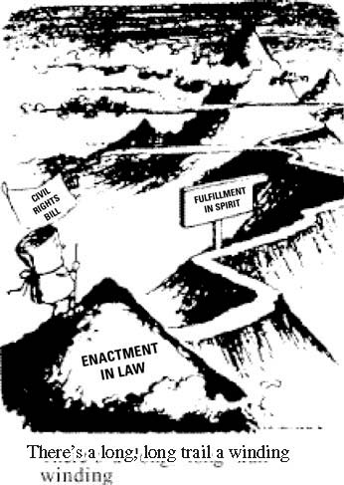
14. Circle the decade in which you believe this cartoon was drawn.
1920s 1940s 1960s 1980s
Citing specific historical evidence, explain why you chose the decade you did.
[Percent partial: 10% Inappropriate: 73%]
15. What is the main message of this cartoon?
[Partial: 10% Inappropriate: 82%]
16. The Monroe Doctrine was intended to
a. promote United States trade with China
b. help keep the peace in Europe
● discourage European involvement in the Americas
d. protect United States business in Japan and Korea
[Percent correct: 30%]
Grade 12
1. Which of the following best describes the British colonial policy called mercantilism?
a. Encouraging colonists to sell manufactured goods to European countries
b. Sending raw materials from Britain to the colonies
● Exercising British control over economic activities in the colonies
d. Attempting to make the colonies economically self-sufficient

[Percent correct: 40%]
“In spite of the obvious advantages held by the North, the South was able to fight for four years and to achieve some real military successes. So while the North held most of the cards, the South had one or two aces up its sleeves.”
2. Identify two of the “aces” (significant advantages) that the South had in the Civil War. Explain how these advantages helped the South.
[Percent essential: 26% Partial: 7%]
3. In which book did Upton Sinclair describe the terrible working and food-production conditions in the meat-packing industry?
a. The Grapes of Wrath
b. Pit
c. The Octopus
● The Jungle
[Percent correct: 41%]
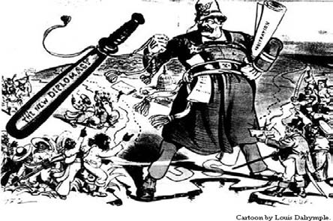
Questions 4–5 refer to the cartoon below.

4. When the cartoon was created, the artist was probably thinking of which foreign policy slogan?
a. The arsenal of democracy
b. Peace with honor
c. We have nothing to fear but fear itself
● Speak softly and carry a big stick
[Percent correct: 45%]
5. Describe the type of foreign policy that the policeman in the cartoon represents. Give one specific example of this type of foreign policy from the period that the cartoon shows.
[Percentage partial: 14% Inappropriate: 63%]
“We will answer [the] demand for a gold standard by saying . . . you shall not press down upon the brow of labor this crown of thorns, you shall not crucify mankind on a cross of gold. ”
—William Jennings Bryan, 1896
6. What was Bryan arguing in his “Cross of Gold” speech?
a. Free coinage of silver would cause a depression.
b. The gold standard was needed to preserve economic stability.
● The gold standard harmed some groups in society.
d. The government should stop buying silver immediately.

[Percent correct: 52%]
7. Many writers of the “lost generation,” such as F. Scott Fitzgerald, wrote books in which they
● criticized what they regarded as the shallow materialism of the United States during the 1920s
b. sought to capture the freedom experienced by people living on the western frontier
c. praised the quick pace and unique opportunities found in large cities in the United States
d. expressed deep yearning for what they regarded as the simple lives led by rural Americans

[Percent correct: 42%]
8. Churches and other religious institutions have been important in reform movements in the United States. Identify one reform movement in which religious institutions have been involved since 1945.
Why did these institutions get involved in this movement, and what actions did they take?
[Percent partial: 5% Inappropriate: 28%]
9. Article I, Section 2, United States Constitution
“[The population of states] shall be determined by adding to the whole number of free persons . . . three-fifths of all other persons.”
An important debate led to the writing of this section of the Constitution. Identify the issue being debated.
Describe the northern position in this debate and explain why many northerners took it.
Describe the southern position in this debate and explain
why many southerners took it.
[Percent essential: 9% Partial: 20%]
10. The Progressive movement of 1890–1920 is best described as
● a broad-based reform movement that tried to reduce the abuses that had come with modernization and industrialization
b. a loose coalition of groups primarily dedicated to passing a constitutional amendment prohibiting the consumption of alcohol
c. an anti-tariff movement led by a federation of business owners and manufacturers who wanted to promote trade abroad
d. a grass-roots movement that attempted to gather support for the establishment of an international organization such as the League of Nations
[Percent correct: 36%]

“Imagine a six-foot-deep ditch weaving from Washington, D.C., to Detroit, Michigan. Men’s heads could not be seen over the top edges. Dugouts would be tunneled for sleeping and eating quarters.”
11. The passage above describes battle conditions first experienced by United States soldiers fighting in the
● First World War
b. Second World War
c. Korean War
d. Vietnam War

[Percent correct: 51%]
Questions 12–13 refer to the quotation below.
“It must be the policy of the United States to support free peoples who are resisting . . . armed minorities or . . . outside pressures.”
—Harry S. Truman, 1947
12. The policy described was part of a larger policy of the Truman administration that was referred to as
a. nativism
b. massive retaliation
c. isolationism
● containment
[Percent correct: 26%]
13. How did Truman’s assertion change traditional United States foreign policy?
Give two specific examples of United States actions that illustrate the new foreign policy.
[Percent partial: 13% Inappropriate: 48%]
Questions 14–15 refer to the headline and newspaper cartoon below.
SOVIETS LAUNCH FIRST MAN-MADE SATELLITE INTO ORBIT
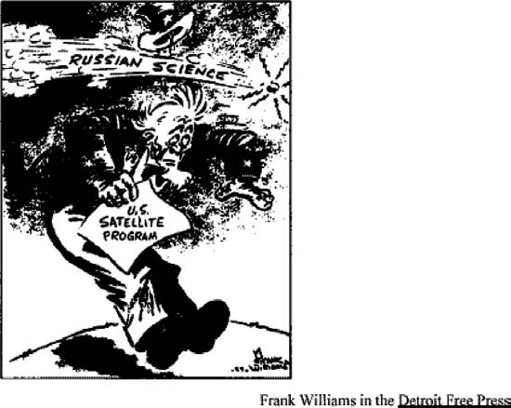
14. What did the United States government do in response to the event referred to in the cartoon and headline?
a. The government decided to seek peace immediately and to end the Cold War.
b. The government banned civilian contact between United States and Soviet citizens.
● The government decided to spend more on both scientific education and the military.
d. The government requested that the United Nations prohibit Soviet space exploration.

[Percent correct: 74%]
15. Give two reasons why many people in the United States were upset by the events shown in the cartoon and the headline.
[Percent partial: 46% Inappropriate: 18%]

