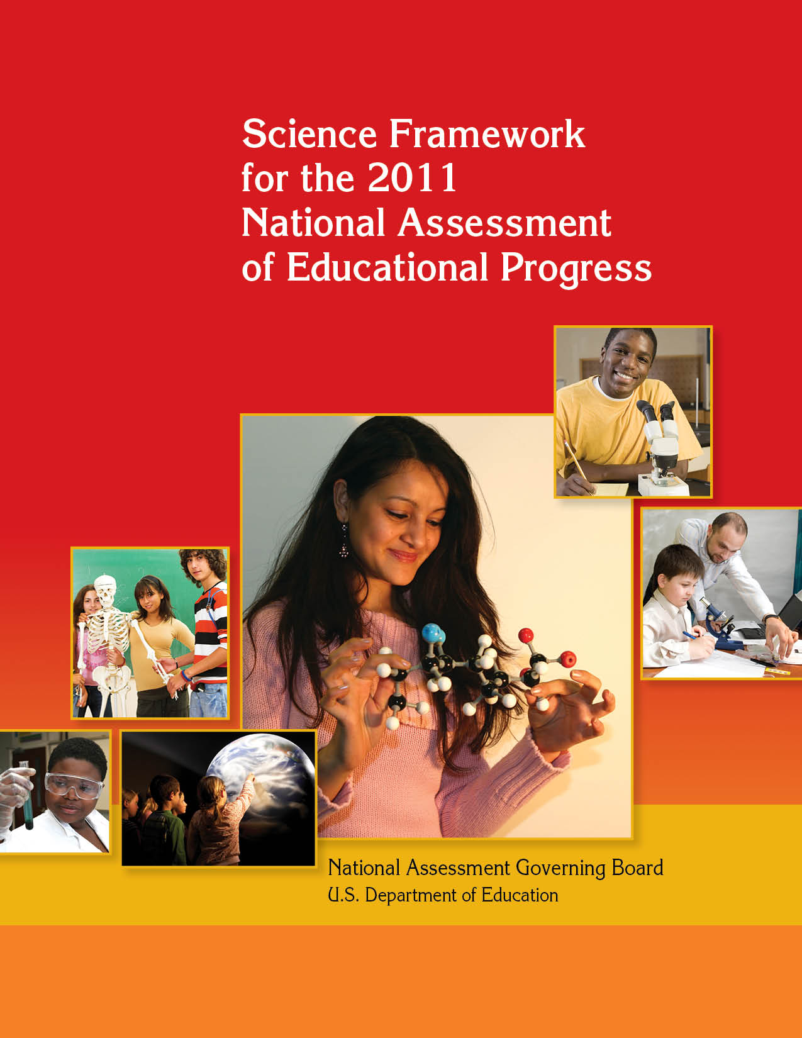

What Is NAEP?
The National Assessment of Educational Progress (NAEP) is a continuing and nationally representative measure of trends in academic achievement of U.S. elementary and secondary students in various subjects. For nearly four
decades, NAEP assessments have been conducted periodically in reading, mathematics, science, writing, U.S.
history, civics, geography, and other subjects. By collecting and reporting information on student performance at
the national, state, and local levels, NAEP is an integral part of our nation's evaluation of the condition and pro-
gress of education.

The 2009–2010 National Assessment Governing Board

The National Assessment Governing Board was created by Congress to formulate policy for NAEP. Among the Governing Board’s responsibilities are developing objectives and test specifications and designing the assessment methodology for NAEP.

Members

Honorable David P. Driscoll, Chair
Former Commissioner of Education
Melrose, Massachusetts

Amanda P. Avallone, Vice Chair
Assistant Principal & 8th Grade Teacher
Summit Middle School
Boulder, Colorado

David J. Alukonis
Former Chairman
Hudson School Board
Hudson, New Hampshire

Louis M. Fabrizio
Director
Accountability Policy and Communications
N.C. Department of Public Instruction
Raleigh, North Carolina

Honorable Anitere Flores
Member
Florida House of Representatives
Miami, Florida

Alan J. Friedman
Consultant
Museum Development and Science Communication
New York, New York

David W. Gordon
County Superintendent of Schools
Sacramento County Office of Education
Sacramento, California

Doris R. Hicks
Principal and Chief Executive Officer
Dr. Martin Luther King, Jr. Charter School for Science and Technology
New Orleans, Louisiana

Kathi M. King
12th Grade Teacher
Messalonskee High School
Oakland, Maine

Kim Kozbial-Hess
4th Grade Teacher and Educational Technology Trainer
Toledo, Ohio

Henry Kranendonk
Mathematics Curriculum Specialist
Milwaukee Public Schools
Milwaukee, Wisconsin

Tonya Miles
General Public Representative
Mitchellville, Maryland

Honorable Steven L. Paine
State Superintendent of Schools
W.V. Department of Education
Charleston, West Virginia

Honorable Sonny Perdue
Governor of Georgia
Atlanta, Georgia

Susan Pimentel
Educational Consultant
Hanover, New Hampshire

W. James Popham
Professor Emeritus
Graduate School of Education and Information Studies
University of California, Los Angeles
Los Angeles, California
Andrew C. Porter
Dean, Graduate School of Education
University of Pennsylvania
Philadelphia, Pennsylvania

Warren T. Smith, Sr.
Vice President
Washington State Board of Education
Olympia, Washington

Mary Frances Taymans, SND
Former Executive Director
Secondary Schools Department
National Catholic Educational Association
Washington, DC

Oscar A. Troncoso
Principal
Anthony High School
Anthony Independent School District
Anthony, Texas

Honorable Leticia Van de Putte
Senator
Texas State Senate
San Antonio, Texas

Eileen L. Weiser
General Public Representative
Ann Arbor, Michigan

Darvin M. Winick
President
Winick & Associates
Austin, Texas
Ex-officio Member

John Q. Easton
Director
Institute of Education Sciences
U.S. Department of Education


National Assessment Governing Board
Honorable David P. Driscoll
Chair
Amanda P. Avallone
Vice Chair
Cornelia S. Orr
Executive Director
Mary Crovo
Deputy Executive Director and
Project Officer

Developed for the National Assessment Governing Board under contract number
ED–04–CO–0148 by WestEd and the Council of Chief State School Officers
For further information, contact:
National Assessment Governing Board
800 North Capitol Street, N.W.
Suite 825
Washington, DC 20002–4233
www.nagb.org
September 2010

Table of Contents

List of Exhibits iii
Executive Summary v
Key Features vi
Content of the Framework vii
Special Studies ix
Achievement Levels ix
NAEP Science Project Staff and Committees xi
Chapter One: Overview 1
Need for a New Framework 1
Context for Planning the Framework 2
The Framework Development Process 3
Steering Committee Guidelines 5
Uses of NAEP Data 6
Challenges of Developing a NAEP Assessment 7
Achievement Levels 10
Introduction to the Assessment Framework 10
Overview of Framework Chapters 12
Comparison of 1996–2005 NAEP Science Framework and 2009–2011 NAEP Science Framework 15
Chapter Two: Science Content 17
Development of the Content Statements 17
Organization of Science Content 19
Interpretation of the Content Statements 20
Crosscutting Content 22
Physical Science 23
Life Science 36
Earth and Space Sciences 47
Components of Science Content as Assessment Item Contexts 60
From Science Content to Science Practices 60
Chapter Three: Science Practices 61
Overview of Practices 61
Identifying Science Principles 63
Using Science Principles 64
Using Scientific Inquiry 69
Using Technological Design 72
Summary of Practices 76
Performance Expectations 78
Generating and Interpreting Items 80
Learning Progressions 86
Cognitive Demands 87
Chapter Four: Overview of the Assessment Design 91
Overview of the Science Assessment 91
Assessment Item Contexts 92
Types of Items 92
Distribution of Items 108
Students With Disabilities and English Language Learners 110
Special Studies 112
Appendix A: Steering Committee Guidelines 119
The Framework Is Informed by the National Standards and Benchmarks 119
The Framework Reflects the Nature and Practice of Science 119
The Framework Incorporates Key Attributes of Effective Assessment 120
The Assessment Provides Data for Research 121
The Specifications Document Is Closely Aligned With the Framework 122
Appendix B: NAEP Science Achievement Level Descriptions 124
NAEP Science Achievement Levels—Grade 4 126
NAEP Science Achievement Levels—Grade 8 129
NAEP Science Achievement Levels—Grade 12 132
Appendix C: Sample Items and Scoring Guides 137
Appendix D: Group 2 Small-Scale Special Studies 151
Knowing What Students Know About Technological Design 151
Extended Investigations by Students 151
Bibliography 153

List of Exhibits

Exhibit 1. Crossing content and practices to generate performance expectations 11
Exhibit 2. Generating items and interpreting responses 12
Exhibit 3. Comparison of NAEP science frameworks: 1996–2005 and 2009–2011 15
Exhibit 4. NAEP science content topics and subtopics 19
Exhibit 5. One grade 8 Physical Science principle represented in the framework, National Standards, and Benchmarks 20
Exhibit 6. Commentary on a Physical Science content statement 21
Exhibit 7. Physical Science content topics and subtopics 24
Exhibit 8. Physical Science content statements for grades 4, 8, and 12 30
Exhibit 9. Life Science content topics and subtopics 37
Exhibit 10. Life Science content statements for grades 4, 8, and 12 42
Exhibit 11. Earth and Space Sciences content topics and subtopics 48
Exhibit 12. Earth and Space Sciences content statements for grades 4, 8, and 12 54
Exhibit 13. General performance expectations for science practices 76
Exhibit 14. Generating examples of grade 8 performance expectations 79
Exhibit 15. Earth and Space Sciences example of generating and interpreting items 81
Exhibit 16. Examples of performance expectations for states of matter 87
Exhibit 17. Distribution of items by content area and grade 109
Exhibit 18. Distribution of items by science practice and grade 109
Exhibit 19. Distribution of items by type of item and grade 110
Exhibit 20. Storyboard showing item design for a “branching” item
bundle on ions and atoms (adapted from Scalise 2004) 116
Exhibit B-1. Generic achievement level policy definitions for NAEP 124

Executive Summary

In the rapidly changing world of the 21st century, science literacy is an essential goal for all of our nation’s youth. Through science education, children come to understand the world in which they live and learn to apply scientific principles in many facets of their lives. In addition, our country has an obligation to provide young people who choose to pursue careers in science and technology with a strong foundation for their postsecondary study and work experience. The nation’s future depends on scientifically literate citizens who can participate as informed members of society and as a highly skilled scientific workforce, well prepared to address challenging issues at the local, national, and global levels. Recent studies, including national and international assessments, indicate that our schools still do not adequately educate all students in science.

Science seeks to increase our understanding of the natural world through empirical
evidence. Such evidence gathered through observation and measurement allows for an explanation and prediction of natural phenomena. Hence, a scientifically literate person is familiar with the natural world and understands key facts, concepts, principles, laws, and theories of science, such as the motion of objects, the function of cells in living organisms, and the properties of Earth materials. Further, a scientifically literate person can connect ideas across disciplines; for example, the conservation of energy in physical, life, Earth, and space systems. Scientific literacy also encompasses understanding the use of scientific principles and ways of thinking to advance our knowledge of the natural world as well as the use of science to solve problems in real-world contexts, which this document refers to as “Using Technological Design.”

The National Assessment of Educational Progress (NAEP) and its reports are a key measure in informing the nation on how well the goal of scientific literacy for all students is being met. The Science Framework for the 2011 National Assessment of Educational Progress sets forth the design of the NAEP Science Assessment. The 2011 NAEP Science Assessment will use the same framework used in 2009. The 2009 NAEP Science Assessment started a new NAEP science trend (i.e., measure of student progress in science), and the 2011 NAEP Science Report Card will include student performance trends from 2009 to 2011. Trends in student science achievement were reported from 1996 to 2005 as well. However, the trend from 1996 to 2005 was not continued due to major differences between the 2005 and 2009 frameworks. The new framework represents a unique opportunity to build on key developments in science standards, assessments, and research. This document is intended to inform the general public, educators, policymakers, and others about what students are expected to know and be able to do in science as part of The Nation’s Report Card, a program of the U.S. Department of Education (ED) that reports on NAEP findings.

In 1988, Congress created the National Assessment Governing Board to set policy for NAEP. The National Center for Education Statistics (NCES, a division of ED) carries out NAEP. As the ongoing national indicator of the academic achievement of U.S. students, NAEP regularly collects information on representative samples of students in grades 4, 8, and 12 and periodically reports on student achievement in reading, mathematics, writing, science, and other subject areas. NAEP scores are always reported at the aggregate level, not for individual students or schools. (By law, NAEP cannot report results for individual students.) For science, NAEP results are reported at the national and state levels and for a number of large urban districts. The district reports are provided for urban school systems that volunteer for the Trial Urban District Assessment component of NAEP.

NAEP produces comparative student achievement results according to demographic
factors such as gender, race/ethnicity, and geographic region. Results are also provided in terms of student, teacher, and school background variables related to science achievement. Taken together, this information from NAEP helps the general public, educators, and policymakers make informed decisions about education. Interested individuals can access performance results and released questions through NAEP reports and websites.

A new framework to guide the science assessment was necessary for several reasons: publication of National Standards for science literacy, advances in both science and cognitive research, growth in national and international science assessments, and increases in innovative assessment approaches. This framework presents the content to be assessed as well as the conceptual base for the assessment. It is intended for a general audience. A more detailed technical document, Science Assessment and Item Specifications for NAEP, is a companion piece. The specifications document provides detailed information on the content to be assessed, item development, and other aspects of assessment development and administration. The audience for the science specifications is NCES and the NAEP assessment development contractors.

Key Features
This framework is the result of extraordinary effort and commitment by hundreds of individuals across the country, including some of the nation’s leading scientists, science educators, policymakers, and assessment experts. Under contract to the Governing Board, WestEd and the Council of Chief State School Officers (CCSSO) spent 18 months developing the framework; this process involved committees, regional hearings, and other public forums. The Governing Board also engaged an external review panel to evaluate the draft framework and convened a public hearing to gather additional input during the
development process.

The new framework incorporates the following key features:
- Its design is based on widely accepted national science standards and assessments in addition to state curriculum standards. However, it is intended to inform development of an assessment, not to advocate for a particular approach to instruction or to represent the entire range of science content and skills.
- In view of the need to keep the United States and its youth internationally competitive in science and technology, the framework development process gave special consideration to international assessment frameworks, such as those for Trends in International Mathematics and Science Study (TIMSS) and Programme for International Student Assessment (PISA).
- The breadth of the science principles represented in the source materials made it necessary to focus on the foundational and pervasive knowledge within each discipline and to pare down the science content to be assessed.
- The framework is based on scientific knowledge and processes derived from tested explanations and supported by accumulated empirical evidence. Explanations of natural phenomena that rely on nonscientific views are not reflected in the framework.
- Science content is presented in detailed, grade-specific charts that also allow the reader to see the progression in complexity of ideas across grades.
- Every attempt has been made to be free of error in describing the science content. The language used strives to be accurate but not technical so as to make the framework accessible to a wide audience.
- The focus is on students’ conceptual understanding, that is, their knowledge and use of science facts, concepts, principles, laws, and theories. Students’ abilities to engage in some components of scientific inquiry and technological design are also reflected in the framework.
- New types of items are recommended, including the use of interactive computer tasks.

Content of the Framework
The framework describes the science content and science practices that form the basis for the NAEP Science Assessment. It also discusses item distribution and types of items, as well as draft achievement levels. Finally, it recommends several small-scale, special studies to be considered in conjunction with the science assessments.

Science Content
The science content for NAEP is defined by a series of statements that describe key facts, concepts, principles, laws, and theories in three broad areas:

- Physical Science
- Life Science
- Earth and Space Sciences

Physical Science deals with matter, energy, and motion; Life Science deals with structures and functions of living systems and changes in living systems; and Earth and Space Sciences deal with Earth in space and time, Earth structures, and Earth systems. Details about the science content and the science content statements can be found in chapter two.

Science Practices
The second dimension of the framework is defined by four science practices:

- Identifying Science Principles
- Using Science Principles
- Using Scientific Inquiry
- Using Technological Design

These practices can be combined with any science content statement to generate student performance expectations, and assessment items can then be developed based on these performance expectations. The cognitive demands placed on students as they engage in assessment tasks are also described. The science practices and cognitive demands are
explained more fully in chapter three.

Distribution of Items
As measured by student response time, the distribution of items by content area should be as follows: approximately equal across Physical Science, Life Science, and Earth and Space Sciences at grade 4; more emphasis on Earth and Space Sciences at grade 8; and a shift to more emphasis on Physical Science and Life Science at grade 12. With respect to science practices, at all grades the greatest emphasis should be on identifying and using science principles and slightly less than a third of the time should be spent on items
related to using scientific inquiry. Specific recommended percentages are discussed in chapter four.

Types of Items
Item types for the NAEP Science Assessment fall into two broad categories: selected-response items (such as multiple choice) and constructed-response items (such as short answer). As measured by student response time, 50 percent of the assessment items at each grade level should be selected response and 50 percent should be constructed response. To further probe students’ abilities to combine their understanding with the investigative skills that reflect practices, a subset of the students sampled should receive an additional 30 minutes to complete hands-on performance or interactive computer tasks. At each grade, at least four of these tasks should be included. Of these four tasks, there should be at least one hands-on performance task and one interactive computer task; the number of interactive computer tasks should not exceed the number of hands-on performance tasks. Chapter four contains more information about types of items.

Hands-on Performance Tasks
In hands-on performance tasks, students manipulate selected physical objects and try to solve a scientific problem involving the objects. NAEP hands-on performance tasks should provide students with a concrete task (problem) along with equipment and
materials. Students should be given the opportunity to determine scientifically justifiable procedures for arriving at a solution. Students’ scores should be based on both the solution and the procedures created for carrying out the investigation. Further discussion about hands-on performance tasks can be found in chapter four.

Interactive Computer Tasks
There are four types of interactive computer tasks: (1) information search and analysis, (2) empirical investigation, (3) simulation, and (4) concept maps. Information search and analysis items pose a scientific problem and ask students to query an information database and analyze relevant data to address the problem. Empirical investigation items place hands-on performance tasks on the computer and invite students to design and conduct a study to draw conclusions about a problem. Simulation items model systems (e.g., food webs) and ask students to manipulate variables, and predict and explain resulting changes in the system. Concept map items probe aspects of the structure or organization of students’ scientific knowledge by providing concept terms and having students create a logical graphic organizer. Chapter four contains more information about interactive computer tasks.

Special Studies
On occasion, NAEP carries out special studies to inform future assessments. Three special study proposals ranked as top priority for the NAEP Science Assessment:
- “Exchangeability” of hands-on performance and interactive computer investigations
- Impact of variation in item format and language demand on the performance of English language learners and students with disabilities
- Computer adaptive testing to assess the development of student understanding of Earth systems

Details of these proposed studies are found in chapter four.

Achievement Levels
Results of the NAEP Science Assessment are reported as average scores for groups
of students and as percentages of students who attain the Basic, Proficient, or Advanced achievement levels. Descriptions of these achievement levels are contained in
appendix B.

NAEP Science Project Staff and Committees

The Science Framework for the National Assessment of Educational Progress is the result of extraordinary effort and commitment by hundreds of individuals across the country, including some of the nation’s leading scientists, science educators, policy-makers, and assessment experts. Every attempt has been made to be accurate in the
description and representation of the science content. Existing framework development policies and procedures ensure periodic reviews and revisions, if necessary, to reflect
advancements in scientific knowledge. Because this is a public endeavor, the Governing Board (www.nagb.org) welcomes suggestions for future versions of the framework.

Steering Committee
Gerald Wheeler, Chair
Executive Director
National Science Teachers Association
Arlington, Virginia

Mary Yakimowski, Co-Chair*
Director of Assessment
Council of Chief State School Officers
Washington, D.C.

Vance R. Ablott
Executive Director
Triangle Coalition for Science and Technology Education
Arlington, Virginia

Eileen M. Ahearn
Project Director
National Association of State Directors of Special Education
Alexandria, Virginia

Margaret A. Bartz
Council of the Great City Schools
(representative)
Assessment Specialist, Administrator
Chicago Public Schools
Chicago, Illinois

Tim Beagley
National Association of State Boards of Education (representative)
Member, District 6
Utah State Board of Education
West Valley, Utah

Ann Elizabeth Benbow
Director of Outreach, Education &
Development
American Geological Institute
Alexandria, Virginia

E. Jane Gallucci
Secretary/Treasurer
National School Boards Association
Clearwater, Florida

Yolanda Scott George
American Institute of Biological Sciences (representative)
Deputy Director and Program Director
American Association for the Advancement of Science
Washington, D.C.

Lisa Brady Gill
Partnership for 21st Century Skills (representative)
Director, Office of Education Policy
Educational and Productivity Solutions
Texas Instruments, Inc.
Dallas, Texas

Heidi Glidden
Senior Associate
American Federation of Teachers
Washington, D.C.

Gary L. Heath
Assistant State Superintendent Accountability and Assessment
Maryland State Department of Education
Baltimore, Maryland

Jack G. Hehn
Director, Education
American Institute of Physics
College Park, Maryland

Paul Hickman
American Physical Society (representative)
Science Consultant
Andover, Massachusetts

Linda Hodge
President
National Parent Teacher Association
Chicago, Illinois

Marilynn Messick Kelley
National Catholic Educational Association (representative)
Science Chair/Physics Teacher
Gonzaga College High School
Washington, D.C.

Ioannis N. Miaoulis
President and Director
Museum of Science, Boston
Boston, Massachusetts

Jacqueline S. Miller
Senior Scientist, Center for Science Education
Education Development Center, Inc.
Newton, Massachusetts

Jean Moon
Director, Board on Science Education
The National Academies, Center for Education
Washington, D.C.

Brett D. Moulding
Past President, Council of State Science Supervisors (representative)
Science Coordinator
Utah Office of Education
Salt Lake City, Utah

Carlo Parravano
Executive Director
Merck Institute for Science Education
Rahway, New Jersey

Leslie Ann Pierce
National Association of Biology Teachers (representative)
Biology and Chemistry Teacher
Thomas A. Edison High School
Alexandria, Virginia

Andrea I. Prejean
Senior Professional Associate, Student Achievement
National Education Association
Washington, D.C.

Judith Richardson
Resident Practitioner for Assessment & Accountability
National Association of Secondary School Principals
Reston, Virginia

Cheryl Riggins-Newby
Associate Executive Director
National Association of Elementary School Principals
Alexandria, Virginia

Mary Lucy “Doc” Sennett
Association for Supervision and Curriculum Development (representative)
Secondary Science Teacher
Northwest Rankin High School
Belhaven College
Brandon, Mississippi

Sally Goetz Shuler
Executive Director
National Science Resources Center
Washington, D.C.

Finbarr C. Sloane**
Program Director, Research, Evaluation & Communication
National Science Foundation
Arlington, Virginia

Patrick Sean Smith
Senior Research Associate
Horizon Research, Inc.
Chapel Hill, North Carolina

Conrad Stanitski
American Chemical Society (representative)
Visiting Professor, Chemistry Department
Franklin & Marshall College
Lancaster, Pennsylvania

Angela Diane Wenger
Association of Science-Technology Centers (representative)
Executive Vice President and Chief Operating Officer
New Jersey Academy for Aquatic Sciences
Camden, New Jersey

Anne S. Yates
Consultant, Center for Collaborative Research & Education
DuPont Company
Wilmington, Delaware

Planning Committee
Richard J. Shavelson, Chair
Margaret Jacks Professor of Education and Senior Fellow, Stanford Institute for the Environment
Stanford University
Stanford, California

Senta A. Raizen, Co-Chair
Director, National Center for
Improving Science Education
WestEd
Arlington, Virginia

Charles W. (Andy) Anderson
Professor, Department of Teacher Education
Michigan State University
East Lansing, Michigan

Myron Atkin
Professor of Education (Emeritus), Center for Educational Research at Stanford (CERAS)
Stanford University
Stanford, California

Rodger W. Bybee
Executive Director
Biological Sciences Curriculum Study
Colorado Springs, Colorado

Audrey Champagne
Professor, Department of Educational Theory and Practice and Department of Chemistry
University at Albany, State University of New York (SUNY)
Albany, New York

Nancy Chesley
Teacher
Mabel I. Wilson School
Cumberland Center, Maine

Linda M. Crocker
Professor (Emeritus)
University of Florida
Hawthorne, Florida

Richard Duschl
Professor, Graduate School of Education
Rutgers, The State University of New Jersey
New Brunswick, New Jersey

Janice Earle
Senior Program Director
National Science Foundation
Arlington, Virginia

Arthur Eisenkraft
Distinguished Professor of Science Education and Senior Research Fellow
University of Massachusetts, Boston
Quincy, Massachusetts

Jim Ellingson
Assistant Professor of Education
Concordia College
Moorhead, Minnesota

Barbara A. Hopkins
Outreach Director, UNH Leitzel Center
University of New Hampshire
Durham, New Hampshire

Jane Butler Kahle
Condit Professor of Science Education, School of Education and Allied Professions
Miami University
Oxford, Ohio

Michele Lombard
Science Specialist
Arlington Public Schools
Arlington, Virginia

María Alicia López Freeman
Executive Director, California Science Project
University of California, Los Angeles
Los Angeles, California

Carolee S. Matsumoto
Director of Research and Dissemination, Center for University, School and Community Partnerships
University of Massachusetts, Dartmouth
New Bedford, Massachusetts
Jim Minstrell
Research Scientist
FACET Innovations
Seattle, Washington

Michael J. Padilla
President, National Science Teachers Association
Professor and Director for Educator Partnerships, College of Education
University of Georgia
Athens, Georgia

Jo Ellen Roseman
Director, Project 2061
American Association for the Advancement of Science
Washington, D.C.

Cary Sneider
Vice President for Educator Programs
Museum of Science, Boston
Boston, MA

Elizabeth K. Stage
Director, Lawrence Hall of Science
University of California, Berkeley
Berkeley, CA

Anne Tweed
Past President, National Science Teachers Association
Senior Science Consultant
Mid-continent Research for Education and Learning (McREL)
Aurora, CO

David J. White
Science Assessment Coordinator
Vermont Department of Education
Berlin, VT

Mark Wilson
Professor, Graduate School of Education
University of California, Berkeley
Berkeley, California

Governing Board Staff
Mary Crovo
Assistant Director for Test Development
National Assessment Governing Board
Washington, DC

Sharif Shakrani
Deputy Executive Director and Contract Officer
National Assessment Governing Board
Washington, DC

Charles Smith
Executive Director
National Assessment Governing Board
Washington, DC

WestEd Staff
Alice Fu
Science Specialist, National Center for Improving Science Education
WestEd
Arlington, VA

Joyce Kaser
Senior Program Associate
WestEd
Albuquerque, NM

Susan Mundry
Associate Director, Mathematics, Science, and Technology Programs
WestEd
Newburyport, MA

Senta A. Raizen
Director, National Center for Improving Science Education
WestEd
Arlington, VA

Steve Schneider
Director, Mathematics, Science, and Technology Programs
WestEd
Redwood City, CA

Mike Timms
Senior Research Associate, Mathematics, Science, and Technology Programs
WestEd
Oakland, CA

CCSSO Staff
Rolf Blank
Director of Education Indicators Programs
Council of Chief State School Officers
Washington, DC

Arthur Halbrook
Senior Associate
Council of Chief State School Officers
Washington, DC

Julia Lara
Deputy Executive Director of State Services and Technical Assistance
Council of Chief State School Officers
Washington, DC

Mary Yakimowski
Director of Assessment
Council of Chief State School Officers
Washington, DC

Note: This list of project staff and committees reflects professional affiliations during the project period for framework development.

Contributing Groups
In developing this framework, the Governing Board benefited from the extraordinary
efforts of hundreds of individuals and organizations across the nation. Although these individuals and organizations provided valuable comments and feedback on draft documents, they were not asked to endorse the final version of this framework. The Governing Board wishes to acknowledge their contributions by listing them below. Although every effort has been made to ensure the list is accurate and comprehensive, we apologize for any omissions or errors.

External Framework Review Panel
Penny J. Gilmer, Professor of Chemistry and Biochemistry, Florida State University
Eric Pyle, Associate Professor of Geology and Environmental Sciences, James Madison University
Gail Richmond, Associate Professor of Biology and Science Education, Michigan State University

Presentations and/or Feedback Sessions
American Association for the Advancement of Science
- Section Q meeting
Center for Assessment and Evaluation of Student Learning
- Annual conference
Council of Chief State School Officers
- Education Information Management Advisory Consortium (EIMAC)
- National Conference on Large-Scale Assessment
- Mega-SCASS Conference
Council of State Science Supervisors
- Thirteen regional feedback meetings with a total of at least 368 participants representing 44 states, the District of Columbia, the U.S. Department of Education, and the U.S. Department of Defense
- National feedback meeting
- Annual meeting
InterAcademy Panel (I.A.P.)
- Workshop on the Evaluation of Inquiry-Based Science Education Programs
NAEP State Coordinators and State Science Supervisors
- Three online WebEx sessions
- Poll on technological design
National Research Council
- Board on Science Education
- Committee on Science Learning K–8
National Science Teachers Association
- National and regional conventions
- Online survey with a total of 1,769 responses, representing all 50 states and the District of Columbia

Smithsonian Institution
- Presentation to education staff
Triangle Coalition for Science and Technology Education
- Annual conference
U.S.-China Education Leaders Forum on Math and Science Education

Testimony at Governing Board Public Hearing, October 2005, Washington, D.C.
Achieve (represented by Jean Slattery)
American Association for the Advancement of Science (represented by Alan Leshner)
Intel Foundation (represented by Wendy Hawkins)
International Technology Education Association (represented by Kendall Starkweather)
Museum of Science, Boston (represented by Patti Curtis)
National Academy of Engineering (represented by William Wulf)
National Science Teachers Association (represented by Gerald Wheeler)
Thomas B. Fordham Foundation (represented by Michael Petrilli)

Governing Board Invitational Science and Industry Discussion Forum, May 2005, Atlanta, Georgia
Lela Blackburn, Atlanta Public Schools
Pete Briggs, Scientific Atlanta
Robert DeHaan, Emory University
Victor De Jesus, Georgia Tech Research Institute
Maynard Hammond, Scientific Atlanta
Stewart Holm, Georgia Pacific
Lamar May, Lockheed Martin (retired)
Seth Marder, Georgia Tech
Tom McKlin, Center for Education Integrating Science, Mathematics, and Computing (CEISMC)
Chris Miller, Cytec Surface Specialties
Bob Moore, Southern Regional Education Board
Paul Ohme, CEISMC
Rick Paulus, EMS Technologies
Randy Rowe, GE Energy
Ken Stefanini, Georgia Power
Marion Usselman, CEISMC
Donna Whiting, CEISMC

In addition, the Governing Board received feedback on the draft framework via hundreds of individual letters and e-mails. The authors of these letters and e-mails included scientists; teachers; university administrators and professors; education researchers; curriculum developers; assessment and measurement specialists; and representatives from
science industry, museums and science centers, community interest groups, professional organizations, and government agencies at the federal, state, and district levels.

Chapter One

Overview
NAEP measures student science achievement nationally, state by state, and, most recently, across selected urban school districts. Periodically, the framework underlying the science assessment is revised or updated. This document, Science Framework for the 2011 National Assessment of Educational Progress, is based on the same framework used for the 2009 NAEP Science Assessment. The framework provides guidance on the science content to be assessed, the types of assessment questions, and the administration of the assessment.

For more than 35 years, NAEP has gathered information on student achievement in selected academic subjects. Originally, assessments were age-based samples of 9-, 13-, and 17-year-old students. Beginning in 1983, the assessment also has included grade-based samples of students in grades 4, 8, and 12. Currently, long-term trend NAEP continues to assess 9-, 13-, and 17-year-olds in mathematics and reading, while main NAEP assesses students in grades 4, 8, and 12. More information about differences between long-term trend and main NAEP can be found on the Internet at http://nces.ed.gov/nationsreportcard/about/ltt_main_diff.asp (NCES 2005b).

NAEP has become an important source of information on what U.S. students know and are able to do in reading, mathematics, science, U.S. history, writing, and other subjects. In addition, NAEP provides information on how student performance has changed over time. Since the 1990s, in addition to the national-level assessments, NAEP has conducted and reported state-level assessments at grades 4 and 8 in reading, mathematics, writing, and science. State-level as well as national science assessments were conducted in 1996, 2000, and 2005. The resulting data on student knowledge and performance have been
accompanied by background information that allows analyses of a number of student demographic and instructional factors related to achievement. The assessments have been designed to allow comparisons of student performance over time and among subgroups of students according to region, parental education, gender, and race/ethnicity. In 2002, NAEP began a Trial Urban District Assessment (TUDA) in districts that volunteered to participate. TUDA has continued through 2005, when 10 districts took part in NAEP
assessments that produced district-level results. The TUDA program has grown in size, with 21 districts volunteering to participate in 2011.

Need for a New Framework
The framework that guided the NAEP Science Assessments administered in 1996, 2000, and 2005 was developed in the early 1990s. Since then, the following developments have taken place, making it necessary to create a new framework for assessing science in 2009 and beyond:

- Publication (for the first time) of National Standards for science literacy in National Science Education Standards (National Research Council [NRC] 1996) (National Standards) and Benchmarks for Scientific Literacy (American Association for the Advancement of Science [AAAS] 1993) (Benchmarks). Since their publication, these two national documents have informed state science standards.
- Advances in science research (e.g., in the relationship between human activity and the natural world) that have increased knowledge and, as a consequence, have influenced the school curriculum in the fields of physical, life, and Earth and Space Sciences.
- Advances in cognitive research (e.g., in how students learn increasingly complex material over time) that have yielded new insights into how and what students learn about science (NRC 1999c).
- Growth in the prevalence of science assessments nationally and internationally, including the requirements in the current federal education legislation (No Child Left Behind) for science assessment starting in 2007, the ongoing international assessment (TIMSS) (http://timss.bc.edu), and PISA (www.pisa.oecd.org).
- Growth in innovative assessment approaches that probe students’ understanding of science in greater depth than before (e.g., clusters of items tapping students’ conceptions of the natural world), sometimes with the use of computer technology (NRC 2001).
- Increased inclusion of formerly excluded groups in science assessments (e.g., students with disabilities and English language learners), requiring a new assessment to be as accessible as possible and also to incorporate accommodations so the widest possible range of students can be fairly assessed. Accommodations should not alter the science constructs being measured.

Context for Planning the Framework
Any NAEP framework must be guided by NAEP purposes as well as the policies and procedures of the Governing Board, which oversees NAEP. For the NAEP Science
Assessment, the main purpose of the framework is to establish what students should know and be able to do in science. Meeting this purpose requires a framework built around what communities involved in science and science education consider as a rigorous body of science knowledge and skills that are most important for NAEP to assess.

In prioritizing the content, the framework developers used the NAEP Science Assessment steering committee guidelines (presented later in this chapter), which recommended the two national documents (National Standards and Benchmarks) as representative of the leading science communities and their expectations for what students should know and be able to do in science. As curriculum frameworks, however, these documents cover a very wide range of science content and performance. The inclusive nature of both documents demonstrates the difficulty of identifying a key body of knowledge for students to learn in science and, therefore, what should be assessed. Neither document limits or prioritizes content as is necessary for developing an assessment, posing a considerable challenge to the framework developers. The development of the framework also was informed by research in science and science education, best practices, international assessment frameworks, and state standards.

The Framework Development Process
In September 2004, the Governing Board awarded a contract to WestEd and CCSSO to develop a recommended framework and specifications. WestEd and CCSSO, in collaboration with AAAS, the Council of State Science Supervisors (CSSS), and the National Science Teachers Association (NSTA), used a process designed to accomplish the purposes of this project with special attention given to the assessment issues specific to K–12 science achievement. The process for developing the framework and related products was inclusive and deliberate, designed to achieve as much broad-based input as possible.

A two-tiered committee structure, consisting of a steering committee and a planning committee, provided the expertise to develop the framework as specified by the Governing Board. (See “NAEP Science Project Staff and Committees” for lists of committee members.) The two committees were composed of members who were diverse in terms of role, gender, race/ethnicity, region of the country, perspective, and expertise regarding the content of the assessment to be developed.

The science assessment steering committee included leaders in science, science education, general education, assessment, and various public constituencies and set the course for the project. Functioning as a policy and oversight body, this group developed a charge that outlined the planning committee’s responsibilities in developing the framework. The committee also reviewed and provided feedback on drafts of the framework and related materials.

The science assessment planning committee, supported by the project staff, was the
development and production group responsible for drafting the framework, the specifications, recommendations for background variables, designs for one or more small-scale studies, and preliminary science achievement level descriptions. This committee was made up of science teachers, district and state science personnel, science educators in higher education, scientists, and assessment experts. The planning committee’s work was guided by policies, goals, and principles identified by the steering committee. In addition, the planning committee used a number of resources to facilitate its work. These resources included an issues and recommendations paper (Champagne et al. 2004) developed specifically for this NAEP project; the frameworks and specifications for the 2005 NAEP Mathematics Assessment and 1996–2005 NAEP Science Assessments; other NAEP
reports and documents produced by the Governing Board and NCES; international
assessment frameworks; syntheses of state and national curriculum standards; and research papers and resources provided by steering and planning committee members and project staff.

The structure for conducting the work consisted of a series of meetings. From December 2004 through September 2005, the steering committee met three times and the planning committee met six times; two of the steering committee meetings overlapped with planning committee meetings. Governing Board staff supported and participated in the work of the committees during the meetings. In addition, between formal work sessions, Governing Board members and staff provided ongoing feedback and guidance on project documents and processes.

During spring 2005, CCSSO led a series of outreach efforts to solicit feedback on draft versions of the framework. Formal activities included the following:
- A series of 13 regional meetings held across the country and hosted by CCSSO and CSSS members
- A national meeting of CSSS representatives
- A Web-based survey of science teachers distributed through NSTA
- An invitational science and industry feedback forum held in Atlanta, Georgia, in conjunction with a Governing Board meeting

These activities are discussed in A Summary of National Feedback Provided on Preliminary Drafts Gathered from Surveys and Regional and National Feedback Meetings (CCSSO 2005). Feedback from these sessions has been incorporated into the framework. Examples include reducing the number of statements of science content to be assessed; comparing the old and new science frameworks; and ensuring a high level of consistency in scope, specificity, language, and format across the science content areas.

Other related outreach activities included but were not limited to presentations and sessions held with AAAS, the CSSS annual conference; the NSTA national and regional conventions; meetings of the NRC’s Board on Science Education and Committee on
Science Learning K–8; and CCSSO’s Mega-SCASS (State Collaborative on Assessment and Student Standards) conference, large-scale assessment conference, and Education Information Management Advisory Consortium (EIMAC). The Governing Board engaged an external review panel to evaluate the draft framework and convened a public hearing to gather additional input during the development process. (See “NAEP Science Project Staff and Committees” for more complete lists of individuals and organizations that contributed to the development of this framework.) The planning committee reviewed feedback from these groups as well as that from the steering committee and made changes as it deemed appropriate. After final approval from the steering committee, the framework, specifications, and related products were submitted to the Governing Board for approval. The Governing Board unanimously approved the Science Framework on November 18, 2005. Final copies of the specifications and related products were submitted to the Governing Board in March 2006.

Steering Committee Guidelines
Because the steering committee guidelines were important to the planning committee in developing the framework, the major points of the guidelines are summarized below. (The complete document is contained in appendix A.) The guidelines consist of criteria that the framework and specifications must meet:

- The framework is informed by the National Standards and Benchmarks. The framework should reflect the nation’s best thinking about the importance and age-appropriateness of science principles and thus be informed by two national documents that were subject to extensive internal and external reviews during their
development.
- The framework reflects the nature and practice of science. The National Standards and Benchmarks include standards that address science as inquiry, nature of science, history of science, and the manmade world. The framework should emphasize the importance of these aspects of science education and should include the expectation that students will understand the nature and practice of science. Because the scientific disciplines are no longer practiced in isolation and research that cuts across discipline boundaries is common, the framework should identify some of the science concepts and skills that cut across the assessed content areas. The framework should address science in both the natural and manmade world, as well as social and historical contexts.
- The framework uses assessment content, formats, and accommodations consistent with the objectives being assessed. It should be guided by the best available research on assessment item design and delivery. The framework should include student diversity as reflected in gender, geographic location, language proficiency, race/ethnicity, socioeconomic status, and disability. The assessment should be designed and written to be accessible by the majority of students, minimizing the need for special accommodations for both students with disabilities and English language learners. However, students with special needs should be provided appropriate accommodations to allow them to participate in the assessment. The framework should reflect knowledge about the acquisition of key science concepts over time, based on research about how students learn. Critical content and skills should be articulated and assessed across grades 4, 8, and 12 (vertically), as well as across the fields of science (horizontally) by creating items that are deliberately layered to achieve these goals.
- The framework uses a variety of assessment formats. This includes well-constructed multiple-choice and open-ended items as well as performance tasks. In addition, multiple methods of assessment delivery should be considered, including appropriate uses of computer technology.
- Each achievement level—Basic, Proficient, and Advanced—includes a range of items assessing various levels of cognitive knowledge that is broad enough to ensure each knowledge level is measured with the same degree of accuracy. Descriptions of Basic, Proficient, and Advanced must be as clear as possible.
- Connections among the framework, the specifications, and the assessment items themselves are transparent, coherent, and have a consistent level of specificity. The specifications should be written with detail consistent with the framework. The content addressed in the specifications should reflect the standards and focus on the significant information and knowledge that students should retain over time (e.g., big ideas, fundamental understandings). The verbs used in the specifications should describe the expected target for assessment (e.g., identify, describe, evaluate, relate, analyze, and demonstrate). The content expectations should match in level of specificity and scope across the disciplines. The specifications should follow the idea of learning progressions. To assess overarching concepts or themes, the specifications should reflect a layered understanding of growth in knowledge of the concepts.
- The framework addresses the use of assessment data to conduct research on science learning and to improve science achievement. Data (background variables) from the assessment should be collected in a way that provides details about the characteristics of the students being assessed (e.g., race/ethnicity and gender), the academic preparation of their teachers, and the nature of their schools. Such data provide feedback to educators for improving science instruction and learning.

Uses of NAEP Data
For more than four decades, NAEP has provided information integral to reporting on the condition and progress of education at grades 4, 8, and 12 for the nation and, more recently, for the states and for a set of large, urban school districts. Legislation concerning NAEP states that its purpose is to provide, in a timely manner, a fair and accurate measurement of student academic achievement and reporting of trends in such achievement in reading, mathematics, and other subject matter (Public Law 107–279).

Because of its rigorous design and methodology, NAEP reports are increasingly used for monitoring the state of education in the subjects that are assessed, as models for designing other large-scale assessments, and for secondary research purposes.

Monitoring
As the nation’s only ongoing survey of students’ educational progress, NAEP has become an increasingly important resource for obtaining information on what students know and can do. Because the information it generates is available to policymakers, educators, and the public, NAEP can be used as a tool for monitoring student achievement in reading, mathematics, science, and other subjects at the national, state, and selected district levels. For example, NAEP reports (known as The Nation’s Report Card) compare student performance in a given subject across states, within the subject over time, or among groups of students within the same grade. NAEP also reports long-term achievement trends for 9-, 13-, and 17-year-olds in reading and mathematics (e.g., Perie, Moran, and Lutkus 2005). To the extent that individual state standards reflect the common core of knowledge and skills specified in the framework, state comparisons can legitimately be made. If a state has unique standards, any comparison is limited by the degree of mismatch between NAEP content and state content. Even with this caveat, NAEP still stands as a key indicator of what students know and can do in science at grades 4, 8, and 12.

Model of Assessment Development and Methods
NAEP assessment frameworks and specifications documents are used as resources for international, state, and local curriculums and assessments. The broad-based process used in the development of the frameworks and specifications means that current thinking and research are reflected in the descriptions of what students should know and be able to do in a given subject. In addition, NAEP uses a rigorous and carefully designed process in developing the assessment instruments. Pilot tests and internal and external reviews ensure that NAEP assessments are reliable and valid with respect to what they attempt to accomplish. This sophisticated methodology serves as a model for other assessment developers. Given the No Child Left Behind requirement to assess students in science, states may wish to use NAEP as one model to guide their own assessment development.

Research and Policy
NAEP data include subject-matter achievement results (reported as both scale scores and achievement levels) for various subgroups; background information about schools, teachers, and students at the subgroup level (e.g., course-taking patterns of Hispanic male 12th graders); state-level results; reports for a set of large urban districts; history of state and district participation; and publicly released assessment questions, student responses, and scoring guides. The NAEP website (http://nces.ed.gov/nationsreportcard) contains user-friendly data analysis software to enable policymakers, researchers, and others to examine all aspects of NAEP data, perform significance tests, and create customized graphic displays of NAEP results. These data and software tools can be used to inform policymaking and for secondary analyses and other research purposes.

Challenges of Developing a NAEP Assessment
There are three major challenges in developing a NAEP framework: (1) measurement constraints and the nature of the items included on the assessment, (2) time and resource constraints and how much can be assessed in NAEP, and (3) the timeline for the framework and the difficulty of developing a 10-year framework with the rapid explosion of knowledge in the Information Age. Each of these challenges is discussed below.

Measurement Constraints
Like any large-scale assessment in education, the workplace, or clinical practice, NAEP is constrained in what it can measure. This has implications for the proper interpretation of NAEP Science Assessment results. The NAEP Science Framework is an assessment framework, not a curriculum framework. Although the two are clearly interrelated, each has a different purpose and a different set of underlying assumptions. A curriculum framework is designed to inform instruction, to guide what is taught, and often, to guide how it is taught. It represents a very wide universe of learning outcomes from which teachers pick and choose what and how they teach. An assessment framework is a subset of the achievement universe from which assessment developers must choose to develop sets of items that can be assessed within time and resource constraints. Hence, the science content to be assessed by NAEP has been identified as that considered central to the Physical, Life, and Earth and Space Sciences. As a result, some important outcomes of science education that are difficult and time consuming to measure (such as habits of mind, sustained inquiry, and collaborative research), but valued by scientists, science educators, and the business community, will be only partially represented in the framework and in the NAEP Science Assessment. Moreover, the wide range of science standards in the guiding national documents that could be incorporated into the framework had to be reduced in number so as to allow some in-depth probing of fundamental science content. As a result, the framework and the specifications represent a careful distillation that is not a complete representation of the original universe of achievement outcomes desirable for science education.

Time and Resource Constraints
What NAEP can assess is limited by time and resources. Like most standardized assessments, NAEP is an “on-demand” assessment. It ascertains what students know and can do in a limited amount of time (50 minutes for paper-and-pencil questions and, for a subset of students sampled, an additional 30 minutes for hands-on performance or interactive computer tasks) and with limited access to resources (e.g., reference materials, feedback from peers and teachers, opportunities for reflection and revision). The national and state standards, however, contain goals that require extended time (days, weeks, or months). Therefore, to assess student achievement in the kinds of extended activities that are a central feature of the national and state standards and many science curricula, it would be necessary to know (for example) the quality of students’:
- reasoning while framing their research questions;
- planning for data collection and the execution of the plan;
- abilities to meet unpredictable challenges that arise during an actual, ongoing scientific investigation;
- lines of argument in deciding how to alter their experimental approach in light of new evidence;
- engagement with fellow students and/or the teacher in interpreting an observation or result and deciding what to do about it; and
- deliberations and reasoning when settling on the defensible conclusions that might be drawn from their work.

Like other on-demand assessments, NAEP cannot be used to draw conclusions about student achievement with respect to the full range of goals of science education. States, districts, schools, and teachers can supplement NAEP and other standardized assessments to assess the full range of science education standards. In addition to describing the content and format of an examination, assessment frameworks like this one signal to the public and to teachers the elements of a subject that are important. The absence of extended inquiry in NAEP, however, is not intended to signal its relative importance in the curriculum. Indeed, because of the significance of inquiry in science education, the framework promotes as much consideration of inquiry as can be accomplished within the time and resources available for assessment.

Balancing Current and Future Curricula
The framework attempts to strike a balance between what can reasonably be predicted about future school science and what students are likely to encounter in their curriculum and instruction now and in the near future. It is a significant challenge to write a framework for the future. Cutting-edge science research creates new knowledge at the intersection of disciplinary boundaries. For example, research on human and natural systems has generated new understanding about environmental science that is closely linked to knowledge generated in the Physical, Life, and Earth and Space Sciences. Although the framework is organized into the more traditional Physical, Life, and Earth and Space
Sciences, features of current science research are woven throughout.

Another example of burgeoning knowledge relates to technology and technological
design and the role of both in the NAEP Science Assessment. Technology and technological design are closely interrelated with science, yet the focus of this assessment is on science. Hence, technology and technological design are included in the framework but are limited to that which has a direct bearing on the assessment of students’ science achievement (see chapter three).

The framework is intended to be both forward looking (in terms of the science content that will be of central importance in the future) and reflective (in terms of current school science). Because it is impossible to predict with certainty the shape of school science, the choices made for this framework should be revisited in response to future developments in school science.

Achievement Levels
Public Law 107–279 specifies the Governing Board’s responsibilities regarding NAEP, including the identification of appropriate achievement goals for each age and grade in the subject areas assessed by NAEP.

To carry out its mandated responsibility to set appropriate achievement goals for NAEP, the Governing Board adopted an achievement levels policy in 1989 (modified in 1993). This policy establishes three levels of achievement—Basic, Proficient, and Advanced. Basic denotes partial mastery of prerequisite knowledge and skills that are fundamental for proficient work at each grade. Proficient represents solid academic performance for each grade assessed. Students reaching this level have demonstrated competency over challenging subject matter, including subject-matter knowledge, application of such knowledge to real-world situations, and analytical skills appropriate to the subject matter. Advanced signifies superior performance. These levels are the primary means of reporting NAEP results to the general public and policymakers regarding what students should know and be able to do on NAEP assessments. (See appendix B for the NAEP science achievement level descriptions and additional information about their development and use.)

Introduction to the Assessment Framework
Science comprises both content and practices. The NAEP Science Assessment provides a snapshot view of what the nation’s 4th, 8th, and 12th graders know and can do in science. One expects students, as a result of their education and life experiences, to have learned about the principles (along with the facts, concepts, laws, and theories) that have been verified by the community of scientists, as well as how scientists discover regularities in the natural world. NAEP will assess students’ abilities to identify and use science
principles as well as use scientific inquiry and technological design (see chapter three). Although the framework distinguishes content from practice, the two are closely linked in assessment as in science itself.

The framework addresses scientific knowledge and processes. Science is a way of knowing about the natural world based on tested explanations supported by accumulated empirical evidence. Explanations of natural phenomena that rely on nonscientific views are not reflected in the framework. The committees responsible for the framework development relied on National Standards, Benchmarks, international frameworks, and state standards for content about the nature and practice of science. As stated in the National Standards:

Scientific explanations must meet certain criteria. First and foremost, they must be consistent with experimental and observational evidence about nature, and must make accurate predictions, when appropriate, about systems being studied. They should also be logical, respect the rules of evidence, be open to criticism, report methods and procedures, and make knowledge public (p. 201).

The design of the NAEP Science Assessment is guided by the framework’s descriptions of the science content and practices to be assessed. Exhibit 1 illustrates how content and practices are combined (crossed) to generate performance expectations. The columns contain the science content (defined by content statements—propositions that express science principles—in three broad areas) and the rows contain the four science practices. A double dashed line distinguishes identifying science principles and using science principles from using scientific inquiry and using technological design. The first two practices can be generally considered as “knowing science” and the last two practices can be considered as the application of that knowledge to “doing science” and “using science to solve real-world problems.” The cells at the intersection of content (columns) and practices (rows) contain student performance expectations. Because content and practice categories are not entirely distinct, some overlap in the resultant performance expectations is to be expected (as denoted by dashed lines).

Exhibit 1. Crossing content and practices to generate performance expectations
 |  | Science Content
 |  | Physical Science  Content Statements | Life Science  Content Statements | Earth and Space Sciences  Content Statements
Science Practices | Identifying Science Principles | Performance Expectations | Performance Expectations | Performance Expectations
Science Practices | Using  Science Principles | Performance Expectations | Performance Expectations | Performance Expectations
Science Practices | Using  Scientific Inquiry | Performance Expectations | Performance Expectations | Performance Expectations
Science Practices | Using  Technological Design | Performance Expectations | Performance Expectations | Performance Expectations

Exhibit 2 illustrates the fuller process of generating assessment items and interpreting student responses. An item is an individual question or exercise on the NAEP Science Assessment and is used to gather information about students’ knowledge and abilities. Exhibit 2 begins with student performance expectations, which describe in observable terms what students are expected to know and do on the assessment. These performance expectations guide the development of assessment items. The cognitive demands (see chapter three) of the items can then be used to interpret students’ responses as evidence of what students know and can do in science (see Ruiz-Primo et al. 2001 for more information on cognitive interpretations of performances on assessment tasks). Exhibit 2 suggests a linear process, but the development of an assessment is iterative (e.g., assessment items are modified based on student responses provided on trials of pilot versions).

Exhibit 2. Generating items and interpreting responses
that are interpreted as evidence of
that elicit
generate
Performance Expectations
Items place cognitive demands on students. These cognitive demands can be used as tools for designing items and interpreting student responses.
What Students Know and Can Do in Science
Student Responses
Assessment Items

Overview of Framework Chapters
This section provides an overview of the content in each chapter of the framework. For ease of understanding, three types of textboxes are used throughout the framework: clarification, crosscutting content, and illustrative item. Clarification textboxes provide details on potentially confusing topics, such as the distinction between mass and weight. Crosscutting content textboxes provide descriptions of science content that cuts across the three broad content areas, such as biogeochemical cycles. Illustrative item textboxes provide assessment items that exemplify recommendations discussed in the text.

Chapter Two: Science Content
Key principles as well as facts, concepts, laws, and theories that describe regularities in the natural world are presented in chapter two as a series of content statements to be
assessed at grades 4, 8, and 12. Taken together, these statements comprise the NAEP science content. They define only what is to be assessed by NAEP and are not intended to serve as a science curriculum framework. The content statements should be revisited periodically in response to new developments in science research and school curriculum.

The content statements are organized according to the three broad content areas that generally comprise the K–12 school curriculum:

- Physical Science
- Life Science
- Earth and Space Sciences

Classifying content statements into one content area is not always clear-cut, but doing so helps ensure the areas of science are assessed in a balanced way. Some common content is found to be significant in each of the three content areas (e.g., energy conservation and its associated principles are applicable to the living and nonliving systems studied by physical, life, and Earth scientists). This crosscutting content is further described in
chapter two.

The content statements are derived from National Standards and Benchmarks and are informed by international frameworks and state standards. Content statements have been added where warranted by advances in science since the development of the standards documents. The selection of science content statements to be assessed at each grade level focuses on principles central to each discipline, tracks related ideas across grade levels, and limits the breadth of science knowledge to be assessed. The selection of content statements used an iterative approach and took into account the many perspectives of various stakeholders.

Chapter Three: Science Practices
The following science practices are found in most or all of the major sources used to develop the framework (see standards documents listed above). The practices to be assessed at grades 4, 8, and 12 are organized into four categories:

- Identifying Science Principles
- Using Science Principles
- Using Scientific Inquiry
- Using Technological Design

As shown in exhibit 1, the Physical Science, Life Science, and Earth and Space Sciences content statements listed in chapter two can be deliberately combined (crossed) with each of the above four practices to generate specific performance expectations. These performance expectations are written in observable terms and guide the development of
assessment items. Performance expectations thus provide an outline of what the NAEP Science Assessment will expect as evidence of what students know and can do. At the end of chapter three, examples of performance expectations, items, and interpretations of student responses are provided. (See the specifications for more examples.)

Students’ understanding increases over time as they learn more, moving from initially naive to increasingly more sophisticated knowledge about the natural world. These learning progressions are further described in chapter three.

Chapter Four: Overview of the Assessment Design
Chapter four provides an overview of the assessment design, including a discussion of assessment item contexts, types of items, distribution of items, accessibility concerns for English language learners and students with disabilities, and recommendations for small-scale special studies.

Beyond the science content statements and practices, there are other valuable components of science that NAEP will not directly assess. These components—the history and nature of science and the relationship between science and technology—are treated as possible contexts in which assessment items may be presented.

The assessment includes selected-response (multiple-choice) items and constructed-response items (which include short and extended constructed-response items as well as concept-mapping tasks). Some combination items may require more than one response. They include item clusters, predict-observe-explain (POE) item sets, hands-on performance tasks, and interactive computer tasks. The responses requested may be all selected response, all constructed response, or a mixture of both. (See chapter four for a fuller explanation of types of items, including examples.)

Chapter four recommends three types of percentages for item distribution (as measured by student response time) at each grade level:
- Items by content area (Physical, Life, and Earth and Space Sciences)
- Items by science practice (Identifying Science Principles, Using Science Principles, Using Scientific Inquiry, and Using Technological Design)
- Items by type (selected-response and constructed-response items)

Additional specifications about the number of hands-on performance tasks and interactive computer tasks are also provided.

Chapter four also describes considerations for English language learners and students with disabilities. In particular, NAEP assessments need to be responsive to growing demands for increased inclusion of all types of students in the general curriculum and increased emphasis and commitment to serve and be accountable for all students. A number of small-scale special studies also are recommended at the end of chapter four.

Comparison of 1996–2005 NAEP Science Framework and 2009–2011 NAEP Science Framework
The chapter overviews provided above reflect the differences between the NAEP 1996–2005 science framework and the new framework to be used for the 2009 and the 2011 NAEP science assessments. The assessments resulting from this framework start a new NAEP science trend (i.e., measure of student progress in science). One difference between the two frameworks is that the 2009 steering and planning committees drew on a variety of new standards and assessments. They also were able to extract findings from research in science, science education, and cognition and to consider the use of technology to increase the options for assessment administration. Exhibit 3 lists the major differences between the 1996–2005 and 2009–2011 NAEP science frameworks.

Exhibit 3. Comparison of NAEP science frameworks: 1996–2005 and 2009–2011
 | 1996–2005 Framework | 2009–2011 Framework
Science Content | Few science standards available on which to base the content to be assessed | Content drawn from existing standards and assessment frameworks: National Standards, Benchmarks, TIMSS, PISA, and state standards
Science Content | Content areas organized into Physical Science, Life Science, and Earth Science | Content areas organized into Physical Science, Life Science, and Earth and Space Sciences
Science Content | Recommendations on distribution of questions by fields of science and grade:  approximately equal distribution in grades 4 and 12; a somewhat heavier emphasis on Life Science in grade 8 | Recommendations on distribution of questions by science content area and grade: equal weight for all three sciences in grade 4; emphasis on Earth and Space Sciences in grade 8; emphasis on Physical Science and Life Science at grade 12
Science Content | Content presented as bullets and short phrases | Content presented as statements in tables organized by science content subtopics (e.g., forces affecting motion from Physical Science) and by grade level
Science Content | Framework employed three abstract themes: systems, models, and patterns of change
Science Content |  | Framework employs crosscutting content among Life, Physical, and Earth and Space Sciences
Science Content | Assessment asked questions about the nature of science

Exhibit 3 (continued). Comparison of NAEP science frameworks: 1996–2005 and 2009–2011
 | 1996–2005 Framework | 2009–2011 Framework
Science Practices | Knowing and doing dimension organized into conceptual understanding, scientific investigation, and practical reasoning | Science practices dimension organized into Identifying Science Principles, Using Science Principles, Using Scientific Inquiry, and Using Technological Design
Science Practices |  | Nature of science treated within science practices, particularly Using Science Principles and Using Scientific Inquiry
Science Practices | Science practices assessed were largely experience based | Science practices assessed take into account extant research and the cognitive complexity of the items
Science Practices | Assessment included items on practical reasoning (i.e., applying science to suggest effective solutions to everyday problems)
Science Practices |  | Assessment includes questions on technological design (i.e., the systematic process of applying science knowledge and skills to solve problems in a real-world context)
Science Practices | Forty-five percent of the assessment focused on conceptual understanding | Sixty percent of the assessment focuses on conceptual understanding (Identifying and Using Science Principles)
Science Practices |  | Learning progressions (i.e., connected sequences of science performances across grade spans) are included
Assessment Items |  | Assessment uses the history of science and the relationship between science and technology as contexts for questions
Assessment Items | Assessment included both paper-and-pencil and hands-on performance tasks | Assessment includes paper-and-pencil questions, hands-on performance tasks, and interactive computer tasks
Assessment Items | No illustrative items to convey science knowledge or practices in the framework; only a few suggested ideas for items provided in the specifications | Illustrative items that convey science knowledge and practices are included in both the framework and the specifications
Assessment Items |  | Framework and specifications include guidelines for assessing students with disabilities and English language learners
Assessment Items |  | Framework includes examples showing how questions are generated and interpreted
Assessment Items |  | Students’ naive conceptions about science principles are explicitly assessed

Chapter Two

Science Content
This chapter presents a series of statements that describe the science content of the NAEP Science Assessment. The content statements contain key science principles for NAEP assessment. In the framework, the phrase “science principles” is broadly conceived and encompasses not only the key principles but also the facts, concepts, laws, and theories of science. To specify the science that should be assessed at each grade level, the framework organizes the science content into the three broad content areas that generally make up the K–12 school curriculum to which students are exposed:

- Physical Science
- Life Science
- Earth and Space Sciences

Classifying statements into one primary content area is not always clear-cut and is artificial to some extent. For example, physicist Ernest Rutherford’s discovery of the nucleus earned him the Nobel Prize in Chemistry and physicist Rosalyn Yalow’s work on radioimmunoassay earned her the Nobel Prize in Medicine. However, using three broad content areas as an organizer helps ensure that key science content is assessed in a balanced way.

For clarity, exhibits are used to depict the content statements at each grade level. The content statements are based on the assumption that a person literate in science is one who understands key science ideas, is aware that science and technology are interdependent human enterprises with strengths and limitations, is familiar with the natural world and recognizes both its diversity and unity, and uses scientific knowledge and ways of thinking for individual and social purposes (see AAAS 1994, p. xvii).

Two types of textboxes are used throughout this chapter. Clarification textboxes provide details on potentially confusing content, such as the distinction between mass and weight. Crosscutting content textboxes provide descriptions of science content that cuts across the three broad content areas, such as biogeochemical cycles.

Development of the Content Statements
The selection and generation of specific content statements at each grade level followed a similar approach across the three broad content areas:
- The National Standards and Benchmarks were used as key documents for identifying the science content to be assessed, pursuant to the charge from the steering committee. Various tools, primarily crosswalks between the National Standards and Benchmarks (AAAS 1997; Kendall and Marzano 2004), were used to cross-check the documents’ content standards and benchmark statements; those that were common to both documents were generally given priority. On a case-by-case basis, content not represented in both documents was discussed and decisions made about inclusion or exclusion. Additions were made where warranted by scientific advances in the decade or more since the development of the National Standards and Benchmarks, or as a consequence of international assessment results from TIMSS and PISA. Some of this framework’s content statements are verbatim reproductions of statements from the National Standards and Benchmarks.
- The focus in the selection process was on the central principles of each discipline. The content statements in the framework represent foundational and pervasive knowledge, key points of scientific theories, and underpinnings upon which complex understanding is built; and/or they demonstrate connectivity to other central content.
- A primary consideration was the grade-level appropriateness and accuracy within grade level of content statements.
- Once key content was identified within subtopics, the progression of ideas and performances, informed by available research, was tracked through grades 4, 8, and 12.
- A deliberate attempt was made to limit the breadth of science content to be assessed so that some important topics could be measured in-depth. Once core content was identified in each science area, additional content statements could be added only if others previously included were eliminated.

The selection and generation of content statements for inclusion in the framework was not a linear process. Although the planning committee attempted to use clear and concise language, the complexities associated with the task of defining what students should know and be able to do in science at particular points in their development necessitated an iterative approach that included many perspectives. In addition to internal review by the project committees and staff, outreach activities gathered external feedback on the content statements from a variety of stakeholders (e.g., teachers, school and district administrators, state science education personnel, policymakers, scientists, and members of the business, industry, and postsecondary communities). The framework should be revisited in the future as new research becomes available and as the influence of new developments in science takes shape in the K–12 curriculum.

Organization of Science Content
As described above, this framework organizes science content into three broad content areas (Physical Science, Life Science, and Earth and Space Sciences). The content is further organized into topics (such as motion), subtopics (such as forces affecting motion), and grade-specific content statements. The description of each broad content area follows this structure of increasing specificity and is presented in two ways: narrative introductions and content statements presented in exhibits (see exhibits 8, 10, and 12 in the sections for Physical Science, Life Science, and Earth and Space Sciences, respectively). Exhibit 4 summarizes the NAEP science content topics and subtopics.

Exhibit 4. NAEP science content topics and subtopics
Physical  Science | Life  Science | Earth and Space  Sciences
Matter  - Properties of matter  - Changes in matter  Energy  - Forms of energy  - Energy transfer and conservation  Motion  - Motion at the macroscopic level  - Forces affecting motion | Structures and Functions of Living Systems  - Organization and development  - Matter and energy transformations  - Interdependence  Changes in Living Systems  - Heredity and reproduction  - Evolution and diversity | Earth in Space and Time  - Objects in the universe  - History of Earth  Earth Structures  - Properties of Earth materials  - Tectonics  Earth Systems  - Energy in Earth systems  - Climate and weather  - Biogeochemical cycles

As an organizational tool in exhibits 8, 10, and 12, each content statement is preceded by a specific code in bold (e.g., “L12.10: Sorting and recombination of genes in sexual reproduction results in a great variety of possible gene combinations from the offspring of any two parents”). Within a code, the letter denotes broad content area (“P” for Physical Science, “L” for Life Science, and “E” for Earth and Space Sciences); the number before the period denotes grade level (grade 4, 8, or 12); and the number following the period denotes the content statement’s order of appearance within a given content area and grade. Thus, L12.10 denotes that this is the tenth content statement to appear in the grade 12 section of the Life Science content statements table. Because the numbering within each content area and grade is strictly sequential, code numbers do not necessarily indicate any relationships across grades (see, for example, P4.13, P8.13, and P12.13).

Interpretation of the Content Statements
In the framework, the content statements generally follow a form that is consistent with the National Standards, Benchmarks, and the practice of the scientific community. The content statements are phrased as propositions that express science principles. Based on evidence, these principles have been verified by the scientific community and are under constant review. Exhibit 5 is an example of how one grade 8 Physical Science principle is represented in the framework, National Standards, and Benchmarks.

Exhibit 5. One grade 8 Physical Science principle represented in the framework, National Standards, and Benchmarks
Framework | National Standards | Benchmarks
P8.16: Forces have magnitude and direction. Forces can be added. The net force on an object is the sum of all the forces acting on the object. A nonzero net force on an object changes the object’s motion; that is, the object’s speed and/or direction of motion changes. A net force of zero on an object does not change the object’s motion; that is, the object remains at rest or continues to move at a constant speed in a straight line (p. 35).* | If more than one force acts on an object along a straight line, then the forces will reinforce or cancel one another, depending on their directions and magnitude.  Unbalanced forces will cause changes in the speed or direction of an object’s motion (p. 154). | An unbalanced force acting on an object changes its speed or direction of motion, or both. If the force acts toward a single center, the object’s path may curve into an orbit around the center (p. 90).

* This content statement is longer in the framework than in the Benchmarks or National Standards—not because it introduces additional science principles, but because it has adopted more detailed language.

The content statements form the basis for explaining or predicting naturally occurring phenomena. For example, the above content statement about objects in motion can be used to explain and predict the motions of many different specific objects (e.g., an ice skater, an automobile, an electron, or a planet).

The content statements do not include observations of phenomena. As the content statements are written, the empirical foundations of the science principles they represent are not detailed. Instead, knowledge is presented in general terms, such as patterns in observations or theoretical models that account for these patterns. The NAEP assessment will require students to apply content statements to specific observations and examples of phenomena. Therefore, the specifications provide boundaries on the range of phenomena and examples that are appropriate for inclusion on the NAEP Science Assessment. The boundaries also describe the appropriate instrumentation, representations, and technical vocabulary to be included in the assessment.

The process of item development and making inferences about students’ knowledge and abilities (see exhibits 1 and 2) may necessitate further clarification of the content statements themselves. For example, this may involve “detailing” the meanings of individual content statements (e.g., “boiling point” assumes standard atmospheric pressure) or further defining the boundaries of the content to be assessed (e.g., grade 12 students are expected to know that DNA provides instructions for assembling proteins but not the details of DNA transcription and translation). Exhibit 6 is an example of commentary on a grade 8 Physical Science content statement. Although the commentary describes key ideas about waves relevant through grade 12, only three of these key ideas are recommended for assessment at grade 8. Whenever possible, commentary on content statements was informed by available research on learning and cognition. Commentary is intended as helpful notes to item writers and is provided for a number of content statements in the Specifications. Commentary is not always of the same kind, and the examples provided do not exhaustively cover the content statements. Assessment developers should continue the process of “detailing” the grade-appropriate principles to be assessed for all content statements sampled for a particular NAEP Science Assessment.

Exhibit 6. Commentary on a Physical Science content statement
Grade 8: Energy—Forms of Energy
Content Statement

P8.10: Energy is transferred from place to place. Light energy from the Sun travels through space to Earth (radiation). Thermal energy travels from a flame through the metal of a cooking pan to the water in the pan (conduction). Air warmed by a fireplace moves around a room (convection). Waves—including sound and seismic waves, waves on water, and light waves—have energy and transfer energy when they interact with matter.

Commentary

Wave principles recommended for assessment at grade 8:

- Waves involve transfer of energy without a transfer of matter.
- Waves are caused by disturbances and are also themselves disturbances. Some of the energy of these disturbances is transmitted by the wave.
- Water, sound, and seismic waves transfer energy through a material.
Exhibit 6 (continued). Commentary on a Physical Science content statement

Wave principles that are related but not recommended for assessment at grade 8:

- Some waves are transverse (water, seismic) and other waves are longitudinal (sound, seismic).
- In transverse waves, the direction of the motion is perpendicular to the disturbance.
- In longitudinal waves, the direction of motion is parallel to the disturbance.
- Waves (e.g., light waves) traveling from one material to another undergo transmission, reflection, and/or changes in speed.
- Waves can be described by their wavelength, amplitude, frequency, and speed (speed is frequency multiplied by wavelength; energy is a function of the amplitude for nonelectromagnetic waves).
- Light has dual wave-particle properties.

Energy and refraction calculations are not recommended for assessment at grade 8. A quantitative understanding of electromagnetic waves is expected at grade 12. See P12.10.

To fully understand the content statements and their intent, readers of the framework should be cognizant of the following:
- Although all content statements have been assigned a primary classification, some are likely to fall into more than one content area.
- Some assessment items may draw on more than one content statement at a time.
- Empty cells in the content statement tables denote that a particular subtopic is not recommended for assessment at that grade level.
- Retention of foundational knowledge from one grade to the next is assumed; however, if the relevant content statement does not appear in a succeeding grade level, it should not be assessed.
- The content statements listed in the framework describe the whole of what is to be assessed on the NAEP Science Assessment. The content statements should not be interpreted as a complete description of the recommended school science curriculum.

Crosscutting Content
Scientists define their specializations narrowly (e.g., astronomy, molecular biology, organic chemistry) to organize their research communities; the categories of Physical Science, Life Science, and Earth and Space Sciences are helpful for organizing school science. These categorizations mask the fact that some science principles cut across the content areas. In this framework, crosscutting content is not represented by abstractions such as “models,” “constancy and change,” or “form and function,” but is anchored in the content statements themselves. Some examples of crosscutting content are described in textboxes that appear throughout the content area introductions: Energy Sources and Transfer in Physical Science; Uses, Transformations, and Conservation of Energy in Life Science; and Biogeochemical Cycles in Earth and Space Sciences. Additional examples are suggested in the specifications. For instance, the theory of plate tectonics and the evolution of Earth’s surface are inextricably linked with environmental pressures (such as geographic barriers), speciation, and the evolution of life. Such examples illustrate opportunities for assessing specific content in greater depth.

Physical Science
Physical Science principles, including fundamental ideas about matter, energy, and
motion are powerful conceptual tools for making sense of phenomena in physical, living, Earth, and space systems. Familiar changes—an ice cube melting, a baseball changing direction after being struck by a bat, the appearance of a bolt of lightning, the formation and erosion of mountains, and the growth of a plant—can be explained using these
fundamental ideas.

Energy is the constant in an ever-changing world. Energy from the Sun fuels electrical storms, hurricanes, tornados, and photosynthesis. In turn, the products of photosynthesis (carbohydrates and oxygen) react during respiration to fuel life processes, such as growth and reproduction of plants and animals. Consequently, it is important for students to develop an understanding of Physical Science principles early and to appreciate their usefulness across Physical Science, Life Science, and Earth and Space Sciences.

The Physical Science principles to be assessed are divided into three topics—matter,
energy, and motion. Matter is the “stuff” of the natural world. Energy is involved in all changes in matter. Motion of the heavenly bodies, of objects found in daily experiences (e.g., balls, birds, cars), and of the tiny particles (atoms, molecules, and their component parts) composing all objects and substances is the result of interactions of matter and energy. The content statements have been divided into topics and subtopics as summarized in exhibit 7.

Exhibit 7. Physical Science content topics and subtopics
Matter
Properties of matter
Changes in matter
Energy
Forms of energy
Energy transfer and conservation
Motion
Motion at the macroscopic level
Forces affecting motion

Matter
The topic “matter” is divided into two subtopics: properties of matter and changes in matter. Conservation of mass, the particulate model of matter, and the periodic table of the elements are the concepts that connect these two subtopics and their related principles.

Properties of Matter
Matter has physical and chemical properties. Physical properties common to all matter as well as those physical properties unique to solids, liquids, and gases are included in the framework, as are chemical properties. All objects and substances in the natural world are composed of matter. Matter has two fundamental properties: it takes up space and it has inertia; that is, it changes motion only when under the influence of a nonzero net force (grade 4). See the following textbox, “Clarification: A Matter of Mass,” for more on mass versus weight and the framework’s treatment of this distinction.

Clarification: A Matter of Mass

Mass is a property common to all objects. It is the amount of matter (or “stuff”) in an object. The more mass an object has, the more inertia (or sluggishness) it displays when attempts are made to change its speed or direction. Mass is measured in grams (g) or kilograms (kg) (1 kg = 1,000 g) using a beam or electronic balance.*

Weight, on the other hand, is a measure of the force of attraction (gravitational force) between an object and Earth. Every object exerts gravitational force on every other object. The force depends on how much mass the objects have and on how far apart they are. Force and weight are measured in newtons (N) using a spring scale.

Changing an object’s position (e.g., from Earth to the Moon) will change its weight, but not its mass. For example, on the surface of Earth, a cannonball has a mass of 10 kg and a weight of 98 N. On the surface of the Moon, the cannonball still has a mass of 10 kg, but its weight is only 16 N. So, the cannonball weighs less on the Moon than on Earth, even though nothing has been taken away. Why? Because of the Moon’s lesser mass and smaller radius, the force of attraction between the Moon and the cannon ball is less than the force of attraction between Earth and the cannonball. Hence, it is said that an object on the Moon weighs less than the same object weighs on Earth.

These concepts of mass and weight are complicated and potentially confusing to 4th grade students. Therefore, this framework uses the more familiar term “weight” in grade 4 to stand for both weight and mass, and this usage is denoted as “weight (mass).” By grades 8 and 12, students are expected to understand the distinction between mass and weight, and both terms will be used as appropriate.
* In current NAEP practice, metric units of measure are used for grades 4, 8, and 12.

Matter exists in several different physical states, each of which has unique properties (grade 4). Three of the most commonly encountered states are solids, liquids, and gases. Shape and compressibility are examples of properties that distinguish solids, liquids, and gases (grade 4).

The particulate model of matter can be used to explain and predict the properties of states of matter, such as why ice is harder than liquid water and why ice (once formed) has a shape independent of its container while liquid water takes the shape of whatever container it is in (grade 4). In the particulate model of matter, the molecules or atoms of which matter is composed are assumed to be tiny particles in motion (grade 8). The motion is translational, rotational, and vibrational (grade 12). This model can be used to explain the properties of solids, liquids, and gases as well as changes of state. The particulate model can be used to explain the unique properties of water, as described in the following textbox.

Clarification: Unique Properties of Water

Grade 12: Matter—Changes in Matter
P12.5: Changes of state require a transfer of energy. Water has a very high specific heat, meaning it can absorb a large amount of energy while producing only small changes in temperature.

The unique properties of water have important consequences for Earth systems and Life Science, including the origin and existence of life on Earth. Understanding the substance of water requires knowledge across the Physical Science categories of Matter, Energy, and Motion.

As with all kinds of matter, water’s unique properties can be explained by the shape of its molecule, the forces between its molecules in solid (ice) and liquid states, and the resulting arrangement of molecules in solid and liquid states. In particular, in the solid state, the molecular bonds are such that they separate the molecules more than in the liquid state, resulting in ice being less dense than liquid water. The strong intermolecular forces of liquid water account for its high specific heat. (The specific heat of a substance is the amount of energy required to change 1 g of the substance by 1 degree centigrade.)

The detailed structures of molecules and the atoms that compose them serve as models that explain the forces of attraction between molecules. The structure of atoms, especially the outermost electrons, explains the chemical properties of the elements and the formation of the chemical bonds made and broken during chemical reactions (grade 12). The Periodic Table of the Elements (introduced at grade 8) is another way in which order can be made out of the complexity of the variety of types of matter. (In grade 8, the emphasis is on observed periodicity of properties.) The Periodic Table demonstrates the relationship between the atomic number of the elements and their chemical and physical properties and provides a structure for inquiry into the characteristics of the chemical elements (grade 12).

Two classes of chemical substances serve as exemplars of chemical properties: metals (elements) and acids (compounds). A chemical property of metals is to react with nonmetals to form salts. One of the properties of acids is the formation of characteristic colors when interacting with acid/base indicators and the interaction with bases to produce salts and water (i.e., neutralization) (grade 8).

Changes in Matter
Matter can undergo a variety of changes. Changes are physical if the relationships between the molecules of the material are changed, such as from a solid to a liquid or from a liquid to a gas (grade 4). When matter undergoes a physical change, generally no changes occur in the structure of the molecules or atoms composing the matter (grade 8), although there are exceptions (e.g., sulfur). Changes are chemical if they involve the rearrangement of how atoms are bound to one another, thereby changing the molecules of the material. These are changes in the configuration of the outermost electron shell surrounding the nuclei of the interacting atoms (grade 12). Changes are nuclear if the particles are emitted from or absorbed into the nucleus of the atom, thereby changing the atoms themselves into isotopes or different elements (grade 12).

The fact that mass is conserved when matter undergoes physical and chemical changes is a powerful principle for understanding the natural world and was influential in the development of chemical theory. Adherence to the principle discourages the conclusion that something “disappears” (as water seems to disappear from a puddle) and encourages the search for the “missing” matter.

Most nuclear reactions, involving changes in the nuclei of atoms, are very high energy and result in the formation of elements or nuclei different from those that began the
process. In nuclear reactions, a measurable amount of mass is converted into energy (grade 12).

Energy
The topic “energy” is divided into two subtopics; one addresses the forms of energy and the other addresses energy transfer and conservation.

Forms of Energy
Knowing the characteristics of familiar forms of energy (grade 4) and the scientific categories of potential and kinetic energy (grade 8) can lead to an understanding that, for the most part, the natural world can be explained and is predictable. The most basic characteristics of thermal, light, sound, electrical, and mechanical energy and the relationship between changes in the natural world and energy are included in the framework. For example, the fact that two objects, one at a higher temperature than the other, come to the same temperature when placed in contact with each other is a familiar experience. Heat as a concept can be used to explain this experience (grade 8).

Energy Transfer and Conservation
The fact that energy is conserved can be demonstrated by keeping track of the familiar forms of energy as they are transferred from one object to another. The chemical potential energy in a battery is transferred by electric current to a light bulb, which in turn transfers the energy in the form of heat (thermal energy) and light to its surroundings (grade 4). The energy stored in the battery decreases as its surroundings are heated. The loss in chemical potential energy equals the light and heat (thermal energy) transferred by the bulb and the wires to their surroundings. Quantitative accounting is complex; however, on a qualitative basis, both the ability to trace energy transfer and the understanding that energy is conserved (grade 8) are of great explanatory and predictive value. Chemical reactions either release energy to the surroundings or cause energy to flow from the surroundings into the system (grade 12). The Sun as the main energy source for the Earth provides an opportunity at all grade levels to make important connections between the science disciplines (see the following textbox).

Crosscutting Content: Energy Sources and Transfer

When a sufficiently high temperature occurs in the Sun because of gravitational attraction, nuclear reactions take place. These reactions result in the transfer of energy from nuclei to their surroundings. At the same time, those high temperatures cause the Sun to radiate visible light and many other forms of electromagnetic waves. A small fraction of this light energy reaches Earth, heating the land, air, and water. Some of this energy causes some water to evaporate. The water vapor travels high into the atmosphere, thus increasing its gravitational potential energy. There it cools and condenses, some of it falling into reservoirs behind dams. At many dams, some of this water is directed downhill through tubes, resulting in the transfer of gravitational potential energy to the descending water as kinetic energy. This water is then used to turn turbines, and energy is transferred from the moving water to electrical appliances through circuits and power lines. Accordingly, the energy used to power commonplace objects such as a light bulb, TV, radio, or stereo can be traced back to nuclear reactions deep inside the Sun.

Consider also the transfer of energy that occurs as a diver falls through air into water. When the diver is initially poised on a cliff high above a lake’s surface, one says that the diver has potential energy with respect to the air and water below. As the diver falls, her speed (kinetic energy) increases as her potential energy decreases. Her body transfers energy to the medium through which she falls; that is, the diver’s body rubs against the air and water (heating them) and exerts force on the air and water (moving them aside). When the diver finally comes to rest in the lake, some or most of her potential energy has been transferred to heating and setting into motion the air and water through which she fell.

The following grade 12 content statements illustrate the crosscutting nature of energy sources and transfer. They are not intended to represent an exhaustive catalog of all statements related to this crosscutting content.

Physical Science | Earth and Space Sciences
P12.11: Fission and fusion are reactions involving changes in the nuclei of atoms. Fission is the splitting of a large nucleus into smaller nuclei and particles. Fusion involves joining of two relatively light nuclei at extremely high temperature and pressure. Fusion is the process responsible for the energy of the Sun and other stars. (Underlining is used here and on pp. 42 and 56 to link segments of the content statements across content areas.) | E12.9: Earth systems have internal and external sources of energy, both of which create heat. The Sun is the major external source of energy. Two primary sources of internal energy are the decay of radioactive isotopes and the gravitational energy from Earth’s original formation.

Motion
The topic “motion” is divided into two subtopics; one addresses motion at the macroscopic level and the other addresses the forces that affect motion.

Motion at the Macroscopic Level
Objects observed in daily life undergo different kinds of motion (grade 4). The framework distinguishes three kinds of motion (translational, rotational, and vibrational) and emphasizes the translational motion of objects in the natural environment (grade 12). Translational motion is more difficult to describe than it appears because descriptions depend on the position of the observer and the frame of reference used. Speed (grades 4 and 8), velocity (grade 12), and acceleration (grade 12) of objects in translational motion are described in terms of change in direction and position in a time interval.

Forces Affecting Motion
It takes energy to change the motion of objects. The energy change is understood in terms of forces. For example, it takes energy for a baseball pitcher to set the ball in motion toward the batter. Also, pushes and pulls applied to objects often result in changes in motion (grade 4). Principles germane to the relationship of forces and motion serve to motivate the search for forces when objects change their motion or when an object remains at rest even though it seems that the forces acting on it should result in setting it in motion (grade 8).

Some forces act through physical contact of objects while others act at a distance. The force of a bat on a ball and the downward push of a lead block resting on a tabletop are contact forces. Gravitational and magnetic forces act at a distance (grade 8). Magnets do not need to be in contact to attract or repel each other. The Earth and an airplane do not need to be in contact for a force of attraction to exist between them. Qualitative relationships (grade 8) and quantitative relationships (grade 12) between the mass of an object, the magnitude and direction of the net force on the object, and its acceleration are powerful ideas to explain and predict changes in the natural world.
Exhibit 8. Physical Science content statements for grades 4, 8, and 12
Grade 4 | Grade 8 | Grade 12
Matter
Properties of Matter: Physical properties common to all objects and substances and physical properties common to solids, liquids, and gases (4); chemical properties, particulate nature of matter, and the Periodic Table of the Elements (8); characteristics of subatomic particles and atomic structure (12).
P4.1: Objects and substances have properties. Weight (mass) and volume are properties that can be measured using appropriate tools.*  P4.2: Objects vary in the extent to which they absorb and reflect light and conduct heat (thermal energy) and electricity.  P4.3: Matter exists in several different states; the most common states are solid, liquid, and gas. Each state of matter has unique properties. For instance, gases are easily compressed while solids and liquids are not. The shape of a solid is independent of its container; liquids and gases take the shape of their containers.  P4.4: Some objects are composed of a single substance; others are composed of more than one substance.  P4.5: Magnets can repel or attract other magnets. They can also attract certain nonmagnetic objects at a distance. | P8.1: Properties of solids, liquids, and gases are explained by a model of matter that is composed of tiny particles in motion.  P8.2: Chemical properties of substances are explained by the arrangement of atoms and molecules.  P8.3: All substances are composed of 1 or more of approximately 100 elements. The periodic table organizes the elements into families of elements with similar properties.  P8.4: Elements are a class of substances composed of a single kind of atom. Compounds are composed of two or more different elements. Each element and compound has physical and chemical properties, such as boiling point, density, color, and conductivity, which are independent of the amount of the sample.†  P8.5: Substances are classified according to their physical and chemical properties. Metals and acids are examples of such classes. Metals are a class of elements that exhibit common physical properties such as conductivity and common chemical properties such as reacting with nonmetals to produce salts. Acids are a class of compounds that exhibit common chemical properties, including a sour taste, characteristic color changes with litmus and other acid/base indicators, and the tendency to react with bases to produce a salt and water. | P12.1: Differences in the physical properties of solids, liquids, and gases are explained by the ways in which the atoms, ions, or molecules of the substances are arranged and the strength of the forces of attraction between the atoms, ions, or molecules.  P12.2: Electrons, protons, and neutrons are parts of the atom and have measurable properties, including mass and, in the case of protons and electrons, charge. The nuclei of atoms are composed of protons and neutrons. A kind of force that is only evident at nuclear distances holds the particles of the nucleus together against the electrical repulsion between the protons.  P12.3: In the Periodic Table, elements are arranged according to the number of protons (called the atomic number). This organization illustrates commonality and patterns of physical and chemical properties among the elements.  P12.4: In a neutral atom, the positively charged nucleus is surrounded by the same number of negatively charged electrons. Atoms of an element whose nuclei have different numbers of neutrons are called isotopes.
* See textbox on p. 27 for more information on the distinction between weight and mass.
† Although this content statement generally holds true, some compounds decompose before boiling.
Exhibit 8 (continued). Physical Science content statements for grades 4, 8, and 12
Grade 4 | Grade 8 | Grade 12
Matter
Changes in Matter: Changes of state (4); physical and chemical changes and conservation of mass (8); particulate nature of matter, unique physical characteristics of water, and changes at the atomic and molecular level during chemical changes (12).
P4.6: One way to change matter from one state to another and back again is by heating and cooling. | P8.6: Changes of state are explained by a model of matter composed of tiny particles that are in motion. When substances undergo changes of state, neither atoms nor molecules them-selves are changed in structure.  Mass is conserved when substances undergo changes of state.  P8.7: Chemical changes can occur when two substances, elements, or compounds react and produce one or more different substances whose physical and chemical properties are different from the reacting substances. When substances undergo chemical change, the number and kinds of atoms in the reactants are the same as the number and kinds of atoms in the products. Mass is conserved when substances undergo chemical change. The mass of the reactants is the same as the mass of the products. | P12.5: Changes of state require a transfer of energy. Water has a very high specific heat, meaning it can absorb a large amount of energy while producing only small changes in temperature.‡  P12.6: An atom’s electron configuration, particularly of the outermost electrons, determines how the atom can interact with other atoms. The interactions between atoms that hold them together in molecules or between oppositely charged ions are called chemical bonds.  P12.7: A large number of important reactions involve the transfer of either electrons (oxidation/reduction reactions) or hydrogen ions (acid/base reactions) between reacting ions, molecules, or atoms. In other chemical reactions, atoms interact with one another by sharing electrons to create a bond. An important example is carbon atoms, which can bond to one another in chains, rings, and branching networks to form, along with other kinds of atoms (hydrogen, oxygen, nitrogen, and sulfur), a variety of structures, including synthetic polymers, oils, and the large molecules essential to life.

‡ See textbox on p. 28 for more information on the unique properties of water.
Exhibit 8 (continued). Physical Science content statements for grades 4, 8, and 12
Grade 4 | Grade 8 | Grade 12
Energy
Forms of Energy: Examples of forms of energy (4); kinetic energy, potential energy, and light energy from the Sun (8); nuclear energy and waves (12).
P4.7: Heat (thermal energy), electricity, light, and sound are forms of energy.§  P4.8: Heat (thermal energy) results when substances burn, when certain kinds of materials rub against each other, and when electricity flows though wires. Metals are good conductors of heat (thermal energy) and electricity. Increasing the temperature of any substance requires the addition of energy.  P4.9: Light travels in straight lines. When light strikes substances and objects through which it cannot pass, shadows result. When light travels obliquely from one substance to another (air and water), it changes direction.  P4.10: Vibrating objects produce sound. The pitch of sound can be varied by changing the rate of vibration. | P8.8: Objects and substances in motion have kinetic energy. For example, a moving baseball can break a window; water flowing down a stream moves pebbles and floating objects along with it.  P8.9: Three forms of potential energy are gravitational, elastic, and chemical. Gravitational potential energy changes in a system as the relative positions of objects are changed. Objects can have elastic potential energy due to their compression, or chemical potential energy due to the nature and arrangement of the atoms.  P8.10: Energy is transferred from place to place. Light energy from the Sun travels through space to Earth (radiation). Thermal energy travels from a flame through the metal of a cooking pan to the water in the pan (conduction). Air warmed by a fireplace moves around a room (convection). Waves (including sound and seismic waves, waves on water, and light waves) have energy and transfer energy when they interact with matter.  P8.11: A tiny fraction of the light energy from the Sun reaches Earth. Light energy from the Sun is Earth’s primary source of energy, heating Earth surfaces and providing the energy that results in wind, ocean currents, and storms. | P12.8: Atoms and molecules that compose matter are in constant motion (translational, rotational, or vibrational).  P12.9: Energy may be transferred from one object to another during collisions.  P12.10: Electromagnetic waves are produced by changing the motion of charges or by changing magnetic fields. The energy of electromagnetic waves is transferred to matter in packets. The energy content of the packets is directly proportional to the frequency of the electromagnetic waves.  P12.11: Fission and fusion are reactions involving changes in the nuclei of atoms. Fission is the splitting of a large nucleus into smaller nuclei and particles. Fusion involves joining two relatively light nuclei at extremely high temperature and pressure. Fusion is the process responsible for the energy of the Sun and other stars.

§ See footnote 5 on p. 29 for more information on the framework’s use of the terms “heat” and “thermal energy.”
Exhibit 8 (continued). Physical Science content statements for grades 4, 8, and 12
Grade 4 | Grade 8 | Grade 12
Energy
Energy Transfer and Conservation: Electrical circuits (4); energy transfer and conservation of energy (8); translational, rotational, and vibrational energy of atoms and molecules, and chemical and nuclear reactions (12).
P4.11: Electricity flowing through an electrical circuit produces magnetic effects in the wires. In an electrical circuit containing a battery, a bulb, and a bell, energy from the battery is transferred to the bulb and the bell, which in turn transfer the energy to their surroundings as light, sound, and heat (thermal energy). | P8.12: When energy is transferred from one system to another, the quantity of energy before transfer equals the quantity of energy after transfer. For example, as an object falls, its potential energy decreases as its speed, and consequently, its kinetic energy increases. While an object is falling, some of the object’s kinetic energy is transferred to the medium through which it falls, setting the medium into motion and heating it.  P8.13: Nuclear reactions take place in the Sun. In plants, light from the Sun is transferred to oxygen and carbon compounds, which, in combination, have chemical potential energy (photosynthesis). | P12.12: Heating increases the translational, rotational, and vibrational energy of the atoms composing elements and the molecules or ions composing compounds. As the translational energy of the atoms, molecules, or ions increases, the temperature of the matter increases. Heating a sample of a crystalline solid increases the vibrational energy of the atoms, molecules, or ions. When the vibrational energy becomes great enough, the crystalline structure breaks down and the solid melts.  P12.13: The potential energy of an object on Earth’s surface is increased when the object’s position is changed from one closer to Earth’s surface to one farther from Earth’s surface.  P12.14: Chemical reactions either release energy to the environment (exothermic) or absorb energy from the environment (endothermic).  P12.15: Nuclear reactions (fission and fusion) convert very small amounts of matter into appreciable amounts of energy.  P12.16: Total energy is conserved in a closed system.

Exhibit 8 (continued). Physical Science content statements for grades 4, 8, and 12
Grade 4 | Grade 8 | Grade 12
Motion
Motion at the Macroscopic Level: Descriptions of position and motion (4); speed as a quantitative description of motion and graphical representations of speed (8); velocity and acceleration as quantitative descriptions of motion and the representation of linear velocity and acceleration in tables and graphs (12).
P4.12: An object’s position can be described by locating the object relative to other objects or a background. The description of an object’s motion from one observer’s view may be different from that reported from a different observer’s view.  P4.13: An object is in motion when its position is changing. The speed of an object is defined by how far it travels divided by the amount of time it took to travel that far. | P8.14: An object’s motion can be described by its speed and the direction in which it is moving. An object’s position can be measured and graphed as a function of time. An object’s speed can be measured and graphed as a function of time. | P12.17: The motion of an object can be described by its position and velocity as functions of time and by its average speed and average acceleration during intervals of time.  P12.18: Objects undergo different kinds of motion (translational, rotational, and vibrational).

Exhibit 8 (continued). Physical Science content statements for grades 4, 8, and 12
Grade 4 | Grade 8 | Grade 12
Motion
Forces Affecting Motion: The association of changes in motion with forces and the association of objects falling toward Earth with gravitational force (4); qualitative descriptions of magnitude and direction as characteristics of forces, addition of forces, contact forces, forces that act at a distance, and net force on an object and its relationship to the object’s motion (8); quantitative descriptions of universal gravitational and electric forces, and relationships among force, mass, and acceleration (12).
P4.14: The motion of objects can be changed by pushing or pulling. The size of the change is related to the size of the force (push or pull) and the weight (mass) of the object on which the force is exerted. When an object does not move in response to a push or a pull, it is because another push or pull (friction) is being applied by the environment.  P4.15: Earth pulls down on all objects with a force called gravity. With a few exceptions (helium-filled balloons), objects fall to the ground no matter where the object is on Earth. | P8.15: Some forces between objects act when the objects are in direct contact or when they are not touching. Magnetic, electrical, and gravitational forces can act at a distance.  P8.16: Forces have magnitude and direction. Forces can be added. The net force on an object is the sum of all the forces acting on the object. A nonzero net force on an object changes the object’s motion; that is, the object’s speed and/or direction of motion changes. A net force of zero on an object does not change the object’s motion; that is, the object remains at rest or continues to move at a constant speed in a straight line. | P12.19: The motion of an object changes only when a net force is applied.  P12.20: The magnitude of acceleration of an object depends directly on the strength of the net force and inversely on the mass of the object. This relationship (a=F_{net}/m) is independent of the nature of the force.  P12.21: Whenever one object exerts force on another, a force equal in magnitude and opposite in direction is exerted by the second object back on the first object. In closed systems, momentum is the quantity of motion that is conserved. Conservation of momentum can be used to help validate the relationship a=F_{net}/m.  P12.22: Gravitation is a universal attractive force that each mass exerts on any other mass. The strength of the gravitational force between two masses is proportional to the masses and inversely proportional to the square of the distance between them.  P12.23: Electric force is a universal force that exists between any two charged objects. Opposite charges attract while like charges repel. The strength of the electric force is proportional to the magnitudes of the charges and inversely proportional to the square of the distance between them. Between any two charged particles, the electric force is vastly greater than the gravitational force.

Life Science
Life Science principles are essential for understanding the functioning of living organisms and their interactions with their environment. In addition, Life Science principles are crucial for understanding advances in science and technology and appreciating their implications for social and personal decisions. For example, the following discoveries of the past 25 years rely on understanding basic ideas in life science: publication of the human genome and genomes of other organisms, ability to monitor the oxygen level of specific regions of the brain, and depletion of the ozone layer by human activities. The media regularly ask questions related to health and disease, such as what constitutes a healthy lifestyle and how to deal with the mutability of bacteria, viruses, and parasites that thwart efforts to develop antibiotics and vaccines. Although science does not currently provide complete answers to these types of questions, it provides the tools for understanding and addressing them.

Understanding principles in Life Science is inextricably linked with understanding principles in Physical Science and Earth and Space Sciences. “Living organisms are made of the same components as all other matter, involve the same kind of transformations of energy, and move using the same basic kinds of forces” (AAAS 1994, p. 59).

Understanding living systems and their interactions with their environment requires not only an understanding of various levels of biological organization—molecules, cells, tissues/organs, organisms, populations, ecosystems—but also an understanding of interactions (including the transfer of information) within and across these levels and how they can change over time. For example, understanding how populations of organisms change over time is greatly facilitated by understanding the changes that occur in DNA molecules. These changes are manifest in an organism’s traits and may affect its ability to survive and reproduce, which can lead to changing proportions of traits in populations over time.

As summarized in exhibit 9, the Life Science content statements are sorted into topics and subtopics that, collectively, address structure, function, and patterns of change in living systems. However, any attempt to organize Life Science by a linear set of topics and subtopics, such as those listed below, is somewhat arbitrary. The overlap is evident in exhibit 10, Life Science Content Statements for Grades 4, 8, and 12.

Exhibit 9. Life Science content topics and subtopics
Structures and Functions of Living Systems
Organization and development
Matter and energy transformations
Interdependence
Changes in Living Systems
Heredity and reproduction
Evolution and diversity

Structures and Functions of Living Systems
This topic comprises the ways in which living systems are organized and how living systems carry out their life functions. Reasoning about living systems often involves relating different levels of organization, from the molecule to the biosphere, and understanding how living systems are structured at each level. The functions of living systems at these levels, particularly how they transform matter and energy, are included, as are the interactions among living systems and how they depend on one another to carry out their functions.

Organization and Development
As it was pointed out early in the 20th century, “Long ago it became evident that the key to every biological problem must finally be sought in the cell; for every living organism is, or at some time has been, a cell” (Wilson 1928, p. 1). All living things are made up of cells whose work is carried out by many different types of molecules. Cellular and molecular biology has the power to explain a wide variety of phenomena related to the organization and development of living systems, such as synthesis and reproduction, the extraction of energy from food, and regulation. Living organisms have a variety of observable features that enable them to obtain food and reproduce (grade 4). The functions of living organisms are carried out at different levels of organization. In multi-cellular organisms, cells form organs and organ systems (grade 8). Organisms are subsystems of populations, communities, ecosystems, and the biosphere. Cellular processes are carried out by molecules, particularly proteins. These processes are regulated, both internally and externally, by the environments in which cells exist, including local environments that lead to cell differentiation during the development of multicellular organisms (grade 12).

Matter and Energy Transformations
Matter and energy transformations are involved in all life processes, such as photosynthesis, growth and repair, cellular respiration, and the need of living systems for continual input of energy.

All single-celled and multicellular organisms have the same basic needs: water, air, a source of energy and materials for growth and repair, waste disposal, and conditions for growth and reproduction (grade 4). In terms of matter and energy transformations, the source of food is the distinguishing difference between plants and animals (see textbox below).

Clarification: Food

Both plants and animals require a source of energy and materials for growth and repair, and both plants and animals use high-energy compounds as a source of fuel and building material. Plants are distinguished from animals by the fact that plants have the capability (through photosynthesis) to take energy from light to form higher energy molecules containing carbon, hydrogen, and oxygen (carbohydrates) from lower energy molecules.

Plants are similar to animals in that, to make other molecules for their growth and reproduction, they use the energy that is released as carbohydrates react with oxygen. In making these other molecules, plants use the breakdown products of carbohydrates, along with minerals from the soil and from fertilizers (known colloquially as “plant foods”), as building blocks. Plants also synthesize substances (carbohydrates, fats, proteins, vitamins) that are components of foods eaten by animals.

Therefore, although synthesis and breakdown are common to both plants and animals, photosynthesis (the conversion of light energy into stored chemical energy) is unique to plants, making them the primary source of energy for all animals.

Basic needs are connected with the processes of growth and metabolism. Organisms are made up of carbon-containing molecules; these molecules originate in molecules that plants assemble from carbon dioxide and water. In converting carbon-containing molecules back to water and carbon dioxide, organisms release energy, making some of it available to support life functions (grade 8). Matter and energy transformations in cells, organisms, and ecosystems have a chemical basis (grade 12). The following textbox on the flow of energy through an ecosystem illustrates principles that cut across the content areas.

Crosscutting Content: Uses, Transformations, and Conservation of Energy

The principles of energy uses, transformations, and conservation hold true across different types of systems. These systems include biological organisms, Earth systems, ecosystems (combining both life forms and their physical environment), the solar system, other systems in the universe, and human-designed systems.

However complex the workings of living organisms, they share with all other natural systems the same physical principles of the conservation and transformation of matter and energy. Over long spans of time, matter and energy are transformed among living things, and between them and the physical environment. In these grand-scale cycles, the total amount of matter and energy remains constant, even though their form and location undergo continual change.

Almost all life on earth is ultimately maintained by transformations of energy from the Sun. Plants capture the Sun’s energy and use it to synthesize complex, energy-rich molecules (chiefly sugars) from molecules of carbon dioxide and water. These synthesized molecules then serve, directly or indirectly, as the source of energy for the plants themselves and ultimately for all animals and decomposer organisms (such as bacteria and fungi). This is the food web: The organisms that consume the plants derive energy and materials from breaking down the plant molecules, use them to synthesize their own structures, and then are themselves consumed by other organisms. At each stage in the food web, some energy is stored in newly synthesized structures and some is dissipated into the environment as heat produced by the energy-releasing chemical processes in cells. A similar energy cycle begins in the oceans with the capture of the Sun’s energy by tiny, plant-like organisms. Each successive stage in a food web captures only a small fraction of the energy content of organisms it feeds on.

Science for All Americans (AAAS 1994, p. 66).

The flow of energy in an ecosystem (such as that described above) can be compared to the flow of energy illustrated earlier (see “Crosscutting Content: Energy Sources and Transfer” textbox on p. 31). They are both identical (the principle) and different (the context). In each case, energy is transformed from one form to another; while some is no longer available for human use, it is not lost to the system.

The following grade 4 content statements illustrate the crosscutting nature of uses, transformations, and conservation of energy. They are not intended to represent an exhaustive catalog of all statements related to this crosscutting content.

Physical Science | Life Science | Earth and Space Sciences
P4.7: Heat (thermal energy), electricity, light, and sound are forms of energy. | L4.2: Organisms have basic needs. Animals require air, water, and a source of energy and building material for growth and repair. Plants also require light. | E4.7: The Sun warms the land, air, and water and helps plants grow.

Interdependence
The interaction of species in an ecosystem, the dynamics of population growth and decline, the use of resources by multiple species, the impact of species on their environment, and the complex interactions among all of these forces have enormous consequences for the survival of all species, including humans.

All animals and most plants depend on both other organisms and their environments for their basic needs (grade 4). Organisms interact with one another in a variety of ways, such as producer/consumer, predator/prey, and parasite/host. In addition to competition among organisms, the size of populations depends on environmental conditions such as the availability of water, light, and other suitable conditions (grade 8). Ecosystems are characterized by both stability and change, on which human populations can have an impact (grade 12).

All animals and most plants depend on both other organisms and their environments for their basic needs (grade 4). Organisms interact with one another in a variety of ways, such as producer/consumer, predator/prey, and parasite/host. In addition to competition among organisms, the size of populations depends on environmental conditions such as the availability of water, light, and other suitable conditions (grade 8). Ecosystems are characterized by both stability and change, on which human populations can have an impact (grade 12).

Changes in Living Systems
This topic comprises how organisms reproduce, how they pass genetic information to their offspring, and how genetic information can change as it passes from one generation to the next. Over time, these changes can affect the size, diversity, and genetic composition of populations (i.e., the process of biological evolution).

Heredity and Reproduction
Organisms closely resemble their parents; their slight variations can accumulate over many generations and result in more obvious differences between organisms and their ancestors. Recent advances in biochemistry and cell biology have increased understanding of the mechanisms of inheritance and have enabled the detection of disease-related genes. Such knowledge is making it possible to design and produce large quantities of substances to treat disease and, in years to come, may lead to cures.

All plants and animals (and one-celled organisms) develop and have the capacity to reproduce (grade 4). Reproduction, whether sexual or asexual, is a requirement for the survival of a species. Characteristics of organisms are influenced by heredity and environment (grade 8). Genetic differences among individuals and species are fundamentally chemical. Different organisms are made up of somewhat different proteins. Reproduction involves passing the DNA with instructions for making these proteins from one generation to the next with occasional modifications (grade 12).

Evolution and Diversity
Earth’s present-day life forms have evolved from common ancestors reaching back to the simplest one-celled organisms almost 4 billion years ago. Modern ideas about evolution provide a scientific explanation for three main sets of observable facts about life on Earth: the enormous number of different life forms that exist, the systematic similarities in anatomy and molecular chemistry seen within that diversity, and the sequences of changes in fossils found in successive layers of rock that have been formed over more than a billion years. The modern concept of evolution, including natural selection and common descent, provides a unifying principle for understanding the history of life on Earth, relationships among all living things, and the dependence of life on the physical environment. The concept is so well established that it provides a framework for organizing most of biological knowledge into a coherent picture.

All organisms are similar to and different from other organisms, and some kinds of organisms and individuals have advantages in particular environments (grade 4). Preferential survival means that differences among individuals in a population affect their ability to survive and reproduce. Classification reflects degrees of relatedness among species (grade 8). Evolution is the consequence of natural selection and differential reproduction. Natural selection and common descent provide the scientific explanation for the history of life on Earth as depicted in the fossil record and as indicated by anatomical and chemical similarities evident within the diversity of existing organisms (grade 12).
Exhibit 10. Life Science content statements for grades 4, 8, and 12
Grade 4 | Grade 8 | Grade 12
Structures and Functions of Living Systems
Organization and Development: Basic needs of organisms (4), levels of organization of living systems (8) the chemical basis of living systems (12).
L4.1: Organisms need food, water, and air; a way to dispose of waste; and an environment in which they can live.* | L8.1: All organisms are composed of cells, from one cell only to many cells. About two-thirds of the weight of cells is accounted for by water, which gives cells many of their properties. In multicellular organisms, specialized cells perform specialized functions. Organs and organ systems are composed of cells and function to serve the needs of cells for food, air, and waste removal. The way in which cells function is similar in all living organisms.†  L8.2: Following fertilization, cell division produces a small cluster of cells that then differentiate by appearance and function to form the basic tissues of an embryo. | L12.1: Living systems are made of complex molecules (including carbohydrates, fats, proteins, and nucleic acids) that consist mostly of a few elements, especially carbon, hydrogen, oxygen, nitrogen, and phosphorous.  L12.2: Cellular processes are carried out by many different types of molecules, mostly proteins. Protein molecules are long, usually folded chains made from combinations of amino-acid molecules. Protein molecules assemble fats and carbohydrates and carry out other cellular functions. The function of each protein molecule depends on its specific sequence of amino acids and the shape of the molecule.  L12.3: Cellular processes are regulated both internally and externally by environments in which cells exist, including local environments that lead to cell differentiation during the development of multicellular organisms. During the development of complex multicellular organisms, cell differentiation is regulated through the expression of different genes.
* See p. 41 for a textbox on “Food.”
† Human organs and organ systems are subsumed under this content statement. See the specifications for more information.

Exhibit 10 (continued). Life Science content statements for grades 4, 8, and 12
Grade 4 | Grade 8 | Grade 12
Structures and Functions of Living Systems
Matter and Energy Transformations: The basic needs of organisms for growth (4), the role of carbon compounds in growth and metabolism (8), the chemical basis of matter and energy transformation in living systems (12).
L4.2: Organisms have basic needs. Animals require air, water, and a source of energy and building material for growth and repair. Plants also require light. | L8.3: Cells carry out the many functions needed to sustain life. They grow and divide, thereby producing more cells. Food is used to provide energy for the work that cells do and is a source of the molecular building blocks from which needed materials are assembled.  L8.4: Plants are producers; that is, they use the energy from light to make sugar molecules from the atoms of carbon dioxide and water.‡ Plants use these sugars along with minerals from the soil to form fats, proteins, and carbohydrates. These products can be used immediately, incorporated into the plant’s cells as the plant grows, or stored for later use.  L8.5: All animals, including humans, are consumers that meet their energy needs by eating other organisms or their products. Consumers break down the structures of the organisms they eat to make the materials they need to grow and function. Decomposers, including bacteria and fungi, use dead organisms or their products to meet their energy needs. | L12.4: Plants have the capability (through photosynthesis) to take energy from light to form higher energy sugar molecules containing carbon, hydrogen, and oxygen from lower energy molecules. These sugar molecules can be used to make amino acids and other carbon-containing (organic) molecules and assembled into larger molecules with biological activity (including proteins, DNA, carbohydrates, and fats).  L12.5: The chemical elements that make up the molecules of living things pass through food webs and are combined and recombined in different ways. At each link in an ecosystem, some energy is stored in newly made structures, but much is dissipated into the environment as heat. Continual input of energy from sunlight keeps the process going.  L12.6: As matter cycles and energy flows through different levels of organization of living systems (cells, organs, organisms, communities) and between living systems and the physical environment, chemical elements are recombined in different ways. Each recombination results in storage and dissipation of energy into the environment as heat. Matter and energy are conserved in each change.

‡ The statement “they use the energy from light” does not imply that energy is converted into matter or that energy is lost. See textbox “Crosscutting Content: Uses, Transformations, and Conservation of Energy.”

Exhibit 10 (continued). Life Science content statements for grades 4, 8, and 12
Grade 4 | Grade 8 | Grade 12
Structures and Functions of Living Systems
Interdependence: The interdependence of organisms (4), specific types of interdependence (8), consequences of interdependence (12).
L4.3: Organisms interact and are interdependent in various ways, including providing food and shelter to one another. Organisms can survive only in environments in which their needs are met. Some interactions are beneficial; others are detrimental to the organism and other organisms.  L4.4: When the environment changes, some plants and animals survive and reproduce; others die or move to new locations. | L8.6: Two types of organisms may interact with one another in several ways: They may be in a producer/ consumer, predator/prey, or parasite/ host relationship. Or, one organism may scavenge or decompose another. Relationships may be competitive or mutually beneficial. Some species have become so adapted to each other that neither could survive without the other.  L8.7: The number of organisms and populations an ecosystem can support depends on the biotic resources available and abiotic factors, such as quantity of light and water, range of temperatures, and soil composition.  L8.8: All organisms cause changes in the environment where they live. Some of these changes are detrimental to the organisms or other organisms, whereas others are beneficial. | L12.7: Although the interrelationships and interdependence of organisms may generate biological communities in ecosystems that are stable for hundreds or thousands of years, ecosystems always change when climate changes or when one or more new species appear as a result of migration or local evolution. The impact of the human species has major consequences for other species.
Exhibit 10 (continued). Life Science content statements for grades 4, 8, and 12

Grade 4 | Grade 8 | Grade 12
Changes in Living Systems
Heredity and Reproduction: Life cycles (4), reproduction and the influence of heredity and the environment on an offspring’s characteristics (8), the molecular basis of heredity (12).
L4.5: Plants and animals have life cycles. Both plants and animals begin life and develop into adults, reproduce, and eventually die. The details of this life cycle are different for different organisms.  L4.6: Plants and animals closely resemble their parents. | L8.9: Reproduction is a characteristic of all living systems; because no individual organism lives forever, reproduction is essential to the continuation of every species. Some organisms reproduce asexually. Other organisms reproduce sexually.  L8.10: The characteristics of organisms are influenced by heredity and environment. For some characteristics, inheritance is more important; for other characteristics, interactions with the environment are more important. | L12.8: Hereditary information is contained in genes, which are located in the chromosomes of each cell. A human cell contains many thousands of different genes. One or many genes can determine an inherited trait of an individual, and a single gene can influence more than one trait.  L12.9: The genetic information encoded in DNA molecules provides instructions for assembling protein molecules. Genes are segments of DNA molecules. Inserting, deleting, or substituting DNA segments can alter genes. An altered gene may be passed on to every cell that develops from it. The resulting features may help, harm, or have little or no effect on the offspring’s success in its environment.  L12.10: Sorting and recombination of genes in sexual reproduction results in a great variety of possible gene combinations from the offspring of any two parents.
Exhibit 10 (continued). Life Science content statements for grades 4, 8, and 12
Grade 4 | Grade 8 | Grade 12
Changes in Living Systems
Evolution and Diversity: Differences and adaptations of organisms (4), preferential survival and relatedness of organisms (8), the mechanisms of evolutionary change and the history of life on Earth (12).
L4.7: Different kinds of organisms have characteristics that enable them to survive in different environments. Individuals of the same kind differ in their characteristics, and sometimes the differences give individuals an advantage in surviving and reproducing. | L8.11: Individual organisms with certain traits in particular environments are more likely than others to survive and have offspring. When an environment changes, the advantage or disadvantage of characteristics can change. Extinction of a species occurs when the environment changes and the characteristics of a species are insufficient to allow survival. Fossils indicate that many organisms that lived long ago are extinct. Extinction of a species is common; most of the species that have lived on the Earth no longer exist.  L8.12: Similarities among organisms are found in anatomical features, which can be used to infer the degree of relatedness among organisms. In classifying organisms, biologists consider details of internal and external structures to be more important than behavior or general appearance. | L12.11: Modern ideas about evolution (including natural selection and common descent) provide a scientific explanation for the history of life on Earth as depicted in the fossil record and in the similarities evident within the diversity of existing organisms.  L12.12: Molecular evidence substantiates the anatomical evidence for evolution and provides additional detail about the sequence in which various lines of descent branched.  L12.13: Evolution is the consequence of the interactions of (1) the potential for a species to increase its numbers, (2) the genetic variability of offspring due to mutation and recombination of genes, (3) a finite supply of the resources required for life, and (4) the ensuing selection from environmental pressure of those organisms better able to survive and leave offspring.

Earth and Space Sciences
The past few decades have brought rapid changes in the character of Earth and Space Sciences. The study of Earth has shifted from surface geology and mining toward global change and Earth systems; research methods have changed from human observations and mapping to remote sensing and computer modeling. This concept of Earth as a complex and dynamic entity of interrelated subsystems implies that there is no process or phenomenon within the Earth system that occurs in complete isolation from other elements of the system. There has also been a shift in goals as advances in theory have made it possible to more accurately predict changes in weather and climate; to provide life-saving warnings of floods, hurricanes, earthquakes, and volcanic eruptions; and to understand how human activities influence ecosystem and climate changes across the globe.

In space science, similar changes have taken place as a result of new technologies. Successful probes to Mars, Jupiter, and Saturn have vastly expanded knowledge of the solar neighborhood. The discovery of more than 100 planets outside the solar system has raised new questions about the origin of life. Furthermore, advances in ground and space-based telescopes capable of observing many different parts of the electromagnetic spectrum with unprecedented detail have revolutionized understanding of the structure and evolution of the universe itself. In brief, descriptive methods of Earth and Space Sciences have given way to theory-based inquiry and problem-solving approaches that have far-reaching consequences with regard to understanding the universe and stewardship of planet Earth.

Changes in Earth and Space Science education are beginning to catch up with advances in research. The National Standards emphasize a systems approach to studying Earth, especially at the high school level. Some of today’s textbooks pay less attention to describing Earth features and focus instead on a systems perspective in which Earth is viewed as a physical system of interrelated phenomena, processes, and cycles. Some high school curricula have integrated the traditional Earth science disciplines of geology,
meteorology, and oceanography with aspects of biology, chemistry, and physics to introduce students to a more holistic study of Earth.

The tools available to students for learning about Earth and space have changed as well, although not all of these resources are available to all students. Visualization tools, such as geographical information system (GIS) software, have made it possible for Earth
science students to have direct access to the raw data and models used by scientists. Other Web-based programs allow students to view and process satellite images of Earth, to direct a camera on board the Space Shuttle, and to access professional telescopes around the world to carry out science projects. In other words, the core concepts, subject matter, and tools used by students have undergone profound changes in recent decades that
mirror many of the advances in Earth and Space Sciences. The data and images gathered by these tools could be used as source materials for assessment items. For example, students could examine data on sea surface temperatures and upper atmospheric winds, derived from satellite observations, to predict the intensity and track of a hurricane.

To reflect the importance of this content area, NAEP will include questions about Earth and Space Sciences at the 4th-, 8th-, and 12th-grade levels. The content statements have been divided into topics and subtopics as summarized in exhibit 11.

Exhibit 11. Earth and Space Sciences content topics and subtopics
Earth in Space and Time
Objects in the universe
History of Earth
Earth Structures
Properties of Earth materials
Tectonics
Earth Systems
Energy in Earth systems
Climate and weather
Biogeochemical cycles

Earth in Space and Time
Earth in space and time is divided into two subtopics: objects in the universe and history of Earth. The idea that “the universe is large and ancient, on scales staggering to the human mind” (AAAS 1994, p. 40) connects these subtopics.

One of the earliest discoveries of the scientific age was that Earth is not the center of the universe. It is now known that Earth is a planet in space, one of a family of planets and other bodies that circle a yellow star in a vast galaxy of other stars. Like countless other worlds that are known to exist, Earth has a beginning and a history. That history can be read by carefully and thoughtfully observing the world and the universe.

Objects in the Universe
Objects in the sky, such as the Sun and the Moon, have patterns of movement. These patterns can be observed through changes in shape or placement in the sky based on time of day or season (grade 4). By recognizing these patterns, people have developed calendars and clocks and explained such phenomena as Moon phases, eclipses, and seasons (grade 8).

It was previously thought that Earth was the center of the universe. However, it is now known that the Sun is the central and largest body in the solar system, which includes Earth and other planets and their moons as well as other objects such as asteroids and comets. Objects in the solar system are kept in predictable motion by the force of gravity (grade 8).

According to the “big bang” theory, the entire contents of the known universe expanded explosively into existence from a hot, dense state 13.7 billion years ago. Early in the history of the universe, stars coalesced out of clouds of hydrogen and helium and clumped together by gravitational attraction into billions of galaxies. When heated to a sufficiently high temperature by gravitational attraction, stars begin nuclear reactions, which convert matter to energy and fuse light elements into heavier ones (grade 12).

History of Earth
Theories of planet formation and radioactive dating of meteorites have led to the conclusion that the Sun, Earth, and the rest of the solar system formed from a nebular cloud of dust and gas 4.6 billion years ago. Early Earth was very different from today’s planet. Initially, there was no life and no molecular oxygen in the atmosphere. Evidence shows that one-celled organisms (bacteria) were the first forms of life on the planet, appearing about 3.5 billion years ago. These bacteria are thought to be responsible for adding
oxygen to Earth’s atmosphere, making it possible for a wider diversity of life forms to evolve (grade 12).

Earth processes seen today, such as erosion and mountain building, have made possible the measurement of geologic time through methods such as observing rock sequences and using fossils to correlate the sequences at various locations. Fossils also provide evidence of how life and environmental conditions have changed (grade 8). Early methods of
determining geological time, such as the use of index fossils and stratigraphic sequences, allowed for the relative dating of geologic events. However, absolute dating was impossible until the discovery that certain radioactive isotopes in rocks have known decay rates, making it possible to determine how many years ago a given rock sample formed (grade 12).

Earth’s surface changes over time. Some changes are due to slow processes, such as
erosion and weathering, and others are due to rapid processes such as volcanic eruptions, landslides, and earthquakes (grade 4). Changes caused by violent earthquakes and
volcanic eruptions can be observed on a human time scale; on the other hand, many
geological processes, such as the building of mountain chains and shifting of entire continents, take place over hundreds of millions of years. Water, ice, waves, and wind sculpt Earth’s surface to produce distinctive landforms (grade 12).

Earth Structures
Content statements related to Earth structures are divided into two subtopics: properties of Earth materials and tectonics. The study of Earth materials has contributed to understanding dynamic processes, which are in turn driven by the movement of vast tectonic plates. Conversely, the development of tectonic theory has made it possible to locate and extract Earth materials for a wide variety of human uses.

Properties of Earth Materials
Earth materials that occur in nature include rocks, minerals, soils, water, and the gases of the atmosphere. Natural materials have different properties that sustain plant and animal life (grade 4). Soil consists of weathered rocks and decomposed organic material from dead plants, animals, and bacteria. Soils are often found in layers, with each having a different chemical composition and texture (grade 8). Some Earth materials have properties either in their present form or after design and modification that make them useful in solving human problems and enhancing the quality of life (grade 4).

Rocks and rock formations bear evidence of the conditions and forces that created them, ranging from the violent conditions of volcanic eruptions to the slow deposition of sediments. The atmosphere is a mixture of nitrogen, oxygen, and trace gases that include
water vapor. The atmosphere has a different physical and chemical composition at different elevations (grade 8).

Tectonics
A basic understanding of geological history (described above) forms the foundation for later understanding of tectonics. Earth’s internal structure is layered with a lithosphere, hot convecting mantle, and dense metallic core. Lithospheric plates, on the scale of continents and oceans, constantly move at rates of centimeters per year in response to movements in the mantle. Major geological events such as earthquakes, volcanic eruptions, and mountain building result from these plate motions (grade 8).

Although continental drift was first suggested as early as the late 16th century and further developed in the early 1900s, it was not widely accepted until more convincing evidence emerged as a result of extensive exploration of the sea floor. By the late 1960s, mapping of the Mid-Atlantic Ridge, evidence of sea floor spreading, and subduction led to the more general theory of plate tectonics. The current explanation is that the outward transfer of Earth’s internal heat propels the plates comprising Earth’s surface across the face of the globe, pushing the plates apart where magma rises to form mid-ocean ridges, and pulling the edges of plates back down where Earth materials sink into the crust at deep trenches (grade 12).

Earth as a whole has a magnetic field that is detectable at the surface with a compass. Earth’s magnetic field is similar to the field of a natural or manmade magnet with north and south poles and lines of force. For thousands of years, people have used compasses to aid navigation on land and sea (grade 8). Crucial evidence in support of tectonic theory came from studies of the magnetic properties of rocks on the ocean floor (grade 12).

Earth Systems
Earth systems is divided into three subtopics: energy in Earth systems, climate and weather, and biogeochemical cycles. The explorers of the 16th century who circumnavigated the planet were the first to become aware of global weather and climate patterns. As science began to mature and diversify in the 19th and 20th centuries, those who
studied the planet scientifically did so from the perspective of the traditional disciplines, such as geology, oceanography, and meteorology. Currently, working with vastly
improved technologies, most scientists take an Earth systems perspective, including the study of how energy moves through Earth systems and the integration of disciplines to better understand Earth’s biogeochemical cycles.

Energy in Earth Systems
The Sun warms the land, air, and water and helps plants grow (grade 4). The Sun is the major source of energy for phenomena on Earth’s surface. It drives convection within the atmosphere and oceans, producing winds, ocean currents, and the water cycle. Seasons result from annual variations in the intensity of sunlight and length of day due to the tilt of Earth’s rotation axis relative to the plane of its yearly orbit around the Sun (grade 8).

Earth’s systems have internal and external sources of energy, both of which create heat. The Sun is the major external source of energy. Two primary sources of internal energy are the decay of radioactive isotopes and the gravitational/thermal energy from Earth’s original formation (grade 12).

Climate and Weather
Weather changes from day to day and during the seasons. Scientists use tools for recording and predicting weather changes (grade 4). Global patterns of atmospheric movement influence local weather (grade 8).

Climate is determined by energy transfer from the Sun at and near Earth’s surface. This energy transfer is influenced by dynamic processes such as cloud cover, atmospheric gases, and Earth’s rotation, as well as static conditions such as the position of mountain ranges and oceans, seas, and lakes (grade 12). Oceans have a major effect on climate
because water in the oceans holds a large amount of heat (grade 8).

Biogeochemical Cycles
Earth is a system containing essentially a fixed amount of each stable chemical atom or element. Each element can exist in several different chemical forms. Elements move within and between the lithosphere, atmosphere, hydrosphere, and biosphere as part of biogeochemical cycles (see the following textbox). Movement of matter through Earth’s systems is driven by Earth’s internal and external sources of energy. These movements are often accompanied by a change in the physical and chemical properties of the matter. For example, carbon occurs in carbonate rocks such as limestone, in coal and other fossil fuels, in the atmosphere as carbon dioxide gas, in water as dissolved carbon dioxide, and in all organisms as complex molecules that control the chemistry of life (grade 12).

Water, which covers the majority of Earth’s surface, circulates through the crust, oceans, and atmosphere in what is known as the water cycle. Water evaporates from Earth’s
surface, rises and cools as it moves to higher elevations, condenses as clouds, falls as rain or snow, and collects in lakes, oceans, soil, and underground (grade 8).

Natural ecosystems provide an array of basic processes that affect humans. These
processes include maintenance of the quality of the atmosphere, generation of soils,
control of the hydrologic cycle, disposal of wastes, and recycling of nutrients (grade 12). The supply of many Earth resources such as fuels, metals, fresh water, and farmland is limited.

Humans change environments in ways that can either be beneficial or detrimental for themselves and other organisms (grade 4). Humans have devised methods for extending the use of Earth resources through recycling, reuse, and renewal (grade 4). However, other activities (reducing the amount of forest cover, increasing the amount and variety of chemicals released into the atmosphere, and intensive farming) have changed Earth’s land, oceans, and atmosphere. Studies of plant and animal populations have shown that such activities can reduce the number and variety of wild plants and animals and sometimes result in the extinction of species (grade 8).

Crosscutting Content: Biogeochemical Cycles

To demonstrate an understanding of biogeochemical cycles, students must draw on their knowledge of matter and energy (Physical Science), structures and functions of living systems (Life Science), and Earth systems (Earth and Space Sciences).

Essentially fixed amounts of chemical atoms or elements cycle within the Earth system, and energy drives their translocation and transformation. Examples of biogeochemical cycles include water, carbon, and nitrogen. The basic processes underlying the translocation of matter (e.g., changes of state, gravity) and transformations involving the rearrangement of atoms in chemical reactions are described in Physical Science (exhibit 8 on p. 34) and the role of living organisms in cycling atoms between inorganic and organic forms is described in Life Science (exhibit 10 on p. 46).

Biogeochemical cycles are described more fully in the Earth Systems section of exhibit 12, Earth and Space Science Content Statements for Grades 4, 8, and 12.

The following grade 12 content statements illustrate the crosscutting nature of biogeochemical cycles. They are not intended to represent an exhaustive catalog of all statements related to this crosscutting content.

Physical Science | Life Science | Earth and Space Sciences
P12.7: A large number of important reactions involve the transfer of either electrons (oxidation/reduction reactions) or hydrogen ions (acid/base reactions) between reacting ions, molecules, or atoms. In other chemical reactions, atoms interact with one another by sharing electrons to create a bond. An important example is carbon atoms, which can bond to one another in chains, rings, and branching networks to form, along with other kinds of atoms (hydrogen, oxygen, nitrogen, and sulfur) a variety of structures, including synthetic polymers, oils, and the large molecules essential to life. | L12.5: The chemical elements that make up the molecules of living things pass through food webs and are combined and recombined in different ways. At each link in an ecosystem, some energy is stored in newly made structures, but much is dissipated into the environment as heat. Continual input of energy from sunlight keeps the process going. | E12.12: Movement of matter through Earth’s systems is driven by Earth’s internal and external sources of energy. These movements are often accompanied by a change in the physical and chemical properties of the matter. Carbon, for example, occurs in carbonate rocks such as limestone, in coal and other fossil fuels, in the atmosphere as carbon dioxide gas, in water as dissolved carbon dioxide, and in all organisms as complex molecules that control the chemistry of life.

Exhibit 12. Earth and Space Sciences content statements for grades 4, 8, and 12
Grade 4 | Grade 8 | Grade 12
Earth in Space and Time
Objects in the Universe: Patterns in the sky (4), a model of the solar system (8), a vision of the universe (12).
E4.1: Objects in the sky have patterns of movement. The Sun, for example, appears to move across the sky in the same way every day, but its path changes slowly over the seasons. The Moon appears to move across the sky on a daily basis much like the Sun.  E4.2: The observable shape of the Moon changes from day to day in a cycle that lasts about a month. | E8.1: In contrast to an earlier theory that Earth is the center of the universe, it is now known that the Sun, an average star, is the central and largest body in the solar system. Earth is the third planet from the Sun in a system that includes seven other planets and their moons, as well as smaller objects such as asteroids and comets.  E8.2: Gravity is the force that keeps most objects in the solar system in regular and predictable motion. These motions explain such phenomena as the day, the year, phases of the Moon, and eclipses. | E12.1: The origin of the universe remains one of the greatest questions in science. The “big bang” theory places the origin approximately 13.7 billion years ago when the universe began in a hot, dense state. According to this theory, the universe has been expanding ever since.  E12.2: Early in the history of the universe, matter (primarily the light atoms hydrogen and helium) clumped together by gravitational attraction to form countless trillions of stars and billions of galaxies.  E12.3: Stars, like the Sun, transform matter into energy in nuclear reactions. When hydrogen nuclei fuse to form helium, a small amount of matter is converted to energy. These and other processes in stars have led to the formation of all the other elements.

Exhibit 12 (continued). Earth and Space Sciences content statements for grades 4, 8, and 12
Grade 4 | Grade 8 | Grade 12
Earth in Space and Time
History of Earth: Evidence of change (4), estimating the timing and sequence of geologic events (8), theories about Earth’s history (12).
E4.3: The surface of Earth changes. Some changes are due to slow processes such as erosion and weathering, and some changes are due to rapid processes such as landslides, volcanic eruptions, and earthquakes. | E8.3: Fossils provide important evidence of how life and environmental conditions have changed in a given location.  E8.4: Earth processes seen today, such as erosion and mountain building, make it possible to measure geologic time through methods such as observing rock sequences and using fossils to correlate the sequences at various locations. | E12.4: Early methods of determining geologic time, such as the use of index fossils and stratigraphic sequences, allowed for the relative dating of geological events. However, absolute dating was impossible until the discovery that certain radioactive isotopes in rocks have known decay rates, making it possible to determine how many years ago a given rock sample formed.  E12.5: Theories of planet formation and radioactive dating of meteorites and lunar samples have led to the conclusion that the Sun, Earth, and the rest of the solar system formed from a nebular cloud of dust and gas 4.6 billion years ago.  E12.6: Early Earth was very different from today’s planet. Evidence for one-celled forms of life (bacteria) extends back more than 3.5 billion years. The evolution of life caused dramatic changes in the composition of Earth’s atmosphere, which did not originally contain molecular oxygen.  E12.7: Earth’s current structure has been influenced by both sporadic and gradual events. Changes caused by violent earthquakes and volcanic eruptions can be observed on a human time scale; however, many geological processes, such as the building of mountain chains and shifting of entire continents, take place over hundreds of millions of years.

Exhibit 12 (continued). Earth and Space Sciences content statements for grades 4, 8, and 12
Grade 4 | Grade 8 | Grade 12
Earth Structures
Properties of Earth Materials: Natural and manmade materials (4), soil analysis and layers of the atmosphere (8).
E4.4: Earth materials that occur in nature include rocks, minerals, soils, water, and the gases of the atmosphere.  E4.5: Natural materials have different properties that sustain plant and animal life.  E4.6: Some Earth materials have properties either in their present form or after design and modification that make them useful in solving human problems and enhancing the quality of life, as in the case of materials used for building or fuels used for heating and transportation. | E8.5: Rocks and rock formations bear evidence of the minerals, materials, temperature/pressure conditions, and forces that created them. Some formations show evidence that they were deposited by volcanic eruptions. Others are composed of sand and smaller particles that are buried and cemented by dissolved minerals to form solid rock again. Still others show evidence that they were once earlier rock types that were exposed to heat and pressure until they changed shape and, in some cases, melted and recrystallized.  E8.6: Soil consists of weathered rocks and decomposed organic material from dead plants, animals, and bacteria. Soils are often found in layers with each having a different chemical composition and texture.  E8.7: The atmosphere is a mixture of nitrogen, oxygen, and trace gases that include water vapor. The atmosphere has a different physical and chemical composition at different elevations.

Exhibit 12 (continued). Earth and Space Sciences content statements for grades 4, 8, and 12
Grade 4 | Grade 8 | Grade 12
Earth Structures
Tectonics: The basics of tectonic theory and Earth magnetism (8), the physical mechanism that drives tectonics and its supporting evidence (12).
 | E8.8: Earth is layered with a lithosphere; a hot, convecting mantle; and a dense, metallic core.  E8.9: Lithospheric plates on the scale of continents and oceans constantly move at rates of centimeters per year in response to movements in the mantle. Major geological events, such as earthquakes, volcanic eruptions, and mountain building, result from these plate motions.  E8.10: Earth as a whole has a magnetic field that is detectable at the surface with a compass. Earth’s magnetic field is similar to the field of a natural or manmade magnet with north and south poles and lines of force. For thousands of years, people have used compasses to aid in navigation on land and sea. | E12.8: Mapping of the Mid-Atlantic Ridge, evidence of sea floor spreading, and subduction provided crucial evidence in support of the theory of plate tectonics. The theory currently explains plate motion as follows: the outward transfer of Earth’s internal heat propels the plates comprising Earth’s surface across the face of the globe. Plates are pushed apart where magma rises to form midocean ridges, and the edges of plates are pulled back down where Earth materials sink into the crust at deep trenches.
Exhibit 12 (continued). Earth and Space Sciences content statements for grades 4, 8, and 12
Grade 4 | Grade 8 | Grade 12
Earth Systems
Energy in Earth Systems: The role of the Sun (4), the Sun’s observable effects (8), internal and external sources of energy in Earth systems (12).
E4.7: The Sun warms the land, air, and water and helps plants grow. | E8.11: The Sun is the major source of energy for phenomena on Earth’s surface. It provides energy for plants to grow and drives convection within the atmosphere and oceans, producing winds, ocean currents, and the water cycle.  E8.12: Seasons result from annual variations in the intensity of sunlight and length of day, due to the tilt of Earth’s rotation axis relative to the plane of its yearly orbit around the Sun. | E12.9: Earth systems have internal and external sources of energy, both of which create heat. The Sun is the major external source of energy. Two primary sources of internal energy are the decay of radioactive isotopes and the gravitational energy from Earth’s original formation.
Climate and Weather: Local weather (4), global weather patterns (8), systems that influence climate (12).
E4.8: Weather changes from day to day and during the seasons.  E4.9: Scientists use tools for observing, recording, and predicting weather changes from day to day and during the seasons. | E8.13: Global patterns of atmospheric movement influence local weather. Oceans have a major effect on climate because water in the oceans holds a large amount of heat. | E12.10: Climate is determined by energy transfer from the Sun at and near Earth’s surface. This energy transfer is influenced by dynamic processes such as cloud cover, atmospheric gases, and Earth’s rotation, as well as static conditions such as the positions of mountain ranges, oceans, seas, and lakes.
Exhibit 12 (continued). Earth and Space Sciences content statements for grades 4, 8, and 12
Grade 4 | Grade 8 | Grade 12
Earth Systems
Biogeochemical Cycles: Uses of Earth resources (4), natural and human-induced changes in Earth materials and systems (8), biogeochemical cycles in Earth systems (12).
E4.10: The supply of many Earth resources such as fuels, metals, fresh water, and farmland is limited. Humans have devised methods for extending the use of Earth resources through recycling, reuse, and renewal.  E4.11: Humans depend on their natural and constructed environment. Humans change environments in ways that can either be beneficial or detrimental for themselves and other organisms. | E8.14: Water, which covers the majority of Earth’s surface, circulates through the crust, oceans, and atmosphere in what is known as the water cycle. Water evaporates from Earth’s surface, rises and cools as it moves to higher elevations, condenses as clouds, falls as rain or snow, and collects in lakes, oceans, soil, and underground.  E8.15: Human activities, such as reducing the amount of forest cover, increasing the amount and variety of chemicals released into the atmosphere, and intensive farming, have changed Earth’s land, oceans, and atmosphere. Studies of plant and animal populations have shown that such activities can reduce the number and variety of wild plants and animals and sometimes result in the extinction of species. | E12.11: Earth is a system containing essentially a fixed amount of each stable chemical atom or element. Most elements can exist in several different chemical forms. Earth elements move within and between the lithosphere, atmosphere, hydrosphere, and biosphere as part of biogeochemical cycles.  E12.12: Movement of matter through Earth’s systems is driven by Earth’s internal and external sources of energy. These movements are often accompanied by a change in the physical and chemical properties of the matter. Carbon, for example, occurs in carbonate rocks such as limestone, in coal and other fossil fuels, in the atmosphere as carbon dioxide gas, in water as dissolved carbon dioxide, and in all organisms as complex molecules that control the chemistry of life.  E12.13: Natural ecosystems provide an array of basic processes that affect humans. These processes include maintenance of the quality of the atmosphere, generation of soils, control of the hydrologic cycle, disposal of wastes, and recycling of nutrients.

Components of Science Content as Assessment Item Contexts
Science-literate citizens should be familiar with certain components of science content, such as the history and nature of science and the relationship between science and technology. These features are highly valued by science educators and are viewed as critical to the teaching and learning of science (AAAS 1993; NRC 1996). In chapter three, the nature of science is partially addressed through a discussion of scientific inquiry. Similarly, the relationship between science and technology is partially addressed in chapter three through a discussion of technological design. In addition, these components of
science content will be incorporated into the contexts of assessment items; they will not be directly assessed because of time and resource constraints. Chapter four contains additional information.

From Science Content to Science Practices
This chapter has presented the science content that defines the NAEP Science Assessment content domain. The content statements, as presented in this chapter, do not
describe students’ performances in observable terms. Chapter three contains a description of science practices and cognitive demands. It also shows how science content statements can be combined (crossed) with science practices to generate performance expectations (i.e., descriptions of students’ expected and observable performances on the NAEP
Science Assessment). Based on these performance expectations, assessment items can be developed and then inferences can be derived from student responses about what students know and can do in science. Chapter three provides an illustrative example of this
process.

Chapter Three

Science Practices
Chapter two presented content statements that define the key science principles (as well as the facts, concepts, laws, and theories) that NAEP will assess. However, NAEP will assess not only science content statements but also the ways in which knowledge is used. This chapter defines what students should be able to do with the science content statements by articulating key science practices that NAEP will assess: Identifying Science Principles, Using Science Principles, Using Scientific Inquiry, and Using Technological Design. These practices are useful for generating science-rich assessment items.

To help assessment developers, the science practices can be associated with the cognitive demands they place on students. This chapter employs a set of four cognitive demands: (1) “knowing that,” (2) “knowing how,” (3) “knowing why,” and (4) “knowing when and where to apply knowledge.” These cognitive demands help ensure that NAEP assessment items are developed in a way that will elicit the kinds of knowledge and thinking that
underlie the framework’s performance expectations (as explained later in this chapter). They also provide a tool for interpreting students’ responses on the assessment items.

This chapter shows how science content statements can be combined or crossed with practices to generate performance expectations, which then guide the development of
assessment items. By comparing student responses with the particular science content and practice being assessed, inferences about what students know (about particular science principles) and can do (with respect to particular science practices) are made.

Two types of textboxes are used throughout this chapter. Clarification textboxes provide details on potentially confusing topics, such as the distinction between Identifying
Science Principles and Using Science Principles. Illustrative item textboxes provide
assessment items that exemplify recommendations discussed in the text. Answers to
selected-response items are indicated within the textbox; appendix C contains scoring guides for constructed-response items. Although items in these textboxes may assess more than one content statement or practice, only the primary content and practice designations are provided. This follows NAEP practice, which uses only primary designations for items in the analysis and reporting of student responses.

Overview of Practices
Over the course of human history, people have developed many interconnected and validated ideas about the physical and biological world. These ideas have enabled successive generations to achieve an increasingly comprehensive and reliable understanding of the natural world. Scientific ideas are generated and verified by observing natural phenomena, finding patterns in these observations, and constructing theoretical models to explain these patterns. The patterns and models can in turn be used to describe, measure, classify, explain, and predict other observations. Science knowledge is used to reason about the natural world and to improve the quality of scientific thought and action. Hence, NAEP will assess how well 4th, 8th, and 12th grade students can engage in the following broadly organized science practices:

- Identifying Science Principles
- Using Science Principles
- Using Scientific Inquiry
- Using Technological Design

Because these practices are closely related, the categories are not distinct and some overlap is expected.

The ability to communicate accurately and effectively is essential in science, and this
expectation is a strand that runs across the practices. Accurate and effective communication may include (but is not limited to) writing clear instructions that others can follow to carry out an investigation; reading and organizing data in tables and graphs; locating
information in computer databases; using audio, video, multimedia, and other technologies to access, process, and integrate scientific findings; using language and scientific terms appropriately; drawing pictures or schematics to aid in descriptions of observations; summarizing the results of scientific investigations; and reporting to various
audiences about facts, explanations, investigations, and data-based alternative explanations and designs (AAAS 1993; NRC 1996; Partnership for 21st Century Skills 2004). Quantitative reasoning is also fundamental to science. It is the capacity not only to calculate (e.g., determine density given an object’s mass and dimensions) but also to model a system (e.g., determine the energy released from a chemical reaction).

Sources for the Development of Practices
The framework developers examined a number of sources to develop the short list of practices to be assessed in the NAEP Science Assessment. The most important sources were the Science as Inquiry sections of the National Standards and chapter 12: Habits of Mind in Benchmarks. The committee also consulted the National Standards and Benchmarks sections on Science and Technology and The Designed World, and the Validities of Science Inquiry Assessments project (Quellmalz et al. 2005). Conducted by SRI International during 2001–05, this project classified assessment items according to the inquiry standards discussed in the National Standards. The practices described below are found in most of the above sources. Cognitive research on science learning, international frameworks, and state standards were also used as reference points.

Identifying Science Principles
This category focuses on students’ ability to recognize, recall, define, relate, and represent basic science principles specified in the Physical Science, Life Science, and Earth and Space Sciences content statements presented in chapter two. The content statements themselves are often closely related to one another conceptually. Moreover, the science principles included in the content statements can be represented in a variety of forms, such as words, pictures, graphs, tables, formulas, and diagrams (AAAS 1993; NRC 1996). NAEP will assess students’ ability to describe, measure, or classify observations; state or recognize principles included in the content statements; connect closely related content statements; and relate different representations of science knowledge. The practices assessed in this category draw on declarative knowledge (or “knowing that”), which is described in the Cognitive Demands section later in this chapter. Identifying Science Principles comprises the following general types of performance expectations:
- Describe, measure, or classify observations (e.g., describe the position and motion of objects; measure temperature; classify relationships between organisms as being predator/prey, parasite/host, producer/consumer).
- State or recognize correct science principles (e.g., mass is conserved when substances undergo changes of state; all organisms are composed of cells; the atmosphere is a mixture of nitrogen, oxygen, and trace gases that include water vapor).
- Demonstrate relationships among closely related science principles (e.g., connect statements of Newton’s three laws of motion, relate energy transfer with the water cycle).
- Demonstrate relationships among different representations of principles (e.g., verbal, symbolic, diagrammatic) and data patterns (e.g., tables, equations, graphs).

Identifying Science Principles is integral to all of the other science practices.

The following two items illustrate the expectation that students will recognize correct
science principles. The first item assesses students’ ability to correctly identify simple information about the location of bodies within the solar system (declarative knowledge). More than half of the eighth graders nationally answered it incorrectly. Thirty-five percent of the students thought that the Moon is sometimes closer to the Sun than to Earth.

Illustrative Item

The Earth’s Moon is

    - always much closer to the Sun than it is to the Earth.
    - always much closer to the Earth than it is to the Sun.
    - about the same distance from the Sun as it is from the Earth.
    - sometimes closer to the Sun than it is to the Earth and sometimes closer to the Earth than it is to the Sun.

Key: B
E8.1, Identifying Science Principles
Source: NAEP 2000, Grade 8.

Illustrative Item

Animals and plants are made up of a number of different chemical elements. What happens to all of these elements when animals and plants die?

- They die with the animal or plant.
- They evaporate into the atmosphere.
- They are recycled back into the environment.
- They change into different elements.

Key: C
L8.5, Identifying Science Principles
Source: TIMSS 2003, Grade 8.*

* TIMSS items appearing in the framework are copyrighted © by the International Association for the Evaluation of Educational Achievement.

Using Science Principles
Scientific knowledge is useful for making sense of the natural world. Both scientists and informed citizens can use patterns in observations and theoretical models to predict and explain observations that they make now or that they will make in the future. The practices assessed in this category draw primarily on schematic knowledge (or “knowing why”) in addition to declarative knowledge, which are described in the Cognitive
Demands section later in this chapter. Using Science Principles comprises the following general types of performance expectations:
- Explain observations of phenomena (using science principles from the content statements).
- Predict observations of phenomena (using science principles from the content statements, including quantitative predictions based on science principles that specify quantitative relationships among variables).
- Suggest examples of observations that illustrate a science principle (e.g., identify examples where the net force on an object is zero; provide examples of observations explained by the movement of tectonic plates; given partial DNA sequences of organisms, identify likely sequences of close relatives).
- Propose, analyze, and/or evaluate alternative explanations or predictions.

The following item illustrates the expectation that students will predict phenomena.

Illustrative Item
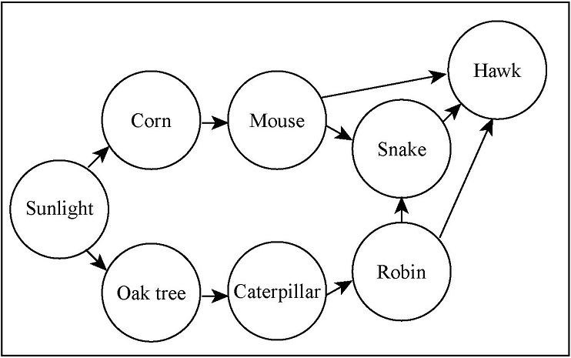

Look at the food web above. If the corn crop failed one year, what would most likely happen to the robin population? Explain your answer.

(See appendix C for item scoring guides.)
L8.6, Using Science Principles
Source: TIMSS 1999, Grade 8.

The first two science practice categories—Identifying Science Principles and Using
Science Principles—both require students to correctly state or recognize the science principles contained in the content statements. A difference between the categories is that
Using Science Principles focuses on what makes science knowledge valuable or, in other words, its usefulness in making accurate predictions about phenomena and in explaining observations of the natural world in coherent ways (i.e., “knowing why”). Distinguishing between these two categories draws attention to differences in the depth and richness of individuals’ knowledge of the content statements. Certain actions on the part of students
lead to an inference of Identifying Science Principles, while other actions lead to an inference of Using Science Principles. Assuming a continuum from “just knowing the facts” to “using science principles,” there is considerable overlap at the boundary. The line between the identifying and using categories is not distinct. Consider the following item, which illustrates the expectation that students will connect different representations. In this case, the student must identify the correct pictorial representation of a complete electrical circuit.

Illustrative Item

The pictures show a light bulb connected to a battery.
Which bulb will light?

Key: C
P4.11, Using Science Principles
Source: TIMSS 2003, Grade 4.

Student responses to this item are open to two interpretations. If students have had a great deal of exposure to these types of circuit representations, their responses would fall under Identifying Science Principles. However if, these circuit representations are relatively new for students, then they would need to apply more reasoning and their responses would fall under Using Science Principles.

The following textbox provides further illustration of the distinction between identifying the boiling point of water (a fact) and using the relationship between boiling point and pressure (altitude) to explain or predict.

Clarification: Distinguishing Between Identifying Science Principles and Using Science Principles—A Boiling Point Example

Grade 8 Content Statement: Matter—Properties of Matter:
P8.4: ...Each element and compound has physical and chemical properties, such as boiling point, density, color, and conductivity, which are independent of the amount of the sample.

Distinguishing between the two categories of Identifying Science Principles and Using Science Principles is a function of actions or performances. Using boiling point as an example, one might observe different responses to the question, “What is the boiling point of water?” Behaviors or actions might include:

- Penciling in the oval corresponding to 100 °C in a selected-response item.
- Writing: “The boiling point of water is 100 °C at sea level.”
- Writing: “The boiling point of water changes as pressure changes. So, even though water boils at 100 °C at sea level (1 atm pressure), it might boil at a lower temperature on top of a mountain because pressure is lower up there.”

The above responses evoke different inferences about the science understanding of the individual responding. Both the first and second responses suggest that the question is only assessing knowledge of facts or the ability to identify a science principle; however, they illustrate the difference between recognizing a correct answer and retrieving that correct answer from memory. The third response contains even more sophisticated information, suggesting that the student can use a science principle to make predictions. Distinctions between these two categories can be clarified by examining student responses and conducting cognitive labs.

The following item set illustrates a combination of Identifying Science Principles and Using Science Principles. It also addresses the expectation that students interpret data presented in a graph and use the data to perform a mathematical calculation.

Illustrative Item

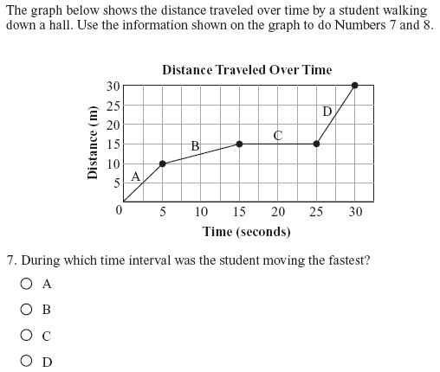

Key: D
P8.14, Identifying Scientific Principles

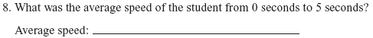

(See appendix C for item scoring guides.)
P8.14, Using Scientific Principles
Source: Colorado Department of Education 2002, Grade 8.

Using Scientific Inquiry
Scientists make observations about the natural world, identify patterns in data, and
propose explanations to account for the patterns. Although scientists differ greatly from one another in the phenomena they study and in how they go about their work, scientific inquiry involves the collection of relevant data, the use of logical reasoning, and the
application of imagination and evidence in devising hypotheses to explain patterns in data. Scientific inquiry is a complex and time-intensive process that is iterative rather than linear. Scientists are also expected to exhibit, indeed to model, the habits of mind—curiosity, openness to new ideas, informed skepticism—that are part of science literacy. This includes reading or listening critically to assertions in the media, deciding what evidence to pay attention to and what to dismiss, and distinguishing careful arguments from shoddy ones. These critical thinking and systems thinking skills are the basis for exercising sound reasoning, making complex choices, and understanding the interconnections among systems (Partnership for 21st Century Skills 2004). Thus, using scientific inquiry depends on the practices described above—Identifying Science Principles and Using Science Principles. Moreover, in addition to involving declarative and schematic knowledge, Using Scientific Inquiry draws heavily on procedural knowledge (“knowing how,” e.g., knowing how to determine the mass of an object). This framework focuses on a few key inquiry practices that are practical to measure in the NAEP Science Assessment. Using Scientific Inquiry comprises the following general types of performance expectations:
- Design or critique aspects of scientific investigations (e.g., involvement of control groups, adequacy of sample).
- Conduct scientific investigations using appropriate tools and techniques (e.g., selecting an instrument that measures the desired quantity—length, volume, weight, time interval, temperature—with the appropriate level of precision).
- Identify patterns in data and/or relate patterns in data to theoretical models.
- Use empirical evidence to validate or criticize conclusions about explanations and predictions (e.g., check to see that the premises of the argument are explicit, notice when the conclusions do not follow logically from the evidence presented).

Scientific inquiry is more complex than simply making, summarizing, and explaining
observations, and it is more flexible than the rigid set of steps often referred to as the “scientific method.” The National Standards make it clear that inquiry goes beyond
“science as a process” to include an understanding of the nature of science (p. 105) and further state the following:

It is part of scientific inquiry to evaluate the results of scientific investigations, experiments, observations, theoretical models, and the explanations proposed by other scientists. Evaluation includes reviewing the experimental procedures, examining the evidence, identifying faulty reasoning, pointing out statements that go beyond the evidence, and suggesting alternative explanations for the same observations (p. 171).

In the NAEP Science Assessment, when students use scientific inquiry they are drawing on their understanding about the nature of science, including the following ideas (see Benchmarks):
- Arguments are flawed when fact and opinion are intermingled, or the conclusions do not follow logically from the evidence presented.
- A single example can never support the inference that something is always true, but sometimes a single example can support the inference that something is not always true.
- If more than one variable changes at the same time in an experiment, the outcome of the experiment may not be clearly attributable to any one of the variables.
- The way in which a sample is drawn affects how well it represents the population of interest. The larger the sample, the smaller the error in inference to the population. However, large samples do not necessarily guarantee representation, especially in the absence of random sampling.

NAEP will assess students’ abilities to use scientific inquiry in two ways: students will be required to do the practices specified above and students will critique examples of scientific inquiry. It is incorrect to assume that assessment of using scientific inquiry is best or only achieved through hands-on performance tasks and interactive computer tasks (ICTs). In both cases of doing and critiquing, some assessment tasks will also be
presented as paper-and-pencil items. In doing, tasks may present data tables and ask
students which conclusions are consistent with the data. Other tasks will be presented as hands-on performance and/or interactive computer tasks (e.g., students collect data and present their results, or students specify experimental conditions on computer simulations and observe the outcomes). In regard to critiquing, students might be asked to identify flaws in a poorly designed investigation or suggest changes in the design to produce more reliable data. Tasks may be based on print or electronic media (e.g., items may ask
students to suggest alternative interpretations of data described in a newspaper article). Chapter four contains more information on types of items.

The following middle school (grade 8) item illustrates the expectation that students will conduct scientific investigations. By manipulating the simulation, students gather data and solve the problems that are presented.

Illustrative Item

This interactive computer task is one module in an extended assessment of students’ abilities to use a range of technologies to investigate a complex problem, “Should lynx be reintroduced into a national park?” Students accessed, organized, and analyzed data on the number of hares in the park over a 25-year period, researched factors that would impact the population, and created a graph to analyze the trend. (See appendix C for a description of the full task.)

This module allows students to interact with a simulated predator/prey (lynx/hare) population model. Students use the modeling tool to observe population trends that result from different parameter values for the lynx and hare populations. The screen shot below is an example of what students see after they have selected parameters and run the simulation. Note that it is a single screen shot and represents only a small subset of the many screens that students actually see when engaged in this interactive computer task. After students have run the modeling software, they are asked a series of questions (e.g., size of the hare population over time).

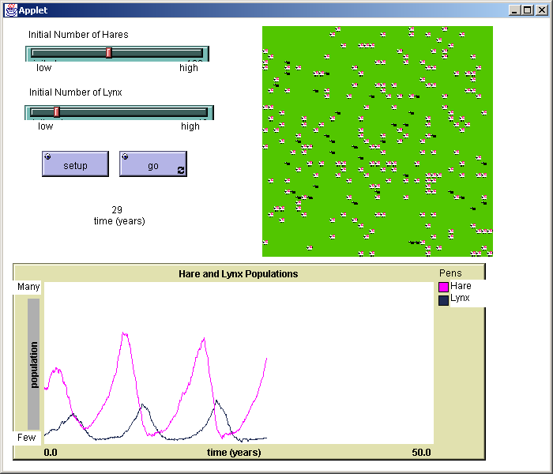

L8.6, Using Scientific Inquiry
Source: Quellmalz et al. 2004.

Using Technological Design
In both the National Standards and Benchmarks, the term “technological design” refers to the process that underlies the development of all technologies, from paper clips to space stations. The National Standards explain that this meaning “is not to be confused with ‘instructional technology,’ which provides students and teachers with exciting tools—such as computers—to conduct inquiry and to understand science” (p. 24).

In the framework, using technological design describes the systematic process of applying science knowledge and skills to solve problems in a real-world context. The National Standards clearly state the reason for including technological design in the science
curriculum: “Although these are science education standards, the relationship between science and technology is so close that any presentation of science without developing an understanding of technology would portray an inaccurate picture of science” (p. 190). The National Standards define technology and its relationship to science as follows:

As used in the Standards, the central distinguishing characteristic between science and technology is a difference in goal: The goal of science is to understand the natural world, and the goal of technology is to make modifications in the world to meet human needs. Technology as design is
included in the Standards as parallel to science as inquiry (p. 24).

As in scientific inquiry, the professional practice of technological design (also called
engineering design) is complex and time intensive. Because NAEP addresses the subject area of science, the use of technological design components in the NAEP Science
Assessment will be limited to those that reveal students’ abilities to apply science principles in the context of technological design. Students’ abilities to Identify and Use Science Principles should provide the opportunities as well as the limits for assessment tasks
related to Using Technological Design. For example, if students are asked to design a town’s energy plan, they may be expected to consider the environmental effects of using natural gas versus using coal, but they would not be expected to consider the economic, political, or social ramifications of such a plan.

The framework samples key components of Using Technological Design from the more complete descriptions found in the National Standards and Benchmarks. Using Technological Design comprises the following general types of performance expectations, all of which involve students using science knowledge to accomplish the following:
- Propose or critique solutions to problems, given criteria and scientific constraints.
- Identify scientific tradeoffs in design decisions and choose among alternative solutions.
- Apply science principles or data to anticipate effects of technological design decisions.

The three components of Using Technological Design are discussed below.

First, the technological design process is rooted in the definition of a problem that can be solved through a technological design process. The problem generally describes a human need or want and specifies criteria and constraints for an acceptable solution (International Technology Education Association 2000). Only constraints that reflect the science content statements in this framework will be considered in developing relevant NAEP assessment items. The engineer who designs a bridge, for example, must take into
account the effects of wind and water currents by using relevant physics principles to simulate these effects on possible structures before the bridge is built.

Second, even if limited to the application of science principles, choosing between alternative solutions almost always involves tradeoffs. As stated in the Benchmarks:

There is no perfect design. Designs that are best in one respect ... may be inferior in other ways. ... Usually some features must be sacrificed to get others. How such trade-offs are received depends upon which features are emphasized and which are down-played (p. 49).

The application of science principles may be used to compare alternative technological solutions to see which will better solve the problem and accomplish the project’s goals.

Finally, while the chosen solution may be intended to solve a human problem or meet a human need, the effects are not always as planned. When the automobile was invented, no one could have predicted the environmental and human health impacts of vehicle emissions. However, scientists and engineers must work together to apply their knowledge of the natural world to make such predictions. According to the National Standards, students in grades K–4 should know about the effects of design solutions:

People continue inventing new ways of doing things, solving problems, and getting work done. New ideas and inventions often affect other
people; sometimes the effects are good and sometimes they are bad. It is helpful to try to determine in advance how ideas and inventions will affect other people (p. 140).

In terms of cognitive demands, both declarative (knowing that) knowledge and schematic (knowing why) knowledge come into play for the three components of Using Technological Design, as does strategic knowledge (knowing when and where to apply knowledge).

The role of technological design in U.S. science classrooms currently varies widely, and it is not possible to predict the extent to which it will be integrated into the school curriculum in the future. The role of technological design in the NAEP Science Assessment will need to be revisited regularly in response to its evolving role in school science.

Since using technological design in the NAEP Science Assessment must have direct relevance to science, it is assumed that students have some understanding of the relationship between science and technology. The science-technology relationship is further discussed in chapter four as providing context for assessment items.

The following item illustrates the expectation that students will apply science principles to anticipate the effects of a technological design decision.

Illustrative Item

Occasionally, a fire will destroy a forest, burning down trees and pushing wildlife out of their forest homes. However, the forest will grow back. Eventually, through the process of forest succession as shown below, short grasses and flowers begin to grow and animals make new homes.
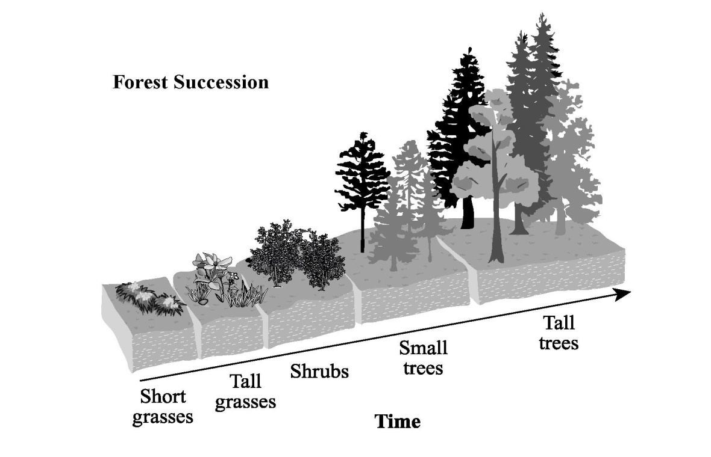
Over time, shrubs and trees begin to grow. The forest returns to a lush habitat for the wildlife listed in the chart below.

Forest Wildlife

Ground dwelling | Worms, beetles
Reptiles and amphibians | American toads, wood frogs, snakes, Eastern box turtles
Small animals | Squirrels, chipmunks
Medium to large animals | Opossums, raccoons, white-tailed deer, black bears
Airborne | Butterflies, moths, bees, wild turkeys, red-tailed hawks, bald eagles

A power company owns part of a forest that was destroyed by a fire. The forest could take decades to rebuild on its own. The company’s department of environmental studies suggests planting new trees to help the forest rebuild.

Using the information in the scenario:
- Explain how planting trees could benefit the natural ecosystem.
- Explain how planting trees could harm the natural ecosystem.

(See appendix C for item scoring guides.)
E8.15, Using Technological Design
Source: Washington Assessment of Student Learning 2004, Grade 8.

Summary of Practices
The general performance expectations for each of the four practices are summarized in exhibit 13. Dashed lines indicate that the boundaries between these categories are not distinct, and some overlap is to be expected.

Exhibit 13. General performance expectations for science practices
← Communicate accurately and effectively → | Identifying Science Principles | Describe, measure, or classify observations. | State or recognize correct science principles. |  | Demonstrate relationships among closely related science principles. |  | Demonstrate relationships among different representations of principles.
← Communicate accurately and effectively → | Using Science  Principles | Explain observations of phenomena. | Predict observations of phenomena. |  | Suggest examples of observations that illustrate a science principle. |  | Propose, analyze, and/or evaluate alternative explanations or predictions.
← Communicate accurately and effectively → | Using Scientific Inquiry | Design or critique aspects of scientific investigations. | Conduct scientific investigations using appropriate tools and techniques. |  | Identify patterns in data and/or relate patterns in data to theoretical models. |  | Use empirical evidence to validate or criticize conclusions about explanations and predictions.
← Communicate accurately and effectively → | Using  Technological Design | Propose or critique solutions to problems given criteria and scientific constraints. |  | Identify scientific tradeoffs in design decisions and choose among alternative solutions. |  | Apply science principles or data to anticipate effects of technological design decisions.

Clarification: Sample Performance Expectations
for a Life Science Content Statement

The examples below are all related to the following grade 8 Life Science content statement:

L8.4: Plants are producers—they use the energy from light to make sugar molecules from the atoms of carbon dioxide and water. Plants use these sugars along with minerals from the soil to form fats, proteins, and carbohydrates. These products can be used immediately, incorporated into the plant’s cells as the plant grows, or stored for later use.

All examples are also related to a specific situation:

Two different varieties of grass—one better adapted to full sunlight and one better adapted to shade—are each grown in sunlight and in shade.

The results of a controlled experiment along these lines might resemble the following:

Condition | Grass Type A | Grass Type B
Sunlight | Better growth* | Less good growth*
Shade | Less good growth* | Better growth*
* Several variables could be used to indicate growth: mass or dry mass of plants, thickness of stems, number of new sprouts, etc.

Identifying Science Principles

- State from where a plant’s food originates.
- Classify the grass plants as producers or consumers.

The first performance calls for students to repeat information found in the content statement with little or no modification. The second performance asks students to use the definition of producers given in the content statement to classify or identify the plants.

Using Science Principles

- Predict whether sugar will move up or down the stems of the grass plants and explain your prediction.
- Explain where the mass of the growing grass originates.

These performances require students to use principles in the content statement to predict or explain specific observations (growing grass in this case). The content statement itself does not provide the answers to the questions.

Using Scientific Inquiry

- Given a data table showing the mass of grass plants of each type grown in the sunlight and shade, draw conclusions about which variety of grass is better adapted to each condition.
- List other variables that should be controlled in order to feel confident about your conclusions.

The first performance is related to the content statement in that the importance of light for plant growth is useful background information for students. However, the performance requires interpretation of new information (the data table) that has to do with differences among types of plants, while the content statement contains generalizations about all plants. Thus, the performance requires students to use the data to develop new knowledge that they did not have previously. The second performance is in part an assessment of the students’ understanding of experimental design. However, good answers would also require knowledge of this and related content statements to identify variables that are relevant to plant growth.

Using Technological Design

- Given experimental results on the growth of different varieties of grass plants under sunlight and shade conditions, develop a plan for using different types of grass seed in different parts of a partially shaded park.

This performance requires students to use knowledge of the content statement and the experimental results to accomplish a practical goal (in this case, a park with grass growing well in areas that receive varying amounts of sunlight).

Performance Expectations
The NAEP Science Assessment will focus on how students bring science content (as
described in chapter two) to bear as they engage in the practices described in this chapter. That is, science practices are not content-free skills; they require knowledge of the Physical, Life, and Earth and Space Sciences as well as knowledge about scientific inquiry and the nature of science (e.g., drawing conclusions from investigations).

Performance expectations are derived from the intersection of content statements and
science practices. If the content statements from the Physical, Life, and Earth and Space Sciences are the columns of a table and the practices (Identifying Science Principles,
Using Science Principles, Using Scientific Inquiry, Using Technological Design) are the rows, the cells of the table are inhabited by performance expectations. Examples are provided in exhibit 14, which is based on exhibit 1 in chapter one. Note that performance expectation cells may overlap because the content and practice categories themselves are not distinct (as indicated by dashed lines).

Exhibit 14. Generating examples of grade 8 performance expectations
 |  | Science Content
 |  | Physical Science Content Statements | Life Science  Content Statements | Earth and Space Sciences  Content Statements
Science Practices | Identifying Science Principles | Identify the units that might be used to measure the speed of an ant and the speed of an airplane (see P8.14).* | Identify the raw materials that plants use to make sugars (see L8.4). | Identify wind as the movement of air from higher to lower pressure regions (see E8.11).
Science Practices | Using Science Principles | An object (e.g., a toy car) moves with a constant speed along a straight line. Predict (with justification) what might happen to this object’s speed as it rolls downhill (see P8.16). | Explain why sugars are found to move primarily down the stem of a growing plant (e.g., potato, carrot) (see L8.4). | Explain why mountain soils are generally thinner than floodplain soils (see E8.6).
Science Practices | Using Scientific Inquiry | Design an experiment to determine how the speed of a battery-operated toy car changes as a result of added mass (see P8.16). | Criticize conclusions about likely consequences of consuming various diets based on flawed premises or flaws in reasoning (see L8.5). | Given data (indexed by month) on annual trends of incoming solar radiation for five cities, determine whether the location is in the Northern or Southern Hemisphere  (see E8.12).
Science Practices | Using Technological Design | Evaluate the following car designs to determine which one is most likely to maintain a constant speed as it goes down a hill (see P8.16). | Identify possible ecological side effects of agricultural fertilizer runoff into a lake (see L8.7). | Describe the consequences (e.g., erosion) of undercutting a steep slope for a road cut (see E8.4).
* To identify the science content statement on which each performance expectation is based, the content statement’s unique code (from exhibits 8, 10, and 12 in chapter two) is provided.
The content statements from chapter two on which these performance expectations are based are written in general terms. The process of creating performance expectations requires further clarification of the content statements themselves. As described in chapter two, this involves “detailing” the meanings of the content statements and setting boundaries on the content to be assessed at a given grade level. Moreover, if the crossing of content statements with practices were done for every science content statement and practice, the number of performance expectations generated could be unmanageably large. Exhibit 15 provides selected example performance expectations for a single Earth and space sciences content statement. The specifications include additional examples. These examples are illustrative, not exhaustive. It is expected that assessment developers will continue this process for all content and practices sampled for a particular NAEP Science Assessment.

Performance expectations are written with particular verbs indicating the desired performance expected of the student. The action verbs associated with each practice are not firmly fixed, and the use of any action verb must be contextualized. For example, when the science practice component “conduct scientific investigations” is crossed with a states-of-matter content statement, it can generate a performance expectation that employs a different action verb, such as “heats as a way to evaporate liquids.”

Generating and Interpreting Items
Neither the content statements from chapter two nor the practices discussed in this chapter will be assessed in isolation. All assessment items will be derived from a combination of the two (i.e., from performance expectations). Observed student responses to these items can then be compared with expected student responses to make inferences about what students know and can do. Exhibit 15 is an Earth and Space Sciences example of the process of generating and interpreting items from performance expectations. The item examples are of two types: item suggestions (descriptions of items to be developed) and illustrative items (released items from various large-scale assessments). Additional
examples of the process of generating and interpreting items are provided in the specifications.

Exhibit 15. Earth and Space Sciences example of generating and interpreting items
Grade 8: Earth in Space and Time—Objects in the Universe
Content Statement

E8.2: Gravity is the force that keeps most objects in the solar system in regular and predictable motion. Those motions explain such phenomena as the day, the year, phases of the Moon, and eclipses.

Commentary

This content statement encompasses two interrelated sets of concepts:

1. Gravity acts between and among all objects in the solar system, and it plays an essential role in the regular and predictable motions of planets around the Sun and of satellites around planets.

- On Earth, gravity is experienced as a force that pulls everything “down” toward the center of the Earth. (A common naive conception is that the atmosphere “pushes” things down and causes gravity.)
- Gravity is a force of attraction that is exerted by every object on every other object.
- Gravity exists in space and on other planets. (A common naive conception among students is that there is no gravity in space because space has no air.)
- The almost circular motion of planets and satellites results from the force of gravity and the tendency of a body to continue moving through space in a straight line unless acted upon by a net force.

2. The regular and predictable motions of Earth, the Sun, and the Moon cause the cyclic phenomena that can be observed in the sky.

- The day-night cycle results from Earth’s rotation on its axis once in 24 hours.
- Annual changes in the visible constellations and the seasons result from Earth’s revolution around the Sun once every 365¹/₄ days.
- Moon phases result from the Moon’s orbit around Earth about once a month, which changes the part of the Moon that is lighted by the Sun and how much of the lighted part can be seen from Earth.

Note the connection between this content statement and the Physical Science subtopic, forces affecting motion.

Students are not expected to use the inverse square relationship of gravitational force and distance to find the strength of the gravitational force between two objects.

Students do not need to know that the motion of planets and satellites is elliptical and not circular.

Examples of Performance Expectations

Identifying Science Principles. Students can:
- Identify gravity as the force exerted by every object in the solar system on every other object.
- Identify gravity as the force that keeps the Moon circling Earth, rather than flying off into space.
- Describe the regular motions of Earth through space, including its daily rotation on its axis and its yearly motion around the Sun.

Exhibit 15 (continued). Earth and Space Sciences example of generating and
interpreting items
Examples of Performance Expectations (cont.)

Using Science Principles. Students can:
- Explain that the orbit of one object around another is due to the tendency of an object to move in a straight line through space and due to the force of gravity between the two objects.
- Explain how the monthly pattern of Moon phases observed from a point on Earth results from the Moon’s orbit around Earth, which changes the part of the Moon that is lighted by the Sun and what portion of the lighted part can be seen from Earth.
- Distinguish between explanations for lunar (Moon) phases and lunar eclipses.
- Explain that astronauts and other objects in orbit seem to “float” because they are in free fall, under the influence of gravity.

Using Scientific Inquiry. Students can:
- Arrange a set of photographs of the Moon taken over a month’s time in chronological order and explain the order in terms of a model of the Earth-Sun-Moon system.
- Design a plan for observing the Sun over a year’s time to find out how the length of the day is related to the rising and setting point of the Sun on the horizon.
- Design a series of observations or measurements to determine why some objects—such as certain asteroids or comets—visit the solar system just once, never to return.

Using Technological Design. Students can:
- Choose among several (qualitative) methods for aiming a rocket so that it reaches the planet Mars and give a rationale that shows understanding of orbital motion.
- Use scientific tradeoffs in deciding whether or not to support a plan to observe and predict orbits of asteroids that enter the inner solar system.
- Given a scenario in which a person is shipwrecked on an island in the ocean, critique plans to create a calendar to keep track of the passage of time.

Items To Assess Identifying Science Principles

Illustrative Item 1

What force keeps the planets in our solar system in orbit around the Sun?

- gravitational
- magnetic
- electrical
- nuclear

Key: A
Source: Adapted from Massachusetts Department of Education, Massachusetts Comprehensive Assessment System (MCAS) 2000, Grade 8.*

* MCAS materials appearing in the framework have been released to the public by the Massachusetts Department of Education and are available at no cost at http://www.doe.mass.edu/mcas/testitems.html.
Exhibit 15 (continued). Earth and Space Sciences example of generating and
interpreting items
Items To Assess Identifying Science Principles (cont.)

Illustrative Item 2

The drawings show a rocket being launched from Earth and returning.
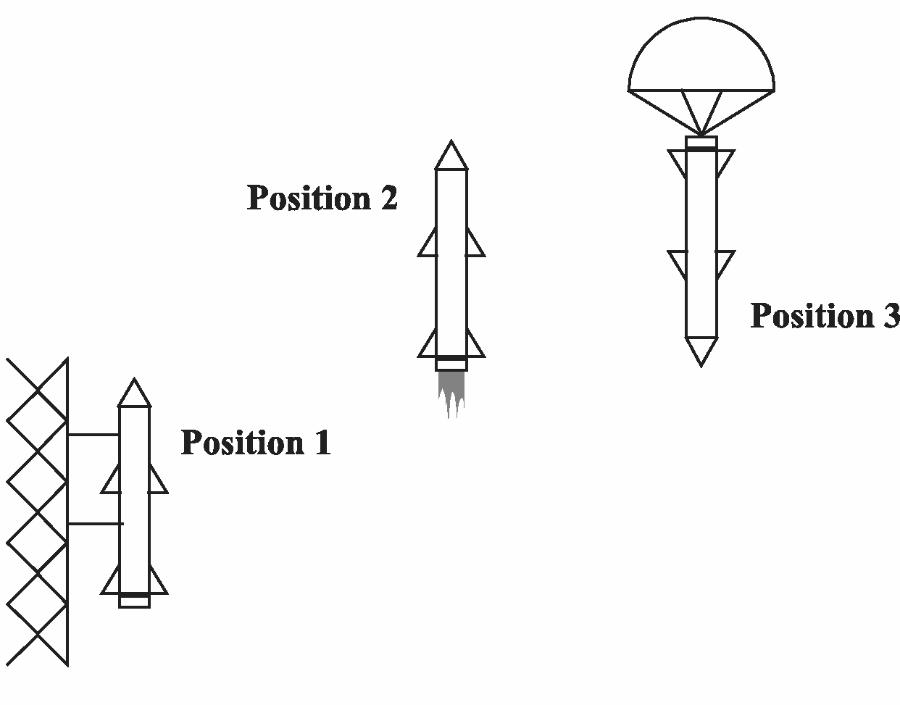
In which of these positions does gravity act on the rocket?

- position 3 only
- positions 1 and 2 only
- positions 2 and 3 only
- positions 1, 2, and 3

Key: D Source: TIMSS 1999, Grade 8.
Items To Assess Using Science Principles

Illustrative Item

A space station is to be located between the Earth and the Moon at the place where the Earth’s gravitational pull is equal to the Moon’s gravitational pull.
On the diagram below, circle the letter indicating the approximate location of the space station.

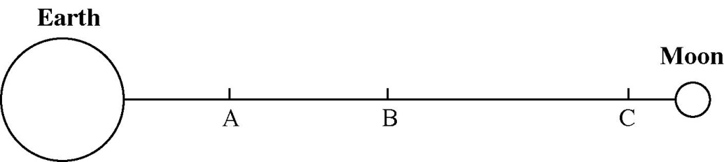

Explain your answer.

Source: NAEP 1996, Grade 8.
Exhibit 15 (continued). Earth and Space Sciences example of generating and
interpreting items
Items To Assess Using Science Principles (cont.)

Interpretation: The correct answer is C. Since the Moon has one-sixth the amount of gravity as Earth, a body that experiences an equal gravitational force from Earth and the Moon should be closer to the Moon. Point C is the only point that is closer to the Moon. Note: Point C is about one-twelfth of the way between the Moon and Earth; it should be one-sixth of the distance. (See appendix C for the item scoring guide.)

Item Suggestion

Is there gravity in space? Which of the following gives the best response to this question?

- No. You can see that astronauts float around weightless in their cabin.
- No. There is no air in space, so gravity cannot exist there.
- Yes. There must be gravity since planets keep circling the Sun.
- Some. The Moon has one-sixth as much gravity as Earth, so we know there is some gravity in space.

Key: C

Interpretation: The correct answer is C. This question is drawn from a series of studies that show a common naive conception—that there is no gravity in space because space has no air. The distractors are drawn from student interviews. It is likely that these naive conceptions stem from images that students have seen of astronauts floating around in a “weightless” environment while in orbit. This item probes schematic knowledge (see Cognitive Demands section later in this chapter).

Item To Assess Using Scientific Inquiry

Item Suggestion

A student is presented with a set of photographs of the Moon taken over a month’s time. The photos are not presented in chronological order. The student is asked to arrange them in the order in which they were taken and explain the reason for Moon phases.

Interpretation: This suggestion reflects items used frequently in curricular materials (e.g., Schatz and Cooper 1994). Students are asked to find patterns in the data. First, they should be sufficiently familiar with the lunar cycle to arrange the photographs in order, either in a line to represent a chronology or in a circle to represent a cycle (tapping declarative knowledge and procedural knowledge to a lesser extent—see Cognitive Demands section later in this chapter). Then, students should be able to explain Moon phases in terms of the Moon circling Earth and the changing angle between the Sun and Moon as observed from Earth. This part of the item probes schematic knowledge—see Cognitive Demands section later in this chapter. This is a challenging question that many educated adults fail to answer. However, studies show that middle school students can learn to do this exercise by observing lunar phases and explaining them using a model of the Earth-Sun-Moon system (Barnett and Morran 2002; Kavanagh, Agan, and Sneider 2005).

Exhibit 15 (continued). Earth and Space Sciences example of generating and interpreting items
Items To Assess Using Technological Design

Item Suggestion 1

NASA wants to launch a spacecraft with rockets from Earth so that it will reach and orbit Mars. Which of the following statements about this flight is WRONG?

- In the first phase of its flight, the forces acting on the spacecraft are the thrust of the rocket engine, gravity, and friction from the Earth’s atmosphere.
- When the rocket engine shuts off, the only force acting on the spacecraft is the force of gravity.
- Once the spacecraft is above the Earth’s atmosphere and the rocket engine is off, it will travel at a constant speed since there is no gravity in space.
- If the spacecraft is aimed correctly and has the proper speed, the spacecraft will reach Mars and require only engine braking to attain orbit.

Key: C

Interpretation: The correct answer is C because there is gravity in space and planning for such a rocket flight would need to take into account the gravity from Earth, Mars, and the Sun (declarative knowledge—see Cognitive Demands section later in this chapter). This question is drawn from a series of studies that show the following naive conceptions about gravity are common among many students at the middle school, high school, and even college levels: If a body is moving, there is a force acting on it in the direction of motion (Finegold and Gorsky 1991; Gunstone and Watts 1985; Sequeira and Leite 1991); there is no gravity in space (Bar et al. 1994; Chandler 1991; Morrison 1999); and gravity cannot act in space because there is no air in space (Bar and Zinn 1998). One study showed that, with effective instruction, middle school students can overcome these naive conceptions and learn that gravity does, in fact, act in space, where it keeps satellites and planets in their orbits (Bar, Sneider, and Martimbeau 1997).

Item Suggestion 2

Decisions about whether or not to develop new technologies always concern tradeoffs. For example, most scientists today believe that the extinction of dinosaurs and many other species was caused by the collision of a large asteroid with Earth 65 million years ago. As a result, there is a proposal to develop two new technologies: (1) the detection and tracking of all asteroids large enough to do considerable damage if they should strike Earth, and (2) the development of a means to send a spacecraft to meet the asteroid in space and change its path. Write a paragraph describing:
- whether or not you think it would be possible to develop these technologies based on your knowledge of science; and
- some of the scientific tradeoffs that should be considered in deciding whether or not to develop these new technologies.

Interpretation: Look for evidence that the students understand what asteroids are, that scientists have observed asteroids, and that observations taken at several points in time allow for the prediction of an asteroid’s path. Also look for evidence that students understand that spacecraft can be built, launched, and navigated to intercept solar system bodies. (In fact, several spacecraft have already intercepted asteroids and comets.) Regarding scientific tradeoffs, look for evidence that students recognize the advantages of the proposed technologies (e.g., avoid a catastrophic collision in which billions of people and animals could die) as well as possible negative effects (e.g., breakup of the asteroid so there are many collisions rather than one, accidents on launch).

Learning Progressions
A learning progression is a sequence of successively more complex ways of reasoning about a set of ideas. For any important set of ideas in science, understanding increases over time as students learn more, moving from initially naive knowledge of the natural world to increasingly more sophisticated knowledge and conceptual understanding; this typically occurs in conjunction with educational experiences in and out of school (NRC 2001). In other words, the progression from novice learner to competent learner to expert begins with the acquisition of relevant experiences, principles, concepts, facts, and skills and moves to the accumulation and organization of knowledge in a specific domain and finally to expertise after extensive experience and practice (e.g., Ericsson 2002). The
attention paid to growth of understanding may yield rich information about student
progress.

Research has been conducted on students’ learning progressions in some areas of science and at some levels of students’ development. It is expected that this research will directly inform the development of assessment items at grades 4, 8, and 12. For example, NRC has commissioned papers on learning progressions in evolution (Catley, Lehrer, and
Reiser 2005) and in atomic molecular theory (Smith et al. 2004). Learning progressions provide opportunities for assessing specific content in greater depth.

Several caveats about learning progressions are in order. First, learning progressions are not developmentally inevitable but depend on instruction interacting with the student’s prior knowledge and construction of new knowledge. Thus, learning progressions need to invoke assumptions about instruction. Second, there is no single “correct order”; there may be multiple pathways by which certain understandings can be reached. The particular pathway taken may be influenced by prior instructional experiences, individual
differences, and current instruction (NRC 1999c, 2001). Thus, learning progressions will necessarily be complex, involving multiple specific paths at the micro level, and will need to be described in ways that encompass such diversity. Third, actual learning is more like ecological succession with changes taking place simultaneously in multiple
interconnected ways. Thus, attempts to describe specific sequences of learning performance (including those in the Catley, Lehrer, and Reiser (2005) and Smith et al. (2004)
papers) must inevitably be artificially constrained and ordered. Finally, the learning
progressions suggested in the framework and specifications are partly hypothetical or
inferential because long-term longitudinal accounts of learning by individual students do not exist.

Exhibit 16 uses a set of related science content statements across grades 4, 8, and 12 and follows the format of the science practices defined in the framework. It illustrates how relevant research (e.g., Smith et al. 2004) can be used as an opportunity to assess content in greater depth—available research on student learning is used to inform the generation of related performance expectations across grades. The exhibit includes examples of
performance expectations for a possible learning progression for states of matter. These illustrative performance expectations do not denote a sense of content priority or importance and are not a complete representation of the research currently available.

Exhibit 16. Examples of performance expectations for states of matter
Grade 4  (See content statement P4.3.) | Grade 8  (See content statement P8.1.) | Grade 12  (See content statement P12.1.)
Identifying Science Principles  Classify samples of material as solid, liquid, or gas. | Identifying Science Principles  Given an animation of molecules in motion, identify the substance that is being illustrated as a solid, liquid, or gas. | Identifying Science Principles  Explain why ice is harder than liquid water in terms of the strength of the force between the molecules.
Using Science Principles  Infer that a change of state (e.g., freezing or melting) affects the identity of an object but not the identity of the material of which it is made. | Using Science Principles  Predict how the mass of a sample of iodine will change after sublimation. Justify the prediction based on what occurs during sublimation at a molecular level. | Using Science Principles  Use the concept of molecular arrangements and bonds to explain why graphite is very soft and diamond is very hard, even though they are both made of pure carbon.
Using Scientific Inquiry  Collect, display, and interpret data showing how the temperature of a substance changes over time as it cools and becomes a solid. | Using Scientific Inquiry  Plan and conduct an investigation to determine the melting point and boiling point of an unknown substance. | Using Scientific Inquiry  Using molecular theory, explain the results of experiments showing how the volume of three different liquids changes when they are heated.
Using Technological Design  Propose a method for determining for certain whether holiday chocolates that have been shaped by different processes (melting, freezing, reshaping, or breaking into pieces) have the same amount of chocolate in them. | Using Technological Design  Choose the best solution for increasing the altitude of a hot air balloon based on an under-standing of the macroscopic and microscopic changes that occur when the gas inside the balloon is heated. | Using Technological Design  Design an instrument to measure temperature as accurately as possible, taking into account both the thermal properties of liquids and solids to be used in the device and the structural shape and dimensions of the device.

Cognitive Demands
The four science practices (Identifying Science Principles, Using Science Principles,
Using Scientific Inquiry, and Using Technological Design) articulate what students should know and be able to do with the science principles presented in chapter two.
Certain ways of knowing and reasoning (cognitive demands) underpin these four science practices. In this section, the four cognitive demands—“knowing that,” “knowing how,” “knowing why,” and “knowing when and where to apply knowledge”—are discussed briefly (see the Specifications for more information). The goal is to further clarify the
descriptions of the science practices, to facilitate item specifications and item writing, and to provide a framework for interpreting students’ responses. That is, the set of four cognitive demands can be used as a lens to facilitate item development and to analyze student responses (Li and Shavelson 2001; Shavelson 2006; Shavelson, Ruiz-Primo, and Wiley 2005), thereby checking expectations regarding the science content and practice(s) that are being tapped by a given assessment item.

“Knowing that” refers to declarative knowledge. This cognitive demand sets up the
expectation that students should know and reason with basic science facts, concepts, and principles (e.g., density is mass per unit volume) and that they should be able to recall, define, represent, use, and relate these basic principles as appropriate. This cognitive
demand corresponds most closely to the science practice of Identifying Science Principles.

“Knowing how” refers to procedural knowledge. This cognitive demand sets up the
expectation that students can apply the science facts, concepts, and principles in doing science. For example, students should know how to perform simple (routine) and complex procedures such as systematically observing and recording which objects sink and float in water, using a balance scale, measuring an object’s mass, calculating an object’s density, and designing and interpreting the results of an investigation (e.g., manipulating one variable and holding others constant). Procedural knowledge underlies much of the science practice of Using Scientific Inquiry as defined in this framework.

“Knowing why” refers to schematic knowledge. This cognitive demand sets up the
expectation that students can explain and predict natural phenomena as well as account for how and why scientific claims are evaluated, argued and justified, or warranted (explaining and reasoning with principles and models). That is, this cognitive demand deals with students’ understanding of how the natural world works (such as why some things sink and others float in water), why light is essential to the propagation of most plants, or why the Moon changes phases. This cognitive demand overlaps considerably with the science understanding expected in the practice of Using Science Principles and also in the practices of Using Scientific Inquiry and Using Technological Design.

The last cognitive demand, “knowing when and where to apply knowledge,” or strategic knowledge, is commonly talked about as transfer of current knowledge to new situations (tasks or problems). Strategic knowledge involves knowing when and where to use
science knowledge in a new situation and reasoning through the novel task to reach a goal. Strategic knowledge sets up the expectation that students can take their current knowledge and apply it to a somewhat novel situation. Such adaptation of knowledge to a particular problem and context underlies especially the practices of Using Scientific
Inquiry and Using Technological Design.

The cognitive demands are related, not independent (similar to the science practices). That is, when explaining “why,” a student will need to call on “knowing that”; at times, in justifying “why,” a student may have to call on “knowing how.” In addition, depending on the novelty of the task, strategic knowledge (knowing when and where to apply knowledge) may be called into play. Nevertheless, these related cognitive demands can be distinguished, and it is helpful to do so for item development and interpretation of
student responses.

Chapter Four

Overview of the Assessment Design
This chapter provides an overview of the Specifications. It begins with a brief description of the NAEP Science Assessment and a discussion of how items can be set in certain contexts (e.g., history and nature of science) to illustrate components of science content that are not otherwise incorporated in the content statements. The types of items to be
included in the assessment are described and examples are provided in illustrative item textboxes. Answers to selected-response items are indicated in the textbox; scoring guides for constructed-response items are provided in appendix C. Although items in the textboxes may assess more than one content statement or practice, only the primary content and practice designations are provided. This follows NAEP practice, which uses only primary designations for items in the analysis and reporting of student responses. To
capture the wide range of science content statements and practices, the assessment will contain an array of item types. Consideration is given to English language learners and students with disabilities. The chapter concludes with recommendations for small-scale
special studies.

Overview of the Science Assessment
The NAEP Science Assessment will include items sampled from the domain of science achievement identified by the intersection of the content areas and science practices (i.e., performance expectations) at grades 4, 8, and 12. The assessment will include selected-response (multiple-choice) items and constructed-response items (which include short and extended constructed-response items as well as concept-mapping tasks). Some combination items may require more than one response; they include item clusters, POE item sets, hands-on performance tasks, and interactive computer tasks. The responses
requested may be all selected-response, all constructed-response, or a mixture. At each of grades 4, 8, and 12, student assessment time will be divided evenly between selected-response items and constructed-response items. Extra assessment time will be provided for a portion of the student sample so that hands-on performance tasks and interactive computer tasks can be administered.

At grade 4, the items will be distributed approximately evenly among Physical Science, Life Science, and Earth and Space Sciences. At grade 8, there is a somewhat greater
emphasis on Earth and Space Sciences. At grade 12, the balance shifts toward Physical Science and Life Science, with less emphasis on Earth and Space Sciences.

Finally, the distribution of items across the science practices will be approximately 60 percent combining Identifying Science Principles and Using Science Principles, 30
percent Using Scientific Inquiry, and 10 percent Using Technological Design. From grade 4 to 8 to 12, the emphasis on Using Science Principles increases and the emphasis on Identifying Science Principles decreases. As students progress through the grades, it is
expected that their critical response skills and methodological and analytical capabilities will increase.

Assessment Item Contexts
Science-literate citizens should be familiar with certain components of science content, such as the history and nature of science and the relationship between science and technology. Chapter three addresses the nature of science largely through a discussion of the science practices (particularly Using Science Principles and Using Scientific Inquiry). The relationship between science and technology is partially addressed in a discussion of the Using Technological Design practice. The history and nature of science not only
clarify facets of science practices but also the human aspect of science and the role
science has played in various cultures. Students can see that science changes, and new conclusions can be reached based on new empirical data (e.g., development of the theory of plate tectonics, use of gaps in early versions of the Periodic Table to “discover” new elements). The reciprocal relationship between science and technology can be seen, for example, in that scientists use technological tools to empirically test proposed explanations for questions about the natural world and engineers develop adaptations to the
natural world to address human problems, needs, and aspirations based in part on science.

When items are written to particular content statements, they may be framed in these contextual components of science content. Aspects of the history and nature of science and the relationship between science and technology should thus be incorporated into the contexts of assessment items as shown below.

Illustrative Item

Ernest Rutherford found that when he fired alpha particles at a thin gold foil, some were scattered at large angles.* What caused this scattering?

- The gold’s positive atomic nuclei attracted the negatively charged alpha particles.
- The gold’s negative atomic nuclei repelled the negatively charged alpha particles.
- The gold’s negative atomic nuclei attracted the positively charged alpha particles.
- The gold’s positive atomic nuclei repelled the positively charged alpha particles.

Key: D
P12.2, Identifying Science Principles
* The framework’s developers created this item for illustrative purposes; it requires further development in that it is not field tested or published.

Types of Items
The judicious selection of items lies at the heart of any effective assessment of science achievement. The framework for the 1996–2005 NAEP Science Assessments called for multiple-choice items (selected response), open-ended paper-and-pencil items (constructed response), and performance exercises. Multiple-choice items made up about 40 percent of the assessment, as measured by student response time, and open-response items made up about 60 percent of assessment time. In addition, subsets of the students sampled were given an extra 20 minutes in grade 4 and 30 minutes in grades 8 and 12 to complete hands-on performance tasks. This framework generally follows the 1996–2005 recommendations in item structure but also specifies additional item types—some selected response and others constructed response. As noted above, the item distribution by item format in this framework, in terms of student response time, is 50 percent selected- response and 50 percent constructed response.

Two additional considerations are the need to develop items that probe students’ ability to use communication skills and quantitative reasoning skills in science (see p. 64).
Although this framework does not prescribe the amount of assessment time to be spent on items that require specific forms of communication or application of mathematics, it is expected that items requiring these skills will be represented at all three grade levels.
Further details will be provided in the specifications.

Justification for Variation in Types of Items
Issues of time and cost are paramount in any assessment. Accordingly, most of the item formats on the NAEP Science Assessment will be traditional selected response and short constructed response. However, some more complex items (e.g., hands-on performance tasks) should be part of any science assessment.

Responses to complex items often correlate positively and cluster with responses to simpler items. However, complex items are recommended in the framework for the following reasons:
- Items may correlate positively with one another, but they do not necessarily measure the same thing; that is, positive correlations can arise even when the cognitive demands of the assessment items vary. Research has shown that items vary in their cognitive demands for different kinds of knowledge and reasoning (e.g., Leighton 2004).
- The NAEP Science Assessment signals the kinds of responses to tasks, problems, and exercises, along with the kinds of knowledge and reasoning, that should be expected of students as a result of what is taught in the science curriculum (consistent with the National Standards and Benchmarks).

For these reasons, the framework calls for a variety of item types for the NAEP Science Assessment (see the specifications for further details and explanation).

Definitions of Types of Items
The framework distinguishes selected-response from constructed-response item formats. For selected-response formats, students respond to a question by selecting the answer they believe to be most scientifically justifiable from a given set of alternatives. In contrast, with constructed-response formats, students respond to a question by “generating” or “constructing” a response. The constructed-response might be a single word, a short answer, an essay explanation, a summary of a laboratory investigation using concrete
materials, or typed responses to a computer simulation.

In addition to these two main item formats, there are combination items that generally require more than one response. These include item clusters, POE item sets, hands-on performance tasks, and interactive computer tasks. These combination items can use an all-selected-response format, an all-constructed-response format, or a mixture of these two main item formats.

Following are the main types of items to be used on the NAEP Science Assessment:

- Selected response
— Individual multiple-choice items
- Constructed response
— Short constructed-response items
— Extended constructed-response items
— Concept-mapping tasks
- Combination
— Item clusters
— POE item sets
— Hands-on performance tasks
— Interactive computer tasks

Item clusters and POE item sets may use selected-response items, constructed-response items, or both. For example, a set of POE items might include a multiple-choice item in which students select a prediction and a short constructed-response item in which students are asked to write a justification for their prediction.

Hands-on performance tasks and interactive computer tasks also may use selected-response items, constructed-response items, or both. In recording their answers, students may be asked to respond to both selected-response and constructed-response items. For example, 12th graders might be asked to manipulate a computer simulation of a chemical reaction, a multiple-choice question could ask students to choose the correct mass of a reaction product, and a short constructed-response question could ask students to describe how mass is conserved in chemical reactions.

Selected-Response Items
Selected-response items include individual multiple-choice items. These types of items are described below.

Individual Multiple-Choice Items
Selected-response items most often are in a multiple-choice format. Students read, reflect, and then select an answer from, for example, four alternatives provided. The alternatives include the most scientifically justifiable response (the answer) as well as three “distractors.” The distractors should appear plausible to students but should not be scientifically justifiable; when feasible, the distractors should also draw from current understanding about students’ mental models and learning progressions. Whenever possible and especially when the focus is on using science principles or “knowing why” (schematic knowledge), naive conceptions, explanations, and predictions of the natural or manmade world should serve as distractors.

Of the following two multiple-choice items, both require identifying science principles and both tap the cognitive demand “knowing that” (declarative knowledge). The first item taps simple factual content. The second item taps more conceptually sophisticated content. For some students, if they cannot easily recall the science content, the second item may require the practice of using science principles (i.e., tapping more of “knowing why” than “knowing that”).

Illustrative Item

Air is made up of many gases. Which gas is found in the greatest amount?

- Nitrogen
- Oxygen
- Carbon dioxide
- Hydrogen

Key: A
E8.7, Identifying Science Principles
Source: TIMSS 1995, Grade 8.

Illustrative Item

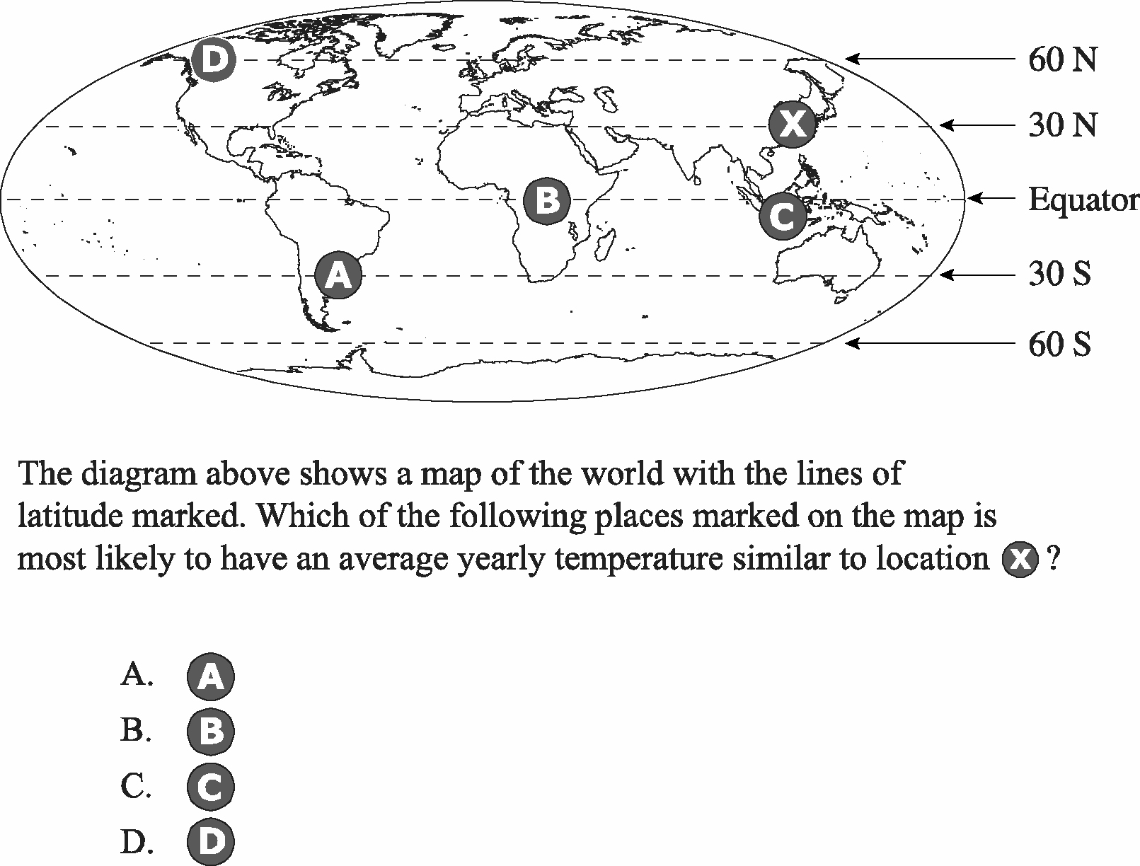
Key: A
E8.12, Identifying Science Principles
Source: TIMSS 2003, Grade 8.
**

Constructed-Response Items
Constructed-response items include short constructed-response items, extended constructed-response items, and concept-mapping tasks.

Short Constructed-Response Items
This item type generally requires students to supply the correct word, phrase, or quantitative relationship in response to the question provided in the item; illustrate with a brief example; or write a concise explanation for a given situation or result. Thus, students must generate the relevant information rather than simply recognize the correct answer from a set of given alternatives, as in selected-response items. Following is an example of a short constructed-response item.

Illustrative Item

On a hot, humid day the air contains a lot of water vapor. What happens to the water vapor in the air when the air becomes very cold?

(See appendix C for item scoring guides.)

P4.6, Identifying Science Principles
Source: TIMSS 2003, Grade 4.

Extended Constructed-Response Items
This item type is generally multidimensional; that is, it taps into multiple content statements, practices, and/or cognitive demands. These types of items can provide useful
insight into students’ levels of conceptual understanding and reasoning. They can also be used to probe students’ ability to communicate in the sciences. Such items generally
present a situation within or across content areas and require students to analyze the
situation, choose and carry out an alternative plan for addressing it, and interpret their response in light of the original situation. Students may also be given an opportunity to explain their responses, reasoning processes, or approach to a problem situation. However, care must be taken (especially with 4th graders and English language learners) to ensure that language ability is not confused with science ability.

The following item involves reasoning with mental models (on carbon cycling) and thus attempts to probe the practice of Using Science Principles and taps into the cognitive
demand of “knowing why.”

Illustrative Item

The biosphere (living organisms), the lithosphere (rocks and soils of Earth’s crust), and the atmosphere are all involved in the cycling of carbon atoms. Describe the role that each plays in the carbon cycle.

(See appendix C for item scoring guides.)
E12.12, Using Science Principles
Source: New Standards Spring Field Test 1999 for High School.*
* The New Standards Spring Field Test 1999 for High School is the property of the University of Pittsburgh and the National Council on Education and the Economy (NCEE) and may not be used, reproduced, or distributed without the express written permission of the University of Pittsburgh and NCEE.

Concept-Mapping Tasks
Concept-mapping tasks may be considered a complex item type because of the cognitive demands placed on students. Concept maps can be used as a reliable and valid assessment of students’ ability to make connections among science principles (Ruiz-Primo and Shavelson 1996a). Thus, concept-mapping tasks tap a science ability that is difficult to measure by other means. These tasks address the practice of Identifying Science Principles and the cognitive demand of “declarative knowledge,” in particular the organization of this knowledge.

In a concept-mapping task, students should be given a set of six to eight concept terms and be asked to construct a map linking pairs of terms with directed arrows. Students should label each arrow with a word or phrase that explains the relationship between a pair of concept terms. An arrow-linked pair of concept terms is called a proposition.
Students’ concept maps can be evaluated as to the accuracy of propositions in their maps. The following textbox provides an illustrative set of instructions for a concept-mapping task and a sample student response. See the Specifications for information about scoring concept maps.

Illustrative Item

Once students are familiar with how to construct concept maps, they might encounter a set of task instructions that resemble the following (adapted from Ruiz-Primo et al. 2001, p. 107):

Examine the concept terms listed below. The terms selected focus on the topic [insert topic].

Construct a concept map using the terms provided below. Organize the terms in relation to one another in any way you want. Draw an arrow between the terms you think are related. Label the arrow using phrases or only one or two linking words.

You can construct your map on the blank pages attached. When you finish your map, check that (1) all the lines have an arrow, (2) all the arrows have labels, (3) your concept map uses all the terms provided, and (4) your map shows what you know about [insert topic].

List of terms: [insert list of terms]

An 11-year-old student constructed the following concept map using terms associated with the water cycle:

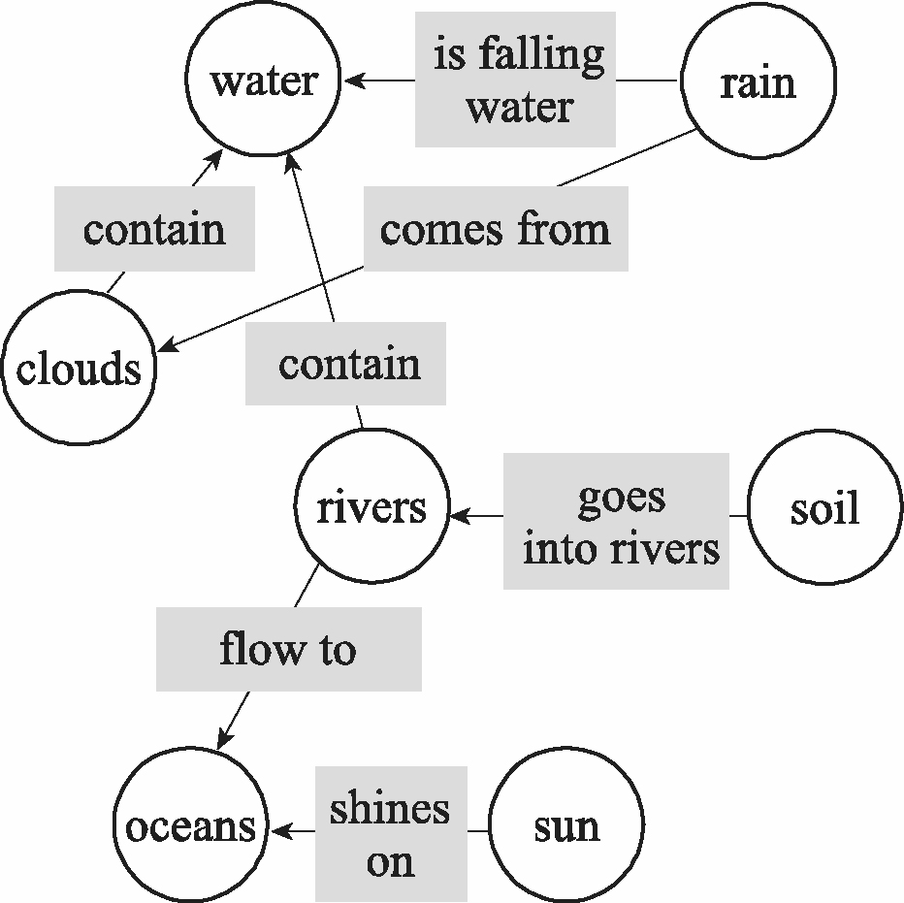

E8.11, Identifying Science Principles
Source: White and Gunstone 1992, p. 16.

Combination Items
Combination items include item clusters, POE item sets, hands-on performance tasks, and interactive computer tasks. Combination items may consist of an all selected-response format, an all constructed-response format, or a mixture of both formats.

Item Clusters
The NAEP Science Assessment should include item clusters, and their development should be guided by current research on different forms of these items. In this type of item set, two or more items focus on an important idea or “mental model.” Hence, these items tap the practice of Using Science Principles and the cognitive demand of “knowing why.” Where a rigorous body of research is available on students’ conceptions (as there is about the solar system), item clusters provide opportunities to assess students’ understanding of a particular key science principle at some depth. This type of item set can probe the conceptions and mental models that underlie students’ explanations of and
reasoning about the natural world. For example, the following questions were part of a set of cluster selected-response items probing high school students’ mental models in astronomy (percentages of student responses to each option are given in parentheses):

Illustrative Items

What causes day and night?

- The earth spins on its axis. (66%)
- The earth moves around the Sun. (26%)
- Clouds block out the Sun’s light. (0%)
- The earth moves into and out of the Sun’s shadow. (3%)
- The Sun goes around the earth. (4%)

Key: A
E8.2, Using Science Principles

The main reason for its being hotter in summer than in winter is:

- The earth’s distance from the Sun changes. (45%)
- The Sun is higher in the sky. (12%)
- The distance between the northern hemisphere and the Sun changes. (36%)
- Ocean currents carry warm water north. (3%)
- An increase occurs in “greenhouse” gases. (3%)

Key: B
E8.12, Using Science Principles
Source: Sadler 1998, pp. 274–276.

Another approach to probing students’ conceptions of the natural world is to develop a cluster of ordered multiple-choice items. These items track students’ performance along a learning progression from naive understanding through more reasoned naive conceptions to full and scientifically justified understanding. In this approach, the progression is first described and then divided into levels so that multiple-choice items can be designed
specifically to assess the performance level that a student (or group of students) has reached. As noted earlier, constructed-response formats are not precluded from use in item clusters.

POE Item Sets
POE item sets ask the student to predict, observe, and/or explain as follows: A situation is described; the student’s task is to provide a prediction for what will happen (sometimes with justification) and/or to provide an explanation for what appears to be an anomaly. POE items tend to tap the practice of Using Science Principles and the cognitive demand of “knowing why” (schematic knowledge). For example, the following POE item was used with middle school students and focuses on prediction based on a mental model of buoyancy:

Illustrative Item

Rich cut block A into two unequal parts.* Part B is 2/3 of the original block A, and part C is 1/3 of the original block A. Block A sinks in water. What will happen to B and C when placed in water?

A
B
C

A. Both B and C will float.
B. B will sink; C will float.
C. B will subsurface float; C will float.
D. Both B and C will sink.

Key: D
P8.4, Using Science Principles
Source: Adapted from Shavelson 2006, and Shavelson, Ruiz-Primo, and Wiley 2005.
* This item assumes that the entire block consists of a completely homogeneous material. The possibility that the block is made of heterogeneous material is unlikely to occur to middle school students.

As noted earlier, a POE item can take either a selected-response or a constructed-response format. In the selected-response format, students choose from a set of possible alternatives (based on known alternative mental models). In the constructed-response format, the student’s task is to write out (with justification) a prediction or an
explanation. In the POE selected-response item above, students are asked to choose among a set of predictions for whether the parts of the block will sink or float. They can choose an answer from several alternatives that include naive conceptions. This item could be extended to further probe students’ mental models of buoyancy. Students could be asked to justify their answers by selecting from a number of possible explanations; again, these alternatives could include the correct explanation along with distractor
explanations based on naive conceptions. Or, instead of using a multiple-choice format, students could be told that the full block sinks in water and be asked to write their prediction (with justification) as to what will happen when the two parts are placed in water. Or, students could observe a simulation or video of what happens to the full block and the two parts and then be asked to explain what they have observed.

Hands-On Performance Tasks
Using hands-on performance tasks, students manipulate selected physical objects and try to solve a scientific problem involving the objects. These exercises, if carefully designed, can probe students’ abilities to combine their science knowledge with the investigative skills that reflect the nature of science and inquiry. In large-scale assessments such as NAEP, uniform administration must be ensured. In the past, this has been accomplished through the use of standardized performance assessment kits, with each exercise proctored and scored by trained personnel. Special accommodations may be necessary for some students.

A particularly cogent criticism of most hands-on performance tasks administered in large-scale assessments is that, rather than tap into students’ ability to inquire into a problem, typical performance assessments instead measure students’ ability to follow step-by-step instructions to arrive at the expected answer. Assessment developers are likely to create these “recipe” types of exercises because they must take into account the vast differences in students’ participation in science courses and their experiences. Given these differences, the absence of structure might produce unanticipated responses that could be problematic for the assessment either at the time the data are collected or when students’ performances are scored by raters. Although both the concern for structure to make large-scale assessment manageable and the criticism of highly structured performance tasks are well taken, there is evidence that valid performance exercises can be designed, developed, administered, and scored without encountering major problems (e.g., Ruiz-Primo and Shavelson 1996b; Shavelson, Baxter, and Pine 1991).

In designing hands-on performance tasks, it is important to keep the following considerations in mind: The degree to which students engage in some aspect of scientific inquiry depends on who selects the problem to be studied, who selects the procedures to be
carried out in tackling the problem, and who selects the answer. The NAEP assessment should provide students with a challenging problem. However, students must have the opportunity to determine scientifically justifiable procedures for addressing the problem and arriving at a solution. Indeed, the problem to be solved involves setting forth procedures that manipulate the variable of interest, control extraneous variables, and provide solid data to be used in arguing for and justifying a problem solution. In addition to
allowing students to determine the procedures for carrying out the experiment, NAEP hands-on performance tasks should be “content rich” in that they require knowledge of science principles to carry them out.

In brief, any hands-on performance task included in the NAEP assessment should present students with a concrete, well-contextualized task (problem, challenge); laboratory equipment and materials; and a response format that leaves the exercise process open. Students’ scores should be based on both the procedures created for carrying out the
investigation and the solution (Shavelson, Baxter, and Pine 1991). The assessment, then, should provide the problem that draws on science principles and practices (performance expectation of interest) and leave students free to design and carry out the exercise to
arrive at an answer or solution. The following item, designed for fifth graders, is an
example of such a task.

Illustrative Item

Students are asked to identify the contents of each of the six boxes (A–F) by using the batteries, bulbs, and wires they are given to complete a circuit. This task requires knowledge of series circuits but leaves problem-solving procedures up to the student. (See appendix C for more information about this task.)

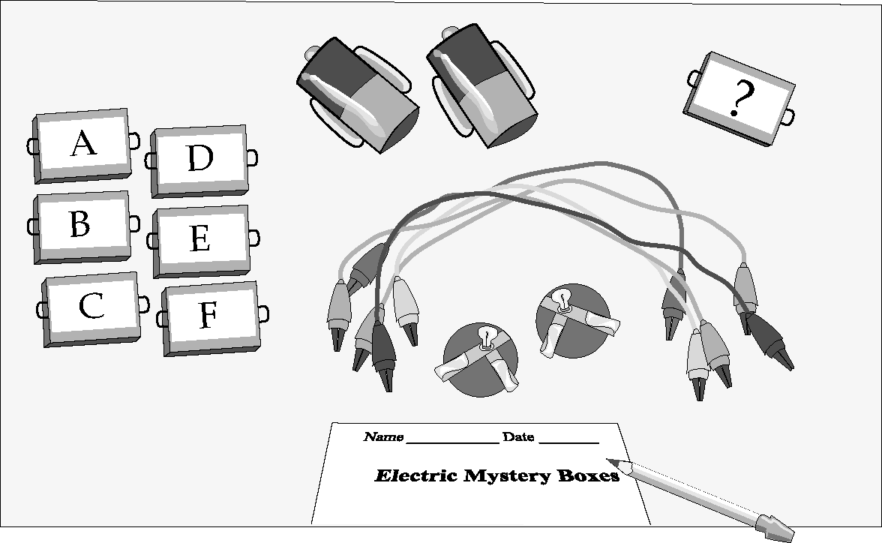

P4.11, Using Scientific Inquiry
Source: Shavelson, Baxter, and Pine 1991.

Interactive Computer Tasks
The NAEP Science Assessment should include some but not necessarily all of the following four types of ICTs: (1) information search and analysis, (2) empirical investigation, (3) simulation, and (4) concept mapping. This framework uses static screen shots to illustrate examples of ICTs; however, the screen shots represent only a small subset of the many screens students see when engaged in actual ICTs.

Information search and analysis items pose a scientific problem and ask students to query an information database to bring conceptual and empirical information to bear (through analysis) on the problem. Following is a screen shot from such an ICT developed for eighth graders.

Illustrative Item

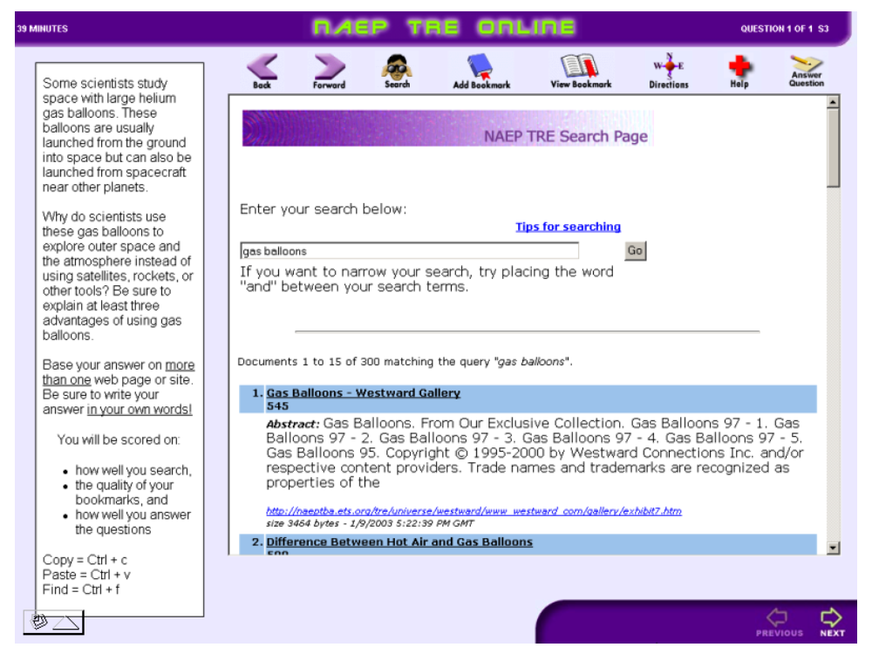

(See appendix C for more information about this task.)
P8.16, Using Scientific Inquiry
Source: Persky et al. 2005.

Empirical investigation items put hands-on performance tasks on the computer and invite students to design and conduct a study to draw inferences and conclusions about a problem. Whether the computer-simulated experiment assesses the same skills, knowledge, and understanding as a hands-on performance task has not been established; a special study will be conducted to address this question (see p. 117). Following is a screen shot from a computer version of the electric mysteries task (see p. 107 and appendix C for more information about this hands-on performance task).

Illustrative Item

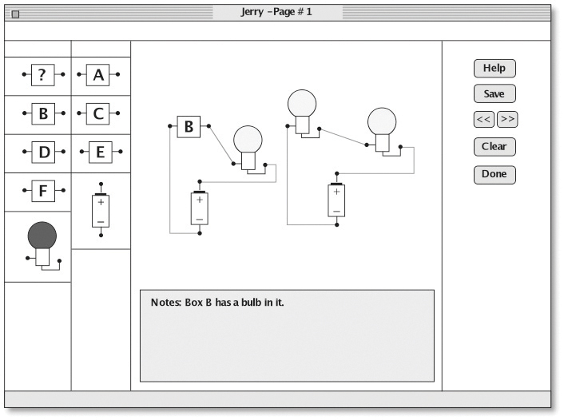

P4.11, Using Scientific Inquiry
Source: Shavelson, Baxter, and Pine 1991, p. 357.

Simulation items model systems (e.g., food webs), pose problems of prediction and explanation about changes in the system, and permit students to collect data and solve problems in the system. The following screen shot comes from such a simulation ICT.

Illustrative Item

High school (grade 12) students are asked to identify locations appropriate for solar power generation. (See appendix C for a description of the full task.) To complete the task, students must:

- Evaluate GIS map visualizations.
- Compare and contrast visualizations of different types of data.
- Use analytical extension to perform computations with visualization data.

Following is an example of one of several tasks that a student completes:

Your task is to identify two states that will have high annual solar energy and will be able to generate the maximum amount of electricity from their solar panels. Name two states that you predict will have a good annual electrical yield. In the rest of this performance assessment, you will generate visualizations and calculate which states will generate the best annual electricity yield from solar panels.

The following screen shot provides an example of a student response:
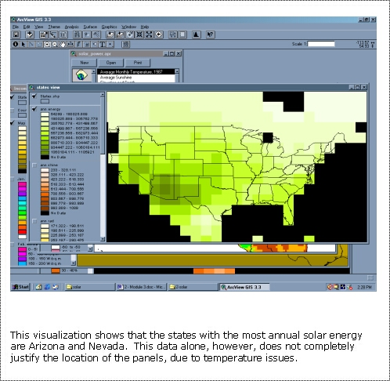

E12.10, Using Technological Design
Source: Quellmalz et al. 2004.
Finally, concept mapping can be done by providing concept terms and asking students to build propositions on the computer by linking pairs of terms with arrows and words or phrases. Following is a screen shot of a completed concept map.

Illustrative Item

In this task, middle and high school students used a customized software program to create concept maps. Students received 18 environmental science terms and 7 link labels.* Students could drag and drop these concepts onto the grid space of the mapping program and add, erase, and link the items in their newly constructed maps. (See appendix C for more information about this task.)

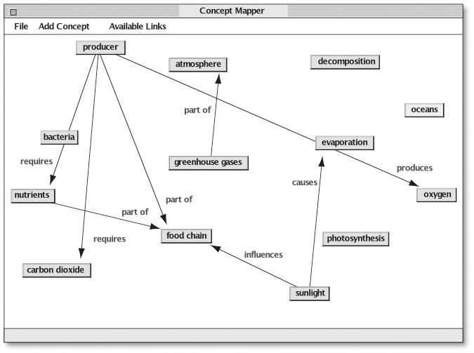
L12.5, Identifying Science Principles
Source: Adapted from Herl et al. 1999.
* Link labels should not be provided to students on the NAEP Science Assessment. See the Specifications for more information.

Computers and other media provide potential solutions to a variety of practical challenges posed by complex assessment exercises. The logistical challenges of hands-on performance tasks can be circumvented with computer simulation. Extensive databases can be used to assess students’ ability to select and evaluate information relevant to the situation or problem they need to address. In addition, the difficulty of providing materials and training for complex tasks (such as concept maps) can be circumvented with computers. To avoid cheating and teaching to the concept map, concept terms can be randomly sampled for a particular map (Ruiz-Primo et al. 2001).

ICTs should be used when the format offers advantages over other assessment modes. ICTs include (but are not limited to) testing student knowledge, skills, and abilities
related to the following situations:
- For scientific phenomena that cannot easily be observed in real time, such as seeing things in slow motion (e.g., the motion of a wave) or at a higher speed (e.g., erosion caused by a river). They are also useful when it is necessary to freeze action or replay.
- For modeling scientific phenomena that are invisible to the naked eye (e.g., the movement of molecules in a gas).
- For working safely in lab-like simulations that would otherwise be hazardous (e.g., using dangerous chemicals) or disorderly in an assessment situation.
- For situations that require several repetitions of an experiment in limited assessment time while varying the parameters (e.g., rolling a ball down a slope while varying the mass, the angle of inclination, or the coefficient of friction of the surface).
- For searching the Internet and resource documents that provide high-fidelity situations related to the actual world in which such performances are likely to be observed.
- For manipulating objects in a simplistic manner, such as moving concept terms in a concept map.

Extended constructed-response items, concept-mapping tasks, and simulated performance tasks are especially strong candidates for ICTs. In this way, the complex science understandings and practices that need to be probed in the NAEP Science Assessment could be captured with less time, cost, and logistical challenges and with greater opportunity for divergent problem-solving tasks than has been the case in the past.

Distribution of Items
This section recommends appropriate item distributions. The three types of distribution, as measured by percentage of student response time at each grade level, are as follows:
- Items by content area—Physical Science, Life Science, and Earth and Space Sciences
- Items by science practice—Identifying Science Principles, Using Science Principles, Using Scientific Inquiry, and Using Technological Design
- Items by type—Selected-response items and constructed-response items

Distribution of Items by Content Area
In the Overview of the Science Assessment section of this chapter, the distribution of items at each grade level by the three science content areas, as measured by percentage of student response time, was described as shown in exhibit 17.

Exhibit 17. Distribution of items by content area and grade
 | Grade 4  (percentage of student response time) | Grade 8  (percentage of student response time) | Grade 12*  (percentage of student response time)
Physical Science | 33.3 | 30.0 | 37.5
Life Science | 33.3 | 30.0 | 37.5
Earth and Space Sciences | 33.3 | 40.0 | 25.0
* These distributions are based on NAEP data regarding students’ course-taking patterns in 12th grade. If these patterns change substantially, the distributions should be reconsidered.

Distribution of Items by Science Practice
The item distribution for the four science practices, as measured by percentage of student response time at each grade level, should have the following approximate allocations:

Exhibit 18. Distribution of items by science practice and grade
 | Grade 4  (percentage of student response time) | Grade 8  (percentage of student response time) | Grade 12  (percentage of student response time)
Identifying Science Principles | 30 | 25 | 20
Using Science Principles | 30 | 35 | 40
Using Scientific Inquiry | 30 | 30 | 30
Using Technological Design | 10 | 10 | 10

Distribution of Items by Item Type
As measured by student response time, 50 percent of the assessment items at each grade level should be selected-response items and 50 percent should be constructed-response items (short constructed response, extended constructed response, concept-mapping tasks). Individual selected-response items and individual constructed-response items used within each of the item clusters, POE item sets, hands-on performance tasks, and ICTs should be included in this distribution. If variation from this distribution becomes necessary as items are developed, preference should be given to constructed-response items.

In regard to the combination item types, the NAEP Science Assessment should contain at least one of each of the following at each grade level: item clusters, POE item sets, hands-on performance tasks, and ICTs. In addition, it is highly recommended that each assessment include at least one concept-mapping task in grades 8 and 12.

Hands-on performance tasks and ICTs are administered to a subset of the students sampled; the quantity for each task is specified in exhibit 19.

Exhibit 19. Distribution of items by type of item and grade
 | Grade 4  (number of tasks) | Grade 8  (number of tasks) | Grade 12  (number of tasks)
Hands-On Performance Task | ≥1 | ≥1 | ≥1
Interactive Computer Task | ≥1 | ≥1 | ≥1
Total | ≥4 | ≥4 | ≥4

In any grade, the number of ICTs should not exceed the number of hands-on performance tasks. No student will be administered both types of tasks.

Students With Disabilities and English Language Learners
Along with the increase in national and state testing, there is an increased demand for
assessment systems to include all students (for example, those with disabilities and those learning English, many of whom have not been included in these systems in the past). As NAEP seeks to measure the educational progress of students in the nation’s classrooms, assessment developers will encounter challenges that require careful thought and consideration to the development of items that provide the most equitable context possible for all students.

NAEP should strive to develop science assessments that allow the widest possible range of students to participate. In this way, the interpretation of scores of all participants leads to valid inferences about the levels of their performance as well as valid comparisons across states and with state assessments. All students should have the opportunity to demonstrate their knowledge of the concepts and ideas that the NAEP Science Assessment is intended to measure.

According to the National Research Council:

Fairness, like validity, cannot be properly addressed as an afterthought once the test has been developed, administered, and used. It must be confronted throughout the interconnected phases of the testing process, from test design and development to administration, scoring, interpretation, and use (1999b, pp. 80–81).

When assessments are first conceptualized, they must be thought of in the context of the entire population that will be assessed (American Educational Research Association, American Psychological Association, and National Council on Measurement in Education 1999; NRC 1999a; Thompson, Johnstone, and Thurlow 2002). NAEP assessments, as well as all large-scale assessments, must be responsive to growing demands: increased diversity, increased inclusion of all types of students in the general curriculum, and
increased emphasis and commitment to serve and be accountable for all students.
Assessments must measure the performance of students who have a wide range of abilities and skills, ensuring that those with diverse learning needs receive opportunities to demonstrate competence on the same content as all other students.

Students with disabilities and English language learners each present challenges in how their science competencies can be assessed in a valid manner. Nevertheless, these groups share some commonalities, including considerable heterogeneity in each group regarding assessment needs. In addition:
- Conceptual frameworks based on appropriate theories of language development and proficiency and of various forms of disabilities will be needed to build inclusive assessments.
- A greater commitment to financial and human resources will be needed to develop and administer tasks and to interpret performance on tasks.

Two general recommendations pertain to both groups in the context of good assessment design for all students: readability of written text and alignment to content statements.

Students’ ability to read and respond to written text often determines successful performance on assessments. Assessment items may pose an unfair disadvantage for some
students if there is a heavy burden on reading skills when reading is not the goal of the assessment. Language that is both straightforward and concise and that uses everyday words to convey meaning is needed. The goal of ensuring that language has these characteristics is to improve the comprehensibility of written text and at the same time preserve the essence of its meaning. Using language that reduces the linguistic demands placed on students reduces the effect of reading skills and language proficiency on students’ science performance and assessment scores. More information on reading level is provided in the specifications.

Items on the NAEP Science Assessment must be aligned to the content statements and science practices with the same depth and breadth of coverage and the same cognitive demands as specified in the framework. Assessment design should emphasize accessibility using different formats, technologies, designs, and accommodations to include as many students as possible. It must be clear from the outset that, to be equitable,
assessments need to measure the achievement of all students on the same content and achievement standards.

To these ends, field tests should sample every type of student expected to participate in the final assessment administration, including students with a wide range of disabilities, English language learners, and students across racial, ethnic, and socioeconomic lines. Field testing NAEP items with a broad range of students will not only help determine whether items are unclear, misleading, or inaccessible for certain groups of students, but will also help ensure that assessment procedures are accessible to students when the NAEP Science Assessment is fully implemented. More information about these recommendations can be found in the Specifications.

NAEP strives to assess all students selected by its sampling process. Rigorous criteria are applied to minimize the number of English language learners and students with disabilities who are excluded from NAEP assessments. Participating students with special needs are permitted to use accommodations, as stated in current NAEP policy:

All special-needs students may use the same accommodations in NAEP assessments that they use in their usual classroom testing unless the accommodation would make it impossible to measure the ability, skill, or proficiency being assessed, or the accommodation is not possible for the NAEP program to administer (NCES 2005a).

See the Specifications for more information on NAEP’s inclusion policy and permitted accommodations.

Special Studies
Special studies bearing on aspects of the NAEP Science Assessment are presented in this framework. Each study contributes to a further understanding of science assessment.

Group 1 special studies have the highest priority:
- “Exchangeability” of hands-on performance and interactive computer investigations
- Impact of variation in item format and language demand on the performance of English language learners and students with disabilities
- Computer adaptive testing to assess the development of student understanding of Earth systems

Group 2 special studies have lower priority:

- Knowing what students know about technological design

- Extended investigations by students

The order in which studies are listed does not imply priority within group 1 or group 2. Group 1 special studies are described in the next section. Group 2 special studies are discussed in appendix D.

Group 1 Special Studies

“Exchangeability” of Hands-on Performance and Interactive Computer Investigations
Inquiry is at the heart of knowing and doing science. A fundamental aspect of inquiry is the design, conduct, and interpretation of empirical investigations to answer a question or test a hypothesis. Although a full assessment of inquiry is not possible on any test that is given on demand, hands-on performance investigations (HPIs) attempt to approximate this aspect of inquiry under time, space, cost, and logistical constraints. For this reason, HPIs have been a part of the NAEP Science Assessment since 1996.

However, HPIs have been criticized as being expensive, logistically difficult, and too highly structured. On the other hand, ICTs or, in this case, interactive computer investigations (ICIs), are logistically simpler, less expensive, and less structured. Therefore, the purpose of this study is to explore whether ICIs and HPIs are exchangeable. The question is not whether ICIs could replace HPIs either on NAEP or in the classroom—they should not. Even if these two approaches produce similar performances and scores, each affords somewhat different opportunities; simulations cannot be exchanged with actual practice. This is a question of assessment: can the cost and logistical challenges of HPIs be
reduced with the use of ICIs and still measure the same competencies with as much
reliability and validity? Some research suggests that the two methods of assessing
student inquiry are exchangeable to a fair degree (e.g., Pine, Baxter, and Shavelson 1993; Rosenquist, Shavelson, and Ruiz-Primo 2000). However, further research is needed on several different investigations to provide a satisfactory answer for large-scale assessment.

Specifically, this study would address the following research questions:
- Does the choice of an ICI or HPI limit the questions that may be asked? Specifically, is there something of value in an HPI that cannot be asked if an ICI is administered?
- Are scores on HPIs and ICIs equally reliable?
- Are scores on HPIs and ICIs of equal magnitude?
- To what extent does performance on an HPI predict performance on an ICI in the same investigation?
- Do scores on HPIs and ICIs correlate somewhat equally with scores on another measure of science inquiry or achievement?
- Are similar thinking processes evoked by HPIs and ICIs?
- Do the answers to these questions depend on individual differences among students (such as gender, English proficiency, race/ethnicity, socioeconomic status, and geographic location)? Variation in student access to computers is also an area of interest; this factor could be confused with other variables listed here.

Impact of Variation in Item Format and Language Demand on the Performance of English Language Learners and Students With Disabilities
English language learners and students with disabilities do not tend to perform as well on standardized achievement assessments as other students. Recent studies, for example, have pointed to a systematic relationship between the linguistic complexity of the
assessment and the test scores of English language learners (e.g., Abedi 2003) and
students with certain disabilities, such as those related to reading and information processing. Science assessments, with their heavy reliance on verbal skills, may exacerbate performance disparities. In cases where this relationship is demonstrable and test items use complex language, the differences become sources of measurement error and construct irrelevant variance; therefore, the nature of the assessment item must be addressed. Until this dimension of the assessment item is more clearly understood, any interpretation of the performance of English language learners or students with disabilities on a content
assessment is problematic; for example, language proficiency and science understanding cannot be separated.

Preliminary results from several studies of scaffolded science assessments that are designed to minimize language complexity and provide alternative response modalities—including graphic organizers or drawn representations of the concepts—indicate that research is needed to clarify the relationship between language complexity, scaffolded assessment items, and the performance of English language learners and students with disabilities.

Specifically, this study would address the following research questions:
- Can the language complexity of a content-based assessment be systematically measured?
- Can content-based assessment items be designed to minimize the language demand while conserving the content information obtained?
- If the content-based assessment contains a graphic response modality, do English language learners and students with disabilities demonstrate higher understanding of the content concept being assessed relative to more linguistically demanding response modalities?
- When the content-based assessment with a graphic response option is also computer based, is there a further benefit in terms of content concept conservation and the performance of these students?

Computer Adaptive Testing To Assess the Development of Student Understanding of Earth Systems
A common critique of large-scale assessment is that its necessary reliance on easily scored, decontextualized, and simplified items has led to an impoverished range of potential learning activities from which valid and reliable measures might be derived (Resnick and Resnick 1992). Attempts to find alternatives include the following:
- The facets approach (Minstrell 1998), which posits a strong model of facets of student knowledge for certain science topic areas and uses coordinated sets of multiple-choice items to hone in on students’ particular conceptions and misconceptions; and
- The progress variable approach (Masters, Adams, and Wilson 1990), which posits a learning progression and uses item response theory to scale students’ responses to (typically open-ended) items to estimate the part of the learning progression in which students will most likely be located.

This special study combines the strengths of each of these approaches to develop a new type of “branching” item that can be used to investigate the more complex types of knowledge structures and complex procedural steps involving contingencies such as those common in inquiry-related contexts, and yet maintain the efficiency of traditional multiple-choice testing. Specifically, the facets approach will contribute its strong knowledge structure and convenient scoring, and the progress variables approach will contribute the interpretational framework of the learning progression and the flexible statistical modeling available through recent advances in item response modeling (De Boeck and Wilson 2004). Together, these approaches allow the use of item bundles (such as those shown in exhibit 20) to provide both the usual result in terms of student ability estimation as well as potentially more educationally informative results such as the prevalence of particular classes of misconceptions among the student body.
Exhibit 20. Storyboard showing item design for a
“branching” item bundle on ions and atoms (adapted from Scalise 2004)

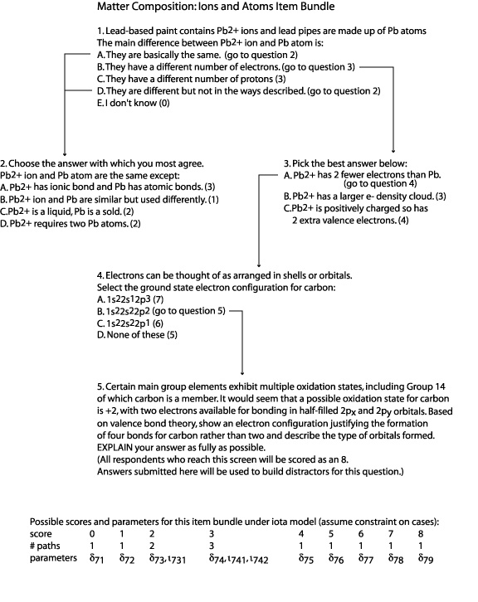

Specifically, this study would address the following research questions:
- Can the “branching” item type be developed and delivered in a logistically efficient way for use in NAEP?
- Can the information from sets of “branching” item bundles be used to provide reliable, valid, and useful information on both overall student ability in science and the classification of students into educationally useful categories?

The study would focus on a specific Earth system that is of practical and environmental significance, such as the biogeochemical carbon cycle. Understanding this system and related environmental issues (e.g., global climate change) requires connected understandings in the Physical, Life, and Earth and Space Sciences, many of which are characterized in the framework. For example, students who understand global warming understand how photosynthesis, cellular respiration, and fossil fuel combustion affect carbon dioxide concentrations in the atmosphere. This connected understanding can be tracked as a learning progression.

While these three specific studies were not conducted due to resource constraints, NAEP continues to pursue a broad program of research in areas related to innovative assessment tasks, testing special needs students, and computer adaptive testing.

Appendix A

Steering Committee Guidelines

The Framework Is Informed by the National Standards and Benchmarks

The framework should reflect the nation’s best thinking in science instruction; therefore, it is guided by two national documents: National Science Education Standards (NRC 1996) and Benchmarks for Science Literacy (AAAS 1993). Both documents were subject to extensive internal and external reviews during their development.

Informed by the National Standards and Benchmarks, the framework should emphasize knowledge and use of science concepts, appropriate linking of science facts to concepts, relationships among concepts, and major themes unifying the sciences. The framework should also incorporate investigative skills.

The Framework Reflects the Nature and Practice of Science

The National Standards and Benchmarks include standards addressing science as inquiry, nature of science, history of science, and the designed world. The framework should
emphasize the importance of these aspects of science education and should include the expectation that students will understand the nature and practice of science. Science is a self-correcting process; that is, a way of knowing in which theories are continually modified and refined based on new research findings. Students should demonstrate the ability to accomplish the following:
- Make warranted inferences from evidence.
- Use evidence to justify conclusions based on scientific investigations.
- Demonstrate reasoning skills in the application of science content and in understanding the connections between science concepts.
- Exercise skepticism when evaluating, using, and discarding data.
- Understand and use models to describe and do science.
- Apply content knowledge and skills to solve problems as they occur in the natural world.
- Understand and apply knowledge of links and commonalities of science across fields.

The scientific disciplines are no longer practiced in isolation, and research that cuts across discipline boundaries is common. The framework should:
- identify some of the science concepts and skills that cut across the assessed content areas;
- address science in both the natural and designed world; and
- clearly define and identify commonalities and differences between “science” and “technology” or “technological design.”

The framework should also address social and historical contexts, which are keys to
understanding how the scientific community has arrived at its current body of knowledge.

The Framework Incorporates Key Attributes of Effective Assessment

The framework should use assessment formats that are consistent with the objectives
being assessed. It should be guided by the best available research on assessment item design and delivery.

The framework should take into account student diversity as reflected in gender,
geographic location, language proficiency, race/ethnicity, socioeconomic status, and disability condition. The assessment should be designed and written so it is accessible by the majority of students and to minimize the need for special accommodations for both
students with disabilities and English language learners. Students with special needs should be provided accommodations so they can participate in the assessment.

The framework should reflect knowledge about the acquisition of key science concepts over time, based on research about how students learn. The existing research findings should make clear, when possible, the progression of science knowledge across the grade levels. Concepts should be represented in a manner that reflects how students progress through a discipline and across disciplines. Assessment items should reflect students’ potential for applying concepts and more varied and complex situations over time.

Critical content and skills should be articulated and assessed across grades 4, 8, and 12 (vertically) and across the fields of science (horizontally) by creating items that are deliberately layered to achieve these goals. An example of measuring similar constructs within and across subjects is the progression of increasingly sophisticated understanding about energy from elementary school to middle school to high school in the content areas of biology, chemistry, Earth science, and physics.

The NAEP assessment should continue to use a variety of assessment formats, including well-constructed multiple-choice and open-ended items as well as performance tasks. In addition, multiple methods of assessment delivery should be considered, including the appropriate uses of digital-based technology. The framework should consider using digital delivery systems for the assessment, including Web-based or CD–ROM formats. Embedded simulations that can represent scientific phenomena such as data, representations, and factors captured within laboratory experiments, along with the use of an adaptively designed series of assessment items, should also be considered. Advances in machine scoring of text should provide the opportunity for increased use of open-response format questions. The assessment format and delivery system employed should be accessible to the widest range of students.

Each achievement level—Basic, Proficient, and Advanced—should include a range of items assessing various levels of cognitive knowledge that is broad enough to ensure each is measured with the same degree of accuracy. Descriptions of Basic, Proficient, and Advanced must be as clear as possible.

The Assessment Provides Data for Research

NAEP assessment results are increasingly being used to review state student assessments and compare student achievement across states. The framework should address the
important uses of assessment data both to conduct research to better understand science learning and to improve science achievement. Data from the assessment should be collected in such a way as to provide information that accomplishes the following:
- supplies details of the attributes (e.g., race/ethnicity, gender) of the students being assessed;
- provides results by student gender, race/ethnicity, and socioeconomic level;
- describes the academic preparation of the teachers whose students are being assessed;
- describes the nature of the educational system of the students being assessed;
- relates the instructional delivery and materials, professional development of the teachers, and the learning environment to the results from the assessment; and
- provides feedback to educators for improving science instruction and learning.

The Specifications Document Is Closely Aligned With the Framework

The connections among the framework, the specifications, and the assessment items should be transparent, have a consistent level of specificity, and be coherent.

The specifications should be written with consistent detail across all fields, domains, and expectations of the framework:
- The specifications should have a consistent structure across all areas.
- The expected science knowledge that represents the target for assessment should be described in a clear and consistent format. The specifications should address content that reflects the standards and focuses on the significant information and knowledge that students should retain over time (e.g., principal ideas, fundamental understandings).
- The specifications should use verbs that describe the expected action to be taken in the assessment (e.g., identify, describe, evaluate, relate, analyze, demonstrate).
- Expectations across the content areas should match in level of specificity and scope.
- The specifications should follow the idea of learning trajectories. To assess overarching concepts or themes, the assessment specifications should reflect a layered understanding of growth in knowledge of the concepts.

Appendix B

NAEP Science Achievement Level Descriptions

Congress authorized the Governing Board to develop appropriate student achievement levels on NAEP. The achievement level descriptions are statements of what students should know and be able to do on NAEP at grades 4, 8, and 12. To fulfill its statutory
responsibility, the Governing Board developed a policy to guide the development of achievement levels for all NAEP subjects. It identified three levels of achievement to provide the public, educators, and policymakers with information on student performance on NAEP. These levels—Basic, Proficient, and Advanced—are used as a primary means of reporting NAEP results to describe “how good is good enough” at grades 4, 8, and 12.

Exhibit B-1 displays the Governing Board’s generic policy definitions for Basic,
Proficient, and Advanced achievement that pertain to all NAEP subjects and grades.

Exhibit B-1. Generic achievement level policy definitions for NAEP
Achievement Level | Policy Definition
Advanced | This level signifies superior performance.
Proficient | This level represents solid academic performance for each grade assessed. Students reaching this level have demonstrated competency over challenging subject matter, including subject-matter knowledge, application of such knowledge to real-world situations, and analytical skills appropriate to the subject matter.
Basic | This level denotes partial mastery of prerequisite knowledge and skills that are fundamental for proficient work at each grade.

During the framework development process, the project committees are asked to develop preliminary achievement level descriptions, based on the generic policy definitions, to guide item development. The descriptions are designed to provide examples of what
students performing at the Basic, Proficient, and Advanced achievement levels should know and be able to do in terms of the science content and practices identified in the framework; they are used to ensure that a broad range of items (covering Basic, Proficient, and Advanced levels) is developed at each grade level. The NAEP assessment
development contractor and item writers are the intended audiences for the descriptions.
Planning committee members used their expert judgment to draft the preliminary
descriptions and were partially guided by the following considerations:

- Basic descriptions could be composed of both moderately challenging content and practice components.
- Proficient descriptions could be composed of a mixture of highly and moderately challenging content and practice components.
- Advanced descriptions could be composed of highly challenging science content and highly challenging components of a given science practice.

The preliminary descriptions include only illustrative statements drawn from the framework’s science content and practices. The statements are not intended to represent the entire set of objectives from the content and practice dimensions, nor do the preliminary achievement level descriptions denote a sense of priority or importance based on the statements selected. In addition, the descriptions should not be interpreted as assessment items or as suggestions for assessment items. Although adjectives are not explicitly
included in every statement, each was written with the expectation that student performances would be “good” and “reasonable.” For example, the phrase “design an investigation” implies “design an organized and logical investigation” and “propose a framework” implies “propose a rational framework.”

The achievement level descriptions are a set of paragraphs derived from the preliminary achievement level descriptions, and these paragraphs are used to report the NAEP science results to the general public and other audiences. For each grade level, the paragraphs describe what students should know and be able to do at the Basic, Proficient, and Advanced levels in terms of the science content and practices identified in the framework. After the assessment is administered, broadly representative panels engage in a standard-setting process to determine the achievement level cut scores on the NAEP scale. The cut scores represent the minimum score required for performance at each NAEP achievement level.

NAEP Science Achievement Level Descriptions
The achievement levels are cumulative; therefore, students performing at the Proficient level also display the competencies associated with the Basic level, and students at the Advanced level also demonstrate the skills and knowledge associated with both the Basic and the Proficient levels. The cut score indicating the lower end of the score range for each level is noted in parentheses. Bold text is a short, general summary to describe performance at each achievement level.

NAEP Science Achievement Levels—Grade 4
Basic | Students performing at the Basic level should be able to describe, measure, and classify familiar objects in the world around them, as well as explain and make predictions about familiar processes. These processes include changes of states of matter, movements of objects, basic needs and life cycles of plants and animals, changes in shadows during the day, and changes in weather. They should be able to critique simple observational studies, communicating observations and basic measurements of familiar systems and processes, and look for patterns in their observations. With regard to scientific constraints, they should also be able to propose and critique alternative solutions to problems involving familiar systems and processes.  Science Practices: Students performing at the Basic level should be able to describe, measure, and classify familiar objects in the world around them, as well as explain and make predictions about familiar processes, using evidence to support their observations and conclusions. They should be able to critique simple observational studies, communicate observations and basic measurements of familiar systems and processes, and look for patterns in their observations. They should also be able to propose and recognize alternative solutions to problems involving familiar systems and processes.  In the physical sciences, students performing at the Basic level should be able to describe the properties of the states of matter, describe how to change matter from one state to another, describe different forms of energy, predict the electrical energy transfers that will take place in a simple circuit, critique alternative explanations for changes in a moving object’s position, and design an investigation to show how exerting a force on an object changes the object’s motion.  In the life sciences, students performing at the Basic level should be able to identify the stages in the life cycles of familiar organisms; describe how familiar animals meet their basic needs for food, air, water, and shelter; observe and describe the changes in plants and animals during their life cycles; and describe how environments meet the survival needs of familiar plants and animals.  In the Earth and space sciences, students performing at the Basic level should be able to predict changes in the length and position of shadows cast by the sun, describe how slow Earth processes (e.g., erosion) and fast Earth processes (e.g., volcanic eruption) can change Earth’s surface, distinguish between natural and manmade materials, choose and use a tool to monitor how weather conditions change, and identify Earth resources that are limited.
Proficient | Students performing at the Proficient level should be able to demonstrate relationships among closely related science concepts, as well as analyze alternative explanations or predictions. They should be able to explain how changes in temperature cause changes of state, how forces can change motion, how adaptations help plants and animals meet their basic needs, how environmental changes can affect their growth and survival, how land formations can result from Earth processes, and how recycling can help conserve limited resources. They should be able to identify patterns in data and/or explain these patterns. They should also be able to identify and critique alternative responses to design problems.  Science Practices: Students performing at the Proficient level should be able to demonstrate relationships among closely related science concepts and familiar phenomena around them, as well as analyze alternative explanations or predictions, using evidence to support their explanations and predictions; critique observational studies and simple investigations; identify patterns in data and/or explain those patterns in data; and apply scientific ideas to identify and critique alternative designs to problems that personally affect them.  In the physical sciences, students performing at the Proficient level should be able to demonstrate the relationship between temperature change and changes in the physical properties of matter, explain how energy in one form can be changed into another form, design an investigation that measures how temperature changes when energy is added to a substance, propose a design for a container that will maintain the temperature of an object that is above or below room temperature, and measure changes in position of an object in motion as different forces are applied.  In the life sciences, students performing at the Proficient level should be able to describe needs of familiar plants and animals at different stages of their life cycles, explain adaptations of familiar plants and animals to their environments, predict effects of environmental changes on plant or animal growth and survival, and apply information about an animal’s basic needs to propose a supportive environment.  In the Earth and space sciences, students performing at the Proficient level should be able to explain how the Sun’s changing position in the sky during the day affects shadows; interpret land formations as resulting from either slow (e.g., erosion) or rapid (e.g., volcanic eruption) Earth processes; explain how natural materials can help sustain the lives of familiar plants and animals; identify how patterns of weather conditions change from season to season; and explain how the practices of recycling, reusing, and reducing help to conserve limited resources.
Advanced | Students performing at the Advanced level should be able to demonstrate relationships among different representations of science principles, as well as propose alternative explanations or predictions of phenomena. They should be able to use numbers, drawings, and graphs to describe and explain motions of objects; analyze how environmental conditions affect growth and survival of plants and animals; describe changes in the Sun’s path through the sky at different times of year; and describe how human uses of Earth materials affect the environment. They should be able to design studies that use sampling strategies to obtain evidence. They should also be able to propose and critique alternative individual and local community responses to design problems.  Science Practices: Students performing at the Advanced level should be able to demonstrate relationships among different representations of principles, as well as propose alternative explanations or predictions of familiar phenomena, using evidence to support their explanations and predictions; design observational studies or simple investigations to validate or criticize explanations or predictions and use sampling strategies to obtain evidence; and propose and critique alternative individual and local community responses to design problems.  In the physical sciences, students at the Advanced level should be able to demonstrate the relationship between the quantity of energy needed to change the state of a sample of a substance and the weight of the sample, demonstrate how different representations (i.e., verbal, numerical, graphical) can be used to show the motion of an object, suggest an example of how the motion of an object can be changed without touching it, and design an investigation that demonstrates how long it takes different forms of energy to change the temperature of matter.  In the life sciences, students at the Advanced level should be able to evaluate relationships between changing environmental conditions and organisms’ growth, survival, and reproduction; analyze environments for how they may have different effects on the growth and survival of plants or animals of the same kind; and investigate the relationship between light and plant growth.  In the Earth and space sciences, students at the Advanced level should be able to relate changes in the Sun’s daily path through the sky to different times of year, suggest examples of Earth materials that can be modified to meet human needs, explain how erosion is caused by daily/seasonal weather events, propose methods of reducing the amount of erosion, describe how humans can change environments that can be either detrimental or beneficial for themselves and other organisms, and describe how the use of Earth materials by humans impacts the environment.

NAEP Science Achievement Levels—Grade 8
Basic | Students performing at the Basic level should be able to state or recognize correct science principles. They should be able to explain and predict observations of natural phenomena at multiple scales, from microscopic to global. They should be able to describe properties and common physical and chemical changes in materials; describe changes in potential and kinetic energy of moving objects; describe levels of organization of living systems—cells, multicellular organisms, and ecosystems; identify related organisms based on hereditary traits; describe a model of the solar system; and describe the processes of the water cycle. They should be able to design observational and experimental investigations employing appropriate tools for measuring variables. They should be able to propose and critique the scientific validity of alternative individual and local community responses to design problems.  Science Practices: Students performing at the Basic level should be able to state or recognize correct science principles; explain and predict observations of natural phenomena at multiple scales, from microscopic to global, using evidence to support their explanations and predictions; design investigations employing appropriate tools for measuring variables; and propose and critique the scientific validity of alternative individual and local community responses to design problems.  In the physical sciences, students at the Basic level should be able to recognize a class of chemical compounds by its properties; design an investigation to show changes in properties of reactants and products in a chemical process such as burning or rusting; describe the changes in kinetic and potential energy of an object such as a swinging pendulum; describe and compare the motions of two objects moving at different speeds from a table of their position and time data; describe the direction of all forces acting on an object; and suggest an example of a system in which forces are acting on an object but the motion of the object does not change.  In the life sciences, students at the Basic level should be able to identify levels of organization within cells, multicellular organisms, and ecosystems; describe how changes in an environment relate to an organism’s survival; describe types of interdependence in ecosystems; identify related organisms based on hereditary traits; discuss the needs of animals and plants to support growth and metabolism; and analyze and display data showing simple patterns in population growth.  In the Earth and space sciences, students at the Basic level should be able to describe a Sun-centered model of the solar system that illustrates how gravity keeps the objects in regular motion; describe how fossils and rock formations can be used as evidence to infer events in Earth’s history; relate major geologic events, such as earthquakes, volcanoes, and mountain building to the movement of lithospheric plates; use weather data to identify major weather events; and describe the processes of the water cycle including changes in the physical state of water.
Proficient | Students performing at the Proficient level should be able to demonstrate relationships among closely related science principles. They should be able to identify evidence of chemical changes; explain and predict motions of objects using position-time graphs; explain metabolism, growth, and reproduction in cells, organisms, and ecosystems; use observations of the Sun, Earth, and Moon to explain visible motions in the sky; and predict surface and groundwater movements in different regions of the world. They should be able to explain and predict observations of phenomena at multiple scales, from microscopic to macroscopic and local to global, and to suggest examples of observations that illustrate a science principle. They should be able to use evidence from investigations in arguments that accept, revise, or reject scientific models. They should be able to use scientific criteria to propose and critique alternative individual and local community responses to design problems.  Science Practices: Students performing at the Proficient level should be able to demonstrate relationships among closely related science principles; explain and predict observations of phenomena at multiple scales, from microscopic to macroscopic and local to global, and to suggest examples of observations that illustrate a science principle; design investigations requiring control of variables to test a simple model, employing appropriate sampling techniques and data quality review processes, and use the evidence to communicate an argument that accepts, revises, or rejects the model; and propose and critique solutions and predict the scientific validity of alternative individual and local community responses to design problems.  In the physical sciences, students at the Proficient level should be able to demonstrate the relationship between the properties of chemical elements and their position on the periodic table; use empirical evidence to demonstrate that a chemical change has occurred; demonstrate the relationship of the motion of an object that experiences multiple forces with the representation of the motion on a position-time graph; predict the position of a moving object based on the position-time data presented in a table; and suggest examples of systems in which potential energy is converted into other forms of energy.  In the life sciences, students at the Proficient level should be able to explain metabolism, growth, and reproduction at multiple levels of living systems: cells, multicellular organisms, and ecosystems; predict the effects of heredity and environment on an organism’s characteristics and survival; use sampling strategies to estimate population sizes in ecosystems; and suggest examples of sustainable systems for multiple organisms.  In the Earth and space sciences, students at the Proficient level should be able to explain how gravity accounts for the visible patterns of motion of the Earth, Sun, and Moon; explain how fossils and rock formations are used for relative dating; use models of Earth’s interior to explain lithospheric plate movement; explain the formation of Earth materials using the properties of rocks and soils; identify recurring patterns of weather phenomena; and predict surface and groundwater movement in different regions of the world.
Advanced | Students performing at the Advanced level should be able to develop alternative representations of science principles and explanations of observations. They should be able to use information from the periodic table to compare families of elements; explain changes of state in terms of energy flow; trace matter and energy through living systems at multiple scales; predict changes in populations through natural selection and reproduction; use lithospheric plate movement to explain geological phenomena; and identify relationships among regional weather and atmospheric and ocean circulation patterns. They should be able to design and critique investigations involving sampling processes, data quality review processes, and control of variables. They should be able to propose and critique alternative solutions that reflect science-based trade-offs for addressing local and regional problems.  Science Practices: Students performing at the Advanced level should be able to demonstrate relationships among different representations of science principles. They should be able to explain and predict observations of phenomena at multiple scales, from microscopic to macroscopic and local to global, and develop alternative explanations of observations, using evidence to support their thinking. They should be able to design control of variable investigations employing appropriate sampling techniques and data quality review processes that strengthen the evidence used to argue for one alternate model over another. They should be able to propose and critique alternative solutions that reflect science-based trade-offs for addressing local and regional problems.  In the physical sciences, students at the Advanced level should be able to interpret diagrams, graphs, and data to demonstrate the relationship between the particulate nature of matter and state changes (for instance, melting and freezing); demonstrate relationships between position on the periodic table and the characteristics of families of the chemical elements; explain changes of state in terms of energy flow in and out of a system; identify possible scientific trade-offs in making decisions on the design of an electrical energy power plant; suggest examples of systems in which objects are undergoing transitional, vibrational, and rotational motion; and suggest examples of systems in which forces are acting both through contact and at a distance.  In the life sciences, students at the Advanced level should be able to explain movement and transformations of matter and energy in living systems at cellular, organismal, and ecosystem levels; predict changes in populations through natural selection and reproduction; and describe an ecosystem’s populations and propose an analysis for changes based on energy flow through the system.  In the Earth and space sciences, students at the Advanced level should be able to explain the seasons, Moon phases, and lunar and solar eclipses; illustrate how fossils and rock formations can provide evidence of changes in environmental conditions over time; use lithospheric plate movement to explain geological phenomena; identify relationships among regional weather and atmospheric and ocean circulation patterns; and use the water cycle to propose and critique ways for obtaining drinkable water.

NAEP Science Achievement Levels—Grade 12
Basic | Students performing at the Basic level should be able to describe, measure, classify, explain, and predict phenomena at multiple scales, from atomic/molecular to interstellar. These phenomena include the structure of atoms and molecules; transformations of matter and energy in physical, Earth, and living systems; motions of objects; the genetic role of DNA; changes in populations and ecosystems due to selection pressures; earthquakes and volcanoes; patterns in weather and climate; and biogeochemical cycles. They should be able to design and critique observational and experimental studies, and they should be able to propose and critique solutions to problems at local or regional scales.  Science Practices: Students performing at the Basic level should be able to describe, measure, classify, explain, and predict phenomena at multiple scales, from atomic/molecular to cosmic; design and critique observational and experimental studies, controlling single variables, making basic decisions about sampling, analyzing reliability of data, and using scientific models to explain results; and propose, critique, and predict scientific outcomes of responses to problems at local or regional scales.  In the physical sciences, students at the Basic level should be able to explain the differences in atomic structure across families in the periodic table and explain how the structures of molecules change in chemical reactions; distinguish linear velocity and acceleration as each is represented graphically and suggest ways in which forces can be measured; critique data that claim to show how gravitational potential energy changes with distance from the Earth’s surface; predict the situations in which a net force changes the motion of an object; and predict how the energy packets of electromagnetic waves change as the frequency of the waves change.  In the life sciences, students at the Basic level should be able to identify changes in populations due to selection pressures and trace matter and energy through organisms and ecosystems; explain changes in ecosystem structure and function and identify ways in which humans can permanently alter ecosystems through intentional design or unintended consequences; and describe the relationship between DNA and an individual’s hereditary traits.  In the Earth and space sciences, students at the Basic level should be able to describe a Sun-centered model of the solar system that illustrates how gravity keeps objects in regular motion; describe how fossils and rock formations can be used as evidence to infer events in Earth’s history; relate major geologic events, such as earthquakes, volcanoes, and mountain building to the movement of lithospheric plates; use weather data to identify major weather events; and describe the processes of the water cycle, including changes in the physical state of water.
Proficient | Students performing at the Proficient level should be able to demonstrate relationships and compare alternative models, predictions, and explanations. They should be able to explain trends among elements in the periodic table; conservation laws; chemical mechanisms for metabolism, growth, and reproduction; changes in populations due to natural selection; the evolution of the Universe; and evidence for boundaries and movements of tectonic plates. They should be able to design and critique observational and experimental studies, controlling multiple variables, using scientific models to explain results, and choosing among alternative conclusions based on arguments from evidence. They should be able to compare scientific costs or risks and benefits of alternative solutions to problems at local or regional scales.  Science Practices: Students performing at the Proficient level should be able to describe, measure, classify, explain, and predict phenomena at multiple scales, from atomic/molecular to cosmic; demonstrate relationships and compare alternative models, predictions, and explanations; design and critique observational and experimental studies, controlling multiple variables, making basic decisions about sampling, analyzing reliability of data, using scientific models to explain results, and choosing among alternative conclusions based on arguments from evidence; and compare scientific costs or risks and benefits of alternative solutions to problems at local or regional scales.  In the physical sciences, students at the Proficient level should be able identify the unique properties of water and their implications for Earth’s organisms and climate; describe the pattern of data expected within a family of elements from the periodic table; predict the nature of an unbalanced force on an object by the object’s motion and describe observations that would imply a conservation principle in science; suggest examples of how energy gets transferred in different processes; and design an experiment that will yield the average speed of an object under a free-fall situation.  In the life sciences, students at the Proficient level should be able to explain chemical mechanisms for metabolism, growth, and reproduction in living systems; analyze cases of evolutionary change in populations using the following related science principles: the potential of a species to increase its numbers, the genetic variability of its offspring, limitations on the resources required for life, and the ensuing selection of those organisms better able to survive and leave offspring; and use scientific models to explain data patterns related to metabolism, genetics, or changes in ecosystems.  In the Earth and space sciences, students at the Proficient level should be able to describe the theory that the Universe expanded from a single point billions of years ago and that most elements are formed in stars; given data about fossils, reconstruct the possible environment in which the organisms lived; select geologic data to infer Earth’s tectonic plate boundaries; explain the factors that affect regional climates; use knowledge of biogeochemical cycles to predict how an ecosystem may change due to pollutant or change in land use; and propose methods to lessen negative impacts on ecosystems.
Advanced | Students performing at the Advanced level should be able to use alternative models to generate predictions and explanations. They should be able to explain differences among physical, chemical, and nuclear changes; the wave and particle nature of light; paths of specific elements through living systems; responses of ecosystems to disturbances; evidence for the theory of an expanding Universe; and evidence for human effects on the Earth’s biogeochemical cycles. They should be able to design and critique investigations that relate data to alternative models of phenomena. They should be able to compare costs or risks and benefits of alternative solutions to problems at local, regional, and global scales.  Science Practices: Students performing at the Advanced level should be able to describe, measure, classify, explain, and predict phenomena at multiple scales, from atomic/molecular to cosmic; demonstrate relationships and use alternative models to generate predictions and explanations; design and critique observational and experimental studies, controlling multiple variables, making complex decisions about sampling, analyzing reliability of data, using scientific models to explain results, and choosing among alternative conclusions based on arguments from evidence; and compare scientific costs or risks and benefits of alternative solutions to problems at local, regional, and global scales.  In the physical sciences, students at the Advanced level should be able to describe how physical, chemical, and nuclear reactions differ; state the changes to a gas in a closed system with the addition of energy; suggest empirical evidence to demonstrate the conservation of matter in physical and chemical changes; describe energy transformations that occur in the transmission of electromagnetic waves and design an investigation to identify the characteristics of electromagnetic waves; demonstrate the relationship of mass and velocity in conserving momentum during a two-body collision; analyze conflicting claims about scientific evidence related to issues such as effects of extended use of cell phones on the human brain and effective methods of containment of nuclear waste materials; and critique an experimental setup that measures velocities of an object to obtain average acceleration.  In the life sciences, students at the Advanced level should be able to predict changes in ecosystems in response to disturbances and trace elements through physical and chemical changes in cells, organisms, and ecosystems; analyze conflicting claims about scientific evidence related to biological issues such as genetically modified organisms and ecological effects of climate change; and design technological systems that mitigate harmful science-related effects on humans and ecosystems.  In the Earth and space sciences, students at the Advanced level should be able to cite evidence (e.g., red shift) that the Universe expanded from a single point billions of years ago and that all but the lightest elements are formed in stars; use data from an excavation site to infer the age of a fossil; explain the mechanisms for phenomena at plate boundaries by employing earthquake data and using conceptual models; identify scientific trade-offs among energy sources; analyze conflicting claims about scientific evidence related to water resource issues such as ground water contamination and effects of stream channelization, levees, or dams on flood control and flood plains; and apply knowledge of biogeochemical cycles to predict changes that may occur if there is a disturbance in Earth’s systems due to a pollutant or the removal of a natural resource in an ecosystem.

Appendix C

Sample Items and Scoring Guides

Item Source: TIMSS 1999, Grade 8 (framework, p. 65).

Look at the food web above. If the corn crop failed one year, what would most likely happen to the robin population? Explain your answer.

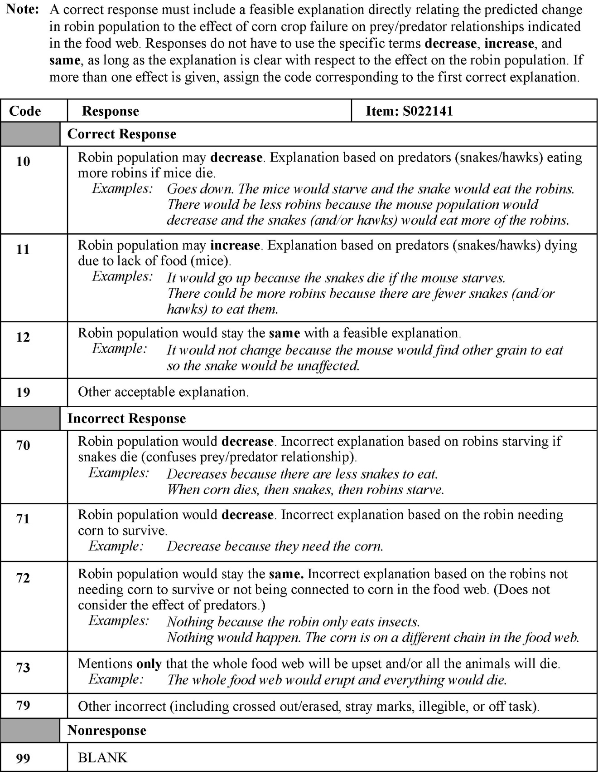

Item Source: Colorado Department of Education 2002, Grade 8 (framework, p. 68).

The graph below shows the distance traveled over time by a student walking down a hall. Use the information shown on the graph to solve questions 7 and 8.

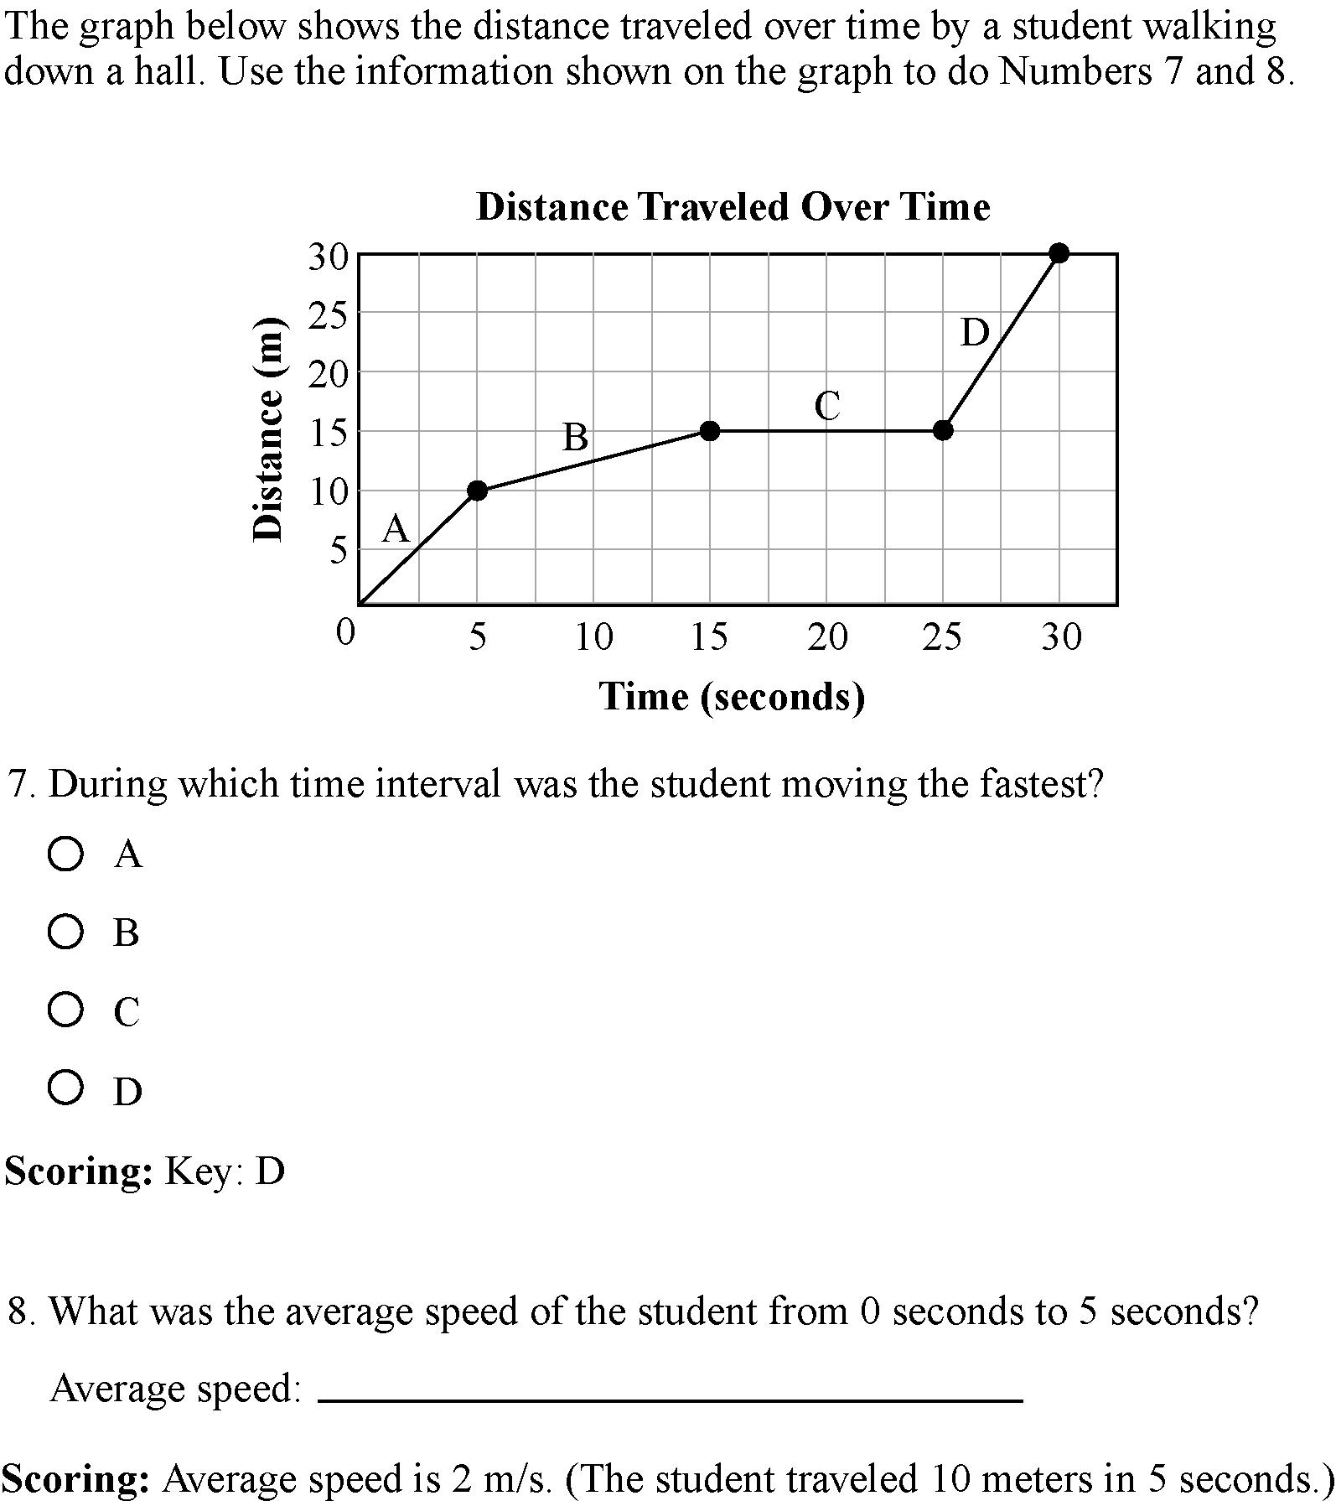

- During which time interval was the student moving the fastest?
Key: D

- What was the average speed of the student from 0 seconds to 5 seconds?

Average speed: __________________________________

Scoring: Average speed is 2 m/s. (The student traveled 10 meters in 5 seconds.)

Item Source: Quellmalz et al. 2004 (framework, p. 71).

Lynx/Hare Task

This is an interactive computer task in which students are expected to conduct a scientific investigation regarding the question of whether or not lynx should be introduced into a national park in order to reduce the abiding overpopulation of hares. Students are directed to complete six modules that use different computer programs to determine the best solution for the proposed question:

- Module 1 asks the student to access, organize, analyze, and interpret data they are given about the populations of hares over the past 4 years. For this module, students can use word processor, spreadsheet, or presentation software.

- Module 2 asks the student to determine a better way to analyze and display some disorganized data that show how many lynx and hares were present each year over the past 25 years.

- Module 3 first asks the student to submit a Web search that will give insight into the relationship between the lynx and hare populations. It subsequently asks the student to critically evaluate the relevance of several supplied Web searches.

- Module 4 asks the student to collect information on specific questions regarding the lynx/hare question, to take notes on the information given on the websites, and to include citations for each site.

- Module 5 asks the student to use a modeling program to predict the results of adding more lynx to the parks through viewing population trends over several years. Students are then asked questions based on what they have observed in the modeling tool regarding increases or decreases in the hare population if lynx are added to the park or not added to the park.

- Module 6 asks the student to create a presentation with word processor or presentation software to communicate the problem, the findings, and any recommendations that resulted from the newly completed research.

For this task, students receive scores for inquiry skills and technology use, and for the appropriate use of concepts within their explanations and recommendations.

For more information, see http://ipat.sri.com/tasks/pred_prey/subtasks/taskstud.html.

Item Source: Washington Assessment of Student Learning 2004, Grade 8 (framework, p. 75).

Occasionally, a fire will destroy a forest, burning down trees and pushing wildlife out of their forest homes. However, the forest will grow back. Eventually, through the process of forest succession as shown below, short grasses and flowers begin to grow and animals make new homes.
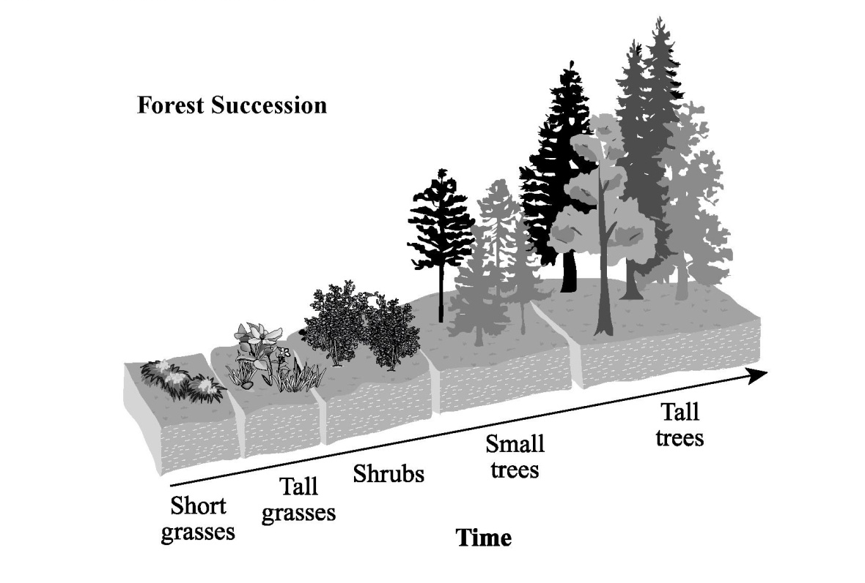

Over time, shrubs and trees begin to grow. The forest returns to a lush habitat for the wildlife listed in the chart below.

Forest Wildlife

Ground dwelling | Worms, beetles
Reptiles and amphibians | American toads, wood frogs, snakes, Eastern box turtles
Small animals | Squirrels, chipmunks
Medium to large animals | Opossums, raccoons, white-tailed deer, black bears
Airborne | Butterflies, moths, bees, wild turkeys, red-tailed hawks, bald eagles

A power company owns part of a forest that was destroyed by a fire. The forest could take decades to rebuild on its own. The company’s department of environmental studies suggests planting new trees to help the forest rebuild.

Using the information in the scenario:
- Explain how planting trees could benefit the natural ecosystem.
- Explain how planting trees could harm the natural ecosystem.

Scoring Rubric

2-point response: The response demonstrates that the student can analyze how human societies’ use of natural resources affects the quality of life and the health of ecosystems.

The student explains one reasonable way in which planting the trees could benefit the natural ecosystem.
AND
The student explains one reasonable way in which planting the trees could harm the natural ecosystem.

Example responses:

Benefits of planting the trees include but are not limited to:
- providing a habitat for animals;
- providing a canopy, which would help prevent soil erosion;
- creating root systems, which would anchor soil in place; and
- creating shade, which would help maintain sunlight levels and inhibit the introduction of nonnative plant species.

Harms of planting the trees include but are not limited to:
- disrupting the natural flow of animals reentering the forest;
- inhibiting the growth of other plants;
- decreasing the diversity of tree species growing in the forest; and
- introducing foreign species into an area, which may affect native species of plants and animals.

1-point response: The response demonstrates that the student can partially analyze how human societies’ use of natural resources affects the quality of life and health of ecosystems.

The student explains one reasonable way in which planting trees could benefit the environment.
OR
The student explains one reasonable way in which planting trees could harm the environment.

0-point response: The response demonstrates that the student can perform little or no analysis of how human societies’ use of natural resources affects the quality of life and the health of ecosystems.

Note: Benefits/harms to the natural ecosystem that only relate to humans will not be credited score points.

Annotated example of a 2-point response:

Explanation of how planting trees could benefit the natural ecosystem:
The ecosystem will rebuild more quickly, and that would give the
animals a new habitat more quickly.
Explanation of how planting trees could harm the natural ecosystem:
It could disrupt the natural order of the ecosystem. If some
smaller plants don’t get a chance to grow first, the trees might
push them out.

Annotation:

The response demonstrates that the student can analyze how human societies’ use of natural resources affects the quality of life and health of ecosystems.

The student explains one reasonable way in which planting the trees could benefit the natural ecosystem, “The ecosystem will rebuild more quickly, and that would give the animals a new habitat more quickly.” (1 point) The student explains one reasonable way in which planting the trees could harm the natural ecosystem, “If some smaller plants don’t get a chance to grow first, the trees might push them out.” (1 point)

Annotated example of a 1-point response:

Explanation of how planting trees could benefit the natural ecosystem:
More plants and trees would mean giving off more oxygen, more shade, and
more food for forest animals.
Explanation of how planting trees could harm the natural ecosystem:
There could be a very big storm and trees could fall on houses.

Annotation:

The response demonstrates that the student can partially analyze how human societies’ use of natural resources affects the quality of life and the health of ecosystems.

The student explains one reasonable way in which planting the trees could benefit the natural ecosystem: “More food for forest animals.” (1 point) The student explains one way in which planting the trees could harm the human structure: “Trees falling on houses” but not the natural ecosystem. (0 points)

Annotated example of a 0-point response:

Explanation of how planting trees could benefit the natural ecosystem:
have more trees
Explanation of how planting trees could harm the natural ecosystem:
half the plants will die

Annotation:

The response demonstrates that the student can perform little to no analysis of how human societies’ use of natural resources affects the quality of life and the health of ecosystems.

The student states one factor, “have more trees,” but does not explain one reasonable way in which planting the trees could benefit the natural ecosystem. (0 points)

The student states a possible harm, “half the plants will die,” but does not explain how planting the trees could cause this harm to the natural ecosystem. (0 points)

Item Source: NAEP 1996, Grade 8 (framework, p. 83).

A space station is to be located between Earth and the Moon at the place where Earth’s gravitational pull is equal to the Moon’s gravitational pull. On the diagram below, circle the letter indicating the approximate location of the space station.

Explain your answer.

Scoring Rationale: Student demonstrates the ability to explain the role of gravity in a manmade satellite and relates the force of gravity to the mass (size) of the object pulling it.

3 = Complete - Student circles point C and gives a correct explanation that gravitational pull depends on mass and distance; thus, the station must be closer to the Moon because the Moon’s mass is less than that of Earth.
2 = Partial - Student circles point C and explains that the Moon has less gravity than Earth but does not link it to mass.
1 = Unsatisfactory/Incorrect - Student circles A, B, or C and gives an incorrect explanation or no explanation.

Sample Student Responses

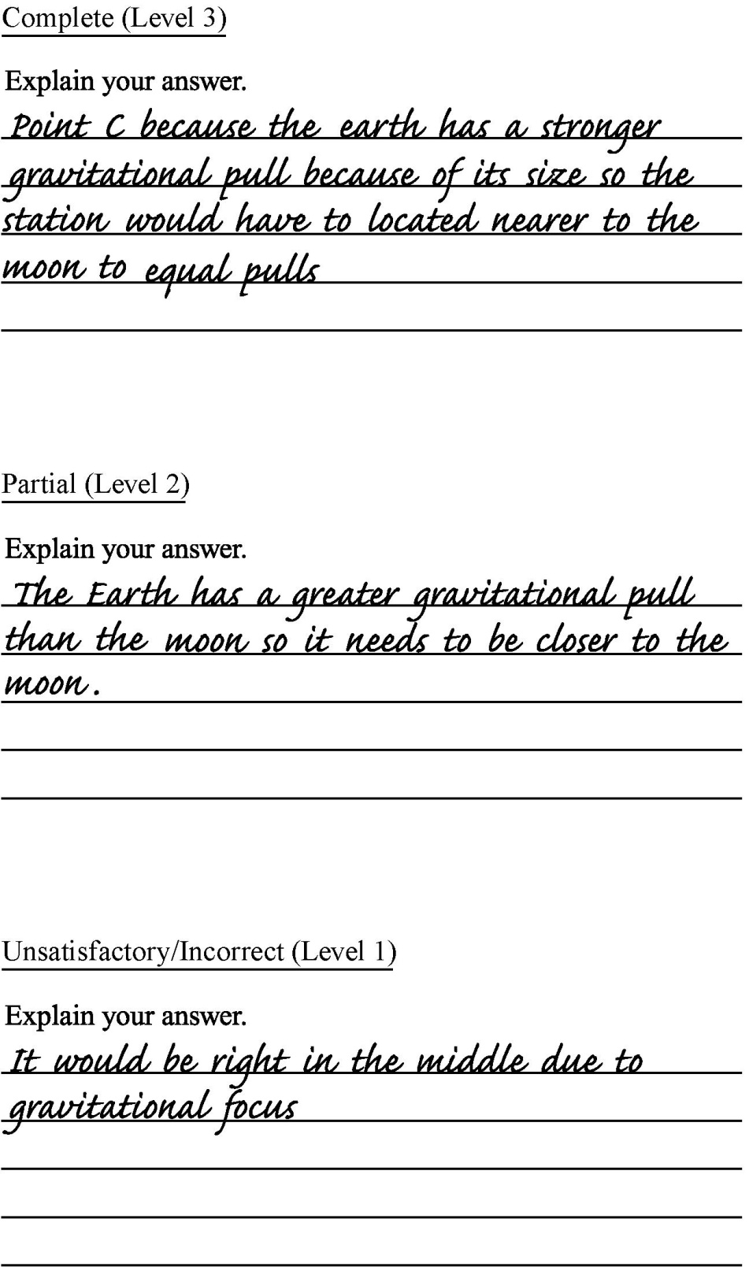

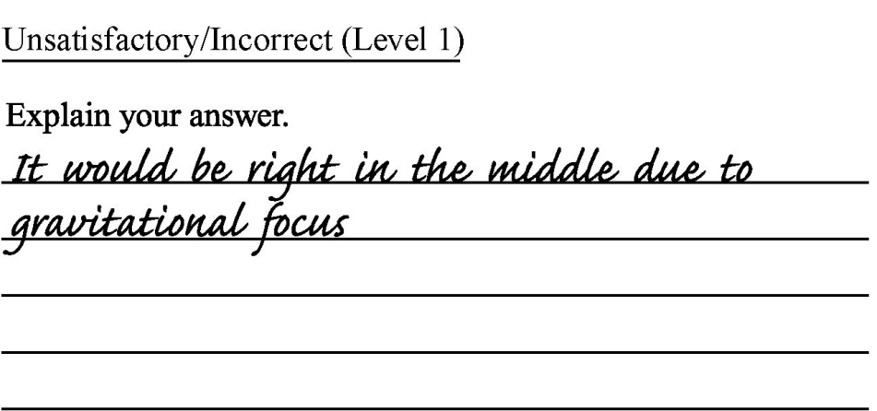
Item Source: TIMSS 2003, Grade 4 (framework, p. 96).

On a hot, humid day the air contains a lot of water vapor. What happens to the water vapor in the air when the air becomes very cold?

Note: Priority should be given to code 10. If a response mentions condensation or freezing, code 10 should be the response even if other correct codes apply. Responses that mention ONLY that the water vapor becomes cold or rises without any mention of a change of state (explicitly or implicitly) are scored as incorrect (code 70 or 71).

Code |  | Response | Item: S031382
 | Correct Response
10 |  | Refers to condensation or freezing (or equivalent).  Examples: It freezes.  It condenses.  Condensation.  It condenses and turns into rain.
11 |  | Mentions cloud formation or a form of precipitation (e.g., rain, snow, fog, etc.).  Examples: The water vapor changes to rain.  It changes to snow.  Water vapor turns into clouds.  It rises into the clouds and becomes rain droplets.  It turns foggy.  It rains.
19 |  | Other correct  Examples: It falls to the ground.
 | Incorrect Response
70 |  | Mentions only that the water becomes cold. [No mention of a change of state or precipitation.]  Examples: The water vapor becomes cold.  Its temperature drops.
71 |  | Mentions only that water vapor rises (or similar). [No mention of condensation or precipitation.]  Example: The water vapor will rise on a hot day.
79 |  | Other incorrect (including crossed out/erased, stray marks, illegible, or off task).  Example: It disappears.
 | Non-response
99 |  | Blank

Item Source: New Standards Spring Field Test 1999 for High School (framework, p. 96).

The biosphere (living organisms), lithosphere (rocks and soils of Earth’s crust), and atmosphere are all involved in the cycling of carbon atoms. Describe the role each plays in the carbon cycle.

Scoring guide:

Score Point | Description
4 | The response describes the cycling of carbon among all three reservoirs. The response is complete and detailed, showing evidence of logical reasoning. There is no evidence of misconceptions.
3 | The response describes the cycling of carbon between two of the reservoirs. The response may contain omissions or minor errors.
2 | The response describes the presence of carbon compounds in two or more reservoirs but may not link the reservoirs. The response may contain errors or misconceptions.
1 | The response is largely incomplete, lacks detail, and contains errors of fact and reasoning.
0 | The response may contain words from the question but does not add any information that might answer the question.
Off topic | Off-topic response.
Blank | No marks were made in the student response section.

Background information for appropriate response:

Carbon forms a variety of compounds. Carbon monoxide (CO) and carbon dioxide (CO₂) are carbon compounds that exist as gases in the atmosphere. Organic carbon compounds come in a wide variety of forms in living organisms: sugars, carbohydrates, cellulose, starches, collagen, chitin, amino acids, proteins, lipids, and nucleic acids. These organic compounds are also to be found in soil due to decaying and decomposition. The carbonate ion (CO₂⁻²) combines with different positive ions to form carbonate compounds found in rocks and soil.

Producers (green plants) take carbon dioxide from the air and convert it to sugar, using solar energy (photosynthesis). Additional nutrients (including carbonate ions from the soil) are taken into the plant via its root system. These nutrients are rearranged and turned into the wide array of carbon compounds listed above, along with the sugar compounds formed via photosynthesis. As consumers eat producers, the carbon compounds are broken down and rearranged into carbon compounds used by the consumer organism.

When any living organism dies, the carbon compounds are broken down and returned to the soil by decomposer organisms. Huge sediment layers of dead marine organisms, which once had chitin cell walls or shells, compress under the weight of continuing sediments and the ocean. Uplifting of these layers forms sedimentary cliffs and rocks. Weathering and erosion continue to change the carbon compounds into forms that will again be incorporated into living organisms.

Producer, consumer, and decomposer organisms harness the chemical bond energy stored in food via cellular respiration. Cellular respiration releases carbon dioxide back into the atmosphere.

The score is based on evidence of: geochemical cycling of carbon.

Item Source: Shavelson, Baxter, and Pine 1991 (framework, pp. 102, 104).

Electric Mysteries

The following is a brief description of two warm-up tasks:

1. Students are asked to connect one battery, one bulb, and wires so the bulb lights. They are then asked to draw a picture of this simple circuit.
2. Given mystery box “?,” students are asked to identify whether it contains a battery or a wire. They are told they can determine the contents of the mystery box by connecting it in a circuit with a bulb.

The following is an excerpt from the main task instructions given to students:

Find out what is in the six mystery boxes A, B, C, D, E, and F. They have five different things inside, shown below. Two of the boxes will have the same thing. All of the others will have something different inside.

[The five options—two batteries, a wire, a bulb, a battery and a bulb, nothing at all—are presented in words and drawings. Drawings are not provided here.]

For each box, connect it in a circuit to help you figure out what is inside. You can use your bulbs, batteries, and wires in any way you like.

When you find out what is in a box, fill in the spaces on the following pages.

The following is an example of the student response format:

Box A: Has ________________________________________________________ inside.

Draw a picture of the circuit that told you what was inside Box A:
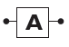

The following is a brief description of the scoring system:

For each of the six boxes (A–F), students’ responses are scored on two components: (1) identification of the contents of the box, and (2) the circuit used to make the conclusion. For each box, if both components are correct, the student receives 1 point; if one or both components are incorrect, the student receives 0 points. Total maximum score is 6 points.

Item Source: Persky et al. 2005 (framework, p. 103).

TRE Web Search Task

In this task, students are asked to use a search engine to determine why scientists use large helium gas balloons to explore outer space and the atmosphere instead of using satellites, rockets, or other such tools. One open-ended question and several multiple-choice questions are presented to students. Students are scored on how well they performed the search, the quality of the bookmarked pages, and how well the questions were answered.

A complex scoring framework is used to assess students’ proficiency on the task. A “student model” is created that describes the “theory” of how different skills are linked together. For this task, there are five component skills: problem solving in technology-rich environments, computer skill, scientific inquiry skill, exploration, and synthesis. An “evidence model” is created that describes how the students’ responses are connected to each of these skills. Once students begin the task, every action is recorded and connected to one or more skills in the student model. Then, a three-step process is used to evaluate this record. The first step is feature extraction, which shows what action the student took, when the action was taken, and any value that was associated with that action. The second step is feature evaluation, which gives the scores for the actions taken based on developed rules that show the best way to complete the task. The third step is evidence accumulation, which systematically combines responses into summary scores that detail the inferences that can be made from the students’ responses.

This task incorporates a multifaceted evaluation process that can uncover the many skills involved in a single task or module. Thus, this module can provide a more comprehensive evaluation of students’ skills and aptitudes than traditional test questions.

Item Source: Quellmalz et al. 2004 (framework, p. 105).

Solar Power Task

This is an interactive computer task in which students act as energy consultants to identify which two states will generate the most amount of electricity from photovoltaic cells. There are four modules in which students use a series of map visualizations and other data to reach and to present their final conclusions. Ultimately, students are asked to create a presentation to one state, recommending that the state apply for federal funds marked for solar energy use.

Module 1 asks the student to review and apply background information on the conditions that both optimize and reduce solar energy production. They are also asked to conduct simple analysis using the ArcView map visualization program.

Module 2 asks the student to explore several datasets to identify states with high incoming solar radiation and to manipulate the ArcView program and its map calculator tool. The student uses the ArcView program to generate visualizations and to calculate which states will generate the best monthly and annual electricity yields from solar panels.

Module 3 asks the student to determine what other data may be necessary to create the most compelling recommendation to the states.

Module 4 asks the student to create a presentation to one of the two states determined to have the highest capacity for solar energy production. The student uses the newly gathered data to support the recommendation to the state.

Both generic and item-specific rubrics are used for scoring; they include scores for content (math and science), use of problem-solving or inquiry strategies (planning and thorough communication), and use of technological tools.

For more information, see http://ipat.sri.com/tasks/solarpower/subtasks/solar_tasks.html.

Item Source: Adapted from Herl et al. 1999 (framework, p. 106).

Concept-Mapping Task

In this task, students use a custom software program to create a concept, or knowledge, map. Students are given 18 environmental science terms (atmosphere, bacteria, carbon dioxide, climate, consumer, decomposition, evaporation, food chain, greenhouse gases, nutrients, oceans, oxygen, photosynthesis, producer, respiration, sunlight, waste, and water cycle) and 7 link labels (causes, influences, part of, produces, requires, used for, and uses). Students can then drag and drop these concepts onto the grid space of the mapping program and add, erase, and link the items in their newly constructed maps. The concept maps are scored based on semantic content, organizational structure, number of terms used, and number of links made.

Additionally, students explore a simulated World Wide Web space, which allows them to search for relevant environmental science information to improve their concept maps. Students can bookmark Web pages they believe are helpful in constructing their concept maps. This portion of the task is scored based on relevant information found, the hypertext links that were selected (browsing), keyword searching, and the accessing of three or more highly relevant Web pages for a single concept (focused browsing).

While performing the concept-mapping task, students are able to access real-time feedback, which compares students’ maps to experts’ maps and gives corresponding feedback about which items are correct and which need improvement. A score is also assigned to how often a student accessed feedback, a measure of monitoring one’s learning.

This computer-based assessment provides a detailed view into both the student’s ultimate performance and the steps of the thought processes that were employed to generate the ultimate product or answer (in this case, the concept map).

Appendix D

Group 2 Small-Scale Special Studies

Knowing What Students Know About Technological Design
Knowledge about technology and the technological design process are prominent in both the National Standards and Benchmarks. The National Standards state, “Although these are science education standards, the relationship between science and technology is so close that any presentation of science without developing an understanding of technology would portray an inaccurate picture of science” (NRC 1996, p. 190). Despite taking some time for schools to include technology in the curriculum for all students, there is growing recognition that technology should be an important component. An increasing number of states include technology in their standards—30 states in 2001 and 38 states by 2004 (Meade and Dugger 2004). Consequently, NAEP is including the process of technological design as parallel to, but with less emphasis than, the process of scientific inquiry.

Because relatively few questions on NAEP will probe the practice of Using Technological Design, this study proposes the development of an additional set of questions to probe students’ understanding of this practice in-depth.

Specifically, this study would address the following research question:
What do students know about technological design in the contexts of agricultural technologies, energy generation technologies, and technologies related to Earth materials and resources?

This study was not conducted because the Governing Board added a new assessment of Technology and Engineering Literacy in 2014 that covers this content.

Extended Investigations by Students
National and local science education standards emphasize scientific inquiry. In many states, this goal requires student engagement in projects that can take days, weeks, and even months as they undertake genuine investigations. Important outcomes of these projects include a range of skills that are a crucial feature of high-quality science education but that cannot be assessed adequately in a 50-minute assessment (NRC 2005). They include, for example, gauging the quality of students’ (a) reasoning while framing their research questions; (b) planning for data collection and the execution of that plan; (c) ability to meet unpredictable challenges that arise during any actual, ongoing scientific investigation; (d) persistence in seeking productive explanations for their observations and revising plans for the investigation; (e) lines of argument in deciding how to alter their experimental approach in the light of new evidence; (f) engagement with fellow students and/or the teacher in interpreting an observation or result and deciding what to do about it; and (g) deliberations when settling on the defensible conclusions that might be drawn from their work.

In many countries, teachers are expected to assess students’ work during extended projects. Often their judgments of student achievement are made during ongoing classroom activities that are part of the regular curriculum. The teachers’ assessments are incorporated into an overall score that also includes results of the short, timed tests. In some countries, a defined percentage of the total score is based on teachers’ judgments about achievement associated with investigative projects.

This study, then, might include both a national sample of students and an exploration of what other countries do under similar circumstances. Specifically, the study would address the following research questions:
- What methods can be or have been developed to assess student achievement with respect to the ability to conduct extended scientific investigations?
- To what extent are shorter investigations interchangeable for the extended investigation and to what extent are they not interchangeable?

This study was not conducted because of lack of available funding.

Bibliography

Abedi, J. (2003). Impact of Student Language Background on Content-Based Performance: Analyses of Extant Data (CSE Technical Report 603). Los Angeles, CA: University of California, National Center for Research on Evaluation, Standards, and Student Testing; Center for the Study of Evaluation; Graduate School of Education and Information Studies.
American Association for the Advancement of Science (1993). Benchmarks for Science Literacy. New York: Oxford University Press.
American Association for the Advancement of Science (1994). Science for All Americans (revised edition). New York: Oxford University Press.
American Association for the Advancement of Science (1997). “Comparisons of Benchmarks to National Standards.” In Resources for Science Literacy:
Professional Development (CD-ROM). New York: Oxford University Press.
American Educational Research Association, American Psychological Association, and National Council on Measurement in Education (1999). Standards for Educational and Psychological Testing. Washington, DC: American Educational Research Association.
Bar, V., and B. Zinn (1998). “Similar Frameworks of Action-at-a-Distance in Early Scientists’ and Pupils’ Ideas.” Science and Education, 7(5).
Bar, V., B. Zinn, R. Goldmuntz, and C. Sneider (1994). “Children’s Concepts About Weight and Free Fall.” Science Education, 78(2):149–169.
Bar, V., C. Sneider, and N. Martimbeau (1997). “What Research Says: Is There Gravity in Space?” Science and Children, 38–43.
Barnett, M., and J. Morran (2002). “Addressing Children’s Alternative Frameworks of the Moon’s Phases and Eclipses.” International Journal of Science Education, 24:859–879.
Catley, K., R. Lehrer, and B. Reiser (2005). Tracing a prospective learning progression for developing understanding of evolution. Paper prepared for the National Research Council, Center for Education, Board on Testing and Assessment, Committee on Test Design for K–12 Science Achievement, Washington, DC.
Champagne, A., K. Bergin, R. Bybee, R. Duschl, and J. Gallagher (2004). NAEP 2009 Science Framework Development: Issues and Recommendations. Paper prepared for the National Assessment Governing Board, Washington, DC.
Chandler, D. (1991). “Weightlessness and Microgravity.” The Physics Teacher, 29(5):312.
Council of Chief State School Officers (2005). A summary of national feedback provided on preliminary drafts gathered from surveys and regional and national feedback meetings. Paper prepared for the National Assessment Governing Board, Washington, DC.
Dalton, B., C.C. Morocco, T. Tivnan, and P. Rawson (1994). “Effect of Format on Learning Disabled and Non-Learning Disabled Students’ Performance on a Hands-On Science Assessment.” International Journal of Educational Research, 21(3):299–316.
De Boeck, P., and M. Wilson, eds. (2004). Explanatory Item Response Models: A Generalized Linear and Nonlinear Approach. New York: Springer-Verlag.
Delgado, J. (2005). Vocabulary assessment: Issues and ideas from science education. Paper presented at the annual meeting of the American Educational Research Association, Montreal, Canada.
Ericsson, K.A. (2002). “Attaining Excellence Through Deliberate Practice: Insights From the Study of Expert Performance.” In M. Ferrari, ed., The Pursuit of Excellence in Education, pp. 21–55. Hillsdale, NJ: Erlbaum.
Finegold, M., and P. Gorsky (1991). “Students’ Concepts of Force as Applied to Related Physical Systems: A Search for Consistency.” International Journal of Science Education, 13(1):97–113.
Gunstone, R., and M. Watts (1985). “Force and Motion.” In R. Driver, E. Guesne, and A. Tiberghien, eds., Children’s Ideas in Science. Philadelphia: Open University Press.
Herl, H.E., H.F. O’Neil, G.K.W.K. Chung, and J. Schacter (1999). “Reliability and Validity of a Computer-Based Knowledge Mapping System to Measure Content Understanding.” Computers in Human Behavior, 15:315–334.
International Technology Education Association (2000). Standards for Technological Literacy: Content for the Study of Technology. Reston, VA.
Kavanagh, C., L. Agan, and C. Sneider (2005). “Learning About Phases of the Moon and Eclipses: A Guide for Teachers and Curriculum Developers.” Astronomy Education Review, 4(1). Retrieved from http://aer.noao.edu/.
Kendall, J.S., and R.J. Marzano (2004). Content Knowledge: A Compendium of Standards and Benchmarks for K–12 Education (4th ed.). Retrieved December 20, 2004, from http://www.mcrel.org/standards-benchmarks/.
Leighton, J.P. (2004). “Avoiding Misconception, Misuse, and Missed Opportunities: The Collection of Verbal Reports in Educational Achievement Testing.” Educational Measurement: Issues and Practice, 23(4):6–15.
Li, M., and R.J. Shavelson (2001). Validating the links between knowledge and test items from a protocol analysis. Paper presented at the annual meeting of the American Educational Research Association, Seattle, WA.
Masters, G.N., R.A. Adams, and M. Wilson (1990). “Charting of Student Progress.” In T. Husen and T.N. Postlethwaite, eds., International Encyclopedia of Education: Research and Studies (supplementary vol. 2, pp. 628–634). Oxford, England: Pergamon Press.
Meade, S.D., and W.E. Dugger, Jr. (2004). “Reporting on the Status of Technology Education in the U.S.” The Technology Teacher, October:29–35.
Minstrell, J. (1998). Student thinking and related instruction: Creating a facet-based learning environment. Paper presented at the meeting of the Committee on Foundations of Assessment, Woods Hole, MA.
Morrison, R.C. (1999). “Weight and Gravity—The Need for Consistent Definitions.” The Physics Teacher, 37(1):51.
National Center for Education Statistics (2005a). “NAEP Inclusion Policy.” The Nation’s Report Card. Retrieved September 7, 2005, from http://nces.ed.gov/nationsreportcard/about/inclusion.asp.
National Center for Education Statistics (2005b). “What Are the Differences Between Long-Term Trend NAEP and Main NAEP?” The Nation’s Report Card. Retrieved November 4, 2005, from http://nces.ed.gov/nationsreportcard/about/ltt_main_diff.asp.
National Research Council (1996). National Science Education Standards. Coordinating Council for Education, National Committee on Science Education Standards and Assessment. Washington, DC: National Academy Press.
National Research Council (1999a). Evaluation of the Voluntary National Tests: Phase 1. L.L. Wise, R.M. Hauser, K.J. Mitchell, and M.J. Feuer, eds. Commission on Behavioral and Social Sciences and Education. Washington, DC: National Academy Press.
National Research Council (1999b). High Stakes: Testing for Tracking, Promotion, and Graduation. J.P. Heubert and R.M. Hauser, eds. Commission on Behavioral and Social Sciences and Education, Committee on Appropriate Test Use. Washington, DC: National Academy Press.
National Research Council. (1999c). How People Learn: Brain, Mind, Experience, and School. J.D. Bransford, A.L. Brown, and R.R. Cocking, eds. Commission on Behavioral and Social Sciences and Education, Committee on Developments in the Science of Learning. Washington, DC: National Academy Press.
National Research Council (2001). Knowing What Students Know: The Science and Design of Educational Assessment. J. Pellegrino, N. Chudowsky, and R. Glaser, eds. Division of Behavioral and Social Sciences and Education, Center for Education, Board on Testing and Assessment, Committee on the Foundations of Assessment. Washington, DC: National Academy Press.
National Research Council (2005). America’s Lab Report: Investigations in High School Science. S.R. Singer, M.L. Hilton, and H.A. Schweingruber, eds. Division of Behavioral and Social Sciences and Education, Center for Education, Committee on High School Science Laboratories: Role and Vision Board on Science Education. Washington, DC: National Academy Press.
Partnership for 21st Century Skills (2004). ICT literacy map for science. Retrieved from http://www.21stcenturyskills.org/images/stories/matrices/ictmap_science.pdf.
Perie, M., R. Moran, and A.D. Lutkus (2005). NAEP 2004 Trends in Academic Progress: Three Decades of Student Performance in Reading and Mathematics (NCES 2005–464). U.S. Department of Education, Institute of Education Sciences, National Center for Education Statistics. Washington, DC: Government Printing Office.
Persky, H., R.E. Bennett, A.R. Weiss, and F. Jenkins (2005). Problem Solving in Technology-Rich Environments: A Report From the NAEP Technology-Based Assessment Project (NCES 2007-466). U.S. Department of Education, Institute of Education Sciences, National Center for Education Statistics. Washington, DC: Government Printing Office.
Pine, J., G. Baxter, and R. Shavelson (1993). “Assessments for Hands-On Elementary Science Curricula.” MSTA Journal, 39(2):3, 5–19.
Quellmalz, E.S., G.D. Haertel, A. DeBarger, and P. Kreikemeier (2005). A Study of Evidence of the Validities of Assessments of Science Inquiry in the National Assessment of Educational Progress (NAEP), Trends in Mathematics and Science Survey (TIMSS), and the New Standards Science Reference Exam (NSSRE) in Science (Validities Technical Report #1). Menlo Park, CA: SRI International.
Quellmalz, E.S., M. Griffin, K. Hurst, P. Kreikemeier, A. Rosenquist, and D. Zalles (2004). Integrated performance assessments with technology (IPAT): Design model and prototypes. Paper presented at the annual meeting of the American Educational Research Association, San Diego, CA. Retrieved from http://ipat.sri.com.
Resnick, L.B., and D.P. Resnick (1992). ”Assessing the Thinking Curriculum: New Tools for Educational Reform.” In B.R. Gifford and M.C. O’Connor, eds., Changing Assessments, pp. 37–76. Boston: Kluwer.
Rosenquist, A., R.J. Shavelson, and M.A. Ruiz-Primo (2000). On the “Exchangeability” of Hands-On and Computer Simulation Science Performance Assessments. Los Angeles: University of California, National Center for Research on Evaluation, Standards, and Student Testing; Center for the Study of Evaluation; Graduate School of Education and Information Studies.
Ruiz-Primo, M.A., and R.J. Shavelson (1996a). “Problems and Issues in the Use of Concept Maps in Science Assessment.” Journal of Research in Science Teaching, 33(6):569–600.
Ruiz-Primo, M.A., and R.J. Shavelson (1996b). “Rhetoric and Reality in Science Performance Assessments: An Update.” Journal of Research in Science Teaching, 33(10):1045–1063.
Ruiz-Primo, M.A., R.J. Shavelson, M. Li, and S.E. Schultz (2001). “On the Validity of Cognitive Interpretations of Scores From Alternative Concept-Mapping Techniques.” Educational Assessment, 7(2):99–141.
Ruiz-Primo, M.A., S.E. Schultz, M. Li, and R.J. Shavelson (2001). “Comparison of the Reliability and Validity of Scores From Two Concept-Mapping Techniques.” Journal of Research in Science Teaching, 38(2):260–278.
Sadler, P.M. (1998). “Psychometric Models of Student Conceptions in Science: Reconciling Qualitative Studies and Distractor-Driven Assessment Instruments.” Journal of Research in Science Teaching, 35(3):265–296.
Scalise, K. (2004). BEAR CAT: Toward a theoretical basis for dynamically driven content in computer-mediated environments. Unpublished doctoral dissertation. Berkeley, CA: University of California.
Schatz, D., and D. Cooper (1994). Astro Adventures. Seattle, WA: Pacific Science Center.
Sequeira, M., and L. Leite (1991). “Alternative Conceptions and History of Science in Physics Teacher Education.” Science Education, 75(1):45–56.
Shavelson, R.J. (2006). “On the Integration of Formative Assessment in Teaching and Learning: Implications for New Pathways in Teacher Education.” In F. Oser, F. Achtenhagen, and U. Renold, eds., Competence-Oriented Teacher Training: Old Research Demands and New Pathways. Utrecht, The Netherlands: Sense Publishers.
Shavelson, R.J., G.P. Baxter, and J. Pine (1991). “Performance Assessment in Science.” Applied Measurement in Education (special issue), 4(4):347–362.
Shavelson, R.J., M.A. Ruiz-Primo, and E.W. Wiley (2005). “Windows Into the Mind.” Higher Education, 49:413–430.
Smith, C., M. Wiser, C.W. Anderson, J. Krajcik, and B. Coppola (2004). Implications of research on children’s learning for assessment: Matter and atomic molecular theory. Paper prepared for the National Research Council, Center for Education, Board on Testing and Assessment, Committee on Test Design for K–12 Science Achievement, Washington, DC.
Thompson, S.J., C.J. Johnstone, and M.L. Thurlow (2002). Universal Design Applied to Large Scale Assessments (Synthesis Report 44). Minneapolis, MN: University of Minnesota, National Center on Educational Outcomes. Retrieved September 13, 2005, from http://education.umn.edu/NCEO/OnlinePubs/Synthesis44.html.
White, R.T., and R. Gunstone (1992). Probing Understanding. New York: Falmer Press.
Wilson, E.B. (1928). The Cell in Development and Heredity. New York: Macmillan.

* CCSSO’s Rolf Blank co-chaired the last meeting of the steering committee.
** Larry Suter substituted for Finbarr Sloane at the third steering committee meeting.
“Science principles” is used throughout this framework to denote not only the principles but also the facts, concepts, theories, and laws of science.
Statements are reprinted from National Science Education Standards (NRC 1996) with permission from the National Academy of Sciences, courtesy of the National Academies Press, Washington, D.C. Statements are reprinted from Benchmarks for Science Literacy (AAAS 1993) with permission from Project 2061, on behalf of the American Association for the Advancement of Science, Washington, D.C.
The importance of developing an understanding early and making connections among the Physical, Life, and Earth and Space Sciences has led to increased attention on Physical Science in elementary school and prompted consideration of rearranging the usual Earth–life–chemistry–physics curriculum sequence.
There are different approaches to helping students understand the concept of energy and related observable phenomena, such as light, heat, and sound. These differences are reflected in the framework’s reference documents and have therefore influenced the framing of the Physical Science, Life Science, and Earth and Space Sciences content statements.
The term “heat” in Physical Science is used to stand for thermal energy in grade 4; this usage is denoted as “heat (thermal energy).” “Thermal energy” is used in grades 8 and 12.
“Earth” is capitalized, rather than referred to as “the earth,” in order to recognize it as one of the planets in the solar system.
Because natural phenomena are understood and described based on collected observations, the terms “phenomena” and “observations” are intricately intertwined. For ease of communication, the framework uses the term “observations” to represent both specific observations of a natural phenomenon and the phenomenon itself.
In addition, 12th graders at the Advanced level are expected to be able to identify a scientific question for investigation. See appendix B for achievement level descriptions.
This practice is discussed in some detail because it is new in NAEP Science Assessments.
More than one cognitive demand can be associated with the more complex science practices. These associations may shift according to the knowledge that students at different grade levels bring to an assessment task.
Currently, a number of states are using computerized testing, consisting largely of translating traditional paper-and-pencil items into computer-based delivery systems. The study suggested here, as well as the first study on p. 114, makes more extensive use of the capabilities inherent in computer-based assessments.

