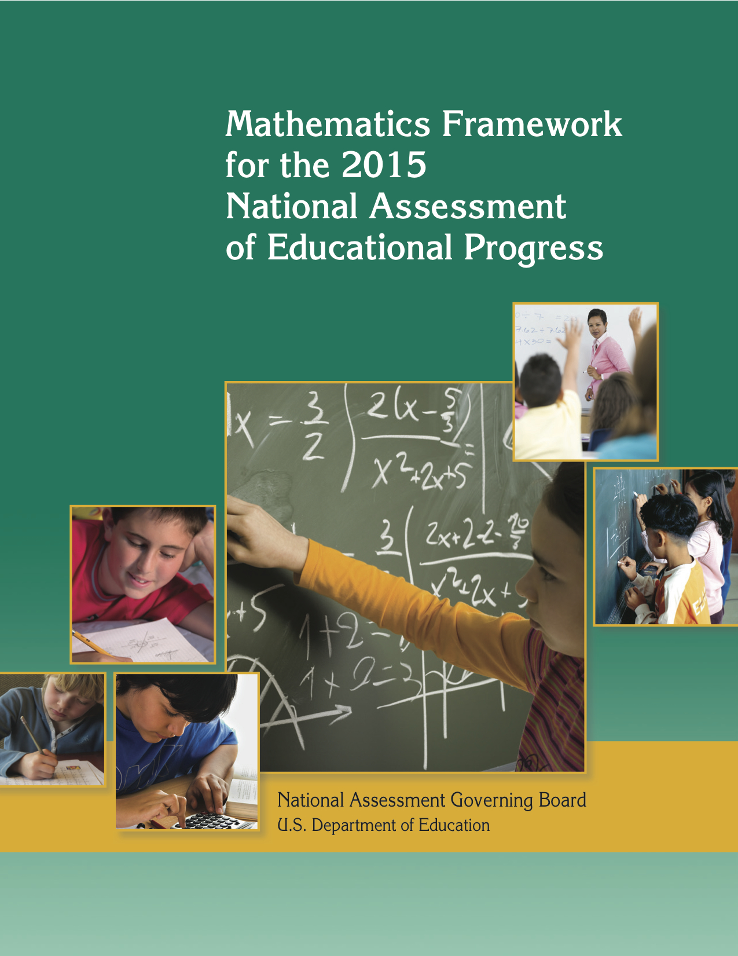

What Is NAEP?
The National Assessment of Educational Progress (NAEP) is a continuing and nationally representative measure of trends in academic achievement of U.S. elementary and secondary students in various subjects. For nearly four
decades, NAEP assessments have been conducted periodically in reading, mathematics, science, writing, U.S.
history, civics, geography, and other subjects. By collecting and reporting information on student performance at
the national, state, and local levels, NAEP is an integral part of our nation's evaluation of the condition and progress of education.

The 2014–2015 National Assessment Governing Board

The National Assessment Governing Board was created by Congress to formulate policy for NAEP. Among the Governing Board’s responsibilities are developing objectives and test specifications and designing the assessment methodology for NAEP.

Members

Terry Mazany, Chair
President and CEO
The Chicago Community Trust
Chicago, Illinois

Susan Pimentel, Vice Chair
Education Consultant
Hanover, New Hampshire

Andrés Alonso
Professor of Practice
Harvard Graduate School of Education
Cambridge, Massachusetts

Honorable Mitchell D. Chester
Commissioner of Elementary and Secondary Education
Massachusetts Department of Elementary and Secondary Education
Malden, Massachusetts

Lucille E. Davy
President and CEO
Transformative Education Solutions, LLC
Pennington, New Jersey

Louis M. Fabrizio
Data, Research and Federal Policy Director
North Carolina Department of Public Instruction
Raleigh, North Carolina

Frank K. Fernandes
Principal
Kaimuki Middle School
Honolulu, Hawaii

Honorable Anitere Flores
Senator
Florida Senate
Miami, Florida

Rebecca Gagnon
School Board Member
Minneapolis Public Schools
Minneapolis, Minnesota

Shannon Garrison
Fourth-Grade Teacher
Solano Avenue Elementary School
Los Angeles, California

Honorable James Geringer
Director of Policy and Public Sector Strategies
Environmental Systems Research Institute (ESRI)
Cheyenne, Wyoming

Doris R. Hicks
Principal and CEO
Dr. Martin Luther King, Jr. Charter School for Science and Technology
New Orleans, Louisiana

Andrew Dean Ho
Professor
Harvard Graduate School of Education
Cambridge, Massachusetts

Honorable Terry Holliday
Commissioner of Education
Kentucky Department of Education
Lexington, Kentucky

Tonya Matthews
President and CEO
Michigan Science Center
Detroit, Michigan

Tonya Miles
General Public Representative
Mitchellville, Maryland

Honorable Ronnie Musgrove
Founding Member
Musgrove/Smith Law
Jackson, Mississippi
Dale Nowlin
Teacher and Mathematics Department Chair
Bartholomew Consolidated School Corporation
Columbus, Indiana

Father Joseph O’Keefe, S.J.
Professor
Boston College Lynch School of Education
Chestnut Hill, Massachusetts

W. James Popham
Emeritus Professor
University of California, Los Angeles
Los Angeles, California

B. Fielding Rolston
Chairman
Tennessee State Board of Education
Kingsport, Tennessee

Cary Sneider
Associate Research Professor
Portland State University
Portland, Oregon

Honorable Leticia Van de Putte
Senator
Texas Senate
San Antonio, Texas
Chasidy White
Eighth-Grade Teacher
Brookwood Middle School
Brookwood, Alabama

Ex-officio Member
Sue Betka
Acting Director
Institute of Education Sciences
U.S. Department of Education
Washington, D.C

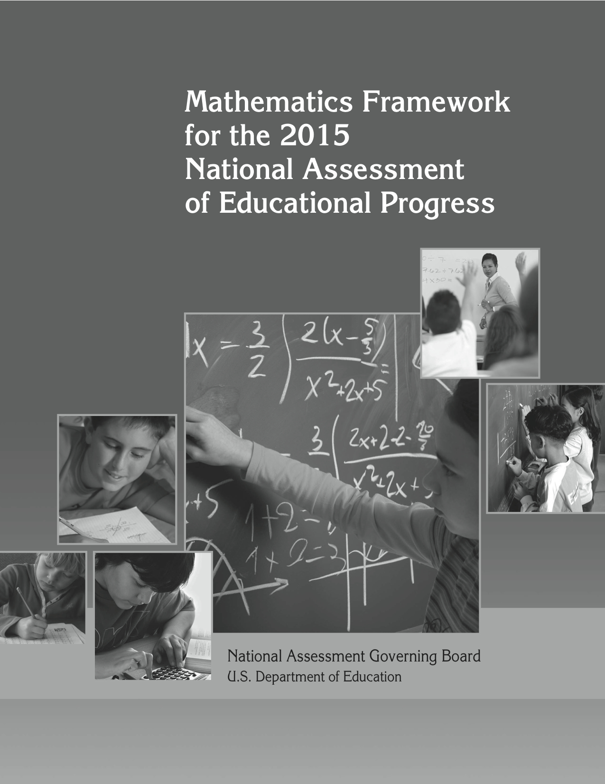

National Assessment Governing Board
Terry Mazany
Chair
Susan Pimentel
Vice Chair
Cornelia S. Orr
Executive Director
Mary Crovo
Deputy Executive Director
National Assessment of Educational Progress
Mathematics Project
Wayne Martin
Project Director
John Olson
Deputy Project Director
Linda Wilson
Consensus Coordinator
Framework Author
Developed for the National Assessment Governing Board under contract number
ED–00–CO–0115 by the Council of Chief State School Officers, with subcontracts to the Council of Basic Education and the Association of State Supervisors of Mathematics and Grade 12 preparedness objectives developed under contract with Achieve, Inc.

For further information, contact:
National Assessment Governing Board
800 N. Capitol St., NW
Suite 825
Washington, DC 20002–4233
www.nagb.org
November 2014

Table of Contents

List of Exhibits ii
Acknowledgments iii
NAEP Mathematics Project Staff and Committees v
Chapter One: Overview 1
What Is an Assessment Framework? 2
Need for a New Framework at Grade 12 2
Chapter Two: Framework for the Assessment 5
Content Areas 5
Item Distribution 6
NAEP Mathematics Objectives Organization 6
Mathematical Content Areas 7
Chapter Three: Mathematical Complexity of Items 37
Low Complexity 38
Moderate Complexity 42
High Complexity 46
Chapter Four: Item Formats 51
Multiple-Choice Items 51
Short Constructed-Response Items 52
Extended Constructed-Response Items 55
Scoring Constructed-Response Items 57
Chapter Five: Design of Test and Items 59
Balance of Content 59
Balance of Mathematical Complexity 60
Balance of Item Formats 60
Balance of Item Contexts 61
Sampling 62
Calculators 63
Manipulatives and Tools 64
Accessibility 66
Item Families 67
Bibliography 69
Appendix A: NAEP Mathematics Achievement Level Descriptions 71
NAEP Mathematics Achievement Levels—Grade 4 71
NAEP Mathematics Achievement Levels—Grade 8 72
NAEP Mathematics Achievement Levels—Grade 12 73

List of Exhibits

Exhibit 1. Comparison of 2005 and 2009–2015 mathematics frameworks 3
Exhibit 2. Percentage distribution of items by grade and content area 6
Exhibit 3. Number properties and operations 9
Exhibit 4. Measurement 14
Exhibit 5. Geometry 19
Exhibit 6. Data analysis, statistics, and probability 25
Exhibit 7. Algebra 31
Exhibit 8. Percent of testing time at each level of complexity 38
Exhibit 9. Percent of testing time by item formats 51
Exhibit 10. Percent distribution of items by grade and content area 59
Exhibit 11. Percent of testing time at each level of complexity 60
Exhibit 12. Percent of testing time by item formats 60

Acknowledgments

The following people were the primary authors of the introductions to the content areas:
- Roger Howe, Yale University (Number Properties and Operations, Geometry, and Algebra)
- Richard Scheaffer, University of Florida (Data Analysis and Probability)
- Mary Lindquist, Columbus State University (Measurement)

NAEP Mathematics Project Staff and Committees

Members of the Board’s Grade 12 Mathematics Panel

Herbert Clemens
Professor, Department of Mathematics
The Ohio State University
Columbus, Ohio

Mary Ann Huntley
Assistant Professor, Mathematics
University of Delaware
Newark, Delaware

Jeremy Kilpatrick
Regents Professor, Mathematics Education
University of Georgia
Athens, Georgia

Mary Lindquist
Fuller E. Callaway Professor, Emeritus
Columbus State University
Lewisburg, West Virginia

Mary Jo Messenger (Retired)
Chair, Department of Mathematics
River Hill High School
Clarksville, Maryland

William Schmidt
University Distinguished Professor
Department of Counseling, Educational Psychology and Special Education
Michigan State University
East Lansing, Michigan

Sharif Shakrani
Director, Education Policy Center
Michigan State University
East Lansing, Michigan

Linda Dager Wilson, Chair
Mathematics Consultant
Washington, D.C.

NAEP Grade 12 Mathematics Project Achieve NAEP Grade 12 Mathematics Panel

Sue Eddins (Retired)
Mathematics Teacher
Illinois Mathematics and Science Academy
Aurora, Illinois

William McCallum
University Distinguished Professor of Mathematics
University of Arizona
Tucson, Arizona

Fabio Milner
Professor of Mathematics
Purdue University
West Lafayette, Indiana

William Schmidt
University Distinguished Professor
Department of Counseling, Educational Psychology and Special Education
Michigan State University
East Lansing, Michigan
Lynn Steen
Professor of Mathematics
St. Olaf College
Northfield, Minnesota

Norman Webb
Senior Research Scientist
Wisconsin Center for Education Research
University of Wisconsin
Madison, Wisconsin

Reviews Received on the Draft of NAEP 12th Grade Mathematics Objectives

Achieve, Inc.
American Mathematical Society
Association of State Supervisors of Mathematics
Thomas B. Fordham Institute
State Mathematics Supervisors from various states
National Council of Teachers of Mathematics
State Testing Directors from various states

2009 NAEP Mathematics Specifications Work Group

Mary Lindquist
Fuller E. Callaway Professor Emeritus
Columbus State University
Lewisburg, West Virginia

Mary Jo Messenger (Retired)
Chair, Department of Mathematics
River Hill High School
Clarksville, Maryland

Linda Dager Wilson, Chair
Mathematics Consultant
Washington, D.C.
Phoebe Winter
Project Director
State Education Assessment Center
Council of Chief State School Officers
Richmond, Virginia

2005 NAEP Mathematics Project Steering Committee

Eileen Ahearn
Project Director
National Association of State Directors
of Special Education
Alexandria, Virginia

Charles Allan
Mathematics Education Consultant
Michigan Department of Education
Lansing, Michigan

B. Marie Byers
National School Boards Association
Hagerstown, Maryland

Randy DeHoff
Colorado State Board of Education
6th Congressional District – Littleton
Denver, Colorado

M.B. “Sonny” Donaldson
Superintendent
Aldine Independent School District
Houston, Texas

Janice Earle
Senior Program Director
National Science Foundation
Arlington, Virginia

Louis M. Fabrizio
Data, Research and Federal Policy Director
North Carolina Department of Public
Instruction
Raleigh, North Carolina
Bettye Forte
Mathematics Consultant
Arlington, Texas

Matt Gandal
Vice President
Achieve, Inc.
Washington, D.C.

Alice Gill
Associate Director, Educational Issues
American Federation of Teachers
Washington, D.C.

M. Kathleen Heid
Distinguished Professor of Education
(Mathematics Education)
The Pennsylvania State University
University Park, Pennsylvania

Audrey Jackson
Assistant Principal
Claymont Elementary School
Parkway City Schools
Fenton, Missouri

James M. Landwehr
Director, Data Analysis Research
Avaya Labs
Basking Ridge, New Jersey

Sharon Lewis
Director of Research
Council of the Great City Schools
Washington, D.C.

Dane Linn
Director, Education Division
National Governors Association
Washington, D.C.

Eddie Lucero
Principal
Griegos Elementary School
Albuquerque, New Mexico
Lee McCaskill
Principal
Brooklyn Technical High School
Brooklyn, New York

Barbara Montalto
Assistant Director of Mathematics
Texas Education Agency
Austin, Texas

Judy Rohde
Mathematics Instructor
John Glenn Middle School
Maplewood, Minnesota

Wilfried Schmid
Professor of Mathematics
Harvard University
Cambridge, Massachusetts

Mary Frances Taymans, SND
Executive Director
Secondary Schools Department
National Catholic Education Association
Washington, D.C.

Zalman Usiskin
Professor of Education
Director, University of Chicago School
Mathematics Project
Chicago, Illinois

Judy Walter
Director of Research and Development
Association for Supervision and
Curriculum Development
Alexandria, Virginia

Diana Wearne
Associate Professor
School of Education
University of Delaware
Newark, Delaware
Hung-Hsi Wu
Professor of Mathematics
University of California, Berkeley
Berkeley, California

2005 NAEP Mathematics Project Planning Committee

Dayo Akinsheye
Mathematics Resource Teacher
Seaton Elementary School
Washington, D.C.

Geri Anderson-Nielsen
Mathematics Specialist
Georgetown Day School
Washington, D.C.

Cindy Chapman
Elementary Teacher
Albuquerque Public Schools
Albuquerque, New Mexico

Herbert Clemens
Professor of Mathematics
University of Utah
Salt Lake City, Utah

Carl Cowen
Professor of Mathematics
Purdue University
West Lafayette, Indiana

Jim Ellingson
Assistant Professor
Concordia College
Moorhead, Minnesota

Joan Ferrini-Mundy
Associate Dean/Director of Science
and Mathematics
College of Natural Science
Michigan State University
East Lansing, Michigan

Kim Gattis
Education Program Consultant
Kansas Department of Education
Association of State Supervisors of
Mathematics
Topeka, Kansas

Anne Gonzales
Middle School Mathematics Teacher
South Gate Middle School
South Gate, California

Jeremy Kilpatrick
Regents Professor, Mathematics Education
University of Georgia
Athens, Georgia

Gerald Kulm
Curtis D. Robert Professor
of Mathematics Education
Texas A&M University
College Station, Texas

Mary Lindquist
Fuller E. Callaway Professor
of Mathematics Education
Columbus State University
Columbus, Georgia

Mary Jo Messenger
Chair, Department of Mathematics
River Hill High School
Clarksville, Maryland

Marjorie Petit
Senior Associate
The National Center for the Improvement of Educational Assessment
Dover, New Hampshire

Edward Silver
William A. Brownell Collegiate Professor School of Education
University of Michigan
Ann Arbor, Michigan

Debra Vitale
Mathematics Specialist
Arlington Public Schools
Fairfax, Virginia

Frank Wang
President/CEO
Saxon Publishing, Inc.
Norman, Oklahoma

Norman Webb
Senior Research Scientist
Wisconsin Center for Education Research
Madison, Wisconsin

John Wisthoff
Member, Maryland State Board of
Education
Mathematics Professor
Anne Arundel Community College
Pasadena, Maryland

2005 NAEP Mathematics Project Technical Advisory Panel

Fen Chou
Psychometrician
Louisiana Department of Education
Baton Rouge, Louisiana

Eugene Johnson
Chief Psychometrician
American Institutes for Research
Washington, D.C.

Edward Kifer
Professor and Chairperson
Department of Educational Policy
Studies and Evaluation
College of Education
University of Kentucky
Lexington, Kentucky

Ina Mullis
Co-Director
TIMSS and PIRLS International Study Center
Boston College
Chestnut Hill, Massachusetts

Barbara Plake
Director
Buros Center for Testing
University of Nebraska–Lincoln
Lincoln, Nebraska

Roger Trent
Ohio State Assessment Director
(Emeritus)
Ohio Department of Education
Columbus, Ohio

CCSSO Staff

Rolf Blank
Director of Indicators Project
State Education Assessment Center
Council of Chief State School Officers
Washington, D.C.

Wayne Martin
Director
State Education Assessment Center
Council of Chief State School Officers
Washington, D.C.

John Olson
Director of Assessment
State Education Assessment Center
Council of Chief State School Officers
Washington, D.C.

Frank Philip
Senior Project Associate
State Education Assessment Center
Council of Chief State School Officers
Washington, D.C.
Linda Dager Wilson
Consensus Coordinator Consultant
Council of Chief State School Officers
Washington, D.C.

Phoebe Winter
Project Director
State Education Assessment Center
Council of Chief State School Officers
Richmond, Virginia

Subcontractors and Consultants

Patricia Kenney
Senior Research Associate
University of Michigan
Ann Arbor, Michigan

Rebecca Kopriva
Director
Center for the Study of Assessment
Validity in Education
Department of Measurement & Statistics
University of Maryland
College Park, Maryland
Christopher Cross
Former President
Council for Basic Education
Washington, D.C.

Kim Gattis
President, Association of State
Supervisors of Mathematics
Education Program Consultant
Kansas State Department of Education
Topeka, Kansas

Linda Plattner
Director of Policy, Standards and
Instruction
Council for Basic Education
Washington, D.C.

Note: This list of project staff and committees reflects professional affiliations during the project period for framework development.

Committee Representation

Policy Organizations
Achieve, Inc.
American Association of School Administrators (AASA)
American Federation of Teachers (AFT)
American Mathematical Society (AMS)
American Statistical Association (ASA)
Association for Supervision and Curriculum Development (ASCD)
Association of State Assessment Programs (ASAP)
Association of State Supervisors of Mathematics (ASSM)
Business Roundtable/National Alliance of Business
Council of the Great City Schools
Education Leaders Council (ELC)
National Association of Elementary School Principals (NAESP)
National Association of Secondary School Principals (NASSP)
National Association of State Boards of Education (NASBE)
National Association of State Directors of Special Education (NASDSE)
National Catholic Education Association (NCEA)
National Education Association (NEA)
National Governors Association (NGA)
National Science Foundation (NSF)
National School Boards Association (NSBA)
Representative from national textbook publisher

Mathematical Associations and Groups
Mathematically Correct
Mathematical Association of America (MAA)
National Council of Teachers of Mathematics (NCTM)
Trends in International Mathematics and Science Study (TIMSS)

Educators
Classroom mathematics teachers from public and non-public schools
Principals
District and state mathematics specialists
Mathematics and mathematics education professors from public and private universities, colleges, and community colleges

Technical Experts
University professors
State testing specialists
Representatives from private research organizations

Chapter One

Overview
Since 1973, the National Assessment of Educational Progress (NAEP) has gathered
information about student achievement in mathematics. Results of these periodic assessments, produced in print and web-based formats, provide valuable information to a wide variety of audiences. They inform citizens about the nature of students’ comprehension of the subject, curriculum specialists about the level and nature of student achievement, and policymakers about factors related to schooling and its relationship to student proficiency in mathematics.

The NAEP Assessment in mathematics has two components that differ in purpose. One assessment measures long-term trends in achievement among 9-, 13-, and 17-year-old students by using the same basic design each time. This unique measure allows for comparisons of students’ knowledge of mathematics since it was first administered in 1973. The main NAEP Assessment is administered at the national, state, and selected urban
district levels. Results are reported on student achievement in grades 4, 8, and 12 at the national level, and for grades 4 and 8 at the state level and for large urban districts that volunteered to participate. The main NAEP Assessment is based on a framework (such as this one) that can be updated periodically. The 2015 Mathematics Framework reflects changes from 2005 in grade 12 only; mathematics content objectives for grades 4 and 8 have not changed. Therefore, main NAEP trend lines from the early 1990s can continue at fourth and eighth grades for the 2015 assessment. Special analyses have also determined that main NAEP trend lines from 2005 can continue at 12th grade for the 2015 assessment.

Taken together, the NAEP Assessments provide a rich, broad, and deep picture of student mathematics achievement in the United States. Results are reported in terms of scale scores and percentiles. These reports provide comprehensive information about what
students in the United States know and can do in the area of mathematics. These reports present information on strengths and weaknesses in students’ knowledge of mathematics and their ability to apply that knowledge in problem-solving situations. In addition, these reports provide comparative student data according to gender, race/ethnicity,
socioeconomic status, and geographic region; describe trends in student performance over time; and report on relationships between student proficiency and certain background variables.

Student results on the main NAEP Assessment are reported for three achievement levels (Basic, Proficient, and Advanced) as described below:
- Basic denotes partial mastery of prerequisite knowledge and skills that are fundamental for proficient work at each grade.
- Proficient represents solid academic performance for each grade assessed. Students reaching this level have demonstrated competency over challenging subject matter, including subject-matter knowledge, application of such knowledge to
real-world situations, and appropriate analytical skills.
- Advanced represents superior performance.

These levels are intended to provide descriptions of what students should know and be able to do in mathematics. Established for the 1992 mathematics scale at grades 4 and 8 and for the 2005 and 2009 mathematics scale at grade 12 through a broadly inclusive process and adopted by the National Assessment Governing Board, the three levels per grade are the primary means of reporting NAEP data. Compared with 2005, the 2009 achievement level descriptions for grade 12 reflect updated content. See appendix A for the NAEP Mathematics Achievement Level Descriptions.

What Is an Assessment Framework?
An assessment framework is like a blueprint. It lays out the basic design of the assessment by describing the mathematics content that should be tested and the types of
assessment questions that should be included. It also describes how the various design factors should be balanced across the assessment. A companion document to this framework, Assessment and Item Specifications for the NAEP Mathematics Assessment, gives more detail about development of the items and conditions for the 2015 NAEP Mathematics Assessment.

This is an assessment framework, not a curriculum framework. In broad terms, this framework attempts to answer the question: What mathematics skills should be assessed on NAEP at grades 4, 8, and 12? The answer to this question must necessarily take into account the constraints of a large-scale assessment such as NAEP with its limitations on time and resources. Of critical importance is the fact that this document does not attempt to answer the question: What (or how) mathematics should be taught? The framework was developed with the understanding that some concepts, skills, and activities in school mathematics are not suitable to be assessed on NAEP, although they may well be important components of a school curriculum. Examples would be an extended project that
involves gathering data or a group project.

This framework describes a design for the main NAEP assessments at the national, state, and district levels, but it is not the framework for the long-term trend NAEP Assessment described earlier.

Need for a New Framework at Grade 12
For several years, the Governing Board has focused special attention on ways to improve the assessment of 12th graders by NAEP. The goal for this 12th-grade initiative is to
enable NAEP to report on how well prepared 12th-grade students are for postsecondary education and training. To accomplish this goal, the content of the assessments as
described in the 2005 Mathematics Framework was analyzed and revisions considered. The challenge was to find the essential mathematics that can form the foundation for these postsecondary paths. These should include use of quantitative tools, broad competence in mathematical reasoning, mathematics required for postsecondary courses, and the ability to integrate and apply mathematics in diverse problem-solving contexts. Analysis of the 2005 Mathematics Framework revealed that some revisions would be necessary to meet this challenge.

Framework Development Process

To implement this change at the 12th grade, the Governing Board contracted with Achieve, Inc., to examine NAEP’s Mathematics Framework in relation to benchmarks set by the American Diploma Project. An Achieve panel of mathematicians, mathematics educators, and policymakers proposed increasing the scope and rigor of 12th-grade NAEP. Achieve developed new assessment objectives, and a panel of mathematicians and mathematics educators (including classroom teachers) reviewed and revised the
objectives and matched them against the current set of objectives for grades 4 and 8. The panel conducted focus groups with the Association of State Supervisors of Mathematics and survey reviews with various NAEP constituents, using repeated rounds of reviews. The Governing Board approved the final set of grade 12 objectives in August 2006.

Changes From 2005 Framework

The exhibit below compares the 2009-2015 and 2005 mathematics frameworks.

Exhibit 1. Comparison of 2005 and 2009–2015 mathematics frameworks
Mathematics content | - Objectives for grades 4 and 8 remain the same  - New subtopic of “mathematical reasoning” at grades 4, 8, and 12  - Distribution of items for each content area at all grades remains the same  - New objectives for grade 12
Mathematical complexity | New clarifications and new examples to describe levels of mathematical complexity
Calculator policy | Remains the same
Item formats | Remains the same
Tools and manipulatives | Remains the same

Conclusion and Preview of Framework

The bullets below summarize each chapter in the NAEP Mathematics Framework:

- Mathematics content. Chapter two contains descriptions of the five major content areas of mathematics (Number Properties and Operations; Measurement; Geometry; Data Analysis, Statistics, and Probability; and Algebra) and specific objectives for grades 4, 8 and 12.

- Mathematical complexity. Each NAEP mathematics test item is designed to measure a specific level of thinking (called the mathematical complexity of the item). Chapter three describes the three levels and offers examples of each.

- Item formats. NAEP mathematics test items are written in one of three formats: multiple choice, short constructed response, or extended constructed response. Chapter four describes each of these formats and gives examples.

- Assessment design. Each form of the NAEP mathematics assessment must be balanced according to a number of different factors, including content, level of complexity, and format. Chapter five describes the guidelines for balancing each factor. This chapter also addresses other issues of design such as sampling, use of calculators, tools and manipulatives, and accessibility for all students.

A valuable resource for learning more about NAEP can be found on the Internet at nces.ed.gov/nationsreportcard/. This site contains reports describing results of
recent assessments and a searchable tool for viewing released items. Items can be searched by many different features such as grade level and content area. Information about the items includes student performance and any applicable scoring rubrics. NAEP-released items used as examples in this document are marked with a designation that matches the item name in the NAEP Questions Tool, which can be found on the website.

Chapter Two

Framework for the Assessment
This chapter presents content areas, distribution of items by content, a description of the matrix format, and a detailed description of each content area followed by the specific objectives of the mathematics framework for that area.

Content Areas
Since its first mathematics assessments in the early 1970s and early 1980s, NAEP has regularly gathered data on students’ understanding of mathematical content. Although the names of the content areas in the frameworks and some of the topics in those areas may change somewhat from one assessment to the next, a consistent focus toward collecting information on student performance in five key areas remains. The framework for the NAEP Mathematics Assessment is anchored in these same five broad areas of mathematical content:

• Number Properties and Operations (including computation and understanding of number concepts)
• Measurement (including use of instruments, application of processes, and concepts of area and volume)
• Geometry (including spatial reasoning and applying geometric properties)
• Data Analysis, Statistics, and Probability (including graphical displays and statistics)
• Algebra (including representations and relationships)

These divisions are not intended to separate mathematics into discrete elements. Rather, they are intended to provide a helpful classification scheme that describes the full spectrum of mathematical content assessed by NAEP. Classification of items into one primary content area is not always clear-cut, but it helps ensure that important mathematical concepts and skills are assessed in a balanced way.

At grade 12, the five content areas are collapsed into four, with geometry and measurement combined into one. This reflects the fact that the majority of measurement topics suitable for 12th-grade students are geometric in nature. Separating these two areas of mathematics at grade 12 becomes forced and unnecessary.

It is important to note that certain aspects of mathematics occur in all content areas. The best example of this is computation, or the skill of performing operations on numbers. This skill should not be confused with the Number Properties and Operations content area, which encompasses a wide range of concepts about our numeration system. The area of Number Properties and Operations includes a variety of computational skills, ranging from operations with whole numbers to work with decimals, fractions, and real numbers. However, computation is also critical in Measurement and Geometry in calculating the perimeter of a rectangle, estimating the height of a building, or finding the hypotenuse of a right triangle, for example. Data Analysis often involves computation in calculating a mean or the range of a set of data, for example. Probability often entails work with rational numbers. Solving algebraic equations also usually involves numerical computation. Computation, therefore, is a foundational skill in every content area. Although the main NAEP assessment is not designed to report a separate score for computation, results from the long-term NAEP assessment can provide insight into students’ computational abilities.

As described in chapter one, one of the changes made from the 2005 framework is the addition of a subtopic for mathematical reasoning that appears in Number Properties and Operations; Geometry; Data Analysis, Statistics, and Probability; and Algebra. At grades 4 and 8, no new objectives were written but some of the objectives from the 2005 framework were moved into this new subtopic area. This reflects a new emphasis on the importance of mathematical reasoning across each content area.

Item Distribution
The distribution of items among the various mathematical content areas is a critical
feature of the assessment design because it reflects the relative importance and value given to each. As has been the case with past NAEP assessments, the categories receive differential emphasis at each grade. Exhibit 2 provides the recommended balance of items in the assessment by content area for each grade (4, 8, and 12). The recommended item distribution is identical to the percentages found in the 2005 NAEP Mathematics Framework. Note that the percentages refer to numbers of items, not the amount of testing time.

Exhibit 2. Percentage distribution of items by grade and content area
Content Area | Grade 4 | Grade 8 | Grade 12
Number Properties and Operations | 40 | 20 | 10
Measurement | 20 | 15 | 30
Geometry | 15 | 20 | 30
Data Analysis, Statistics, and Probability | 10 | 15 | 25
Algebra | 15 | 30 | 35

NAEP Mathematics Objectives Organization
Organizing the framework by content areas has the potential for fragmentation. However, the intent is that the objectives and the test items built on them will, in many cases, cross content area boundaries.

To provide clarity and specificity in the objectives for each grade level, the framework matrix (Exhibits 3, 4, 5, 6, and 7) depicts the particular objectives appropriate for assessment under each subtopic. For example, within the Number Properties and Operations subtopic of Number Sense, specific objectives are listed for assessment at grades 4, 8, and 12. The same objective at different grade levels depicts a developmental sequence for that concept or skill. An empty cell in the matrix conveys that a particular objective is not appropriate for assessment at that grade level.

To fully understand these objectives and their intent, please note the following:

• These objectives describe what is to be assessed on NAEP. They should not be interpreted as a complete description of mathematics that should be taught at these grade levels.
- Some of the grade 12 objectives are marked with an asterisk (*). This denotes objectives that describe mathematics content beyond that typically taught in a standard 3-year course of study (the equivalent of 1 year of geometry and 2 years of algebra). Therefore, these objectives will be selected less often than the others for inclusion on the assessments. Although all test items will be assigned a primary classification, some test items could potentially fall into more than one content area or under more than one objective.
- When the word or is used in an objective, it should be understood that an item may assess one or more of the concepts included.
• Further clarification of some objectives along with sample items may be found in Assessment and Item Specifications for the NAEP Mathematics Assessment.

Mathematical Content Areas

Number Properties and Operations

Numbers are our main tools for describing the world quantitatively. As such, they
deserve a privileged place in the NAEP Mathematics Framework. With whole numbers, we can count collections of discrete objects of any type. We can also use numbers to
describe fractional parts, to describe continuous quantities such as length, area, volume, weight, and time, and even to describe more complicated derived quantities such as rates of speed, density, inflation, interest, and so on. Thanks to Cartesian coordinates, we can use pairs of numbers to describe points in a plane or triads of numbers to label points in space. Numbers let us talk in a precise way about anything that can be counted, measured, or located in space.

Numbers are not simply labels for quantities: they form systems with their own internal structure. Arithmetic operations (addition, subtraction, multiplication, and division) help us model basic real-world operations. For example, joining two collections or laying two lengths end to end can be described by addition, whereas the concept of rate depends on division. Multiplication and division of whole numbers lead to the beginnings of number theory, including concepts of factorization, remainder, and prime number. The other basic structure of real numbers is ordering, as in which is greater and which is lesser. These reflect our intuitions about the relative size of quantities and provide a basis for making sensible estimates.

The accessibility and usefulness of arithmetic is greatly enhanced by our efficient means for representing numbers: the Hindu-Arabic decimal place value system. In its full development, this remarkable system includes decimal fractions, which let us approximate any real number as closely as we wish. Decimal notation allows us to do arithmetic by means of simple routine algorithms and it also makes size comparisons and estimation easy. The decimal system achieves its efficiency through sophistication as all the basic algebraic operations are implicitly used in writing decimal numbers. To represent ratios of two whole numbers exactly, we supplement decimal notation with fractions.

Comfort in dealing with numbers effectively is called number sense. It includes intuition about what numbers tell us; understanding the ways to represent numbers symbolically (including facility with converting between different representations); ability to calculate, either exactly or approximately, and by several means (mentally, with paper and pencil, or with calculator, as appropriate); and skill in estimation. Ability to deal with proportion (including percent) is another important part of number sense.

Number sense is a major expectation of the NAEP mathematics assessment. In fourth grade, students are expected to have a solid grasp of whole numbers as represented by the decimal system and to begin understanding fractions. By eighth grade, they should be comfortable with rational numbers, represented either as decimal fractions (including percentages) or as common fractions, and should be able to use them to solve problems involving proportionality and rates. At this level, numbers should also begin to coalesce with geometry by extending students’ understanding of the number line. This concept should be connected with ideas of approximation and the use of scientific notation. Eighth graders should also have some acquaintance with naturally occurring irrational numbers such as square roots and pi. By 12th grade, students should be comfortable dealing with all types of real numbers and various representations such as exponents or logarithms. Students at the 12th-grade level should be familiar with complex numbers and be able to establish the validity of numerical properties using mathematical arguments.

Exhibit 3. Number properties and operations

1) Number sense
Grade 4 | Grade 8 | Grade 12
a) Identify place value and actual value of digits in whole numbers. | a) Use place value to model and describe integers and decimals.
b) Represent numbers using models such as base 10 representations, number lines, and two-dimensional models. | b) Model or describe rational numbers or numerical  relationships using number lines and diagrams.
c) Compose or decompose whole quantities by place value (e.g., write whole numbers in expanded notation using place value: 342 = 300 + 40 + 2).
d) Write or rename whole numbers (e.g., 10: 5 + 5, 12 – 2, 2 × 5). | d) Write or rename rational numbers. | d) Represent, interpret, or compare expressions for real numbers, including expressions using exponents and logarithms.
e) Connect model, number word, or number using various models and representations for whole numbers, fractions, and decimals. | e) Recognize, translate or apply multiple representations of rational numbers (fractions, decimals, and percents) in meaningful contexts.
 | f) Express or interpret numbers using scientific notation from real-life contexts. | f) Represent or interpret expressions involving very large or very small numbers in scientific notation.
 | g) Find or model absolute value or apply to problem situations. | g) Represent, interpret, or compare expressions or problem situations involving absolute values.
 | h) Order or compare rational numbers (fractions, decimals, percents, or integers) using various models and repre-sentations (e.g., number line).
i) Order or compare whole numbers, decimals, or fractions. | i) Order or compare rational numbers including very large and small integers, and deci-mals and fractions close to zero. | i) Order or compare real numbers, including very large and very small real numbers.

Exhibit 3 (continued). Number properties and operations

2) Estimation
Grade 4 | Grade 8 | Grade 12
a) Use benchmarks (well-known numbers used as meaningful points for comparison) for whole numbers, decimals, or fractions in contexts (e.g., ½ and .5 may be used as benchmarks for fractions and decimals between 0 and 1.00). | a) Establish or apply benchmarks for rational numbers and common irrational numbers (e.g., π) in contexts.
b) Make estimates appropriate to a given situation with whole numbers, fractions, or decimals by:  - Knowing when to estimate,  - Selecting the appropriate type of estimate, including overestimate, underestimate, and range of estimate, or  - Selecting the appropriate method of estimation (e.g., rounding). | b) Make estimates appropriate to a given situation by:  - Identifying when estimation is appropriate,  - Determining the level of accuracy needed,  - Selecting the appropriate method of estimation, or  - Analyzing the effect of an estimation method on the accuracy of results. | b) Identify situations where estimation is appropriate, determine the needed degree of accuracy, and analyze* the effect of the estimation method on the accuracy of results.
c) Verify solutions or determine the reasonableness of results in meaningful contexts. | c) Verify solutions or determine the reasonableness of results in a variety of situations, including calculator and computer results. | c) Verify solutions or determine the reasonableness of results in a variety of situations.
 | d) Estimate square or cube roots of numbers less than 1,000 between two whole numbers. | d) Estimate square or cube roots of numbers less than 1,000 between two whole numbers.
* Objectives that describe mathematics content beyond that typically taught in a standard 3-year course of study (the equivalent of 1 year of geometry and 2 years of algebra)

Exhibit 3 (continued). Number properties and operations

3) Number operations
Grade 4 | Grade 8 | Grade 12
a) Add and subtract:  - Whole numbers, or  - Fractions with like denominators, or  - Decimals through hundredths. | a) Perform computations with rational numbers. | a) Find integral or simple fractional powers of real numbers.
b) Multiply whole numbers:  - No larger than two digit by two digit with paper and pencil computation, or  - Larger numbers with use of calculator. |  | b) Perform arithmetic operations with real numbers, including common irrational numbers.
c) Divide whole numbers:  - Up to three digits by one digit with paper and pencil computation, or  - Up to five digits by two digits with use of calculator. |  | c) Perform arithmetic operations with expressions involving absolute value.
d) Describe the effect of operations on size (whole numbers). | d) Describe the effect of multiplying and dividing by numbers including the effect of multiplying or dividing a rational number by:  - Zero, or  - A number less than zero, or  - A number between zero and one,  - One, or  - A number greater than one. | d) Describe the effect of multiplying and dividing by numbers including the effect of multiplying or dividing a real number by:  - Zero, or  - A number less than zero, or  - A number between zero and one, or  - One, or  - A number greater than one.
e) Interpret whole number operations and the relationships between them. | e) Interpret rational number operations and the relationships between them.
f) Solve application problems involving numbers and operations. | f) Solve application problems involving rational numbers and operations using exact answers or estimates as appropriate. | f) Solve application problems involving numbers, including rational and common irrationals.

Exhibit 3 (continued). Number properties and operations

4) Ratios and proportional reasoning
Grade 4 | Grade 8 | Grade 12
a) Use simple ratios to describe problem situations. | a) Use ratios to describe problem situations.
 | b) Use fractions to represent and express ratios and proportions.
 | c) Use proportional reasoning to model and solve problems (including rates and scaling). | c) Use proportions to solve problems (including rates of change).
 | d) Solve problems involving percentages (including percent increase and decrease, interest rates, tax, discount, tips, or part/whole relationships). | d) Solve multistep problems involving percentages, including compound percentages.

5) Properties of number and operations
Grade 4 | Grade 8 | Grade 12
a) Identify odd and even numbers. | a) Describe odd and even integers and how they behave under different operations.
b) Identify factors of whole numbers. | b) Recognize, find, or use factors, multiples, or prime factorization.
 | c) Recognize or use prime and composite numbers to solve problems. | c) Solve problems using factors, multiples, or prime factorization.
 | d) Use divisibility or remainders in problem settings. | d) Use divisibility or remainders in problem settings.
e) Apply basic properties of operations. | e) Apply basic properties of operations. | e) Apply basic properties of operations, including conventions about the order of operations.
 |  | f) Recognize properties of the number system (whole numbers, integers, rational numbers, real numbers, and complex numbers) and how they are related to each other, and identify examples of each type of number.

Exhibit 3 (continued). Number properties and operations

6) Mathematical reasoning using number
Grade 4 | Grade 8 | Grade 12
a) Explain or justify a mathematical concept or relationship (e.g., explain why 15 is an odd number or why 7-3 is not the same as 3-7). | a) Explain or justify a mathematical concept or relationship (e.g., explain why 17 is prime). | a) Give a mathematical argument to establish the validity of a simple numerical property or relationship.
 | b) Provide a mathematical argument to explain operations with two or more fractions. | b) *Analyze or interpret a proof by mathematical induction of a simple numerical relationship.
* Objectives that describe mathematics content beyond that typically taught in a standard 3-year course of study (the equivalent of 1 year of geometry and 2 years of algebra)

Measurement

Measuring is the process by which numbers are assigned to describe the world quantitatively. This process involves selecting the attribute of the object or event to be measured, comparing this attribute to a unit, and reporting the number of units. For example, in measuring a child, we may select the attribute of height and the inch as the unit for the comparison. In comparing the height to the inch, we may find that the child is about 42 inches. If considering only the domain of whole numbers, we would report that the child is 42 inches tall. However, since height is a continuous attribute, we may consider the domain of rational numbers and report that the child is 41³/₁₆ inches tall (to the nearest 16th of the inch). Measurement also allows us to model positive and negative numbers as well as the irrational numbers.

This connection between measuring and number makes measuring a vital part of the school curriculum. Measurement models are often used when students are learning about number and operations. For example, area and volume models can help students understand multiplication and its properties. Length models, especially the number line, can help students understand ordering and rounding numbers. Measurement also has a strong connection to other areas of school mathematics and to the other subjects in the school curriculum. Problems in algebra are often drawn from measurement situations. One can also consider measurement to be a function or a mapping of an attribute to a set of
numbers. Geometry as taught in U.S. schools often focuses on the measurement aspect of geometric figures. Statistics also provides ways to measure and to compare sets of data. These are just some of the ways that measurement is intertwined with the other four
content areas.

In this NAEP Mathematics Framework, attributes such as capacity, weight/mass, time, and temperature are included, as are the geometric attributes of length, area, and volume. Although many of these attributes are included in the grade 4 framework, the emphasis there is on length, including perimeter, distance, and height. More emphasis is placed on areas and angles in grade 8. By grade 12, volumes and rates constructed from other attributes, such as speed, are emphasized.

The NAEP assessment includes nonstandard, customary, and metric units. At grade 4, common customary units such as inch, quart, pound, and hour; and common metric units such as centimeter, liter, and gram are emphasized. Grades 8 and 12 include the use of both square and cubic units for measuring area, surface area, and volume, degrees for measuring angles, and constructed units such as miles per hour. Converting from one unit in a system to another, such as from minutes to hours, is an important aspect of measurement included in problem situations. Understanding and using the many conversions available is an important skill. There are a limited number of common, everyday equivalencies that students are expected to know (see Assessment and Item Specifications for the NAEP Mathematics Assessment for more detail).

Items classified in this content area depend on some knowledge of measurement. For example, an item that asks the difference between a 3-inch and a 1³/₄-inch line segment is a number item, whereas an item comparing a 2-foot segment with an 8-inch line segment is a measurement item. In many secondary schools, measurement becomes an integral part of geometry; this is reflected in the proportion of items recommended for these two areas.

Exhibit 4. Measurement

1) Measuring physical attributes
Grade 4 | Grade 8 | Grade 12
a) Identify the attribute that is appropriate to measure in a given situation.
b) Compare objects with respect to a given attribute, such as length, area, volume, time, or temperature. | b) Compare objects with respect to length, area, volume, angle measurement, weight, or mass. | b) Determine the effect of proportions and scaling on length, area, and volume.
c) Estimate the size of an object with respect to a given measurement attribute (e.g., length, perimeter, or area using a grid). | c) Estimate the size of an object with respect to a given measurement attribute (e.g., area). | c) Estimate or compare perimeters or areas of two-dimensional geometric figures.
 |  | d) Solve problems of angle measure, including those involving triangles or other polygons or parallel lines cut by a transversal.
Exhibit 4 (continued). Measurement

1) Measuring physical attributes (continued)
Grade 4 | Grade 8 | Grade 12
e) Select or use appropriate measurement instruments such as ruler, meter stick, clock, thermometer, or other scaled instruments. | e) Select or use appropriate measurement instrument to determine or create a given length, area, volume, angle, weight, or mass.
f) Solve problems involving perimeter of plane figures. | f) Solve mathematical or real-world problems involving perimeter or area of plane figures such as triangles, rectangles, circles, or composite figures. | f) Solve problems involving perimeter or area of plane figures such as polygons, circles, or composite figures.
g) Solve problems involving area of squares and rectangles.
 | h) Solve problems involving volume or surface area of rectangular solids, cylinders, prisms, or composite shapes. | h) Solve problems by determining, estimating, or comparing volumes or surface areas of three-dimensional figures.
 | i) Solve problems involving rates such as speed or population density. | i) Solve problems involving rates such as speed, density, population density, or flow rates.

2) Systems of measurement
Grade 4 | Grade 8 | Grade 12
a) Select or use an appropriate type of unit for the attribute being measured such as length, time, or temperature. | a) Select or use an appropriate type of unit for the attribute being measured such as length, area, angle, time, or volume. | a) Recognize that geometric measurements (length, area, perimeter, and volume) depend on the choice of a unit, and apply such units in expressions, equations, and problem solutions.
Exhibit 4 (continued). Measurement

2) Systems of measurement (continued)
Grade 4 | Grade 8 | Grade 12
b) Solve problems involving conversions within the same measurement system such as conversions involving inches and feet or hours and minutes. | b) Solve problems involving conversions within the same measurement system such as conversions involving square inches and square feet. | b) Solve problems involving conversions within or between measurement systems, given the relationship between the units.
c) Estimate the measure of an object in one system given the measure of that object in another system and the approximate conversion factor. For example:
- Distance conversion: 1 kilometer is approximately 5/8 of a mile.
- Money conversion: U.S. dollars to Canadian dollars.
- Temperature conversion: Fahrenheit to Celsius.
d) Determine appropriate size of unit of measurement in problem situation involving such attributes as length, time, capacity, or weight. | d) Determine appropriate size of unit of measurement in problem situation involving such attributes as length, area, or volume. | d) Understand that numerical values associated with measurements of physical quantities are approximate, are subject to variation, and must be assigned units of measurement.
e) Determine situations in which a highly accurate measurement is important. | e) Determine appropriate accuracy of measurement in problem situations (e.g., the accuracy of each of several lengths needed to obtain a specified accuracy of a total length) and find the measure to that degree of accuracy. | e) Determine appropriate accuracy of measurement in problem situations (e.g., the accuracy of measurement of the dimensions to obtain a specified accuracy of area) and find the measure to that degree of accuracy.
 | f) Construct or solve problems (e.g., floor area of a room) involving scale drawings. | f) Construct or solve problems involving scale drawings.

Exhibit 4 (continued). Measurement

3) Measurement in triangles
Grade 4 | Grade 8 | Grade 12
 | a) Solve problems involving indirect measurement such as finding the height of a building by comparing its shadow with the height and shadow of a known object. | a) Solve problems involving indirect measurement.
 |  | b) Solve problems using the fact that trigonometric ratios (sine, cosine, and tangent) stay constant in similar triangles.
 |  | c) Use the definitions of sine, cosine, and tangent as ratios of sides in a right triangle to solve problems about length of sides and measure of angles.
 |  | d) Interpret and use the identity sin²θ + cos²θ = 1 for angles θ between 0° and 90°; recognize this identity as a special representation of the Pythagorean theorem.
 |  | e) * Determine the radian measure of an angle and explain how radian measurement is related to a circle of radius 1.
 |  | f) * Use trigonometric formulas such as addition and double angle formulas.
 |  | g) * Use the law of cosines and the law of sines to find unknown sides and angles of a triangle.
* Objectives that describe mathematics content beyond that typically taught in a standard 3-year course of study (the equivalent of 1 year of geometry and 2 years of algebra)

Geometry

Geometry began as a practical collection of rules for calculating lengths, areas, and
volumes of common shapes. In classical times, the Greeks turned it into a subject for reasoning and proof, and Euclid organized their discoveries into a coherent collection of
results, all deduced using logic from a small number of special assumptions, called postulates. Euclid’s Elements stood as a pinnacle of human intellectual achievement for more than 2,000 years.

The 19th century saw a new flowering of geometric thought going beyond Euclid, and leading to the idea that geometry is the study of the possible structures of space. This had its most striking application in Einstein’s theories of relativity describing the
behavior of light and gravity in terms of a four-dimensional geometry, which combines the usual three dimensions of space with time as an additional dimension.

A major insight of the 19th century is that geometry is intimately related to ideas of symmetry and transformation. The symmetry of familiar shapes under simple transformations—that our bodies look more or less the same if reflected across the middle or that a square looks the same if rotated by 90 degrees—is a matter of everyday experience. Many of the standard terms for triangles (scalene, isosceles, equilateral) and quadrilaterals (parallelogram, rectangle, rhombus, square) refer to symmetry properties. Also, the behavior of figures under changes of scale is an aspect of symmetry with myriad practical consequences. At a deeper level, the fundamental ideas of geometry (for example, congruence) depend on transformation and invariance. In the 20th century, symmetry ideas were also seen to underlie much of physics, including not only Einstein’s relativity theories but also atomic physics and solid-state physics (the field that produced computer chips).

Geometry as taught in U.S. schools roughly mirrors historical development through Greek times with some modern additions, most notably symmetry and transformations. By grade 4, students are expected to be familiar with a library of simple figures and their attributes, both in the plane (lines, circles, triangles, rectangles and squares) and in space (cubes, spheres, and cylinders). In middle school, understanding of these shapes deepens, with study of cross-sections of solids and the beginnings of an analytical understanding of properties of plane figures, especially parallelism, perpendicularity, and angle relations in polygons. Schools introduce right angles and the Pythagorean theorem, and geometry becomes more and more mixed with measurement. Study of the number lines forms the basis for analytic geometry. In secondary school, instruction includes Euclid’s legacy and the power of rigorous thinking. Students are expected to make, test, and validate conjectures. Via analytic geometry, the key areas of geometry and algebra merge into a powerful tool that provides a basis for calculus and the applications of mathematics that helped create the modern technological world in which we live.

Symmetry is an increasingly important component of geometry. Elementary school
students are expected to be familiar with the basic types of symmetry transformations of plane figures, including flips (reflection across lines), turns (rotations around points), and slides (translations). In middle school, this knowledge becomes more systematic and
analytical, with each type of transformation distinguished from other types by their qualitative effects. For example, a rigid motion of a plane that leaves at least two points fixed (but not all points) must be a reflection in a line. In high school, students are expected to be able to represent transformations algebraically. Some students may also gain insight into their systematic structure such as the classification of rigid motions of the plane as reflections, rotations, translations, or glide reflections, and what happens when two or more isometries are performed in succession (composition).

Exhibit 5. Geometry

1) Dimension and shape
Grade 4 | Grade 8 | Grade 12
a) Explore properties of paths between points. | a) Draw or describe a path of shortest length between points to solve problems in context.
b) Identify or describe (informally) real-world objects using simple plane figures (e.g., triangles, rectangles, squares, and circles) and simple solid figures (e.g., cubes, spheres, and cylinders). | b) Identify a geometric object given a written description of its properties.
c) Identify or draw angles and other geometric figures in the plane. | c) Identify, define, or describe geometric shapes in the plane and in three-dimensional space given a visual representation. | c) Give precise mathematical descriptions or definitions of geometric shapes in the plane and in three-dimensional space.
 | d) Draw or sketch from a written description polygons, circles, or semicircles. | d) Draw or sketch from a written description plane figures and planar images of three-dimensional figures.
 | e) Represent or describe a three-dimensional situation in a two-dimensional drawing from different views. | e) Use two-dimensional representations of three-dimensional objects to visualize and solve problems.
f) Describe attributes of two- and three-dimensional shapes. | f) Demonstrate an under-standing about the two- and three-dimensional shapes in our world through identifying, drawing, modeling, building, or taking apart. | f) Analyze properties of three-dimensional figures including spheres and hemispheres.
Exhibit 5 (continued). Geometry

2) Transformation of shapes and preservation of properties
Grade 4 | Grade 8 | Grade 12
a) Identify whether a figure is symmetrical or draw lines of symmetry. | a) Identify lines of symmetry in plane figures or recognize and classify types of symmetries of plane figures. | a) Recognize or identify types of symmetries (e.g., point, line, rotational, self-congruence) of two- and three-dimensional figures.
 |  | b) Give or recognize the precise mathematical relationship (e.g., congruence, similarity, orientation) between a figure and its image under a transformation.
c) Identify the images resulting from flips (reflections), slides (translations), or turns (rotations). | c) Recognize or informally describe the effect of a transformation on two-dimensional geometric shapes (reflections across lines of symmetry, rotations, translations, magnifications, and contractions). | c) Perform or describe the effect of a single transformation on two- and three-dimensional geometric shapes (reflections across lines of symmetry, rotations, translations, and dilations).
d) Recognize which attributes (such as shape and area) change or do not change when plane figures are cut up or rearranged. | d) Predict results of combining, subdividing, and changing shapes of plane figures and solids (e.g., paper folding, tiling, cutting up and rearranging pieces). | d) Identify transformations, combinations, or subdivisions of shapes that preserve the area of two-dimensional figures or the volume of three-dimensional figures.
e) Match or draw congruent figures in a given collection. | e) Justify relationships of congruence and similarity and apply these relationships using scaling and proportional reasoning. | e) Justify relationships of congruence and similarity and apply these relationships using scaling and proportional reasoning.
 | f) For similar figures, identify and use the relationships of conservation of angle and of proportionality of side length and perimeter.
 |  | g) Perform or describe the effects of successive transformations.

Exhibit 5 (continued). Geometry

3) Relationships between geometric figures
Grade 4 | Grade 8 | Grade 12
a) Analyze or describe patterns of geometric figures by increasing number of sides, changing size or orientation (e.g., polygons with more and more sides).
b) Assemble simple plane shapes to construct a given shape. | b) Apply geometric properties and relationships in solving simple problems in two and three dimensions. | b) Apply geometric properties and relationships to solve problems in two and three dimensions.
c) Recognize two-dimensional faces of three-dimensional shapes. | c) Represent problem  situations with simple geometric models to solve mathematical or real-world problems. | c) Represent problem situations with geometric models to solve mathematical or real-world problems.
 | d) Use the Pythagorean theorem to solve problems. | d) Use the Pythagorean theorem to solve problems in two- or three-dimensional situations.
e) Recall and interpret
definitions and basic properties of congruent and similar triangles, circles, quadrilaterals, polygons, parallel, perpendicular and intersecting lines, and associated angle relationships.
f) Describe and compare properties of simple and compound figures composed of triangles, squares, and rectangles. | f) Describe or analyze simple properties of, or relationships between, triangles, quadrilaterals, and other polygonal plane figures. | f) Analyze properties or relationships of triangles, quadrilaterals, and other polygonal plane figures.
Exhibit 5 (continued). Geometry

3) Relationships between geometric figures (continued)
Grade 4 | Grade 8 | Grade 12
 | g) Describe or analyze properties and relationships of parallel or intersecting lines. | g) Analyze properties and relationships of parallel, perpendicular, or intersecting lines including the angle relationships that arise in these cases.
h) Analyze properties of
circles and the intersections of lines and circles (inscribed angles, central angles, tangents, secants, and chords).

4) Position, direction, and coordinate geometry
Grade 4 | Grade 8 | Grade 12
a) Describe relative positions of points and lines using the geometric ideas of parallelism or perpendicularity. | a) Describe relative positions of points and lines using the geometric ideas of midpoint, points on common line through a common point, parallelism, or perpendicularity. | a) Solve problems involving the coordinate plane such as the distance between two points, the midpoint of a segment, or slopes of perpendicular or parallel lines.
 | b) Describe the intersection of two or more geometric figures in the plane (e.g., intersection of a circle and a line). | b) Describe the intersections of lines in the plane and in space, intersections of a line and a plane, or of two planes in space.
 | c) Visualize or describe the cross section of a solid. | c) Describe or identify conic sections and other cross sections of solids.
d) Construct geometric figures with vertices at points on a coordinate grid. | d) Represent geometric figures using rectangular coordinates on a plane. | d) Represent two-dimensional figures algebraically using coordinates and/or equations.
 |  | e) * Use vectors to represent velocity and direction; multiply a vector by a scalar and add vectors both algebraically and graphically.
* Objectives that describe mathematics content beyond that typically taught in a standard 3-year course of study (the equivalent of 1 year of geometry and 2 years of algebra)
Exhibit 5 (continued). Geometry

4) Position, direction, and coordinate geometry (continued)
Grade 4 | Grade 8 | Grade 12
 |  | f) Find an equation of a circle given its center and radius and, given an equation of a circle, find its center and radius.
 |  | g) * Graph ellipses and hyperbolas whose axes are parallel to the coordinate axes and demonstrate understanding of the relationship between their standard algebraic form and their graphical characteristics.
 |  | h) * Represent situations and solve problems involving polar coordinates.

5) Mathematical reasoning in geometry
Grade 4 | Grade 8 | Grade 12
a) Distinguish which objects in a collection satisfy a given geometric definition and explain choices. | a) Make and test a geometric conjecture about regular polygons. | a) Make, test, and validate geometric conjectures using a variety of methods including deductive reasoning and counterexamples.
 |  | b) Determine the role of hypotheses, logical implications, and conclusion in proofs of geometric theorems.
 |  | c) Analyze or explain a geometric argument by contradiction.
 |  | d) Analyze or explain a geometric proof of the Pythagorean theorem.
 |  | e) Prove basic theorems about congruent and similar triangles and circles.
* Objectives that describe mathematics content beyond that typically taught in a standard 3-year course of study (the equivalent of 1 year of geometry and 2 years of algebra)

Data Analysis, Statistics, and Probability

Data analysis and statistics covers the entire process of collecting, organizing, summarizing, and interpreting data. This is the heart of the discipline called statistics and is in
evidence whenever quantitative information is used to determine a course of action. To emphasize the spirit of statistical thinking, data analysis should begin with a question to be answered: not with the data. Data should be collected only with a specific question (or questions) in mind and only after a plan (usually called a design) for collecting data relevant to the question is thought out. Beginning at an early age, students should grasp the fundamental principle that looking for questions in an existing data set is far different from the scientific method of collecting data to verify or refute a well-posed question. A pattern can be found in almost any data set if one looks hard enough; however, a pattern discovered in this way is often meaningless, especially from the point of view of statistical inference.

In the context of data analysis or statistics, probability can be thought of as the study of potential patterns in outcomes that have not yet been observed. We say that the probability of a balanced coin coming up heads when flipped is one half because we believe that about half of the flips would turn out to be heads if we flipped the coin many times.
Under random sampling, patterns for outcomes of designed studies can be anticipated and used as the basis for making decisions. If the coin actually turned up heads 80 percent of the time, we would suspect that it was not balanced. The whole probability distribution of all possible outcomes is important in most statistics problems because the key to decision making is to decide whether or not a particular observed outcome is unusual (located in a tail of the probability distribution) or not. For example, four as a grade-point average is unusually high among most groups of students, four as the pound weight of a baby is
unusually low, and four as the number of runs scored in a baseball game is not unusual in either direction.

By grade 4, students should be expected to apply their understanding of number and quantity to pose questions that can be answered by collecting appropriate data. They should be expected to organize data in a table or a plot and summarize the essential
features of center, spread, and shape both verbally and with simple summary statistics. Simple comparisons can be made between two related data sets but more formal inference based on randomness should come later. The basic concept of chance and statistical reasoning can be built into meaningful contexts, such as “If I draw two names from among those of the students in the room, am I likely to get two girls?” Such problems can be addressed through simulation.

Building on the same definition of data analysis and the same principles of describing data distributions through center, spread, and shape, grade 8 students should be expected to be able to use a wider variety of organizing and summarizing techniques. They can also begin to analyze statistical claims through designed surveys and experiments that involve randomization, with simulation being the main tool for making simple statistical inferences. They will begin to use more formal terminology related to probability and data analysis.

Students in grade 12 should be expected to use a wide variety of statistical techniques for all phases of the data analysis process, including a more formal understanding of statistical inference (still with simulation as the main inferential analysis tool). In addition to comparing univariate data sets, students at this level should be able to recognize and
describe possible associations between two variables by looking at two-way tables for categorical variables or scatterplots for measurement variables. Association between variables is related to the concepts of independence and dependence and an understanding of these ideas requires knowledge of conditional probability. These students should be able to use statistical models (linear and nonlinear equations) to describe possible
associations between measurement variables and should be familiar with techniques for fitting models to data.

Exhibit 6. Data analysis, statistics, and probability

1) Data representation
Grade 4 | Grade 8 | Grade 12
The following representations of data are indicated for each grade level. Objectives in which only a subset of these representations is applicable are indicated in the parenthesis associated with the objective.
Pictographs, bar graphs, circle graphs, line graphs, line plots, tables, and tallies. | Histograms, line graphs, scatterplots, box plots, bar graphs, circle graphs, stem and leaf plots, frequency distributions, and tables. | Histograms, line graphs, scatterplots, box plots, bar graphs, circle graphs, stem and leaf plots, frequency distributions, and tables, including two-way tables.
a) Read or interpret a single set of data. | a) Read or interpret data, including interpolating or extrapolating from data. | a) Read or interpret graphical or tabular representations of data.
b) For a given set of data, complete a graph (limits of time make it difficult to construct graphs completely). | b) For a given set of data, complete a graph and then solve a problem using the data in the graph (histograms, line graphs, scatterplots, circle graphs, and bar graphs). | b) For a given set of data, complete a graph and solve a problem using the data in the graph (histograms, scatterplots, and line graphs).
Exhibit 6 (continued). Data analysis, statistics, and probability

1) Data representation (continued)
Grade 4 | Grade 8 | Grade 12
c) Solve problems by estimating and computing within a single set of data. | c) Solve problems by estimating and computing with data from a single set or across sets of data. | c) Solve problems involving univariate or bivariate data.
 | d) Given a graph or a set of data, determine whether information is represented effectively and appropriately (histograms, line graphs, scatterplots, circle graphs, and bar graphs). | d) Given a graphical or tabular representation of a set of data, determine whether information is represented effectively and appropriately.
 | e) Compare and contrast the effectiveness of different representations of the same data. | e) Compare and contrast different graphical representations of univariate and bivariate data.
 |  | f) Organize and display data in a spreadsheet in order to recognize patterns and solve problems.

2) Characteristics of data sets
Grade 4 | Grade 8 | Grade 12
 | a) Calculate, use, or interpret mean, median, mode, or range. | a) Calculate, interpret, or use summary statistics for distributions of data including measures of typical value (mean, median), position (quartiles, percentiles), and spread (range, interquartile range, variance, and standard deviation).
b) Given a set of data or a graph, describe the distribution of data using median, range, or mode. | b) Describe how mean, median, mode, range, or interquartile ranges relate to distribution shape. | b) Recognize how linear transformations of one-variable data affect mean, median, mode, range, interquartile range, and standard deviation.
 | c) Identify outliers and determine their effect on mean, median, mode, or range. | c) Determine the effect of outliers on mean, median, mode, range, interquartile range, or standard deviation.
Exhibit 6 (continued). Data analysis, statistics, and probability

2) Characteristics of data sets (continued)
Grade 4 | Grade 8 | Grade 12
d) Compare two sets of related data. | d) Using appropriate statistical measures, compare two or more data sets describing the same characteristic for two different populations or subsets of the same population. | d) Compare data sets using summary statistics (mean, median, mode, range, interquartile range, or standard deviation) describing the same characteristic for two different populations or subsets of the same population.
 | e) Visually choose the line that best fits given a scatterplot and informally explain the meaning of the line. Use the line to make predictions. | e) Approximate a trend line if a linear pattern is apparent in a scatterplot or use a graphing calculator to determine a least-squares regression line and use the line or equation to make predictions.
 |  | f) Recognize that the correlation coefficient is a number from –1 to +1 that measures the strength of the linear relationship between two variables; visually estimate the correlation coefficient (e.g., positive or negative, closer to 0, .5, or 1.0) of a scatterplot.
 |  | g) Know and interpret the key characteristics of a normal distribution such as shape, center (mean), and spread (standard deviation).

Exhibit 6 (continued). Data analysis, statistics, and probability

3) Experiments and samples
Grade 4 | Grade 8 | Grade 12
 | a) Given a sample, identify possible sources of bias in sampling. | a) Identify possible sources of bias in sample surveys and describe how such bias can be controlled and reduced.
 | b) Distinguish between a random and nonrandom sample. | b) Recognize and describe a method to select a simple random sample.
 |  | c) * Draw inferences from samples, such as estimates of proportions in a population, estimates of population means, or decisions about differences in means for two “treatments.”
 | d) Evaluate the design of an experiment. | d) Identify or evaluate the characteristics of a good survey or of a well-designed experiment.
 |  | e) * Recognize the differences in design and in conclusions between randomized experiments and observational studies.

4) Probability
Grade 4 | Grade 8 | Grade 12
a) Use informal probabilistic thinking to describe chance events (i.e., likely and unlikely, certain and impossible). | a) Analyze a situation that involves probability of an independent event. | a) Recognize whether two events are independent or dependent.
b) Determine a simple probability from a context that includes a picture. | b) Determine the theoretical probability of simple and compound events in familiar contexts. | b) Determine the theoretical probability of simple and compound events in familiar or unfamiliar contexts.
* Objectives that describe mathematics content beyond that typically taught in a standard 3-year course of study (the equivalent of 1 year of geometry and 2 years of algebra)
Exhibit 6 (continued). Data analysis, statistics, and probability

4) Probability (continued)
Grade 4 | Grade 8 | Grade 12
 | c) Estimate the probability of simple and compound events through experimentation or simulation. | c) Given the results of an experiment or simulation, estimate the probability of simple or compound events in familiar or unfamiliar contexts.
 | d) Use theoretical probability to evaluate or predict experimental outcomes. | d) Use theoretical probability to evaluate or predict experimental outcomes.
e) List all possible outcomes of a given situation or event. | e) Determine the sample space for a given situation. | e) Determine the number of ways an event can occur using tree diagrams, formulas for combinations and permutations, or other counting techniques.
 | f) Use a sample space to determine the probability of possible outcomes for an event.
g) Represent the probability of a given outcome using a picture or other graphic. | g) Represent the probability of a given outcome using fractions, decimals, and percents.
 | h) Determine the probability of independent and dependent events. (Dependent events should be limited to a small sample size.) | h) Determine the probability of independent and dependent events.
 |  | i) Determine conditional probability using two-way tables.
 | j) Interpret probabilities within a given context. | j) Interpret and apply probability concepts to practical situations.
 |  | k) * Use the binomial theorem to solve problems.
* Objectives that describe mathematics content beyond that typically taught in a standard 3-year course of study (the equivalent of 1 year of geometry and 2 years of algebra)

Exhibit 6 (continued). Data analysis, statistics, and probability

5) Mathematical reasoning with data
Grade 4 | Grade 8 | Grade 12
 |  | a) Identify misleading uses of data in real-world settings and critique different ways of presenting and using information.
 |  | b) Distinguish relevant from irrelevant information, identify missing information, and either find what is needed or make appropriate approximations.
 |  | c) * Recognize, use, and distinguish between the processes of mathematical (deterministic) and statistical modeling.
 |  | d) Recognize when arguments based on data confuse correlation with causation.
 |  | e) * Recognize and explain the potential errors caused by extrapolating from data.
* Objectives that describe mathematics content beyond that typically taught in a standard 3-year course of study (the equivalent of 1 year of geometry and 2 years of algebra).

Algebra

Algebra was pioneered in the Middle Ages by mathematicians in the Middle East and Asia as a method of solving equations easily and efficiently by manipulation of symbols, rather than by the earlier geometric methods of the Greeks. The two approaches were eventually united in the analytic geometry of René Descartes. Modern symbolic notation, developed in the Renaissance, greatly enhanced the power of the algebraic method and from the 17th century forward, algebra in turn promoted advances in all branches of mathematics and science.

The widening use of algebra led to study of its formal structure. Out of this were gradually distilled the “rules of algebra,” a compact summary of the principles behind algebraic manipulation. A parallel line of thought produced a simple but flexible concept of function and also led to the development of set theory as a comprehensive background for mathematics. When taken liberally to include these ideas, algebra reaches from the foundations of mathematics to the frontiers of current research.

These two aspects of algebra—as a powerful representational tool and as a vehicle for comprehensive concepts such as function—form the basis for the expectations throughout the grades. By grade 4, students should be able to recognize and extend simple numeric patterns as one foundation for a later understanding of function. They can begin to understand the meaning of equality and some of its properties as well as the idea of an unknown quantity as a precursor to the concept of variable.

As students move into middle school, the ideas of function and variable become more important. Representation of functions as patterns, via tables, verbal descriptions,
symbolic descriptions, and graphs, can combine to promote a flexible grasp of the idea of function. Linear functions receive special attention. They connect to the ideas of proportionality and rate, forming a bridge that will eventually link arithmetic to calculus.
Symbolic manipulation in the relatively simple context of linear equations is reinforced by other means of finding solutions, including graphing by hand or with calculators.

In high school, students should become comfortable manipulating and interpreting more complex expressions. The rules of algebra should come to be appreciated as a basis for reasoning. Nonlinear functions, especially quadratic, power, and exponential functions, are introduced to solve real-world problems. Students should become accomplished at translating verbal descriptions of problem situations into symbolic form. By grade 12, students should encounter expressions involving several variables, systems of linear equations, and solutions to inequalities.

Exhibit 7. Algebra

1) Patterns, relations, and functions
Grade 4 | Grade 8 | Grade 12
a) Recognize, describe, or extend numerical patterns. | a) Recognize, describe, or extend numerical and geometric patterns using tables, graphs, words, or symbols. | a) Recognize, describe, or extend numerical patterns, including arithmetic and geometric progressions.
b) Given a pattern or sequence, construct or explain a rule that can generate the terms of the pattern or sequence. | b) Generalize a pattern appearing in a numerical sequence, table, or graph using words or symbols. | b) Express linear and exponential functions in recursive and explicit form given a table, verbal description, or some terms of a sequence.
c) Given a description, extend or find a missing term in a pattern or sequence. | c) Analyze or create patterns, sequences, or linear functions given a rule.
Exhibit 7 (continued). Algebra

1) Patterns, relations, and functions (continued)
Grade 4 | Grade 8 | Grade 12
d) Create a different representation of a pattern or sequence given a verbal description.
e) Recognize or describe a relationship in which quantities change proportionally. | e) Identify functions as linear or nonlinear or contrast distinguishing properties of functions from tables, graphs, or equations. | e) Identify or analyze distinguishing properties of linear, quadratic, rational, exponential, or *trigonometric functions from tables, graphs, or equations.
 | f) Interpret the meaning of slope or intercepts in linear functions.
 |  | g) Determine whether a relation, given in verbal, symbolic, tabular, or graphical form, is a function.
 |  | h) Recognize and analyze the general forms of linear, quadratic, rational, exponential, or *trigonometric functions.
 |  | i) Determine the domain and range of functions given in various forms and contexts.
 |  | j) * Given a function, determine its inverse if it exists and explain the contextual meaning of the inverse for a given situation.
* Objectives that describe mathematics content beyond that typically taught in a standard 3-year course of study (the equivalent of 1 year of geometry and 2 years of algebra)
Exhibit 7 (continued). Algebra

2) Algebraic representations
Grade 4 | Grade 8 | Grade 12
a) Translate between the different forms of repre-sentations (symbolic, numerical, verbal, or pictorial) of whole number relationships (such as from a written description to an equation or from a function table to a written description). | a) Translate between different representations of linear expressions using symbols, graphs, tables, diagrams, or written descriptions. | a) Create and translate between different repre-sentations of algebraic ex-pressions, equations, and inequalities (e.g., linear, quadratic, exponential, or *trigonometric) using sym-bols, graphs, tables, diagrams, or written descriptions.
 | b) Analyze or interpret linear relationships expressed in symbols, graphs, tables, diagrams, or written descriptions. | b) Analyze or interpret relationships expressed in symbols, graphs, tables, diagrams (including Venn diagrams), or written descriptions and evaluate the relative advantages or disadvantages of different representations to answer specific questions.
c) Graph or interpret points with whole number or letter coordinates on grids or in the first quadrant of the coordinate plane. | c) Graph or interpret points represented by ordered pairs of numbers on a rectangular coordinate system.
 | d) Solve problems involving coordinate pairs on the rectangular coordinate system. | d) Perform or interpret transformations on the graphs of linear, quadratic, exponential, and *trigonometric functions.
 |  | e) Make inferences or predictions using an algebraic model of a situation.
* Objectives that describe mathematics content beyond that typically taught in a standard 3-year course of study (the equivalent of 1 year of geometry and 2 years of algebra)
Exhibit 7 (continued). Algebra

2) Algebraic representations (continued)
Grade 4 | Grade 8 | Grade 12
 | f) Identify or represent functional relationships in meaningful contexts including proportional, linear, and common nonlinear (e.g., compound interest, bacterial growth) in tables, graphs, words, or symbols. | f) Given a real-world situation, determine if a linear, quadratic, rational, exponential, logarithmic, or *trigonometric function fits the situation.
 |  | g) Solve problems involving exponential growth and decay.
 |  | h) *Analyze properties of exponential, logarithmic, and rational functions.

3) Variables, expressions, and operations
Grade 4 | Grade 8 | Grade 12
a) Use letters and symbols to represent an unknown quantity in a simple mathematical expression.
b) Express simple mathematical relationships using number sentences. | b) Write algebraic expressions, equations, or inequalities to represent a situation. | b) Write algebraic expressions, equations, or inequalities to represent a situation.
 | c) Perform basic operations, using appropriate tools, on linear algebraic expressions (including grouping and order of multiple operations involving basic operations, exponents, roots, simplifying, and expanding). | c) Perform basic operations, using appropriate tools, on algebraic expressions including polynomial and rational expressions.
 |  | d) Write equivalent forms of algebraic expressions, equations, or inequalities to represent and explain mathematical relationships.
* Objectives that describe mathematics content beyond that typically taught in a standard 3-year course of study (the equivalent of 1 year of geometry and 2 years of algebra)
Exhibit 7 (continued). Algebra

3) Variables, expressions, and operations (continued)
Grade 4 | Grade 8 | Grade 12
 |  | e) Evaluate algebraic expressions including polynomials and rational expressions.
 |  | f) Use function notation to evaluate a function at a specified point in its domain and combine functions by addition, subtraction, multiplication, division, and composition.
 |  | g) * Determine the sum of finite and infinite arithmetic and geometric series.
 |  | h) Use basic properties of exponents and *logarithms to solve problems.

4) Equations and inequalities
Grade 4 | Grade 8 | Grade 12
a) Find the value of the unknown in a whole number sentence. | a) Solve linear equations or inequalities (e.g., ax + b = c or ax + b = cx + d or ax + b > c). | a) Solve linear, rational, or quadratic equations or inequalities, including those involving absolute value.
 | b) Interpret “=” as an equivalence between two expressions and use this interpretation to solve problems.
 | c) Analyze situations or solve problems using linear equations and inequalities with rational coefficients sym-bolically or graphically (e.g., ax + b = c or ax + b = cx + d). | c) Analyze situations, develop mathematical models, or solve problems using linear, quadratic, exponential, or logarithmic equations or inequalities symbolically or graphically.
* Objectives that describe mathematics content beyond that typically taught in a standard 3-year course of study (the equivalent of 1 year of geometry and 2 years of algebra)
Exhibit 7 (continued). Algebra

4) Equations and inequalities (continued)
Grade 4 |  | Grade 8 | Grade 12
 |  | d) Interpret relationships between symbolic linear expressions and graphs of lines by identifying and computing slope and intercepts (e.g., know in y = ax + b, that a is the rate of change and b is the vertical intercept of the graph). | d) Solve (symbolically or graphically) a system of equations or inequalities and recognize the relationship between the analytical solution and graphical solution.
 |  | e) Use and evaluate common formulas (e.g., relationship between a circle’s circum-ference and diameter [C = pi d], distance and time under constant speed). | e) Solve problems involving special formulas such as: A = P(I + r)^{t} or A = Pe^{rt}.
 |  |  | f) Solve an equation or formula involving several variables for one variable in terms of the others.
 |  |  | g) Solve quadratic equations with complex roots.

5) Mathematical reasoning in algebra
Grade 4 | Grade 8 |  | Grade 12
a) Verify a conclusion using algebraic properties. | a) Make, validate, and justify conclusions and generalizations about linear relationships. |  | a) Use algebraic properties to develop a valid mathematical argument.
 |  |  | b) Determine the role of hypotheses, logical implications, and conclusions in algebraic argument.
 |  |  | c) Explain the use of relational conjunctions (and, or) in algebraic arguments.

Chapter Three

Mathematical Complexity of Items
Each NAEP item assesses an objective that can be associated with a content area of mathematics, such as Number Properties and Operations or Geometry. Each item also makes certain demands on students’ thinking. These demands determine the mathematical complexity of an item, which is the second dimension of the mathematics framework. The three levels of mathematical complexity in NAEP assessment are low, moderate, and high.

The demands on thinking that an item expects—what it asks the student to recall, understand, reason about, and do—assume that students are familiar with the mathematics of the task. For example, a task with low complexity might ask students simply to state the formula to find the distance between two points. Those students who had never learned anything about distance formula would not be successful on the task even though the
demands were low. Items are developed for administration at a given grade level on the basis of the framework, and complexity of those items is independent of the particular curriculum a student has experienced.

Mathematical complexity deals with what the students are asked to do in a task. It does not take into account how they might undertake it. In the distance formula task, for instance, students who had studied the formula might simply reproduce it from memory. Others, however, who could not recall the exact formula might end up deriving it from the Pythagorean theorem, engaging in a different kind of thinking than the task presupposed.

The categories—low complexity, moderate complexity, and high complexity—form an ordered description of the demands an item may make on a student. Items at the low level of complexity, for example, may ask a student to recall a property. At the moderate level, an item may ask the student to make a connection between two properties; at the high level, an item may ask a student to analyze the assumptions made in a mathematical model. This is an example of the distinctions made in item complexity to provide balance
in the item pool. The ordering is not intended to imply that mathematics is learned or should be taught in such an ordered way. Using levels of complexity to describe that
dimension of each item allows for a balance of mathematical thinking in the design of the assessment.

The mathematical complexity of an item is not directly related to its format (multiple choice, short constructed response, or extended constructed response). Items requiring that the student generate a response tend to make somewhat heavier demands on students than items requiring a choice among alternatives, but that is not always the case. Any type of item can deal with mathematics of greater or less depth and sophistication. There are multiple-choice items that assess complex mathematics, and constructed-response items can be crafted to assess routine mathematical ideas.
The remainder of this chapter gives brief descriptions of each level of complexity as well as examples from previous NAEP assessments to illustrate each level. A brief rationale is included to explain why an item is so classified. All example items found in this chapter can also be found in Assessment and Item Specifications for the NAEP Mathematics
Assessment, where they are accompanied by full scoring rubrics. That document also
contains other examples and more detailed discussion of the complexity levels.

Items in the NAEP Mathematics Assessment should be balanced according to levels of complexity as described in more detail in chapter five. The ideal balance should be as follows.

Exhibit 8. Percent of testing time at each level of complexity
High complexity
25
Moderate
complexity
50
25
Low
complexity

Low Complexity
Low-complexity items expect students to recall or recognize concepts or procedures
specified in the framework. Items typically specify what the student is to do, which is
often to carry out some procedure that can be performed mechanically. The student is not left to come up with an original method or to demonstrate a line of reasoning. The
following examples have been classified at the low-complexity level.

Example 1: Low Complexity Source: 1996 NAEP 4M9 #1
Grade 4 Percent correct: 50%
Number Properties and Operations: Number sense No calculator
How many fourths make a whole?

Answer: _________
Correct answer: 4

Rationale: This item is of low complexity since it explicitly asks students to recognize an example of a concept (four-fourths make a whole).

Example 2: Low Complexity Source: 2005 NAEP 4M12 #12
Grade 4 Percent correct: 54%
Geometry: Transformations of shapes No calculator
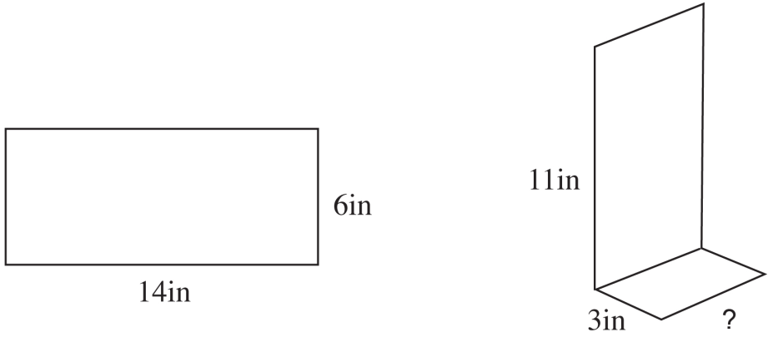
A piece of metal in the shape of a rectangle was folded as shown above. In the figure on the right, the “?” symbol represents what length?

A. 3 inches
B. 6 inches
C. 8 inches
Correct answer: B

D. 11 inches

Rationale: Although this is a visualization task, it is of low complexity since it requires only a straightforward recognition of the change in the figure. Students in the fourth grade are expected to be familiar with sums such as 11 + 3, so this does not increase the complexity level for these students.

Example 3: Low Complexity Source: 2005 NAEP 8M12 #17
Grade 8 Percent correct: 54%
Algebra: Algebraic representations No calculator
x | 0 | 1 | 2 | 3 | 10
y | –1 | 2 | 5 | 8 | 29

Which of the following equations represents the relationship between x and y shown in the table above?

A. y = x² + 1
B. y = x + 1
C. y = 3x – 1
Correct answer: C
D. y = x² – 3
E. y = 3 x² – 1

Rationale: This item would be at the moderate level if it were written as follows, “Write the equation that represents the relationship between x and y.” In generating the equation students would first have to decide if the relationship was linear.
Example 4: Low Complexity Source: 2005 NAEP 8M12 #6
Grade 8 Percent correct: 51%
Data Analysis, Statistics, and Probability: Characteristics of data sets No calculator
The prices of gasoline in a certain region are $1.41, $1.36, $1.57, and $1.45 per gallon. What is the median price per gallon for gasoline in this region?

A. $1.41
B. $1.43
C. $1.44
D. $1.45
Correct answer: B
E. $1.47

Rationale: Students do not have to decide what to do, but rather, they need to recall the concept of a median and the procedure for handling a set of data with an even number of entries.

Example 5: Low Complexity Source: 2005 NAEP B3M3#12
Grade 12 Percent correct: 31%
Algebra: Equations and inequalities No calculator
x + 2y = 17
x – 2y = 3

The graphs of the two equations shown above intersect at the point (x, y).
What is the value of x at the point of intersection?

A. 3½
B. 5
C. 7
D. 10
Correct answer: D 1010
E. 20

Rationale: This item is of low complexity since it involves a procedure that should be carried out mechanically by grade 12.

Example 6: Low Complexity Source: 2005 NAEP B3M3 #16
Grade 12 Percent correct: 26%
Algebra: Variables, expressions, and operations No calculator
Correct answer: 4x² + 30x + 56

If f(x) = x² + x and g(x) = 2x + 7, what is the expression for f(g(x))?

Rationale: Although the content of the task could be considered advanced, it involves recognizing the notation for composition of two functions and carrying out a procedure.

Example 7: Low Complexity Source: 2005 NAEP B3M3 #11
Grade 12 Percent correct: 39%
Data Analysis, Statistics, and Probability: Data representation No calculator
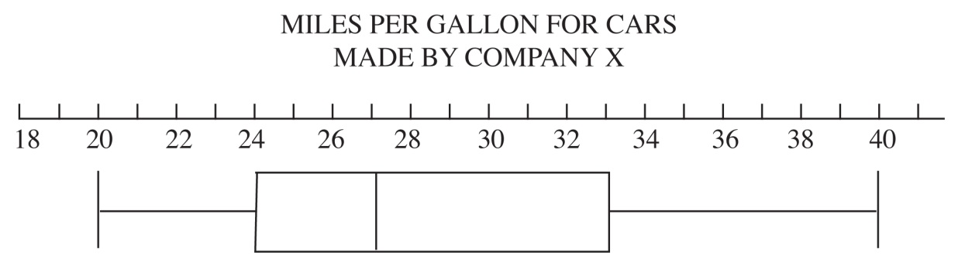

According to the box-and-whisker plot above, three-fourths of the cars made by Company X got fewer than how many miles per gallon.

A. 20
B. 24
C. 27
D. 33
Correct answer: D

E. 40

Rationale: This item is of low complexity since it requires reading a graph and recalling that the four sections of the box-and-whisker plot are quartiles (each represents one-fourth of the data).

Moderate Complexity
Items in the moderate-complexity category involve more flexibility of thinking and choice among alternatives than do those in the low-complexity category. The student is expected to decide what to do and how to do it, bringing together concepts and processes from various domains. For example, the student may be asked to represent a situation in more than one way, to draw a geometric figure that satisfies multiple conditions, or to solve a problem involving multiple unspecified operations. Students might be asked to show or explain their work but would not be expected to justify it mathematically. The following examples are items that have been classified at the moderate complexity level.

Example 8: Moderate Complexity Source: 2005 NAEP 4M4 #12
Grade 4 Percent correct: 34% (full credit), Algebra: Equations and inequalities 22% (partial credit)
No calculator, tiles provided
Questions 11–14 [these questions included this item] refer to the number tiles or the paper strip. Please remove the 10 number tiles and the paper strip from your packet and put them on your desk.

Jan entered four numbers less than 10 on his calculator. He forgot what his second and fourth numbers were. This is what he remembered doing.

8 + – 7 + = 10

List a pair of numbers that could have been the second and fourth numbers.
(You may use the number tiles to help you.)

________, ________
List a different pair that could have been the second and fourth numbers.

Correct answer: Any two of these combinations:
(0,9) (9,0)
(1,8) (8,1)
(2,7) (7,2)
(3,6) (6,3)
(4,5) (5,4)

________, ________

Rationale: This item is of moderate complexity because students have to decide what to do and how to do it. It requires some flexibility in thinking since students at this grade level are not expected to have a routine method to determine two missing numbers and they also have to find two different solutions.
Example 9: Moderate Complexity Source: 2005 NAEP 4M12 #11
Grade 4 Percent correct: 52%
Data Analysis, Statistics, and Probability: Data representation No calculator
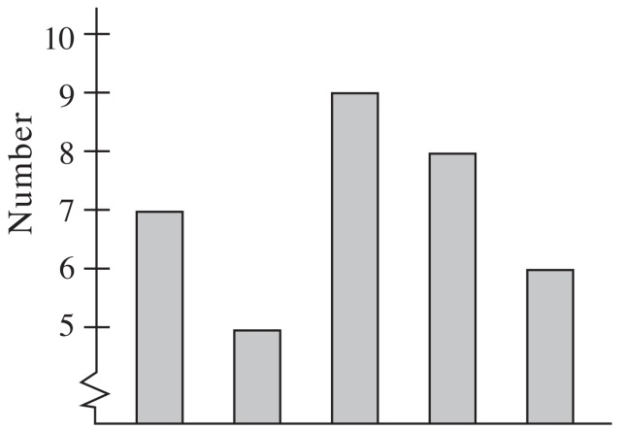
Jim made the graph above. Which of these could be the title for the graph?

A. Number of students who walked to school on Monday through Friday
B. Number of dogs in five states
C. Number of bottles collected by three students
Correct answer: A

D. Number of students in 10 clubs

Rationale: Students must analyze the graph and the choices for a title and eliminate choices because of knowledge of dogs and clubs and the structure of the graph (five sets of data) in order to choose an appropriate title for the graph.

Example 10: Moderate Complexity Source: 2005 NAEP 8M3 #3
Grade 8 Percent correct: 44% (full credit), Measurement: Measuring physical attributes 13% (partial credit)
No calculator, ruler provided
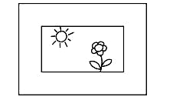
The figure above shows a picture and its frame.

In the space below, draw a rectangular picture 2 inches by 3 inches and draw a 1-inch wide frame around it.

Rationale: Students must plan their drawing, decide whether to begin with the inside or outside rectangle, and determine how the other rectangle is related to the one chosen. Often creating a drawing that satisfies several conditions is more complex than describing a given figure.

Example 11: Moderate Complexity Source: 2005 NAEP 8M3 #10
Grade 8 Percent correct: 34%
Algebra: Patterns, relations, and functions No calculator
In the equation y = 4x, if the value of x is increased by 2, what is the effect on the value of y?

A. It is 8 more than the original amount
B. It is 6 more than the original amount
C. It is 2 more than the original amount
D. It is 16 times the original amount
Correct answer: A
E. It is 8 times the original amount

Rationale: This item is of moderate complexity because it involves more flexibility and a choice of alternative ways to approach the problem rather than a low complexity level, which more clearly states what is to be done. At grade 8, students have not learned a procedure for answering this type of question.

Example 12: Moderate Complexity Source: 2005 NAEP 8M3 #14
Grade 8 Percent correct: 28%
Geometry: Relationships in geometric figures No calculator
A certain 4-sided figure has the following properties.

• Only one pair of opposite sides are parallel

• Only one pair of opposite sides are equal in length

• The parallel sides are not equal in length

Which of the following must be true about the sides that are equal in length?

A. They are perpendicular to each other
B. They are each perpendicular to an adjacent side
C. They are equal in length to one of the other two sides
D. They are not equal in length to either of the other two sides
E. They are not parallel
Correct answer: E

Rationale: This item is of moderate complexity since it requires some visualization and reasoning but no mathematical justification for the answer chosen.

Example 13: Moderate Complexity Source: 2005 NAEP B3M3
Grade 12 Percent correct: 22%
Number Properties and Operations: Number operations No calculator
Correct answer: E
The remainder when a number n is divided by 7 is 2. Which of the following is the remainder when 2n + 1 is divided by 7?

A. 1
B. 2
C. 3
D. 4
E. 5

Rationale: Although the problem could be approached algebraically (n = 7m + 2, for some whole number m, and 2n + 1= 2(7m + 2) + 1 or 14 m + 5, so the remainder is 5), students can solve the problem by using a value for n that satisfies the condition that it has a remainder of 2 when divided by 7. If the students were asked to justify their solution algebraically, then this would be an item of high complexity.

Example 14: Moderate Complexity Source: 2005 NAEP B3M12 #15
Grade 12 Percent correct: 41%
Measurement: Measuring physical attributes Calculator available
A cat lies crouched on level ground 50 feet away from the base of a tree. The cat can see a bird’s nest directly above the base of the tree. The angle of elevation from the cat to the bird’s nest is 40°. To the nearest foot, how far above the base of the tree is the bird’s nest?

A. 32
B. 38
C. 42
D. 60
Correct answer: C
E. 65

Rationale: Students must draw or visualize the situation, recall the appropriate trigonometric function, and use a calculator to determine the value of that function.

Example 15: Moderate Complexity Source: 2005 NAEP B3M12 #16
Grade 12 Percent correct: 12%
Data Analysis, Statistics, and Probability: Characteristics of data sets Calculator available
A clock manufacturer has found that the amount of time their clocks gain or lose
per week is normally distributed with a mean of 0 minutes and a standard
deviation of 0.5 minute, as shown below.

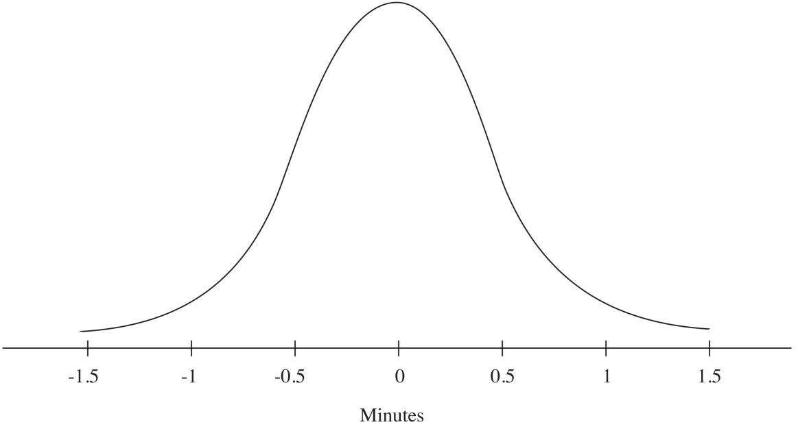

In a random sample of 1,500 of their clocks, which of the following is closest to the expected number of clocks that would gain or lose more than 1 minute per week?

A. 15
B. 30
C. 50
D. 70
Correct answer: D
E. 90

Rationale: Students must recall information about the normal curve (that the region between the mean ± 2 standard deviations contains 95 percent of the data), and apply that information to solve the problem.

High Complexity
High-complexity items make heavy demands on students, because they are expected to use reasoning, planning, analysis, judgment, and creative thought. Students may be
expected to justify mathematical statements or construct a mathematical argument. Items might require students to generalize from specific examples. Items at this level take more time than those at other levels due to the demands of the task, not due to the number of parts or steps. In the example items at the moderate level, several suggestions were made in the rationale that would make the items at a high level of complexity. The following examples are items that have been classified at the high-complexity level.

Example 16: High Complexity Source: 2003 NAEP 4M7 #20
Grade 4 Percent correct: 3% (extended),
Algebra: Patterns, relations, and functions 6% (satisfactory), 13% (partial),
27% (minimal)
Calculator available
The table below shows how the chirping of a cricket is related to the temperature outside. For example, a cricket chirps 144 times each minute when the temperature is 76°.

Number of Chirps  Per Minute | Temperature
144 | 76°
152 | 78°
160 | 80°
168 | 82°
176 | 84°

What would be the number of chirps per minute when the temperature outside is 90° if this pattern stays the same?

Answer: _________________________

Correct answer: 200
Explain how you figured out your answer.

Rationale: To receive full credit for this item, students must give the correct number of chirps and explain that for every 2-degree rise in the temperature, the number of chirps increases by eight. The item requires creative thought for students at this grade as well as planning a solution strategy. Additionally, it requires a written justification of their answer, more than just showing work.

Example 17: High Complexity Source: 2005 NAEP 8M4 #11 Grade 8 Percent correct: 12% (full credit),
Algebra: Patterns, relations, and functions 24% (partial credit)
No calculator
If the grid in Question 10 [the previous question] were large enough and the beetle continued to move in the same pattern [over 2 and up 1], would the point that is 75 blocks up and 100 blocks over from the starting point be on the beetle’s path?
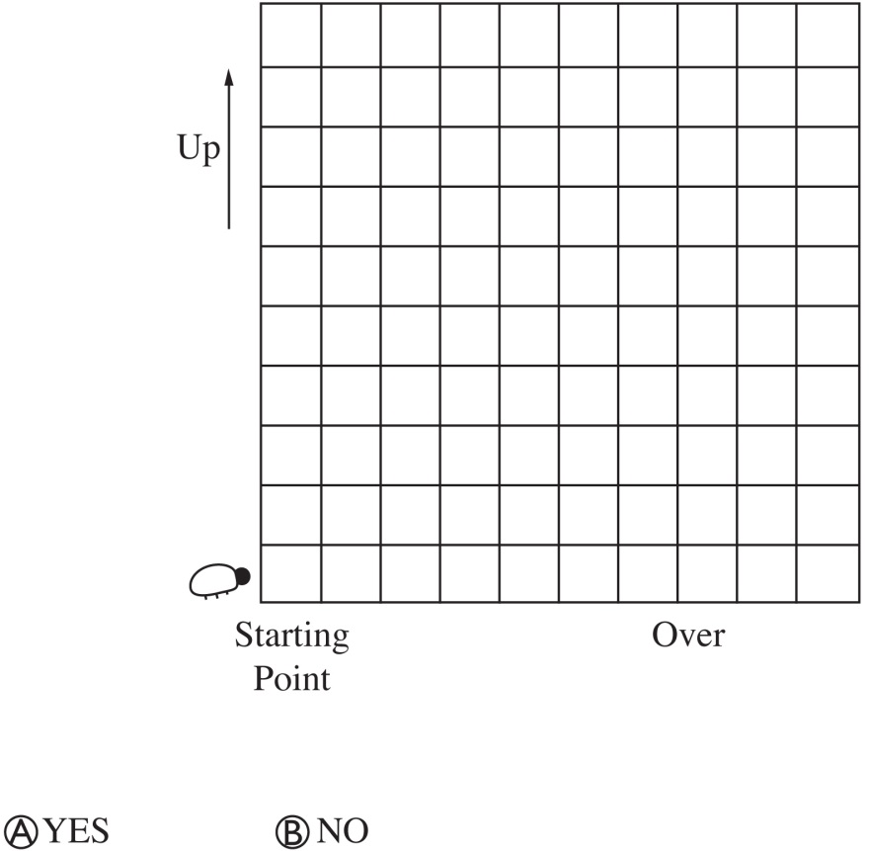

Give a reason for your answer.

Rationale: Students must justify their yes or no answer by using the concept of slope showing that moving over 2 and up 1 repeatedly would result in the beetle being at a point 100 blocks over and 50 blocks up. This requires analysis of the situation as well as a mathematical explanation of the thinking. Since it is not realistic to extend the grid, students are expected to generalize about the ratio.

Example 18: High Complexity Source: Modified NAEP item
Grade 12 No protractor
Geometry: Mathematical reasoning
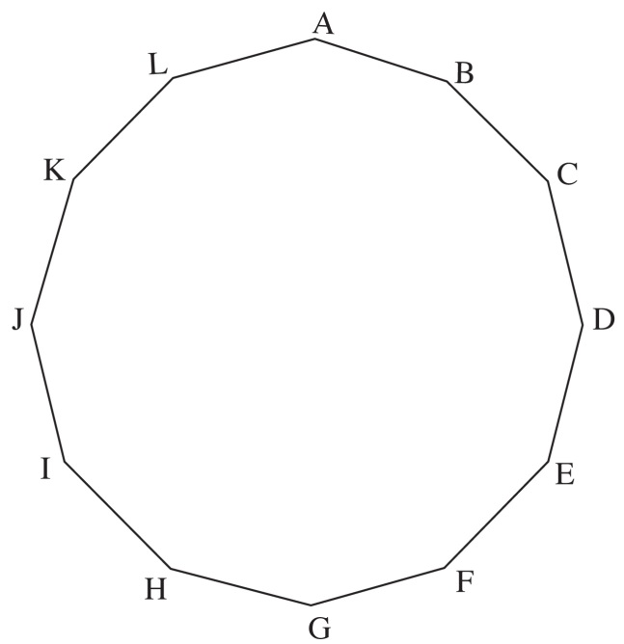

Each of the 12 sides of the regular figure above has the same length.

1. Which of the following angles has a measure of 90°?

A. Angle ABI
B. Angle ACG
C. Angle ADF
D. Angle ADI
E. Angle AEH

2. Prove that no angle formed by joining three vertices of the figure could have a measure of 50 degrees
Correct answer: B

Modification: This item (2005 NAEP B3M3 #1) has been modified to illustrate a high-complexity item. The original item allowed the use of a protractor and did not ask for a proof.
Rationale: There are several ways to approach part 1 of this problem, so students must decide which method to use. Part 2 raises the complexity to high since it requires students to present a mathematical argument requiring creative thought and the bringing together of information about circle arcs and inscribed angles. They could argue that no angle can be 50° because all angles must be multiples of 15°.

Example 19: High Complexity Source: Modified NAEP item
Grade 12 No calculator
Number Properties and Operations: Number sense
Which of the following is false for all values of x if x is any real number?

A. x < x² < x³
B. x³ < x < x²
C. x² < x < x³
D. x < x³ < x^{2’}
Correct answer: C
E. x³ < x² < x

Rationale: This multiple-choice item requires planning, deciding what strategy to use, and reasoning about which statement is always false.

Additional examples of items and their classifications can be found in Assessment and Item Specifications for the NAEP Mathematics Assessment as well as on the National Center for Education Statistics’ website nces.ed.gov/nationsreportcard/itmrlsx/. All the released items from recent mathematics assessments can be accessed from this site. The complexity classification is available only for items beginning with the 2005 assessment since this was the first year that the framework specified this dimension.

Chapter Four

Item Formats
Central to the development of the NAEP assessment in mathematics is the careful selection of items. Since 1992, the NAEP Mathematics Assessment has used three formats or item types: multiple choice, short constructed response, and extended constructed
response. Testing time on NAEP is divided evenly between multiple-choice items and both types of constructed-response items, as shown below.

Exhibit 9. Percent of testing time by item formats
50
50
Multiple
choice
Constructed
response

Multiple-Choice Items
Multiple-choice items require students to read, reflect, or compute and then to select the alternative that best expresses the answer. This format is appropriate for quickly determining whether students have achieved certain knowledge and skills. A carefully
constructed multiple-choice item can assess any of the levels of mathematical complexity (described in chapter three) from simple procedures to more sophisticated concepts. Such items, however, are limited in the extent to which they can provide evidence of the depth of students’ thinking. Multiple-choice items for grade 4 have four choices, and at grades 8 and 12, there are five choices. These items are scored as either correct or incorrect.

The types of item formats are illustrated in this chapter. The presentations of the items often have been reduced, but students have ample space to work and to respond in the actual NAEP test booklet.

Example 1: Multiple Choice Source: 2005 NAEP 4M12 #2
Grade 4 Percent correct: 53%
Number Properties and Operations: Number operations No calculator
$\frac{4}{6}−\frac{1}{6}=$
A. 3
Correct answer: B

B. 3/6
C. 3/0
D. 5/6

Example 2: Multiple Choice Source: 2005 NAEP 3M4 #13
Grade 12 Percent correct: 25%
Geometry: Relationships between geometric figures No calculator
Which of the right triangles below could NOT be a 30°-60°-90° triangle?
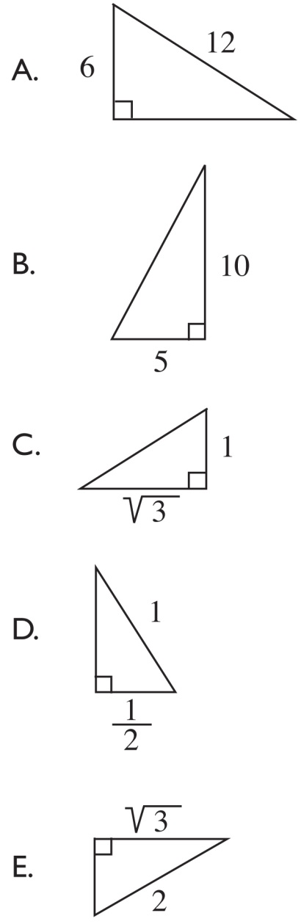
Correct answer: B

Short Constructed-Response Items
To provide more reliable and valid opportunities for extrapolating about students’
approaches to problems, NAEP assessments include items often referred to as short
constructed-response items. These are short-answer items that require students to give either a numerical result or the correct name or classification for a group of mathematical objects, draw an example of a given concept, or possibly write a brief explanation for a given result. Short constructed-response items may be scored correct, incorrect, or partially correct, depending on the nature of the problem and the information gained from students’ responses.

Example 3: Short Constructed Response Source: 2003 NAEP 8M7 #13
Grade 8 Percent correct: 19%
Data Analysis, Statistics, and Probability: Characteristics of data sets Calculator available
Score | Number of Students
90 | 1
80 | 3
70 | 4
60 | 0
50 | 3

The table above shows the scores of a group of 11 students on a history test. What is the average (mean) score of the group to the nearest whole number?

Answer: _________________________

The scoring guide below describes one correct answer.
Scoring Guide

1 – Correct response: 69

0 – Incorrect

Example 4: Short Constructed Response Source: 2003 NAEP 4M7 #6
Grade 4 Percent correct: 29%, 51%
Algebra: Patterns, relations, and functions (incorrect), 17% (partial)
Calculator available
A schoolyard contains only bicycles and wagons like those in the figure below.
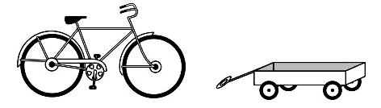
On Tuesday, the total number of wheels in the schoolyard was 24. There are several ways this could happen.

a. | How many bicycles and how many wagons could there be for this to happen?
 | Number of bicycles ________
 | Number of wagons ________
b. | Find another way that this could happen.
 | Number of bicycles ________
 | Number of wagons ________

Scoring Guide

Solution:
Any two of the following correct responses:
0 bicycles, 6 wagons
2 bicycles, 5 wagons
4 bicycles, 4 wagons
6 bicycles, 3 wagons
8 bicycles, 2 wagons
10 bicycles, 1 wagon
12 bicycles, 0 wagons
2 – Correct
Two correct responses
1 – Partial
One correct response, for either part a or part b
OR
Same correct response in both parts
0 – Incorrect: Any incorrect or incomplete response

Extended Constructed-Response Items
Extended constructed-response items require students to consider a situation that requires more than a numerical response or a short verbal communication. Extended constructed-response items have more parts to the response and the student is expected to take more time to complete them. The student may be asked, for example, to describe a situation, analyze a graph or table of values or an algebraic equation, or compute specific numerical values.

Extended constructed-response items are scored at either four or five levels.

Example 5: Extended Constructed Response Source: 2005 NAEP 8M3 #18
Grade 8 Percent correct: 9% (extended credit),
Measurement: Measuring physical attributes 5% (satisfactory), 4% (partial), 5% (minimal)
No calculator
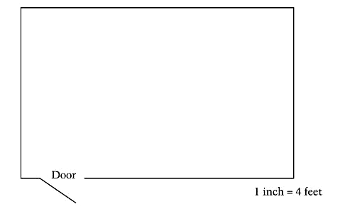
The floor of a room in the figure above is to be covered with tiles. One box of floor tiles will cover 25 square feet. Use your ruler to determine how many boxes of these tiles must be bought to cover the entire floor.

___________ boxes of tiles

The scoring guide has five possible levels ranging from the most complete and mathematically correct response to a response that was incorrect.

Scoring Guide

Solution:
7 boxes
Correct process for solution includes evidence of each of the following (may be implied or explicit):
a) measuring dimensions correctly (getting 2.5 inches and 4 inches) (if centimeters are used the measure must be exact)
b) converting to feet correctly (getting 10 feet and 16 feet)
c) finding the area (160 square feet)
d) dividing by 25 to find the number of boxes (6.4)

(Note: Steps b and c may be interchanged; if done this would yield 10 square inches and 60 square feet, respectively)
4 – Extended
Correct response
3 – Satisfactory
Response contains correct complete process as outlined above (a through d) but has a minor error (such as dimensions in inches are measured incorrectly OR the answer to the scale conversion is incorrect OR one other minor computational error OR does not round)
2 – Partial
7 with no explanation OR response contains correct complete process as outlined above (a through d) but has a major conceptual error (such as use of incorrect conversion factor OR use of perimeter [52] instead of area OR perceives the floor as a square and performs all 4 steps)
1 – Minimal
6.4 with no explanation
OR
Measures 2.5 inches and 4 inches correctly and gets 10 square inches for area
OR
Measures 2.5 inches correctly and converts correctly to 10 feet and 16 feet (may also indicate area is 160 square feet)
0 – Incorrect
Any incorrect response

Scoring Constructed-Response Items
Since 1996, each constructed-response item has had a unique scoring guide that defines the criteria used to evaluate students’ responses. Many of the short constructed-response items are rated according to guides that permit partial credit as seen in Example 4: Short Constructed Response. Other short constructed-response items are scored as either correct or incorrect.

The extended constructed-response items are evaluated with scoring guides refined from a sample of actual student responses from pilot testing. The scoring guide used follows a multiple-point format similar to one shown for Example 5: Extended Constructed
Response.

Additional information about the NAEP Mathematics Assessment can be found at www.nagb.org and https://nces.ed.gov/nationsreportcard, including additional samples of each of the types of items described in this chapter.

Chapter Five

Design of Test and Items
The NAEP Mathematics Assessment is complex in its structure. The design of the
assessment demands that multiple features stay in balance. The test items should adequately cover a broad range of content, balanced at each grade level according to the
required distribution for each content area. At the same time, items make differing
demands on students according to how mathematically complex they are. This, too,
requires balance. The assessments also need to be balanced according to three item formats: multiple choice, short constructed response, and extended constructed response. An additional balance issue involves the mathematical setting of the item, whether it is purely mathematical or set in a real-world context.

Other features of both the test and the items are important in the design of a valid and
reliable assessment. These include how sampling is used in the design of NAEP, the use of calculators, and the use of manipulatives and other tools. Of critical importance is the issue of accessibility for all students, which is addressed in several different ways. A final design feature is the use of families of items. This chapter describes each of these features and issues.

Balance of Content
As described in chapter two, each NAEP mathematics item is developed to measure one of the objectives, which are organized into five major content areas. The table below shows the distribution of items by grade and content area. See chapter two for more
details.

Exhibit 10. Percent distribution of items by grade and content area
Content Area | Grade 4 | Grade 8 | Grade 12
Number Properties and Operations | 40 | 20 | 10
Measurement | 20 | 15 | 30
Geometry | 15 | 20 | 30
Data Analysis, Statistics, and Probability | 10 | 15 | 25
Algebra | 15 | 30 | 35

Balance of Mathematical Complexity
As described in chapter three, items are classified according to the level of demands they make on students; this is known as mathematical complexity. Each item is considered to be at one of three levels of complexity: low, moderate, or high.

The ideal balance sought for the NAEP Mathematics Assessment is not necessarily the balance one would wish for curriculum or instruction in mathematics education. Balance here must be considered in the context of the constraints of an assessment such as NAEP. These constraints include the timed nature of the test and its paper-and-pencil format. Items of high complexity, for example, often take more time to complete. At the same time, some items of all three types are essential to assess the full range of students’ mathematical achievement.

The ideal balance would be that half of the total testing time on the assessment is spent on items of moderate complexity, with the remainder of the total time spent equally on items of low and high complexity. This balance would apply for all three grade levels.

Exhibit 11. Percent of testing time at each level of complexity
High complexity
Moderate
complexity
25
50
Low complexity
25

Balance of Item Formats
Items consist of three formats: multiple choice, short constructed response, and extended constructed response (see chapter three for an in-depth discussion of each type). Testing time on NAEP is divided evenly between multiple-choice items and both types of constructed-response items as shown below.

Exhibit 12. Percent of testing time by item formats
50
50
Multiple
choice
Constructed
response

The design of the assessment, then, must take into account the amount of time students are expected to spend on each format.

Balance of Item Contexts
Just as mathematics can be separated into pure and applied mathematics, NAEP items should seek a balance of items that measure students’ knowledge within both realms. Therefore, some items will deal with purely mathematical ideas and concepts, whereas others will be set in the context of real-world problems.

In the two pairs of examples below, the first item is purely mathematical, whereas the second is set in the context of a real-world problem.

Example Pair 1: Pure Mathematical Setting Source: 2005 NAEP 4M4 #1
Grade 4 Percent correct: 76%
Number Properties and Operations: Number operations No calculator
Subtract:
972
– 46
Correct answer: 926

Answer: ______________________

Example Pair 1: Contextual Mathematical Setting Source: 2005 NAEP 4M12 #4
Grade 4 Percent correct: 80%
Number Properties and Operations: Number operations No calculator
There are 30 people in the music room. There are 74 people in the cafeteria. How many more people are in the cafeteria than the music room?

A. 40
Correct answer: B
B. 44
C. 54
D. 104

Both items involve computation. In the first item the operation is specified. In the other item, the students must interpret the contextual situation, recognize that it calls for finding the difference between 74 and 30, and then compute.

Example Pair 2: Pure Mathematical Setting Source: Modified NAEP Item
Grade 12 Calculator Available
Measurement: Measuring physical attributes
In the triangle below $\overline{\text{AC}}=\text{50}$feet and $mÐC=\text{40}$°.
B

C
A

What is the length of $\overline{\text{AB}}$ to the nearest foot?
Correct answer: 42 feet
Answer: ____________________

Example Pair 2: Contextual Mathematical Problem Source: 2005 NAEP B3M12#15
Grade 12 Percent correct: 41%
Measurement: Measuring physical attributes Calculator available
A cat lies crouched on level ground 50 feet away from the base of a tree. The cat can see a bird’s nest directly above the base of the tree. The angle of elevation from the cat to the bird’s nest is 40°. To the nearest foot, how far above the base of the tree is the bird’s nest?

A. 32
B. 38
C. 42
D. 60
Correct answer: C
E. 65

Sampling
Since the set of content objectives described in chapter two would constitute too many items for a single test given to all students, the design of NAEP allows for matrix sampling. This means that there are multiple forms of the test booklets. Items are distributed across booklets so that students taking part in the assessment do not all receive the same items. In NAEP mathematics, students take two 25-minute blocks (sets of items). Matrix sampling greatly increases the capacity to obtain information across a much broader range of the objectives than would otherwise be possible. Not only items, but also schools and students, are sampled. See the Assessment and Item Specifications for the NAEP Mathematics Assessment for more details about how the representative
samples of schools and students are chosen.

Calculators
The assessment contains blocks of items for which calculators are not allowed and other blocks that contain some items that would be difficult to solve without a calculator. At each grade level, approximately two-thirds of the blocks measure students’ mathematical knowledge and skills without access to a calculator; the other third allow use of a calculator. The type of calculator students may use varies by grade level, as follows:

- At grade 4, a four-function calculator is supplied to students, with training at the time of administration.

- At grade 8, a scientific calculator is supplied to students, with training at the time of administration.

- At grade 12, students are allowed to bring whatever calculator, graphing or otherwise, they are accustomed to using in the classroom with some restrictions for test security purposes. For students who do not bring a calculator to use on the assessment, NAEP will provide a scientific calculator.

No items at either grade 8 or grade 12 will be designed to provide an advantage to
students with a graphing calculator. Estimated time required for any item should be based on the assumption that students are not using a graphing calculator. Items are categorized according to the degree to which a calculator is useful in responding to the item:

A calculator-inactive item is one whose solution neither requires nor suggests the use of a calculator.

Example: Calculator-Inactive Item Source: 2005 NAEP 8M3 #4
Grade 8 Percent correct: 86%
Geometry: Transformation of shapes and preservation of properties Calculator available
The paper tube in the figure above is to be cut along the dotted line and opened up. What will be the shape of the flattened piece of paper?
Correct answer: Rectangle or square
Answer: _________________________

A calculator is not necessary for solving a calculator-neutral item; however, given the option, some students might choose to use one.

Example: Calculator-Neutral Item Source: 2005 NAEP 8M3 #12
Grade 8 Percent correct: 60%
Algebra: Patterns, relations, and functions Calculator available
1 + 3 = 4
1 + 3 + 5 = 9
1 + 3 + 5 + 7 = 16
1 + 3 + 5 + 7 + 9 = 25

According to the pattern suggested by the four examples above, how many consecutive odd integers are required to give a sum of 144?
A. 9
B. 12
Correct answer: B
C. 15
D. 36
E. 72

A calculator is necessary or very helpful in solving a calculator-active item; a student would find it very difficult to solve the problem without the aid of a calculator.

Example: Calculator-Active Item Source: 2005 NAEP 3M12 #15
Grade 12 Percent correct: 41%
Measurement: Measuring physical attributes Calculator available
A cat lies crouched on level ground 50 feet away from the base of a tree. The cat can see a bird’s nest directly above the base of the tree. The angle of elevation from the cat to the bird’s nest is 40°. To the nearest foot, how far above the base of the tree is the bird’s nest?
A. 32
B. 38
C. 42
Correct answer: C
D. 60
E. 65

Manipulatives and Tools
The assessment uses reasonable manipulative materials where possible in measuring students’ ability to represent their understandings and to use tools to solve problems. Examples of manipulative materials include number tiles, geometric shapes, rulers, and protractors. The manipulative materials and accompanying tasks are carefully chosen to cause minimal disruption of the test administration process.

In the following example, number tiles are provided to the student.

Example: Number Tiles Provided Source: 2005 NAEP 4M4 #11
Grade 4 Percent correct: 47% (correct),
Number Properties and Operations: Number operations 42% (partially correct)
No calculator; tiles provided
This question refers to the number tiles. Please remove the 10 number tiles and the paper strip from your packet and put them on your desk.

Audrey used only the number tiles with the digits 2, 3, 4, 6, and 9. She placed one tile in each box below so the difference was 921.
Write the numbers in the boxes below to show where Audrey placed the tiles.
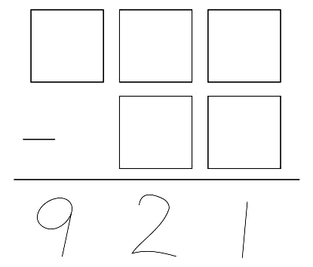

Correct answer:
9 6 3

4 2

In the next example, students are provided with a protractor.

Example: Protractor Provided Source: 2005 NAEP 8M3 #2
Grade 8 Percent correct: 21%,
Measurement: Measuring physical attributes 47% (partially correct)
No calculator; protractor provided
The weather service reported a tornado 75° south of west. On the figure below, use your protractor to draw an arrow from P in the direction in which the tornado was sighted. 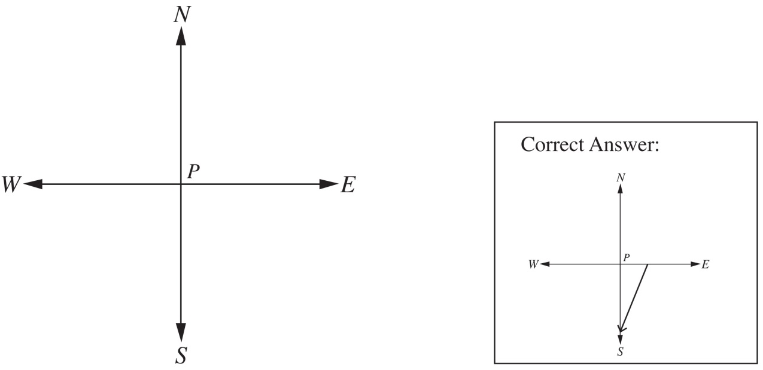

Accessibility
The NAEP Mathematics Assessment is designed to measure the achievement of students across the nation. Therefore, it should allow students who have learned mathematics in a variety of ways, following different curricula and using different instructional materials; students who have mastered the content to varying degrees; students with disabilities; and students who are English language learners to demonstrate their content knowledge and skill. The related design issue is to determine a reasonable way to measure mathematics in the same way for students who come to the assessment with different experiences, strengths, and challenges; who approach mathematics from different perspectives; and who have different ways of displaying their knowledge and skill.

Two methods NAEP uses to design an accessible assessment program are developing the standard assessment so that it is accessible and providing accommodations for students with special needs. The first is addressed by careful item design. For many students with disabilities and students whose native language is not English, the standard
administration of the NAEP assessment will be most appropriate. For other students with disabilities and some English language learners, the NAEP mathematics accommodations policy allows for a variety of accommodations, which can be used alone or in combination. These accommodations include but are not limited to:

    - One-on-one testing
    - Small group testing
    - Extended time
    - Oral reading of directions
    - Large-print booklets
    - Bilingual English/Spanish booklets
    - Use of an aide to transcribe responses

For more detailed information about item design and accommodations see Assessment and Item Specifications for the NAEP Mathematics Assessment.

Item Families
Item families are groups of related items designed to measure the depth of student
knowledge within a particular content area (vertical item families) or the breadth of
student understanding of specific concepts, principles, or procedures across content areas (horizontal item families). Within a family, items may cross content areas, vary in mathematical complexity, and cross grade levels.

Using item families in different ways provides for a more in-depth analysis of student
performance than would a collection of discrete, unrelated items. For example, a family of items might be designed to see how students use proportional thinking in different mathematical contexts such as geometry, algebra, and measurement. Another family might be designed to explore students’ knowledge of a concept and their ability to apply that knowledge in increasingly sophisticated problem situations.

Bibliography

Achieve, Inc. (2000). Foundations for Success: Mathematics for the Middle Grades (consultation draft). Washington, DC: Mathematics Achievement Partnership.
Anderson, N.E., F.F. Jenkins, and K.E. Miller (1995). NAEP Inclusion Criteria and Testing Accommodations: Findings From the NAEP 1995 Field Test in Mathematics. Princeton, NJ: Educational Testing Service.
Blank, R., and L.D. Wilson. (1999). Improving Mathematics Education Using Results From NAEP and TIMSS. Washington, DC: Council of Chief State School Officers.
Bourque, M.L., and S. Byrd. (2000). Student Performance Standards on the National Assessment of Educational Progress: Affirmation and Improvements. Washington, DC: National Assessment Governing Board.
Braswell, J.S., A.D. Lutkus, W.S. Grigg, S.L. Santapau, B. Tay-Lim, and M. Johnson. (August 2001). The Nation’s Report Card: Mathematics 2000. Washington, DC: National Center for Education Statistics.
Carlson, J.E., A.D. Lutkus, J. Mazzeo, and K.E. Voelkl (2000). Increasing the Participation of Special Needs Students in NAEP. Jessup, MD: U.S. Department of Education, Office of Educational Research and Improvement.
Council for Basic Education (November 8, 2000). Issues in Mathematics Education Assessment: NAEP Mathematics 2005. Washington, DC: Council of Chief State School Officers.
Diperna, P., and T. Loveless. (2000). The Brown Center Report on American Education: How Well Are American Students Learning? Washington, DC: The Brookings Institution.
Dossey, J.A., J. Mazzeo, K.E. Miller, and C.M. Reese. (1997). NAEP 1996 Mathematics Report Card for the Nation and the States. Washington, DC: Educational Testing Service and National Center for Education Statistics.
Educational Testing Service (1988). Mathematics Objectives 1990 Assessment. Princeton, NJ: Author.
Findell, B., J. Kilpatrick, and J. Swafford. (2001). Adding It Up: Helping Children Learn Mathematics. Washington, DC: National Research Council.
Kenney, P.A. (1999). An Analysis of the 1996 NAEP Mathematics Framework and Items for grade 8. Pittsburgh, PA: University of Pittsburgh, Learning Research and Development Center.
Kenney, P.A., E.A. Silver, C. Alacaci, and J.S. Zawojewski. (1998). Content Analysis Project—State and NAEP Mathematics Assessment (final report). Pittsburgh, PA: University of Pittsburgh, Learning Research and Development Center.
Mazzeo, J., J. Carlson, K. Voelkl, and A. Lutkus (1999). Increasing the Participation of Special Needs Students in NAEP: A Report on 1996 Research Activities (NCES Publication No. 2000-473). Washington, DC: National Center for Education Statistics.
Mitchell, J., E.F. Hawkins, F.B. Stancavage, and J.A. Dossey (1999). Estimation Skills, Mathematics-in-Context, and Advanced Skills in Mathematics. Washington, DC: National Center for Education Statistics.
Mullis, I.V.S., M.O. Martin, T.A. Smith, R.A. Garden, K.D. Gregory, E.J. Gonzalez, S.J. Chrostowski, and K.M. O’Connor (2001). TIMSS Assessment Frameworks and Specifications 2003. Boston: Boston College, International Study Center.
National Assessment Governing Board (2005). 2005 National Assessment of Educational Progress Mathematics Assessment Framework. Washington, DC: Author.
National Assessment Governing Board (2005). 2005 National Assessment of Educational Progress Mathematics Assessment and Item Specifications. Washington, DC: Author.
National Assessment Governing Board (1992). 1994 National Assessment of Educational Progress: Mathematics Assessment Framework and Specifications. Washington, DC: The College Board and Author.
National Assessment Governing Board (1994). Mathematics Framework for the 1996 and 2000 National Assessment of Educational Progress. Washington, DC: Author.
Olson, J.F., and A.A. Goldstein (1997). The Inclusion of Students With Disabilities and Limited English Proficient Students in Large-Scale Assessments: A Summary of Recent Progress (NCES Publication No. 97-482). Washington, DC: National Center for Education Statistics.
Silver, E., and P. Kenney (eds.) (2000). Results From the Seventh Mathematics Assessment of the National Assessment of Educational Progress. Reston, VA: National Council of Teachers of Mathematics.
U.S. Department of Education (1999). The NAEP Guide: A Description of the Content and Methods of the 1999 and 2000 Assessments. Washington, DC: National Center for Education Statistics and U.S. Department of Education, Office of Educational Research and Improvement.
U.S. Department of Education. (2000). Before It’s Too Late. Washington, DC: U.S. Department of Education, National Commission of Mathematics and Science Teaching for the 21st Century.

Appendix A

NAEP Mathematics Achievement-Level Descriptions
The NAEP achievement levels are cumulative; therefore, students performing at the Proficient level also display the competencies associated with the Basic level, and students at the Advanced level also demonstrate the skills and knowledge associated with both the Basic and the Proficient levels. The cut score indicating the lower end of the score range for each level is noted in parentheses. Bold text is a short, general summary to describe performance at each achievement level.

Mathematics Achievement-Levels Descriptions for Grade 4
Basic  (214) | Fourth-grade students performing at the Basic level should show some evidence of understanding the mathematical concepts and procedures in the five NAEP content areas.  Fourth-graders performing at the Basic level should be able to estimate and use basic facts to perform simple computations with whole numbers; show some understanding of fractions and decimals; and solve some simple real-world problems in all NAEP content areas. Students at this level should be able to use—although not always accurately—four-function calculators, rulers, and geometric shapes. Their written responses are often minimal and presented without supporting information.
Proficient  (249) | Fourth-grade students performing at the Proficient level should consistently apply integrated procedural knowledge and conceptual  understanding to problem solving in the five NAEP content areas.  Fourth-graders performing at the Proficient level should be able to use whole numbers to estimate, compute, and determine whether results are reasonable. They should have a conceptual understanding of fractions and decimals; be able to solve real-world problems in all NAEP content areas; and use four-function calculators, rulers, and geometric shapes appropriately. Students performing at the Proficient level should employ problem-solving strategies such as identifying and using appropriate information. Their written solutions should be organized and presented both with supporting information and explanations of how they were achieved.
Advanced  (282) | Fourth-grade students performing at the Advanced level should apply integrated procedural knowledge and conceptual understanding to complex and nonroutine real-world problem solving in the five NAEP content areas.  Fourth-graders performing at the Advanced level should be able to solve complex nonroutine real-world problems in all NAEP content areas. They should display mastery in the use of four-function calculators, rulers, and geometric shapes. These students are expected to draw logical conclusions and justify answers and solution processes by explaining why, as well as how, they were achieved. They should go beyond the obvious in their interpretations and be able to communicate their thoughts clearly and concisely.

Mathematics Achievement-Levels Descriptions for Grade 8
Basic  (262) | Eighth-grade students performing at the Basic level should exhibit  evidence of conceptual and procedural understanding in the five NAEP content areas. This level of performance signifies an understanding of arithmetic operations—including estimation—on whole numbers, decimals, fractions, and percents.  Eighth-graders performing at the Basic level should complete problems correctly with the help of structural prompts such as diagrams, charts, and graphs. They should be able to solve problems in all NAEP content areas through the appropriate selection and use of strategies and technological tools—including calculators, computers, and geometric shapes. Students at this level also should be able to use fundamental algebraic and informal geometric concepts in problem solving.  As they approach the Proficient level, students at the Basic level should be able to determine which of the available data are necessary and sufficient for correct solutions and use them in problem solving. However, these eighth-graders show limited skill in communicating mathematically.
Proficient  (299) | Eighth-grade students performing at the Proficient level should apply mathematical concepts and procedures consistently to complex problems in the five NAEP content areas.  Eighth-graders performing at the Proficient level should be able to conjecture, defend their ideas, and give supporting examples. They should understand the connections among fractions, percents, decimals, and other mathematical topics such as algebra and functions. Students at this level are expected to have a thorough understanding of Basic level arithmetic operations—an understanding sufficient for problem solving in practical situations.  Quantity and spatial relationships in problem solving and reasoning should be familiar to them, and they should be able to convey underlying reasoning skills beyond the level of arithmetic. They should be able to compare and contrast mathematical ideas and generate their own examples. These students should make inferences from data and graphs; apply properties of informal geometry; and accurately use the tools of technology. Students at this level should understand the process of gathering and organizing data and be able to calculate, evaluate, and communicate results within the domain of statistics and probability.

Advanced  (333) | Eighth-grade students performing at the Advanced level should be able to reach beyond the recognition, identification, and application of mathematical rules in order to generalize and synthesize concepts and principles in the five NAEP content areas.  Eighth-graders performing at the Advanced level should be able to probe examples and counterexamples in order to shape generalizations from which they can develop models. Eighth-graders performing at the Advanced level should use number sense and geometric awareness to consider the reasonableness of an answer. They are expected to use abstract thinking to create unique problem-solving techniques and explain the reasoning processes underlying their conclusions.

Mathematics Achievement-Levels Descriptions for Grade 12
Basic  (141) | Twelfth-grade students performing at the Basic level should be able  to solve mathematical problems that require the direct application  of concepts and procedures in familiar mathematical and real-world settings.  Students performing at the Basic level should be able to compute, approximate, and estimate with real numbers, including common irrational numbers. They should be able to order and compare real numbers and be able to perform routine arithmetic calculations with and without a scientific calculator or spreadsheet. They should be able to use rates and proportions to solve numeric and geometric problems.  At this level, students should be able to interpret information about functions presented in various forms, including verbal, graphical, tabular, and symbolic. They should be able to evaluate polynomial functions and recognize the graphs of linear functions. Twelfth-grade students should also understand key aspects of linear functions, such as slope and intercepts.  These students should be able to extrapolate from sample results; calculate, interpret, and use measures of center; and compute simple probabilities.  Students at this level should be able to solve problems involving area and perimeter of plane figures, including regular and irregular polygons, and involving surface area and volume of solid figures. They should also be able to solve problems using the Pythagorean theorem and using scale drawings. Twelfth-graders performing at the Basic level should be able to estimate, calculate, and compare measures, as well as to identify and compare properties of two- and three-dimensional figures. They should be able to solve routine problems using two-dimensional coordinate geometry, including calculating slope, distance, and midpoint. They should also be able to perform single translations or reflections of geometric figures in a plane.

Proficient  (176) | Twelfth-grade students performing at the Proficient level should be able to recognize when particular concepts, procedures, and strategies are appropriate, and to select, integrate, and apply them to solve  problems. They should also be able to test and validate geometric and algebraic conjectures using a variety of methods, including deductive reasoning and counterexamples.  Twelfth-grade students performing at the Proficient level should be able to compute, approximate, and estimate the values of numeric expressions using exponents (including fractional exponents), absolute value, order of magnitude, and ratios. They should be able to apply proportional reasoning, when necessary, to solve problems in nonroutine settings, and to understand the effects of changes in scale. They should be able to predict how transformations, including changes in scale, of one quantity affect related quantities.  These students should be able to write equivalent forms of algebraic expressions, including rational expressions, and use those forms to solve equations and systems of equations. They should be able to use graphing tools and to construct formulas for spreadsheets; to use function notation; and to evaluate quadratic, rational, piecewise-defined, power, and exponential functions. At this level, students should be able to recognize the graphs and families of graphs of these functions and to recognize and perform transformations on the graphs of these functions. They should be able to use properties of these functions to model and solve problems in mathematical and real-world contexts, and they should understand the benefits and limits of mathematical modeling. Twelfth graders performing at the Proficient level should also be able to translate between representations of functions, including verbal, graphical, tabular, and symbolic representations; to use appropriate representations to solve problems; and to use graphing tools and to construct formulas for spreadsheets.  Students performing at this level should be able to use technology to calculate summary statistics for distributions of data. They should be able to recognize and determine a method to select a simple random sample, identify a source of bias in a sample, use measures of center and spread of distributions to make decisions and predictions, describe the impact of linear transformations and outliers on measures of center, calculate combinations and permutations to solve problems, and understand the use of the normal distribution to describe real-world situations. Twelfth-grade students should be able to use theoretical probability to predict experimental outcomes involving multiple events.  These students should be able to solve problems involving right triangle trigonometry, use visualization in three dimensions, and perform successive transformations of a geometric figure in a plane. They should be able to understand the effects of transformations, including changes in scale, on corresponding measures and to apply slope, distance, and midpoint formulas to solve problems.

Advanced  (216) | Twelfth-grade students performing at the Advanced level should  demonstrate in-depth knowledge of and be able to reason about mathematical concepts and procedures. They should be able to integrate this knowledge to solve nonroutine and challenging problems, provide mathematical justifications for their solutions, and make  generalizations and provide mathematical justifications for those generalizations. These students should reflect on their reasoning, and they should understand the role of hypotheses, deductive reasoning, and conclusions in geometric proofs and algebraic arguments made by themselves and others. Students should also demonstrate this deep knowledge and level of awareness in solving problems, using appropriate mathematical language and notation.  Students at this level should be able to reason about functions as mathematical objects. They should be able to evaluate logarithmic and trigonometric functions and recognize the properties and graphs of these functions. They should be able to use properties of functions to analyze relationships and to determine and construct appropriate representations for solving problems, including the use of advanced features of graphing calculators and spreadsheets.  These students should be able to describe the impact of linear transformations and outliers on measures of spread (including standard deviation), analyze predictions based on multiple data sets, and apply probability and statistical reasoning to solve problems involving conditional probability and compound probability.  Twelfth-grade students performing at the Advanced level should be able to solve problems and analyze properties of three-dimensional figures. They should be able to describe the effects of transformations of geometric figures in a plane or in three dimensions, to reason about geometric properties using coordinate geometry, and to do computations with vectors and to use vectors to represent magnitude and direction.



