Mathematics Framework for
the 2007 National Assessment
of Educational Progress



National Assessment Governing Board
U.S. Department of Education

National Assessment Governing Board
Darvin M. Winick
Chair
Sheila Ford
Vice Chair
Charles E. Smith
Executive Director
Mary Crovo
Project Officer
NAEP Mathematics Project
Wayne Martin
Project Director
John Olson
Deputy Project Director
Linda Wilson
Consensus Coordinator
Framework Author
Developed for the National Assessment Governing Board under contract number
ED–00–CO–0115 by the Council of Chief State School Officers, with subcontracts to the Council of Basic Education and the Association of State Supervisors of Mathematics

For further information, contact:
National Assessment Governing Board
800 North Capitol Street, N.W.
Suite 825
Washington, DC 20002–4233
www.nagb.org
September 2006
For sale by the U.S. Government Printing Office
Superintendent of Documents, Mail Stop: SSOP, Washington, DC 20402–9328
Table of Contents
Chapter One: Overview of Recommendations 1
Introduction 1
Context for Planning the Assessment 1
The Consensus Approach 3
Achievement Levels 4
Recommendations for the NAEP Mathematics Assessment 4
Chapter Two: Framework for the Assessment 7
Content Areas 7
Mathematical Complexity of Items 8
Distribution of Items 9
Calculators 10
Chapter Three: NAEP Mathematics Objectives 11
Mathematical Content Areas 11
Chapter Four: Mathematical Complexity of Items 35
Low Complexity 36
Moderate Complexity 37
High Complexity 40
Balance of Mathematical Complexity 42
Chapter Five: Item Formats 43
Multiple-Choice Items 43
Short Constructed-Response Items 44
Extended Constructed-Response Items 45
Scoring Extended Constructed-Response Items 46
Bibliography 49
Appendix A: NAEP Mathematics Achievement Level Descriptions 51
Grade 4 53
Grade 8 54
Appendix B: Mathematical Complexity Items Scoring Guide 57
Low Complexity 59
Moderate Complexity 60
High Complexity 64
Appendix C: NAEP Mathematics Project Staff and Committees 69
NAEP Mathematics Project 71
Steering Committee 71
Planning Committee 73
Technical Advisory Panel 74
Committee Representation 74
Acknowledgments 77

Chapter One: Overview of Recommendations
Introduction
Since 1973, the National Assessment of Educational Progress (NAEP) has gathered information about student achievement in mathematics. The results of these periodic assessments, produced in print and Web-based formats, inform citizens about the nature of students’ comprehension of the subject, inform curriculum specialists about the level and nature of student understanding, and inform policymakers about factors related to schooling and its effect on student proficiency in mathematics.
Based on these surveys of students at the elementary, middle school, and high school levels, NAEP has provided comprehensive information about what students in the United States know and can do in the area of mathematics, as well as in a number of other subject areas. These reports present information on strengths and weaknesses in students’ understanding and their ability to apply that understanding in problem-solving situations; provide comparative student data according to race/ethnicity, type of community, and geographic region; describe trends in student performance over time; and report on relationships between student proficiency and certain background variables.
This document contains the framework and a set of recommendations for the NAEP 2007 mathematics assessment, which will assess student achievement nationally and state-by-state, as well as in select urban districts, in grades 4 and 8. It includes descriptions of the mathematical content of the test, the types of test questions, and recommendations for administration of the test. In broad terms, this framework attempts to answer the question, “What should be assessed?” The answer to this question must necessarily consider the constraints of a large-scale assessment such as NAEP, with its limitations on time and resources.
It is important to understand that this document does not attempt to answer the question, “What should be taught, or how?” This is an assessment framework, not a curriculum framework. It was developed with the understanding that some concepts, skills, and activities in school mathematics are not suitable to be assessed on NAEP, even though they may be important components of a school curriculum (e.g., an extended project that involves gathering data, or a group project).
The Assessment and Item Specifications for the 2005 NAEP Mathematics Assessment, a companion document to this framework, gives more detail about the items and conditions for the NAEP mathematics assessment.
Context for Planning the Assessment
The National Assessment Governing Board, created by Congress in 1988, is responsible for formulating policy for NAEP. The Governing Board is specifically charged with developing assessment objectives and test specifications, identifying appropriate achievement goals for each age and grade, and carrying out other NAEP policy responsibilities.
Congress also authorized the trial state assessment program in 1988. This voluntary program for gathering state-level achievement data in mathematics began with the 1990 assessment at grade 8, and with the 1992 assessment in grade 4. National data at grades 4, 8, and 12 were also gathered during those years.
In preparation for the 1990 mathematics assessment, a contract was awarded to the Council of Chief State School Officers (CCSSO) to design a framework for the assessment. The CCSSO project gave special attention to the formal state objectives and frameworks for mathematics instruction. State-, district-, and school-level objectives were considered, as well as the frameworks on which previous NAEP mathematics assessments had been based, and a draft version of the National Council of Teachers of Mathematics’ (NCTM’s) Curriculum and Evaluation Standards for School Mathematics. The result was a “content by mathematical ability” matrix design that was used to guide both the 1990 and 1992 mathematics assessments conducted by NAEP at the national and state levels.
To prepare for the next NAEP mathematics assessment, in 1991 the Governing Board awarded a contract to College Board to develop the assessment and item specifications for the 1994 mathematics assessment. The College Board project had two primary purposes: (1) to recommend a framework in terms of describing what students know and can do in mathematics, and (2) to develop specifications for the assessment items, specifically the mix of item formats, the item distribution for mathematics content areas, and the conditions under which items are presented to students (e.g., use of manipulatives, use of calculators, and length of time to complete tasks).
Taking into account the three NAEP achievement levels adopted by the Governing Board—Basic, Proficient, and Advanced—the College Board effort resulted in the “content areas by mathematical abilities by mathematical power” grid that was used to guide the development of the 1996 and 2000 national and state mathematics assessments conducted by NAEP.
Before the reauthorization of the Individuals with Disabilities Education Act (IDEA) in the mid-1990s, participation in NAEP of students with disabilities and English language learners was limited, with schools excluding them from the assessment in accordance with criteria provided by the program at that time. For the 1996 NAEP assessment, modifications were made in two areas: inclusion criteria were revised to make them more clear, more inclusive, and more likely to be applied consistently across jurisdictions in the United States; and a variety of assessment accommodations was offered for the first time.
In 1998, NAEP began new trend lines for some subject areas that presented data reported for the first time on samples that included accommodated special-needs students. This trend toward more inclusive assessments has also led to a closer look at how test items are developed and assessments designed.
Over the years, NAEP has implemented procedures that are designed to make items more accessible for a variety of special-needs students. The NAEP mathematics framework enables the continuation of this best practices approach, and the assessment and item specifications document (Assessment and Item Specifications for the 2005 NAEP Mathematics Assessment) provides clear and detailed guidance on how to develop a more inclusive assessment.
The long-range plan established by the Governing Board called for the development of a new mathematics framework to be used as the basis for the 2005 national and state assessments of mathematics. Prior to initiating work on a new framework, the Governing Board conducted a series of public meetings to gather input to serve as the basic purpose(s) for the new framework. At the public meetings, a strong concern was raised by states about the need to continue the short-term trend lines for the nation and the states. Many states were using the short-term trend lines as an independent monitor of their standards-based reform efforts.
Several other concerns were also raised:
- Had computational skills been overlooked by the reform efforts because of the emphasis placed on higher order skills by most state mathematics standards and the work by NCTM?
- Were U.S. students capable of handling a more rigorous curriculum, especially algebra and geometry, at grade 8?
- What should our mathematical expectations be for grade 12 students?
Based on the input received, the Governing Board awarded a contract to CCSSO in September 2000 to update the mathematics assessment framework used for the 1996 and 2000 assessments. The revisions were to address the concerns raised at the public meetings while maintaining the short-term trend lines in grades 4 and 8 that began with the 1990 mathematics assessment.
It is within this context that the recommendations contained in this document were developed.
The Consensus Approach
CCSSO established a steering committee, representative of national policy organizations, mathematics associations, research mathematicians, business and industry, and educators, to develop policy recommendations for the mathematics assessment and to guide the direction and scope of the project. A planning committee of mathematics educators, mathematicians, curriculum supervisors, and teachers was established to draft the content of the framework, working within the policy recommendations established by the steering committee. Care was taken with both committees to ensure that the diversity of opinion regarding mathematics issues was represented and reflected. To reach meaningful consensus, all points of view were heard and considered. Such consensus has been the goal of this project.
A technical advisory panel, composed of university professors, state testing specialists, and measurement experts from private research organizations, was established to consider the policy recommendations and to draft content from the perspective of whether it would threaten NAEP’s ability to continue the short-term mathematics trend lines that began in 1990.
The steering committee and planning committee both began their work with a review of the framework used in 1996 and 2000. A discussion of the current debates in mathematics education was also part of their meetings. In their deliberations, the committees considered state mathematics content standards and frameworks, new standards prepared by NCTM, reports from the Third International Mathematics and Science Study, reports from the Achieve Project, and a 2001 report issued by the National Research Council of the National Academy of Sciences. In addition, input was provided by mathematics teachers and supervisors as well as others through CCSSO’s partners, the Council for Basic Education and the Association of State Supervisors of Mathematics.
The suggested revisions contained in this framework are intended (1) to reflect recent curricular emphases and objectives; (2) to include what various policymakers, scholars, practitioners, and interested citizens believe should be in the assessment; (3) to maintain the short-term trend lines in grades 4 and 8 that began with the 1990 mathematics assessment to permit the reporting of changes in student achievement over time; and (4) to include objectives that are more clear and more specific for each grade level.
Achievement Levels
The NAEP Mathematics Framework was considered in light of the three NAEP achievement levels: Basic, Proficient, and Advanced. Basic denotes partial mastery of prerequisite knowledge and skills that are fundamental for proficient work at each grade. Proficient represents solid academic performance for each grade assessed. Students reaching this level have demonstrated competency over challenging subject matter, including subject-matter knowledge, application of such knowledge to real-world situations, and analytical skills appropriate to the subject matter. Advanced represents superior performance.
These levels are intended to provide descriptions of what students should know and be able to do in mathematics. Established for the 1992 mathematics scale through a broadly inclusive process and adopted by the Governing Board, the three levels per grade are a major means of reporting NAEP data. The updated mathematics framework was developed to ensure congruence between the achievement levels and the test content. See appendix A for the NAEP Mathematics Achievement Level Descriptions.
Recommendations for the NAEP Mathematics Assessment
As a result of analysis and review, the steering committee and planning committee endorsed the following recommendations for the NAEP mathematics assessment:
1. Content Areas
The NAEP mathematics assessment should be based on essentially the same five content areas as the 1996 and 2000 assessments: (1) Number Properties and Operations, (2) Measurement, (3) Geometry, (4) Data Analysis and Probability, and (5) Algebra. Details about each of these content areas can be found in chapter three.
2. Mathematical Complexity of Items
The second dimension of the framework, formerly known as “mathematical abilities,” should be refined to describe the level of mathematical complexity that an item demands of a student. Each level describes the degree of procedural knowledge, conceptual understanding, problem solving, reasoning, or communicating required to respond to an item at that level. Further description of how this revision relates to the former framework is presented in chapter two, and the levels are described at length in chapter four.
3. Distribution of Items
The percentage of items allotted to each of the five content areas should remain the same at grade 4 as called for in the framework for the 1996–2005 assessments. The percentages for grade 8 should be altered somewhat in the areas of Number Properties and Operations and Algebra to reflect the increasing importance of algebraic concepts. At grade 12, the percentages should be changed to more closely correspond to the mathematics that high school students experience in a typical 3-year sequence of courses, with algebra and geometry/measurement forming the anchors, along with an increasing emphasis on data analysis and probability. The recommended percentages are discussed in chapter two.
4. Item Formats
Given that NAEP is a paper-and-pencil test administered in a timed setting (for students not receiving accommodations), the assessment should continue to use three types of items: multiple choice, short constructed response, and extended constructed response. As in the previous framework, approximately half of a student’s testing time should be allotted to multiple-choice items, with the remaining half devoted to constructed-response items of both types. Further description of the item formats can be found in chapter five. For items with multiple-score points, students receive full credit only if they fulfill all the requirements of the item and provide the correct solution.
5. Manipulatives
The assessment should continue to use reasonable manipulative materials, where possible, in measuring students’ ability to represent their understandings and to use tools to solve problems. Such manipulative materials and accompanying tasks should be carefully chosen to cause minimal disruption of the test administration process.
6. Calculators
It is appropriate for some portions (two-thirds) of NAEP at all grade levels to assess students’ mathematical knowledge and skills without access to a calculator, but for other portions (one-third) of the test to allow the use of a calculator. At grade 4, a four-function calculator should be supplied by NAEP with appropriate training at the time of administration. Eighth- and 12th-grade students should be allowed to bring whatever calculator, graphing or otherwise, they are accustomed to using in the classroom.
The Governing Board determined that eighth-grade students should be provided with scientific calculators beginning with the 2005 assessment based on a survey of state testing programs. More details and discussion about the calculator recommendations can be found in chapter two.
Chapter Two: Framework for the Assessment
This chapter further discusses the rationale for recommendations, especially those that reflect a change from current policy.

Content Areas
Since its first mathematics assessments, NAEP has regularly gathered data on students’ understanding of mathematical content. Although the names of the content areas in the frameworks, as well as some of the topics in those areas, may have changed somewhat from one assessment to the next, there remained a consistent focus toward collecting information on student performance in five key areas:
- Number (including computation and the understanding of number concepts)
- Measurement (including use of instruments, application of processes, and concepts of area and volume)
- Geometry (including spatial reasoning and applying geometric properties)
- Data Analysis (including probability, graphs, and statistics)
- Algebraic Representations and Relationships
The framework for the mathematics assessment is anchored in these same five broad areas of mathematical content:
- Number Properties and Operations
- Measurement
- Geometry
- Data Analysis and Probability
- Algebra
These divisions are not intended to separate mathematics into discrete elements. Rather, they are intended to provide a helpful classification scheme that describes the full spectrum of mathematical content assessed by NAEP. Classifying items into one primary content area is not always clear cut, but doing so brings us closer to the goal of ensuring that important mathematical concepts and skills are assessed in a balanced way.
At grade 12, the five content areas are collapsed into four, with geometry and measurement combined into one. This reflects the fact that the majority of measurement topics suitable for 12th-grade students are geometrical in nature.
It is important to note that certain aspects of mathematics occur in all of the content areas. The best example of this is computation. Computation is the skill of performing operations on numbers. It should not be confused with the content area of NAEP called Number Properties and Operations, which encompasses a wide range of concepts about our numeration system (see chapter three for a thorough discussion). Certainly the area of Number Properties and Operations includes a variety of computational skills, ranging from operations with whole numbers to work with decimals and fractions and finally real numbers. But computation is also critical in Measurement and Geometry, such as in calculating the perimeter of a rectangle, estimating the height of a building, or finding the hypotenuse of a right triangle. Data analysis often involves computation, such as calculating a mean or the range of a set of data. Probability often entails work with rational numbers. Solving algebraic equations usually involves numerical computation as well. Computation, therefore, is a foundational skill in every content area.
Mathematical Complexity of Items
The framework used for the 1996 and 2000 NAEP included three dimensions: mathematical content, mathematical abilities, and power (reasoning, connections, and communication). That framework was intended to address the primary need of ensuring that NAEP assessed an appropriate balance of mathematical content and at the same time assessed a variety of ways of knowing and doing mathematics. The abilities and power dimensions were not intended for reporting, but rather to provide for a wide range of mathematical activity in the items.
That framework had many laudable features. Notions of conceptual understanding, procedural knowledge, and problem solving sent a strong message about the depth and breadth of engaging in mathematical activity. The dimensions of mathematical power gave further emphasis to the idea that certain activities cut across content areas. At the same time, there was an acknowledgement that the dimension of mathematical abilities proved somewhat difficult for experts to agree on, relying as it does on inferences about students’ approaches to each particular item.
The intent of this current framework is to build on the previous one, retaining its strengths while addressing some of its weaknesses. The purpose remains the same: to ensure that NAEP assesses an appropriate balance of content as well as a variety of ways of knowing and doing mathematics. The major change is to create a second dimension of the framework based on the properties of an item, rather than on the abilities of a student. Mathematical complexity of an item answers the question, “What does the item ask of the students?”
Each level of complexity includes aspects of knowing and doing mathematics, such as reasoning, performing procedures, understanding concepts, or solving problems. The levels are ordered, so that items at a low level would demand that students perform simple procedures, understand elementary concepts, or solve simple problems. Items at the high end would ask students to reason or communicate about sophisticated concepts, perform complex procedures, or solve non-routine problems. Ordering of the levels is not intended to imply a developmental sequence or the sequencing in which teaching or learning occurs. Rather, it is a description of the different demands made on students by particular test items. See chapter five for further discussion of the levels of mathematical complexity.
Distribution of Items
The distribution of items among the various mathematical content areas is a critical feature of the assessment design, as it reflects the relative importance and value given to each of the curricular content areas within mathematics. As has been the case with past NAEP assessments in mathematics, the categories have received differential emphasis at each grade, and the differentiation continues in the framework for this assessment. Table 1 provides the recommended balance of items in the assessment by content area for each grade (4, 8, and 12) in this assessment. Note that the percentages refer to numbers of items, not the amount of student testing time (see chapter five for recommendations on item formats and student testing time).
Table 1. Percentage Distribution of Items by Grade and Content Area
Content Area (2005) | Grade 4 (%) | Grade 8 (%) | Grade 12 (%)
Number Properties and Operations | 40 | 20 | 10
Measurement | 20 | 15 | 30
Geometry | 15 | 20 | 30
Data Analysis and Probability | 10 | 15 | 25
Algebra | 15 | 30 | 35
The percentages in grade 4 are not different from those recommended in the previous framework. Change was not recommended, as these numbers continue to be a reasonable reflection of the relative weights of each of these content areas at that grade level.
At grade 8, new number concepts occur in the form of more advanced work with properties and operations on rational numbers (fractions and decimals) and more sophisticated work in number theory. However, much of the work in numbers happens in the context of other content areas, such as Measurement and Data Analysis and Probability. Grade 8 also has an increased emphasis on informal algebraic concepts and on Geometry. Therefore, the percentages show a slight increase in Algebra and a corresponding slight decrease in Number Properties and Operations at grade 8 compared with the percentages of the previous framework.
More students are taking higher levels of mathematics in high school. According to data from the 2000 NAEP, approximately 79 percent of 12th-grade students have taken the equivalent of 2 years of algebra and 1 year of geometry. Because NAEP needs to assess the full range of content in mathematics, the percentages for 12th grade have been adjusted, with primary emphasis on Geometry/Measurement and Algebra. At this grade level, the majority of measurement topics are geometrical in nature and the distinction between Geometry and Measurement becomes blurred, so this framework calls for these two content areas to be combined into one. The percentages also show the increased importance of Data Analysis and Probability in the secondary school curriculum. The majority of work in Number Properties and Operations is done in the context of the other content areas, so it receives a decreased emphasis.
Calculators
At each grade level, approximately two-thirds of the assessment measures students’ mathematical knowledge and skills without access to a calculator; the other third of the assessment allows the use of a calculator. The assessment contains blocks for which calculators are not allowed, and calculator blocks, which contain some items that would be difficult to solve without a calculator. The type of calculator students may use on a calculator block varies by grade level, as follows:
- At grade 4, a four-function calculator is supplied to students, with training at the time of administration.
- At grade 8, a scientific calculator is supplied to students, with training at the time of administration.
No items at grade 8 will be designed to provide an advantage to students with a graphing calculator. The estimated time required for any item should be based on the assumption that students are not using a graphing calculator.
In determining whether an item belongs on a calculator block or a non-calculator block, the developer should consider the technology available to students and the measurement intent of the item. The content and skills being assessed should guide whether an item should be considered calculator active and whether it should go in a calculator block. For example, a multiple-choice item asking students to select the graph that represents a given equation should be on a non-calculator block, if the intent of the item is to measure students’ ability to recognize the graph of a given equation and if the equation is in a form that is readily entered into a graphing calculator to obtain a graph (for example, y = –x²).
Chapter Three: NAEP Mathematics Objectives
In order to describe the specific mathematics that should be assessed at each grade level, it is necessary to organize the domain of mathematics into component parts. This is accomplished by using the five content areas, as described in chapter two. Though such an organization brings with it the danger of fragmentation, the hope is that the objectives and the test items built on them will, in many cases, cross some of the boundaries of these content areas.
One of the goals of this framework is to provide more clarity and specificity in the objectives for each grade level. To accomplish this, a matrix was created that depicts the particular objectives that are appropriate for assessment under each subtopic. Within Number, for example, and the subtopic of Number Sense, specific objectives are listed for assessment at grade 4 and grade 8. The same objective at different grade levels depicts a developmental sequence for that concept or skill. An empty cell in the matrix is used to convey the fact that a particular objective is not appropriate for assessment at that grade level.
In order to fully understand the objectives and their intent, please note the following:
• Further clarification of some of these objectives, along with some sample items, may be found in the companion document, Assessment and Item Specifications for the 2005 NAEP Mathematics Assessment.
• While all test items will be assigned a primary classification, some test items could potentially fall into more than one content area or more than one objective.
• When the word “or” is used in an objective, it should be understood as inclusive; that is, an item may assess one or more of the concepts included. However, all concepts described should be measured across the full range of the assessment.
• These objectives describe what is to be assessed on the 2007 NAEP. They should not be interpreted as a complete description of mathematics that should be taught at these grade levels.
Mathematical Content Areas
Number Properties and Operations
Numbers are our main tools for describing the world quantitatively. As such, they deserve a privileged place in this framework. With whole numbers, we can count collections of discrete objects of any type. We can also use numbers to describe fractional parts and even to describe continuous quantities such as length, area, volume, weight, and time, and more complicated derived quantities such as rates, speed, density, inflation, interest, and so forth. Thanks to Cartesian coordinates, we can use pairs of numbers to describe points in a plane or triples of numbers to label points in space. Numbers let us talk in a precise way about anything that can be counted, measured, or located in space.
Numbers are not simply labels for quantities. They form systems with their own internal structure. The arithmetic operations (addition and subtraction, multiplication and division) help us model basic real-world operations. For example, joining two collections, or laying two lengths end to end, can be described by addition, while the concept of rate depends on division. Multiplication and division of whole numbers lead to the beginnings of number theory, including concepts of factorization, remainder, and prime number. Besides the arithmetic operations, the other basic structure of the real numbers is ordering, as in which is greater and lesser. These reflect our intuitions about the relative size of quantities and provide a basis for making sensible estimates.
The accessibility and usefulness of arithmetic are greatly enhanced by our efficient means for representing numbers: the Hindu-Arabic decimal place value system. In its full development, this remarkable system includes decimal fractions, which let us approximate any real number as closely as we wish. Decimal notation allows us to do arithmetic by means of simple, routine algorithms, and it makes size comparisons and estimation easy. The decimal system achieves its efficiency through sophistication, as all the basic algebraic operations are implicitly used in writing decimal numbers. To represent ratios of two whole numbers exactly, we supplement decimal notation with fractions.
Comfort in dealing with numbers effectively is called number sense. It includes firm intuitions about what numbers tell us; an understanding of the ways to represent them symbolically (including facility with converting between different representations); the ability to calculate, either exactly or approximately, and by several means (mentally, with paper and pencil, or with calculator, as appropriate); and skill in estimation. The ability to deal with proportion, including percents, is another important part of number sense.
Number sense is a major expectation of the 2007 NAEP. At fourth grade, students are expected to have a solid grasp of whole numbers, as represented by the decimal system, and to have the beginnings of understanding fractions. By eighth grade, they should be comfortable with rational numbers, represented either as decimal fractions (including percents) or as common fractions. They should be able to use them to solve problems involving proportionality and rates. Also in middle school, number should begin to coalesce with geometry via the idea of the number line. This should be connected with ideas of approximation and the use of scientific notation. Eighth graders should also have some acquaintance with naturally occurring irrational numbers, such as square roots and pi. By 12th grade, students should be comfortable dealing with all types of real numbers.
Number Properties and Operations
1) Number sense
GRADE 4 | GRADE 8 | GRADE 12
a) Identify the place value and actual value of digits in whole numbers. | a) Use place value to model and describe integers and decimals.
b) Represent numbers using models such as base 10 representations, number lines, and two-dimensional models. | b) Model or describe rational numbers or numerical relationships using number lines and diagrams.
c) Compose or decompose whole quantities by place value (e.g., write whole numbers in expanded notation using place value: 342 = 300 + 40 + 2).
d) Write or rename whole numbers (e.g., 10: 5 + 5, 12 – 2, 2 x 5). | d) Write or rename rational numbers. | d) Write, rename, represent, or compare real numbers (e.g., π, $\sqrt{2}$, numerical, relationships using number lines, models, or diagrams.
e) Connect model, number word, or number using various models and representations for whole numbers, fractions, and decimals. | e) Recognize, translate between, or apply multiple representations of rational numbers (fractions, decimals, and percents) in meaningful contexts.
 | f) Express or interpret numbers using scientific notation from real-life contexts. | f) Represent very large or very small numbers using scientific notation in meaningful contexts.
 | g) Find or model absolute value or apply to problem situations. | g) Find or model absolute value or apply to problem situations.
 |  | h) Interpret calculator or computer displays of numbers given in scientific notation.
 | i) Order or compare rational numbers (fractions, decimals, percents, or integers) using various models and representations (e.g., number line).
j) Order or compare whole numbers, decimals, or fractions. | j) Order or compare rational numbers including very large and small integers, and decimals and fractions close to zero. | j) Order or compare real numbers, including very large or small real numbers.
continued on page 14
Number Properties and Operations (continued)
2) Estimation
GRADE 4 | GRADE 8 | GRADE 12
a) Use benchmarks (well-known numbers used as meaningful points for comparison) for whole numbers, decimals, or fractions in contexts (e.g., ½ and .5 may be used as benchmarks for fractions and decimals between 0 and 1.00). | a) Establish or apply benchmarks for rational numbers and common irrational numbers (e.g., π) in contexts. | a) Establish or apply benchmarks for real numbers in contexts.
b) Make estimates appropriate to a given situation with whole numbers, fractions, or decimals by:  • knowing when to estimate,  • selecting the appropriate type of estimate, including overestimate, underestimate, and range of estimate, or  • selecting the appropriate method of estimation (e.g., rounding). | b) Make estimates appropriate to a given situation by:  • identifying when estimation is appropriate,  • determining the level of accuracy needed,  • selecting the appropriate method of estimation, or  • analyzing the effect of an estimation method on the accuracy of results. | b) Make estimates of very large or very small numbers appropriate to a given situation by:  • identifying when estimation is appropriate or not,  • determining the level of accuracy needed,  • selecting the appropriate method of estimation, or  • analyzing the effect of an estimation method on the accuracy of results.
c) Verify solutions or determine the reasonableness of results in meaningful contexts. | c) Verify solutions or determine the reasonableness of results in a variety of situations including calculator and computer results. | c) Verify solutions or determine the reasonableness of results in a variety of situations including scientific notation, calculator, and computer results.
 | d) Estimate square or cube roots of numbers less than 1,000 between two whole numbers. | d) Estimate square or cube roots of numbers less than 1,000 between two whole numbers.
continued on page 15
Number Properties and Operations (continued)
3) Number operations
GRADE 4 | GRADE 8 | GRADE 12
a) Add and subtract:  • whole numbers, or  • fractions with like denominators, or  • decimals through hundredths. | a) Perform computations with  rational numbers. | a) Perform computations with real numbers including common irrational numbers or the absolute value of numbers.
b) Multiply whole numbers:
• no larger than two-digit by two-digit with paper and pencil computation, or
• larger numbers with use of calculator.
c) Divide whole numbers:
• up to three-digits by one-digit with paper and pencil computation, or
• up to five-digits by two-digits with use of calculator.
d) Describe the effect of operations on size (whole numbers). | d) Describe the effect of multiplying and dividing by numbers including the effect of multiplying or dividing a rational number by:  • zero, or  • a number less than zero, or  • a number between zero and one,  • one, or  • a number greater than one. | d) Describe the effect of multiplying and dividing by numbers including the effect of multiplying or dividing a real number by:  • zero, or  • a number less than zero, or  • a number between zero and one, or  • one, or  • a number greater than one.
 | e) Provide a mathematical argument to explain operations with two or more fractions.
f) Interpret whole number operations and the relationships between them. | f) Interpret rational number operations and the relationships between them.
g) Solve application problems involving numbers and operations. | g) Solve application problems involving rational numbers and operations using exact answers or estimates as appropriate. | g) Solve application problems involving numbers, including rational and common irrationals, using exact answers or estimates as appropriate.
continued on page 16
Number Properties and Operations (continued)
4) Ratios and proportional reasoning
GRADE 4 | GRADE 8 | GRADE 12
a) Use simple ratios to describe problem situations. | a) Use ratios to describe problem situations.
 | b) Use fractions to represent and express ratios and proportions. | b) Use proportions to model problems.
 | c) Use proportional reasoning to model and solve problems (including rates and scaling). | c) Use proportional reasoning to solve problems (including rates).
 | d) Solve problems involving percentages (including percent increase and decrease, interest rates, tax, discount, tips, or part/whole relationships). | d) Solve problems involving percentages (including percent increase and decrease, interest rates, tax, discount, tips, or part/whole relationships).
5) Properties of number and operations
GRADE 4 | GRADE 8 | GRADE 12
a) Identify odd and even numbers. | a) Describe odd and even integers and how they behave under different operations.
b) Identify factors of whole numbers. | b) Recognize, find, or use factors, multiples, or prime factorization. | b) Solve problems involving factors, multiples, or prime factorization.
 | c) Recognize or use prime and composite numbers to solve problems. | c) Use prime or composite numbers to solve problems.
 | d) Use divisibility or remainders in problem settings. | d) Use divisibility or remainders in problem settings.
e) Apply basic properties of operations. | e) Apply basic properties of operations. | e) Apply basic properties of operations.
f) Explain or justify a mathematical concept or relationship (e.g., explain why 15 is an odd number or why 7–3 is not the same as 3–7). | f) Explain or justify a mathematical concept or relationship (e.g., explain why 17 is prime). | f) Provide a mathematical argument about a numerical property or relationship.

Measurement
Measuring is the process by which numbers are assigned in order to describe the world quantitatively. This process involves selecting the attribute of the object or event to be measured, comparing this attribute to a unit, and reporting the number of units. For example, in measuring a child, we may select the attribute of height and the inch as the unit for the comparison. In comparing the height to the inch, we may find that the child is about 42 inches. If considering only the domain of whole numbers, we would report that the child is 42 inches tall. However, since height is a continuous attribute, we may consider the domain of rational numbers and report that the child is 413/16 inches tall (to the nearest 16th of an inch). Measurement also allows us to model positive and negative numbers as well as irrational numbers.
This connection between measuring and number makes measuring a vital part of the school curriculum. Measurement models are often used when students are learning about number and operations. For example, area and volume models can help students understand multiplication and the properties of multiplication. Length models, especially the number line, can help students understand ordering and rounding numbers. Measurement also has a strong connection to other areas of school mathematics and to the other subjects in the school curriculum. Problems in algebra are often drawn from measurement situations. One can also consider measurement to be a function or a mapping of the attribute to a set of numbers. Much of school geometry focuses on the measurement aspect of geometric figures. Statistics also provides ways to measure and to compare sets of data. These are some of the ways in which measurement is intertwined with the other four content areas.
In this NAEP Mathematics Framework, attributes such as capacity, weight/mass, time, and temperature are included, as well as the geometric attributes of length, area, and volume. Although many of these attributes are included in the grade 4 framework, the emphasis is on length, including perimeter, distance, and height. More emphasis is placed on area and angle in grade 8. By grade 12, volumes and rates constructed from other attributes, such as speed, are emphasized.
Units involved in items on the NAEP assessment include non-standard, customary, and metric units. At grade 4, common customary units such as inch, quart, pound, and hour and the common metric units such as centimeter, liter, and gram are emphasized. Grades 8 and 12 include the use of both square and cubic units for measuring area, surface area, and volume; degrees for measuring angles; and constructed units such as miles per hour. Converting from one unit in a system to another (such as from minutes to hours) is an important aspect of measurement included in problem situations. Understanding and using the many conversions available is an important skill. There are a limited number of common, everyday equivalencies that students are expected to know (see the Assessment and Item Specifications document for more detail).
Items classified in this content area depend on some knowledge of measurement. For example, an item that asks the difference between a 3-inch and a 1¾-inch line segment is a number item, while an item comparing a 2-foot segment with an 8-inch line segment is a measurement item. In many secondary schools, measurement becomes an integral part of geometry; this is reflected in the proportion of items recommended for these two areas.
Measurement
1) Measuring physical attributes
GRADE 4 | GRADE 8 | GRADE 12
a) Identify the attribute that is appropriate to measure in a given situation.
b) Compare objects with respect to a given attribute, such as length, area, volume, time, or temperature. | b) Compare objects with respect to length, area, volume, angle measurement, weight, or mass.
c) Estimate the size of an object with respect to a given measurement attribute (e.g., length, perimeter, or area using a grid). | c) Estimate the size of an object with respect to a given measurement attribute (e.g., area). | c) Estimate or compare perimeters or areas of two-dimensional geometric figures.
 |  | d) Estimate or compare volume or surface area of three-dimensional figures.
 |  | e) Solve problems involving the coordinate plane such as the distance between two points, the midpoint of a segment, or slopes of perpendicular or parallel lines.
 |  | f) Solve problems of angle measure, including those involving triangles or other polygons or parallel lines cut by a transversal.
g) Select or use appropriate measurement instruments such as ruler, meter stick, clock, thermometer, or other scaled instruments. | g) Select or use appropriate measurement instrument to determine or create a given length, area, volume, angle, weight, or mass.
h) Solve problems involving perimeter of plane figures. | h) Solve mathematical or real-world problems involving perimeter or area of plane figures such as or composite figures. | h) Solve mathematical or real-world problems involving perimeter or area of plane figures such as polygons, circles, or composite figures.
i) Solve problems involving area of squares and rectangles.
 | j) Solve problems involving volume or surface area of rectangular solids, cylinders, prisms, or composite shapes. | j) Solve problems involving volume or surface area of rectangular solids, cylinders, cones, pyramids, prisms, spheres, or composite shapes.
continued on page 19
Measurement (continued)
1) Measuring physical attributes (continued)
GRADE 4 | GRADE 8 | GRADE 12
 | k) Solve problems involving indirect measurement such as finding the height of a building by comparing its shadow with the height and shadow of a known object. | k) Solve problems involving indirect measurement such as finding the height of a building by finding the distance to the base of the building and the angle of elevation to the top.
 | l) Solve problems involving rates such as speed or population density. | l) Solve problems involving rates such as speed, density, population density, or flow rates.
 |  | m) Use trigonometric relations in right triangles to solve problems.
2) System of measurement
GRADE 4 | GRADE 8 | GRADE 12
a) Select or use appropriate type of unit for the attribute being measured such as length, time, or temperature. | a) Select or use appropriate type of unit for the attribute being measured such as length, area, angle, time, or volume. | a) Select or use appropriate type of unit for the attribute being measured such as volume or surface area.
b) Solve problems involving conversions within the same measurement system such as conversions involving inches and feet or hours and minutes. | b) Solve problems involving conversions within the same measurement system such as conversions involving square inches and square feet. | b) Solve problems involving conversions within or between measurement systems, given the relationship between the units.
c) Estimate the measure of an object in one system given the measure of that object in another system and the approximate conversion factor. For example:
• Distance conversion: 1 kilometer is approximately e of a mile.
• Money conversion: U.S. dollar is approximately 1.5 Canadian dollars.
• Temperature conversion: Fahrenheit to Celsius
d) Determine appropriate size of unit of measurement in problem situation involving such attributes as length, time, capacity, or weight. | d) Determine appropriate size of unit of measurement in problem situation involving such attributes as length, area, or volume.
continued on page 20

2) Systems of measurement (continued)
GRADE 4 | GRADE 8 | GRADE 12
e) Determine situations in which a highly accurate measurement is important. | e) Determine appropriate accuracy of measurement in problem situations (e.g., the accuracy of each of several lengths needed to obtain a specified accuracy of a total length) and find the measure to that degree of accuracy. | e) Determine appropriate accuracy of measurement in problem situations (e.g., the accuracy of measurement of the dimensions to obtain a specified accuracy of area) and find the measure to that degree of accuracy.
 | f) Construct or solve problems (e.g., floor area of a room) involving scale drawings. | f) Construct or solve problems (e.g., number of rolls needed for insulating a house) involving scale drawings.
 |  | g) Compare lengths, areas, or volumes of similar figures using proportions.

Geometry
Geometry began as a practical collection of rules for calculating lengths, areas, and volumes of common shapes. In classical times, the Greeks turned it into a subject for reasoning and proof, and Euclid organized their discoveries into a coherent collection of results, all deduced using logic from a small number of special assumptions called postulates. Euclid’s Elements stood as a pinnacle of human intellectual achievement for over 2000 years.
The 19th century saw a new flowering of geometric thought, going beyond Euclid, and leading to the idea that geometry is the study of the possible structures of space. This had its most striking application in Einstein’s theories of relativity, which describes the behavior of light, and also of gravity, in terms of a four-dimensional geometry, which combines the usual three dimensions of space with time as an additional dimension.
A major insight of the 19th century is that geometry is intimately related to ideas of symmetry and transformation. The symmetry of familiar shapes under simple transformations (that our bodies look more or less the same if reflected across the middle, or that a square looks the same if rotated by 90 degrees) is a matter of everyday experience. Many of the standard terms for triangles (scalene, isosceles, equilateral) and quadrilaterals (parallelogram, rectangle, rhombus, square) refer to symmetry properties. Also, the behavior of figures under changes of scale is an aspect of symmetry with myriad practical consequences. At a deeper level, the fundamental ideas of geometry itself (for example, congruence) depend on transformation and invariance. In the 20th century, symmetry ideas were seen to also underlie much of physics, not only Einstein’s relativity theories, but atomic physics and solid-state physics (the field that produced computer chips).
School geometry roughly mirrors the historical development through Greek times with some modern additions, most notably symmetry and transformations. By grade 4, students are expected to be familiar with a library of simple figures and their attributes, both in the plane (lines, circles, triangles, rectangles, and squares) and in space (cubes, spheres, and cylinders). In middle school, understanding of these shapes deepens, with the study of cross-sections of solids and the beginnings of an analytical understanding of properties of plane figures, especially parallelism, perpendicularity, and angle relations in polygons. Right angles and the Pythagorean theorem are introduced, and geometry becomes more and more mixed with measurement. The basis for analytic geometry is laid by study of the number line. In high school, attention is given to Euclid’s legacy and the power of rigorous thinking. Students are expected to make, test, and validate conjectures. Via analytic geometry, the key areas of geometry and algebra are merged into a powerful tool that provides a basis for calculus and the applications of mathematics that helped create the modern technological world in which we live.
Symmetry is an increasingly important component of geometry. Elementary students are expected to be familiar with the basic types of symmetry transformations of plane figures, including flips (reflection across lines), turns (rotations around points), and slides (translations). In middle school, this knowledge becomes more systematic and analytical, with each type of transformation being distinguished from other types by their qualitative effects. For example, a rigid motion of the plane that leaves at least two points fixed (but not all points) must be a reflection in a line. In high school, students are expected to be able to represent transformations algebraically. Some may also gain insight into systematic structure, such as the classification of rigid motions of the plane as reflections, rotations, translations, or glide reflections, and what happens when two or more isometries are performed in succession (composition).
Geometry
1) Dimension and shape
GRADE 4 | GRADE 8 | GRADE 12
a) Explore properties of paths between points. | a) Draw or describe a path of shortest length between points to solve problems in context.
b) Identify or describe (informally) real-world objects using simple plane figures (e.g., triangles, rectangles, squares, and circles) and simple solid figures (e.g., cubes, spheres, and cylinders). | b) Identify a geometric object given a written description of its properties. | b) Use two-dimensional representations of three-dimensional objects to visualize and solve problems involving surface area and volume.
c) Identify or draw angles and other geometric figures in the plane. | c) Identify, define, or describe geometric shapes in the plane and in three-dimensional space given a visual representation. | c) Give precise mathematical descriptions or definitions of geometric shapes in the plane and in three-dimensional space.
 | d) Draw or sketch from a written description polygons, circles, or semicircles. | d) Draw or sketch from a written description plane figures (e.g., isosceles triangles, regular polygons, curved figures) and planar images of three-dimensional figures (e.g., polyhedra, spheres, and hemispheres).
 | e) Represent or describe a three-dimensional situation in a two-dimensional drawing from different views. | e) Describe or analyze properties of spheres and hemispheres.
f) Describe attributes of two- and three-dimensional shapes. | f) Demonstrate an understanding about the two- and three-dimensional shapes in our world through identifying, drawing, modeling, building, or taking apart.
continued on page 23
Geometry (continued)
2) Transformation of shapes and preservation of properties
GRADE 4 | GRADE 8 | GRADE 12
a) Identify whether a figure is symmetrical, or draw lines of symmetry. | a) Identify lines of symmetry in plane figures or recognize and classify types of symmetries of plane figures. | a) Recognize or identify types of symmetries (e.g., point, line, rotational, self-congruences) of two- and three-dimensional figures.
 |  | b) Give or recognize the precise mathematical relationship (e.g., congruence, similarity, orientation) between a figure and its image under a transformation.
c) Identify the images resulting from flips (reflections), slides (translations), or turns (rotations). | c) Recognize or informally describe the effect of a transformation on two-dimensional geometric shapes (reflections across lines of symmetry, rotations, translations, magnifications, and contractions). | c) Perform or describe the effect of a single transformation on two- and three-dimensional geometric shapes (reflections across lines of symmetry, rotations, translations, and dilations).
d) Recognize which attributes (such as shape and area) change or don’t change when plane figures are cut up or rearranged. | d) Predict results of combining, subdividing, and changing shapes of plane figures and solids (e.g., paper folding, tiling, and cutting up and rearranging pieces). | d) Describe the final outcome of successive transformations.
e) Match or draw congruent figures in a given collection. | e) Justify relationships of congruence and similarity, and apply these relationships using scaling and proportional reasoning. | e) Justify relationships of congruence and similarity, and apply these relationships using scaling and proportional reasoning.
 | f) For similar figures, identify and use the relationships of conservation of angle and of proportionality of side length and perimeter.
continued on page 24
Geometry (continued)
3) Relationships between geometric figures
GRADE 4 | GRADE 8 | GRADE 12
a) Analyze or describe patterns of geometric figures by increasing number of sides, changing size or orientation (e.g., polygons with more and more sides).
b) Assemble simple plane shapes to construct a given shape. | b) Apply geometric properties and relationships in solving simple problems in two and three dimensions. | b) Apply geometric properties and relationships in solving multi-step problems in two and three dimensions (including rigid and non-rigid figures).
c) Recognize two-dimensional faces of three-dimensional shapes. | c) Represent problem situations with simple geometric models to solve mathematical or real-world problems. | c) Represent problem situations with geometric models to solve mathematical or real-world problems.
 | d) Use the Pythagorean theorem to solve problems. | d) Use the Pythagorean theorem to solve problems in two- or three-dimensional situations.
 |  | e) Describe and analyze properties of circles (e.g., perpendicularity of tangent and radius, angle inscribed in a semicircle).
f) Describe and compare properties of simple and compound figures composed of triangles, squares, and rectangles. | f) Describe or analyze simple properties of, or relationships between, triangles, quadrilaterals, and other polygonal plane figures. | f) Analyze properties or relationships of triangles, quadrilaterals, and other polygonal plane figures.
 | g) Describe or analyze properties and relationships of parallel or intersecting lines. | g) Describe or analyze properties and relationships of parallel, perpendicular, or intersecting lines, including the angle relationships that arise in these cases.
continued on page 25

Geometry (continued)
4) Position and direction
GRADE 4 | GRADE 8 | GRADE 12
a) Describe relative positions of points and lines using the geometric ideas of parallelism or perpendicularity. | a) Describe relative positions of points and lines using the geometric ideas of midpoint, points on common line through a common point, parallelism, or perpendicularity.
 | b) Describe the intersection of two or more geometric figures in the plane (e.g., intersection of a circle and a line). | b) Describe the intersection of two or more geometric figures in the plane (e.g., intersection of a circle and a line).
 | c) Visualize or describe the cross section of a solid. | c) Visualize or describe the cross section of a solid.
d) Construct geometric figures with vertices at points on a coordinate grid. | d) Represent geometric figures using rectangular coordinates on a plane. | d) Represent geometric figures using rectangular coordinates on a plane.
 |  | e) Use vectors to represent velocity and direction.
5) Mathematical reasoning
GRADE 4 | GRADE 8 | GRADE 12
a) Distinguish which objects in a collection satisfy a given geometric definition and explain choices. | a) Make and test a geometric conjecture about regular polygons. | a) Make, test, and validate geometric conjectures using a variety of methods including deductive reasoning and counterexamples.

Data Analysis and Probability
Data analysis covers the entire process of collecting, organizing, summarizing, and interpreting data. This is the heart of the discipline called statistics; it is in evidence whenever quantitative information is used to determine a course of action. To emphasize the spirit of statistical thinking, data analysis should begin with a question to be answered, not with the data. Data should be collected only with a specific question (or questions) in mind and only after a plan (usually called a design) for collecting data relevant to the question is thought out. Beginning at an early age, students should grasp the fundamental principle that looking for questions in an existing data set is far different from the scientific method of collecting data to verify or refute a well-posed question. A pattern can be found in almost any data set if one looks hard enough, but a pattern discovered in this way is often meaningless, especially from the point of view of statistical inference.
In the context of data analysis, or statistics, probability can be thought of as the study of potential patterns in outcomes that have not yet been observed. We say that the probability of a balanced coin coming up heads when flipped is one-half because we believe that about half of the flips would turn out to be heads if we flipped the coin many times. Under random sampling, patterns for outcomes of designed studies can be anticipated and used as the basis for making decisions. If the coin actually turned up heads 80 percent of the time, we would suspect that it was not balanced. The whole probability distribution of all possible outcomes is important in most statistics problems because the key to decisionmaking is to decide whether a particular observed outcome is unusual (located in a tail of the probability distribution). For example, 4 as a grade point average is unusually high among most groups of students, 4 as the pound weight of a baby is unusually low, and 4 as the number of runs scored in a baseball game is not unusual in either direction.
By grade 4, students should be expected to apply their understanding of number and quantity to pose questions that can be answered by collecting appropriate data. They should be expected to organize data in a table or a plot and summarize the essential features of center, spread, and shape both verbally and with simple summary statistics. Simple comparisons can be made between two related data sets, but more formal inference based on randomness should come later. The basic concept of chance and statistical reasoning can be built into meaningful contexts, though, such as, “If I draw two names from among those of the students in the room, am I likely to get two girls?” Such problems can be addressed through simulation.
Building on the same definition of data analysis and the same principles of describing distributions of data through center, spread, and shape, grade 8 students will be expected to use a wider variety of organizing and summarizing techniques. They can also begin to analyze statistical claims through designed surveys and experiments that involve randomization, with simulation being the main tool for making simple statistical inferences. They will begin to use more formal terminology related to probability and data analysis.
Students in grade 12 will be expected to use a wide variety of statistical techniques for all phases of the data analysis process, including a more formal understanding of statistical inference (but still with simulation as the main inferential analysis tool). In addition to comparing univariate data sets, students at this level should be able to recognize and describe possible associations between two variables by looking at two-way tables for categorical variables or scatter plots for measurement variables. Association between variables is related to the concepts of independence and dependence, and an understanding of these ideas requires knowledge of conditional probability. These students should be able to use statistical models (linear and non-linear equations) to describe possible associations between measurement variables and should be familiar with techniques for fitting models to data.
Data Analysis and Probability
1) Data representation
GRADE 4 | GRADE 8 | GRADE 12
The following representations of data are indicated for each grade level. Objectives in which only a subset of these representations is applicable are indicated in the parenthesis associated with the objective.
Pictographs, bar graphs, circle graphs, line graphs, line plots, tables, and tallies. | Histograms, line graphs, scatter plots, box plots, circle graphs, stem and leaf plots, frequency distributions, tables, and bar graphs. | Histograms, line graphs, scatter plots, box plots, circle graphs, stem and leaf plots, frequency distributions, and tables.
a) Read or interpret a single set of data. | a) Read or interpret data, including interpolating or extrapolating from data. | a) Read or interpret data, including interpolating or extrapolating from data.
b) For a given set of data, complete a graph (limits of time make it difficult to construct graphs completely). | b) For a given set of data, complete a graph and then solve a problem using the data in the graph (histograms, line graphs, scatter plots, circle graphs, and bar graphs). | b) For a given set of data, complete a graph and then solve a problem using the data in the graph (histograms, scatter plots, line graphs).
c) Solve problems by estimating and computing within a single set of data. | c) Solve problems by estimating and computing with data from a single set or across sets of data. | c) Solve problems by estimating and computing with univariate or bivariate data (including scatter plots and two-way tables).
 | d) Given a graph or a set of data, determine whether information is represented effectively and appropriately (histograms, line graphs, scatter plots, circle graphs, and bar graphs). | d) Given a graph or a set of data, determine whether information is represented effectively and appropriately (bar graphs, box plots, histograms, scatter plots, line graphs).
 | e) Compare and contrast the effectiveness of different representations of the same data. | e) Compare and contrast the effectiveness of different representations of the same data.
continued on page 28

Data Analysis and Probability (continued)
2) Characteristics of data sets
GRADE 4 | GRADE 8 | GRADE 12
 | a) Calculate, use, or interpret mean, median, mode, or range. | a) Calculate, interpret, or use mean, median, mode, range, interquartile range, or standard deviation.
b) Given a set of data or a graph, describe the distribution of the data using median, range, or mode. | b) Describe how mean, median, mode, range, or interquartile ranges relate to the shape of the distribution. | b) Recognize how linear transformations of one-variable data affect mean, median, mode, and range (e.g., effect on the mean by adding a constant to each data point).
 | c) Identify outliers and determine their effect on mean, median, mode, or range. | c) Determine the effect of outliers on mean, median, mode, range, interquartile range, or standard deviation.
d) Compare two sets of related data. | d) Using appropriate statistical measures, compare two or more data sets describing the same characteristic for two different populations or subsets of the same population. | d) Compare two or more data sets using mean, median, mode, range, interquartile range, or standard deviation describing the same characteristic for two different populations or subsets of the same population.
 | e) Visually choose the line that best fits given a scatter plot and informally explain the meaning of the line. Use the line to make predictions. | e) Given a set of data or a scatter plot, visually choose the line of best fit and explain the meaning of the line. Use the line to make predictions.
 |  | f) Use or interpret a normal distribution as a mathematical model appropriate for summarizing certain sets of data.
 |  | g) Given a scatter plot, make decisions or predictions involving a line or curve of best fit.
 |  | h) Given a scatter plot, estimate the correlation coefficient (e.g., Given a scatter plot, is the correlation closer to 0, .5, or 1.0? Is it a positive or negative correlation?).
continued on page 29

Data Analysis and Probability (continued)
3) Experiments and samples
GRADE 4 | GRADE 8 | GRADE 12
 | a) Given a sample, identify possible sources of bias in sampling. | a) Identify possible sources of bias in data collection methods and describe how such bias can be controlled and reduced.
 | b) Distinguish between a random and non-random sample. | b) Recognize and describe a method to select a simple random sample.
 | d) Evaluate the design of an experiment. | c) Make inferences from sample results.
 |  | d) Identify or evaluate the characteristics of a good survey or of a well-designed experiment.
4) Probability
GRADE 4 | GRADE 8 | GRADE 12
a) Use informal probabilistic thinking to describe chance events (i.e., likely and unlikely, certain and impossible). | a) Analyze a situation that involves probability of an independent event. | a) Analyze a situation that involves probability of independent or dependent events.
b) Determine a simple probability from a context that includes a picture. | b) Determine the theoretical probability of simple and compound events in familiar contexts. | b) Determine the theoretical probability of simple and compound events in familiar or unfamiliar contexts.
 | c) Estimate the probability of simple and compound events through experimentation or simulation. | c) Given the results of an experiment or simulation, estimate the probability of simple or compound events in familiar or unfamiliar contexts.
 | d) Use theoretical probability to evaluate or predict experimental outcomes. | d) Use theoretical probability to evaluate or predict experimental outcomes.
e) List all possible outcomes of a given situation or event. | e) Determine the sample space for a given situation. | e) Determine the number of ways an event can occur using tree diagrams, formulas for combinations and permutations, or other counting techniques.
 | f) Use a sample space to determine the probability of the possible outcomes of an event. | f) Determine the probability of the possible outcomes of an event.
g) Represent the probability of a given outcome using a picture or other graphic. | g) Represent probability of a given outcome using fractions, decimals, and percents.
continued on page 30
Data Analysis and Probability (continued)
4) Probability (continued)
GRADE 4 | GRADE 8 | GRADE 12
 | h) Determine the probability of independent and dependent events. (Dependent events should be limited to linear functions with a small sample size.) | h) Determine the probability of independent and dependent events.
 |  | i) Determine conditional probability using two-way tables.
 | j) Interpret probabilities within a given context. | j) Interpret probabilities within a given context.

Algebra
Algebra was pioneered in the Middle Ages by mathematicians in the Middle East and Asia as a method of solving equations easily and efficiently by manipulation of symbols, rather than by the earlier geometric methods of the Greeks. The two approaches were eventually united in the analytic geometry of René Descartes. Modern symbolic notation, developed in the Renaissance, greatly enhanced the power of the algebraic method; from the 17th century forward, algebra in turn promoted advances in all branches of mathematics and science.
The widening use of algebra led to the study of its formal structure. Out of this were gradually distilled the “rules of algebra,” a compact summary of the principles behind algebraic manipulation. A parallel line of thought produced a simple but flexible concept of function and also led to the development of set theory as a comprehensive background for mathematics. When it is taken liberally to include these ideas, algebra reaches from the foundations of mathematics to the frontiers of current research.
These two aspects of algebra, a powerful representational tool and a vehicle for comprehensive concepts such as function, form the basis for the expectations throughout the grades. By grade 4, students are expected to be able to recognize and extend simple numeric patterns as one foundation for a later understanding of function. They can begin to understand the meaning of equality and some of its properties, as well as the idea of an unknown quantity as a precursor to the concept of variable.
As students move into middle school, the ideas of function and variable become more important. Representation of functions as patterns, via tables, verbal descriptions, symbolic descriptions, and graphs, can combine to promote a flexible grasp of the idea of function. Linear functions receive special attention. They connect to the ideas of proportionality and rate, forming a bridge that will eventually link arithmetic to calculus. Symbolic manipulation in the relatively simple context of linear equations is reinforced by other means of finding solutions, including graphing by hand or with calculators.
In high school, students should become comfortable in manipulating and interpreting more complex expressions. The rules of algebra should come to be appreciated as a basis for reasoning. Non-linear functions, especially quadratic functions, and also power and exponential functions, are introduced to solve real-world problems. Students should become accomplished at translating verbal descriptions of problem situations into symbolic form. Expressions involving several variables, systems of linear equations, and the solutions to inequalities are encountered by grade 12.
Algebra
1) Patterns, relations, and functions
GRADE 4 | GRADE 8 | GRADE 12
a) Recognize, describe, or extend numerical patterns. | a) Recognize, describe, or extend numerical and geometric patterns using tables, graphs, words, or symbols. | a) Recognize, describe, or extend arithmetic, geometric progressions, or patterns using words or symbols.
b) Given a pattern or sequence, construct or explain a rule that can generate the terms of the pattern or sequence. | b) Generalize a pattern appearing in a numerical sequence or table or graph using words or symbols. | b) Express the function in general terms (either recursively or explicitly), given a table, verbal description, or some terms of a sequence.
c) Given a description, extend or find a missing term in a pattern or sequence. | c) Analyze or create patterns, sequences, or linear functions given a rule.
d) Create a different representation of a pattern or sequence given a verbal description.
e) Recognize or describe a relationship in which quantities change proportionally. | e) Identify functions as linear or non-linear or contrast distinguishing properties of functions from tables, graphs, or equations. | e) Identify or analyze distinguishing properties of linear, quadratic, inverse (y = k/x) or exponential functions from tables, graphs, or equations.
 | f) Interpret the meaning of slope or intercepts in linear functions.
 |  | g) Determine the domain and range of functions given various contexts.
 |  | h) Recognize and analyze the general forms of linear, quadratic, inverse, or exponential functions (e.g., in y = ax + b, recognize the roles of a and b).
 |  | i) Express linear and exponential functions in recursive and explicit form given a table or verbal description.
continued on page 32
Algebra (continued)
2) Algebraic representations
GRADE 4 | GRADE 8 | GRADE 12
a) Translate between the different forms of representations (symbolic, numerical, verbal, or pictorial) of whole number relationships (such as from a written description to an equation or from a function table to a written description). | a) Translate between different representations of linear expressions using symbols, graphs, tables, diagrams, or written descriptions. | a) Translate between different representations of algebraic expressions using symbols, graphs, tables, diagrams, or written descriptions.
 | b) Analyze or interpret linear relationships expressed in symbols, graphs, tables, diagrams, or written descriptions. | b) Analyze or interpret relationships expressed in symbols, graphs, tables, diagrams, or written descriptions.
c) Graph or interpret points with whole number or letter coordinates on grids or in the first quadrant of the coordinate plane. | c) Graph or interpret points that are represented by ordered pairs of numbers on a rectangular coordinate system. | c) Graph or interpret points that are represented by one or more ordered pairs of numbers on a rectangular coordinate system.
 | d) Solve problems involving coordinate pairs on the rectangular coordinate system. | d) Perform or interpret transformations on the graphs of linear and quadratic functions.
e) Verify a conclusion using algebraic properties. | e) Make, validate, and justify conclusions and generalizations about linear relationships. | e) Use algebraic properties to develop a valid mathematical argument.
 |  | f) Use an algebraic model of a situation to make inferences or predictions.
 | g) Identify or represent functional relationships in meaningful contexts including proportional, linear, and common non-linear (e.g., compound interest, bacterial growth) in tables, graphs, words, or symbols. | g) Given a real-world situation, determine if a linear, quadratic, inverse, or exponential function fits the situation (e.g., half-life bacterial growth).
 |  | h) Solve problems involving exponential growth and decay.
continued on page 33

Algebra (continued)
3) Variables, expressions, and operations
GRADE 4 | GRADE 8 | GRADE 12
a) Use letters and symbols to represent an unknown quantity in a simple mathematical expression.
b) Express simple mathematical relationships using number sentences. | b) Write algebraic expressions, equations, or inequalities to represent a situation. | b) Write algebraic expressions, equations, or inequalities to represent a situation.
 | c) Perform basic operations, using appropriate tools, on linear algebraic expressions (including grouping and order of multiple operations involving basic operations, exponents, roots, simplifying, and expanding). | c) Perform basic operations, using appropriate tools, on algebraic expressions (including grouping and order of multiple operations involving basic operations, exponents, roots, simplifying, and expanding).
 |  | d) Write equivalent forms of algebraic expressions, equations, or inequalities to represent and explain mathematical relationships.
continued on page 34

Algebra (continued)
4) Equations and inequalities
GRADE 4 | GRADE 8 | GRADE 12
a) Find the value of the unknown in a whole number sentence. | a) Solve linear equations or inequalities (e.g., ax + b = c or ax + b = cx + d or ax + b > c). | a) Solve linear, rational, or quadratic equations or inequalities.
 | b) Interpret "=" as an equivalence between two expressions and use this interpretation to solve problems.
 | c) Analyze situations or solve problems using linear equations and inequalities with rational coefficients symbolically or graphically (e.g., ax + b = c or ax + b = cx + d). | c) Analyze situations or solve problems using linear or quadratic equations or inequalities symbolically or graphically.
 | d) Interpret relationships between symbolic linear expressions and graphs of lines by identifying and computing slope and intercepts (e.g., know in y = ax + b, that a is the rate of change and b is the vertical intercept of the graph). | d) Recognize the relationship between the solution of a system of linear equations and its graph.
 | e) Use and evaluate common formulas [e.g., relationship between a circle’s circumference and diameter (C = πd), distance and time under constant speed]. | e) Solve problems involving more advanced formulas [e.g., the volumes and surface areas of three dimensional solids; or such formulas as: A = P(1 + r)^{t}, A = Pe^{rt}].
 |  | f) Given a familiar formula, solve for one of the variables.
 |  | g) Solve or interpret systems of equations or inequalities.

Chapter Four: Mathematical Complexity
of Items
Each NAEP item assesses an objective that can be associated with a single content area of mathematics, such as number or geometry. The item also makes certain demands on students’ thinking. These demands constitute the mathematical complexity of the item, which is the second dimension of the mathematics framework. The demands on thinking that an item makes (what it asks the student to recall, understand, reason about, and do) are determined on the assumption that the student is familiar with the mathematics of the task. If a student has not studied the mathematics, the task is likely to make different and heavier demands, and the student may well not be successful. Items are chosen for administration at a given grade level in part on the basis of their appropriateness for typical curricula, but the complexity of those items is always independent of the particular curriculum a student has experienced.
The categories (low complexity, moderate complexity, and high complexity) form an ordered description of the demands an item may make on a student. Items at the low level of complexity, for example, may ask a student to recall a property. At the moderate level, an item may ask the student to make a connection between two properties; at the high level, an item may ask a student to analyze the assumptions made in a mathematical model. This is an example of the distinctions made in item complexity to provide balance in the item pool. The ordering is not intended to imply that mathematics is learned or should be taught in such an ordered way.
The complexity dimension is both similar to and different from the levels of mathematical ability (conceptual understanding, procedural knowledge, and problem solving) that were used in the NAEP Mathematics Framework for the 1996 and 2000 assessments. The dimensions are similar in that both attempt to address the kind of thinking that the student is doing when working on an item. They are also similar in that although neither dimension is used to define specific percentages of items in each content area, both are used to help define item descriptors and achieve a balance across the tasks administered at each grade level. Level of complexity is different from level of mathematical ability, however, in that complexity describes the mathematical expectations of an item, whereas mathematical ability (along with the associated construct of mathematical power) requires an inference about the skill, knowledge, and background of the students taking the item.
The mathematical complexity of an item is not directly related to its format (multiple choice, short constructed response, or extended constructed response). Items requiring that the student generate a response tend to make somewhat heavier demands on students than items requiring a choice among alternatives, but that is not always the case. Any type of item can deal with mathematics of greater or lesser depth and sophistication. There are multiple-choice items that assess complex mathematics, and constructed-response items can be crafted to assess routine mathematical ideas. Moreover, the mathematical complexity of an item is constant; it does not vary depending on the score given for a certain kind or level of response.
Low Complexity
This category relies heavily on the recall and recognition of previously learned concepts and principles. Items typically specify what the student is to do, which is often to carry out some procedure that can be performed mechanically. It is not left to the student to come up with an original method or solution. The following are some, but not all, of the demands that items in the low-complexity category might make:
- Recall or recognize a fact, term, or property.
- Recognize an example of a concept.
- Compute a sum, difference, product, or quotient.
- Recognize an equivalent representation.
- Perform a specified procedure.
- Evaluate an expression in an equation or formula for a given variable.
- Solve a one-step word problem.
- Draw or measure simple geometric figures.
- Retrieve information from a graph, table, or figure.
Examples
See appendix B for solutions and scoring guides.
- Recall or recognize a fact, term, or property.
How many fourths make a whole?
Answer: ___________________

Source: 1996 NAEP (grade 4) Percent correct: 50

- Compute a sum, difference, product, or quotient.
+6 + -12 =
A. -6
B. +6
C. -18
D. +18

Source: 1990 NAEP (grade 8) Percent correct: 68

- Provide or recognize equivalent representations.
N stands for the number of stamps John had. He gave 12 stamps to his sister.
Which expression tells how many stamps John has now?
A. N + 12
B. N – 12
C. 12 – N
D. 12 x N

Source: 1996 NAEP (grade 4) Percent correct: 67

- Perform a specified procedure.
How many hours are equal to 150 minutes?
A. 1½
B. 2¼
C. 21/3
D. 2½
E. 25/6

Source: 1990 NAEP (grade 12) Percent correct: 74

- Retrieve information from a graph, table, or figure.

What is the weight shown on the scale?
A. 6 pounds
B. 7 pounds
C. 51 pounds
D. 60 pounds

Source: 1992 NAEP (grade 4) Percent correct: 44

Moderate Complexity
Items in the moderate-complexity category involve more flexibility of thinking and choice among alternatives than do those in the low-complexity category. They require a response that goes beyond the habitual, is not specified, and ordinarily has more than a single step. The student is expected to decide what to do, using informal methods of reasoning and problem-solving strategies, and to bring together skill and knowledge from various domains. The following illustrate some of the demands that items of moderate complexity might make:
- Represent a situation mathematically in more than one way.
- Select and use different representations, depending on situation and purpose.
- Solve a word problem requiring multiple steps.
- Compare figures or statements.
- Provide a justification for steps in a solution process.
- Interpret a visual representation.
- Extend a pattern.
- Retrieve information from a graph, table, or figure and use it to solve a problem requiring multiple steps.
- Formulate a routine problem, given data and conditions.
- Interpret a simple argument.
Examples
See appendix B for solutions and scoring guides.
The following shapes were provided to students. (Shapes were larger than shown.)
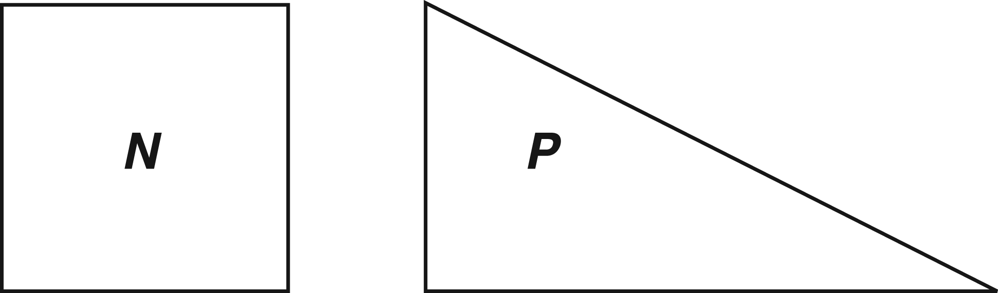
(Grade 8 version)

Bob, Carmen, and Tyler were comparing the areas of N and P. Bob said that N and P have the same area. Carmen said that the area of N is larger. Tyler said that the area of P is larger.

Who was correct? _______________________________

Use words or pictures (or both) to explain why.

Source: 1996 NAEP (grades 4 and 8) Percent correct: 27

- Interpret a visual representation.
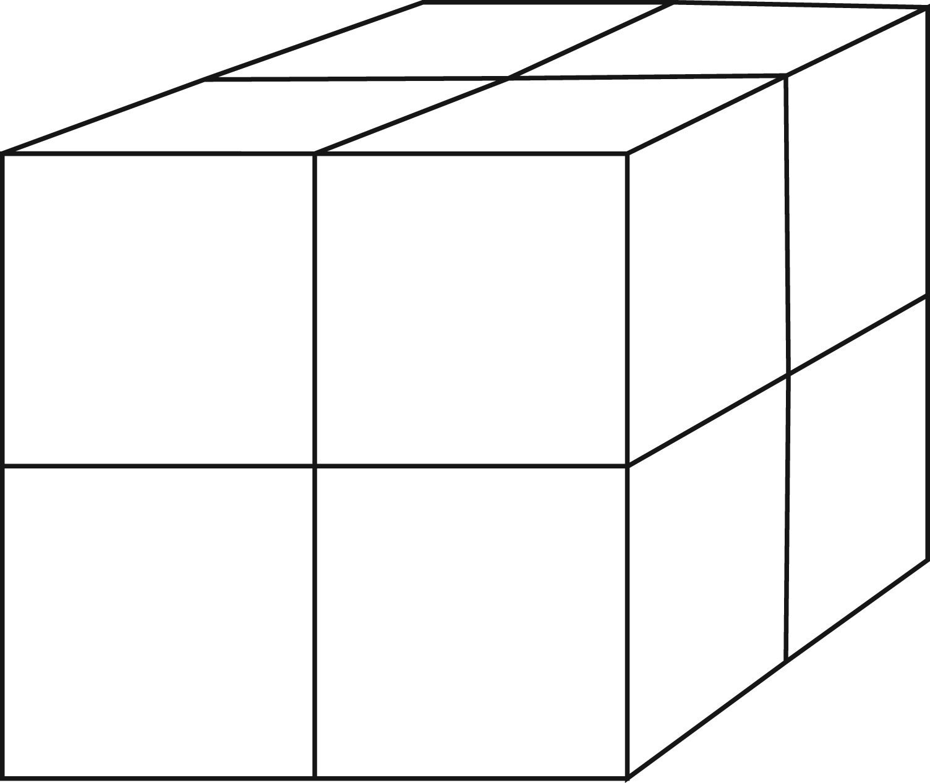

In this figure, how many small cubes were put together to form the large cube?
A. 7
B. 8
C. 12
D. 24

Source: 1996 NAEP (grade 4) Percent correct: 33

- Extend a pattern.
From any vertex of a 4-sided polygon, 1 diagonal can be drawn.
From any vertex of a 5-sided polygon, 2 diagonals can be drawn.
From any vertex of a 6-sided polygon, 3 diagonals can be drawn.
From any vertex of a 7-sided polygon, 4 diagonals can be drawn.

How many diagonals can be drawn from any vertex of a 20-sided polygon?

Answer: ___________________________

Source: 1996 NAEP (grade 8) Percent correct: 54

- Interpret a simple argument.
Tracy said, “I can multiply 6 by another number and get an answer that is smaller than 6.”

Pat said, “No, you can’t. Multiplying 6 by another number always makes the answer 6 or larger.”

Who is correct? Give a reason for your answer.

Source: 1992 NAEP (grades 8 and 12) Percent correct: 49 (grade 8); 63 (grade 12)

High Complexity
High-complexity items make heavy demands on students, who must engage in more abstract reasoning, planning, analysis, judgment, and creative thought. A satisfactory response to the item requires that the student think in abstract and sophisticated ways. Items at the level of high complexity may ask the student to do any of the following:
- Describe how different representations can be used for different purposes.
- Perform a procedure having multiple steps and multiple decision points.
- Analyze similarities and differences between procedures and concepts.
- Generalize a pattern.
- Formulate an original problem, given a situation.
- Solve a novel problem.
- Solve a problem in more than one way.
- Explain and justify a solution to a problem.
- Describe, compare, and contrast solution methods.
- Formulate a mathematical model for a complex situation.
- Analyze the assumptions made in a mathematical model.
- Analyze or produce a deductive argument.
- Provide a mathematical justification.
Examples
See appendix B for solutions and scoring guides.
- Generalize a pattern.
A pattern of dots is shown below. At each step, more dots are added to the pattern. The number of dots added at each step is more than the number added in the previous step. The pattern continues infinitely.

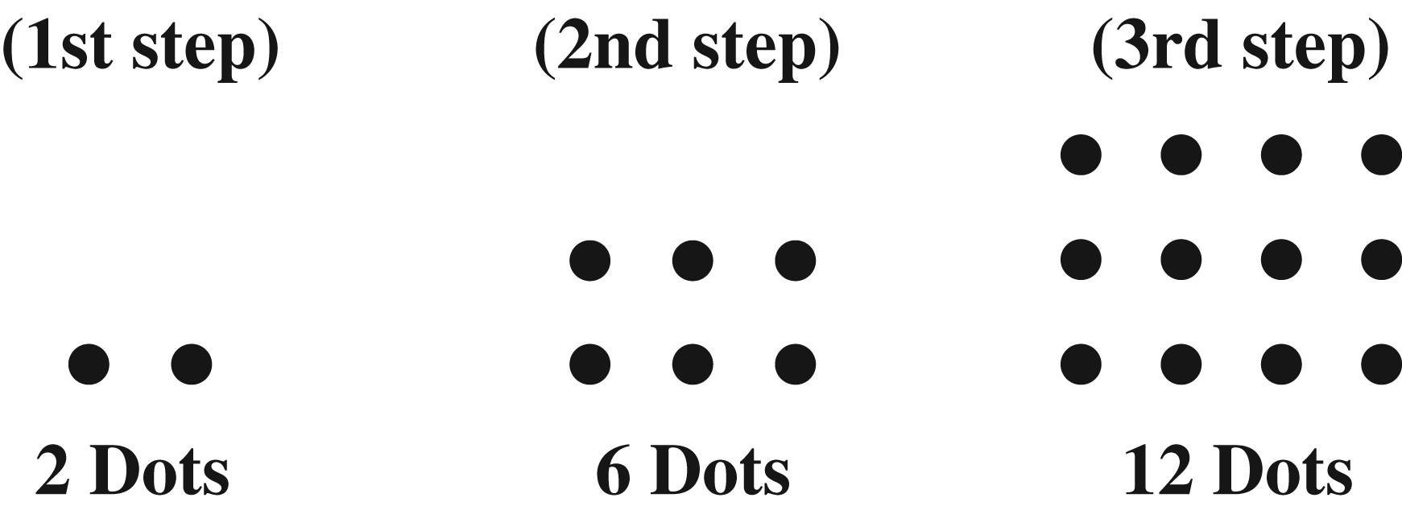
Marcy has to determine the number of dots in the 20th step, but she does not want to draw all 20 pictures and then count the dots. Explain or show how she could do this and give the answer that Marcy should get for the number of dots.

Source: 1992 NAEP (grade 8) Percent correct: 6

- Analyze or produce a deductive argument.
Jaime knows the following facts about points A, B, and C.
• Points A, B, and C are on the same line, but might not be in that order.
• Point C is twice as far from point A as it is from point B.
Jaime concluded that point C is always between points A and B.
Is Jaime’s conclusion correct?

Yes No

In the space provided, use a diagram to explain your answer.

Source: 1996 NAEP (grade 8) Percent correct: 23

- Provide a mathematical justification
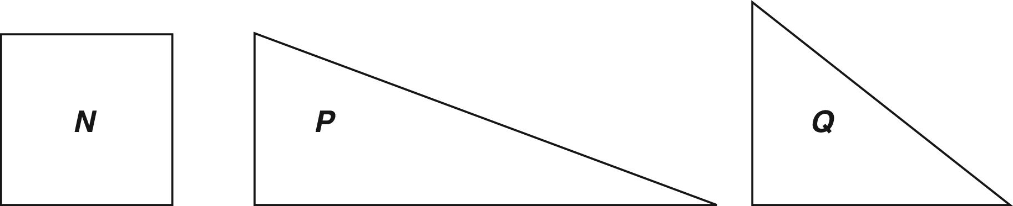

In Mr. Bell’s classes, the students voted for their favorite shape for a symbol.
Here are the results.

 | Class 1 | Class 2 | Class 3
Shape N | 9 | 14 | 11
Shape P | 1 | 9 | 17
Shape Q | 22 | 7 | 2

Using the information in the chart, Mr. Bell must select one of the shapes to be the symbol. Which one should he select and why?

The shape Mr. Bell should select: _________________

Explain.

Source: 1996 NAEP (grades 4 and 8) Percent correct: 31 (grade 4); 58 (grade 8)

Balance of Mathematical Complexity
The ideal balance sought for NAEP is not necessarily the balance one would wish for curriculum or instruction in mathematics education. Balance here must be considered in the context of the constraints of an assessment such as NAEP. These constraints include the timed nature of the test and its paper-and-pencil format. Items of high complexity, for example, often take more time to complete. At the same time, some items of all three types are essential to assess the full range of students’ mathematical achievement. Within that context, the ideal balance would be that half of the score on the assessment is based on items of moderate complexity, with the remainder of the score based equally on items of low and high complexity.

Chapter Five: Item Formats
Central to the development of the NAEP assessment in mathematics is the careful selection of items/tasks. Since the 1992 assessment, items have consisted of three formats: multiple choice, short constructed response, and extended constructed response. Testing time on NAEP is divided evenly between multiple-choice items and both types of constructed-response items, as shown below:
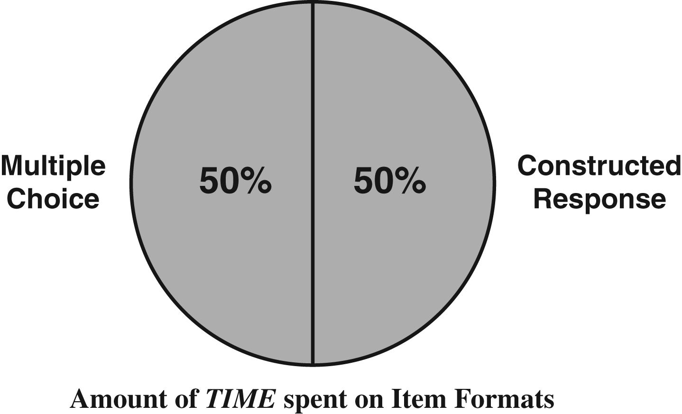

Multiple-Choice Items
Multiple-choice items require students to read, reflect, or compute, and then to select the alternative that best expresses what they believe the answer to be. This format is appropriate for quickly determining whether students have achieved certain knowledge and skills. A carefully constructed multiple-choice item can assess any of the levels of mathematical complexity (described in chapter four), from simple procedures to more sophisticated concepts. Such items are limited in the extent to which they can provide evidence of the depth of students’ thinking.
Example
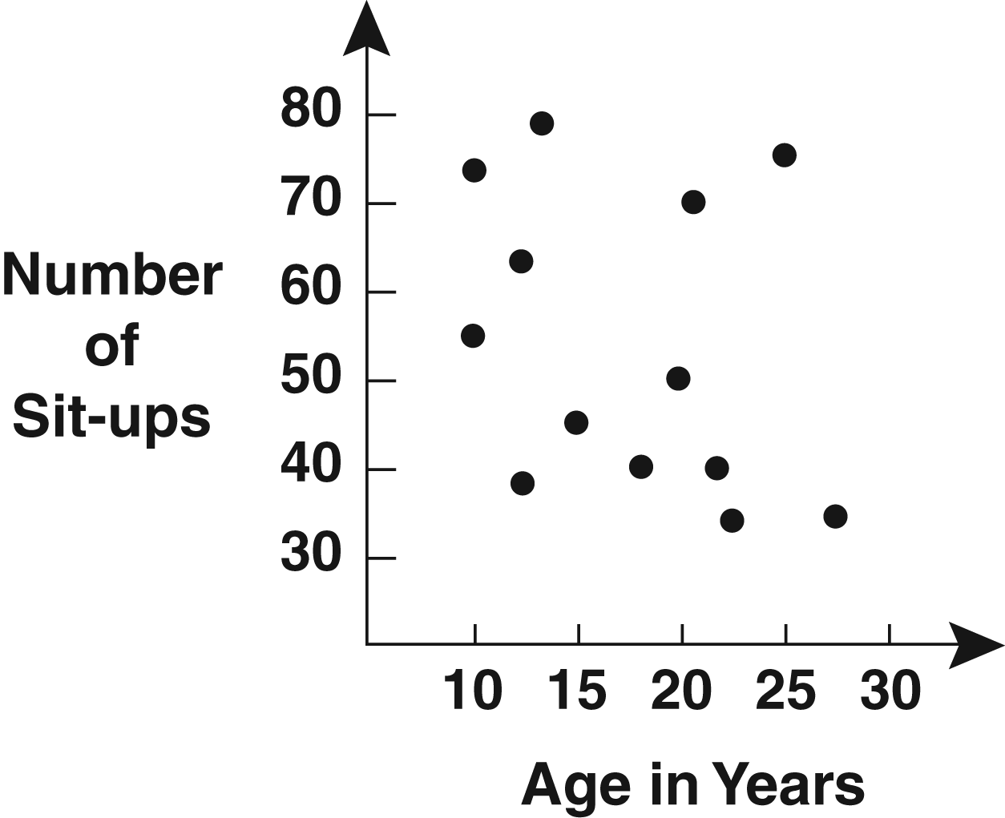
In the graph above, each dot shows the number of sit-ups and the corresponding age for 1 of 13 people. According to this graph, what is the median number of sit-ups for these 13 people?
A. 15
B. 20
C. 45
D. 50
E. 55

This item assesses students’ understanding of two concepts: median, and how data are displayed on a graph. For students who are able to combine these concepts, little or no computation is required to determine the correct answer (D).
Short Constructed-Response Items
To provide more reliable and valid opportunities for extrapolating about students’ approaches to problems, NAEP assessments have included items that are often referred to as short constructed-response items. These are short-answer items that require students to give either a numerical result or the correct name or classification for a group of mathematical objects, draw an example of a given concept, or perhaps write a brief explanation for a given result.
Example
Product
2 x 2 = 4
2 x 2 x 2 = 8
2 x 2 x 2 x 2 = 16
2 x 2 x 2 x 2 x 2 = 32

If the pattern shown continues, could 375 be one of the products in this pattern?
Explain why or why not.

Scoring Guide
Score and Description
1 - Correct
Correct reason:
“Because 375 is not divisible by 2 (or is not even)”
OR
“Because 375 is between two of the numbers in the pattern.”
Acceptable: “Because 375 is uneven.”
Not acceptable:
“Because you’re counting by 2s.”
OR
“Because you’re multiplying by 2.”
0 - Incorrect
Any incorrect or incomplete reason.
This item assesses students’ understanding of number patterns and of odd and even numbers. Students are given the opportunity to explain why 375 could not be one of the products in the pattern. Scoring for this item was done on a correct/incorrect basis. Items such as this are valuable in providing greater evidence of the depth of students’ understanding than might be accomplished in other formats. Scoring for some short constructed-response items uses more than two points in the scale to award partial credit for work that is partially correct. Full credit is reserved for work that is mathematically correct and complete.
Extended Constructed-Response Items
Extended constructed-response items require students to consider a situation that demands more than a numerical response or a short verbal communication. If it is a problem to solve, the student is asked to carefully consider a situation within or across content areas, understand what is required to “solve” the situation, choose a plan of attack, carry out the attack, and interpret the solution derived in terms of the original situation. In the example that follows, the student is asked to analyze a situation and provide a mathematical explanation.
Example
In a game, Carla and Maria are making subtraction problems using tiles numbered 1 to 5. The player whose subtraction problem gives the largest answer wins the game.

Look at where each girl placed two of her tiles.
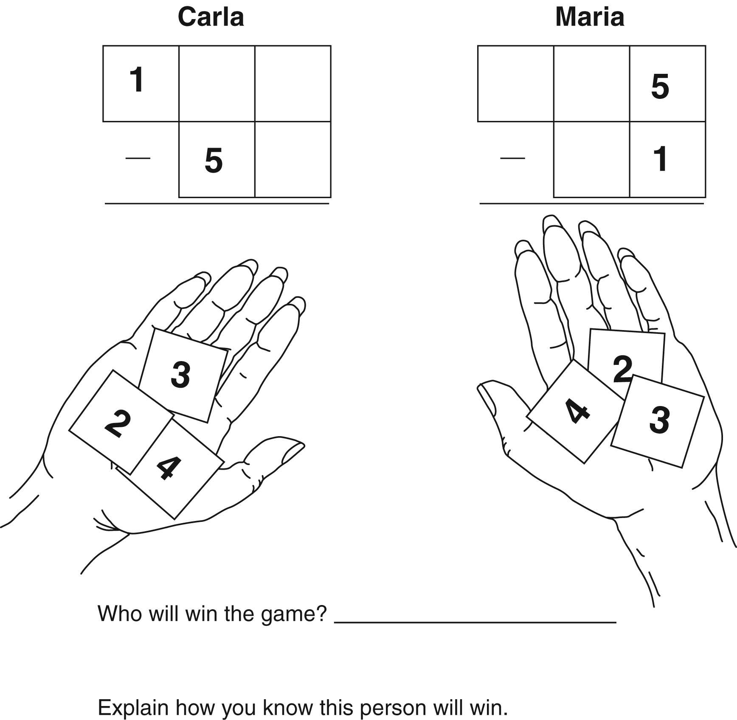

In this item, students are given the opportunity to display their understanding of place value and subtraction. They must examine the numbers left on each player’s tiles, consider all the possible placements of those tiles in the remaining spaces, then compare the results of the subtraction and construct an explanation of the situation.
Scoring Extended Constructed-Response Items
Extended constructed-response items in mathematics should be evaluated according to an established grading scale developed from a sample of actual student responses. The scale used should follow a multiple-point format similar to the following (this is the scoring guide for the previous example item):
Scoring Guide
Solution:
Maria will win the game.
The following reasons may be given:
a. The largest possible difference for Carla is less than 100 and the smallest possible difference for Maria is 194.
b. Carla will only get a difference of 91 or less but Maria will get several larger differences.
c. Carla can have only up to 143 as her top number, but Maria can have 435 as her largest number.
d. Carla has only 1 hundred but Maria can have 2, 3, or 4 hundreds.
e. Maria can never take away as much as Carla.
f. Any combination of problems to show that Maria’s difference is greater.

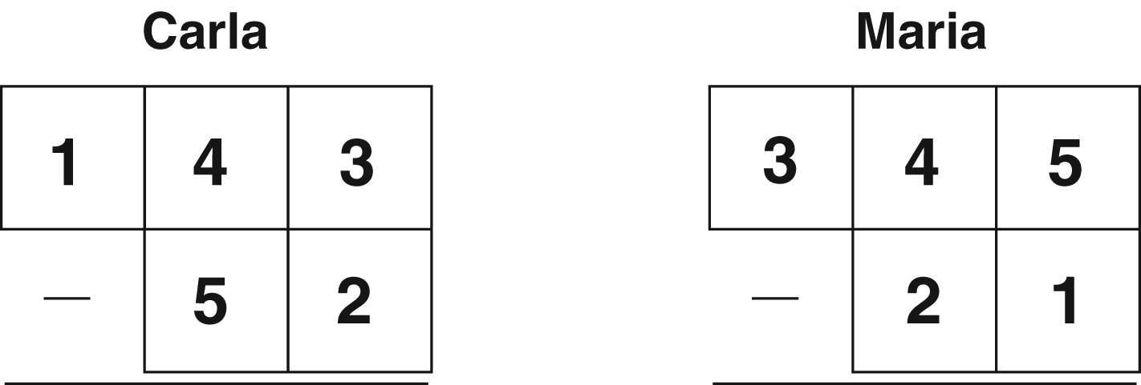

Score and Description
4 - Extended
Student answers Maria and gives explanation such as (a) or (b), or an appropriate combination of the other explanations.
3 - Satisfactory
Student answers Maria and gives explanation such as (c), (d), or (e).
2 - Partial
Student answers Maria with partially correct, or incomplete but relevant, explanation.
1 - Minimal
Student answers Maria and gives example such as in (f) but no explanation OR answers Maria with an incorrect explanation.
0 - Incorrect
Incorrect response
A scoring scale adapted to a particular problem and applied by experienced scorers provides rich information about students’ understanding of concepts and procedures, and about their ability to solve a problem and communicate understanding of the process.

Bibliography
Achieve, Inc. (2000). Foundations for Success: Mathematics for the Middle Grades (consultation draft). Washington, DC: Mathematics Achievement Partnership.
Anderson, N.E., F.F. Jenkins, and K.E. Miller (1995). NAEP Inclusion Criteria and Testing Accommodations: Findings From the NAEP 1995 Field Test in Mathematics. Princeton, NJ: Educational Testing Service.
Blank, R., and L.D. Wilson (1999). Improving Mathematics Education Using Results From NAEP and TIMSS. Washington, DC: Council of Chief State School Officers.
Bourque, M.L., and S. Byrd (2000). Student Performance Standards on the National Assessment of Educational Progress: Affirmation and Improvements. Washington, DC: National Assessment Governing Board.
Braswell, J., A. Lutkus, W. Grigg, S. Santapau, B. Tay-Lim, and M. Johnson (2001). The Nation’s Report Card: Mathematics 2000. Washington, DC: National Center for Education Statistics.
Carlson, J.E., A.D. Lutkus, J. Mazzeo, and K.E. Voelkl (2000). Increasing the Participation of Special Needs Students in NAEP. Jessup, MD: U.S. Department of Education, Office of Educational Research and Improvement.
Council for Basic Education (2000). Issues in Mathematics Education Assessment: NAEP Mathematics 2005. Washington, DC: Council of Chief State School Officers.
Diperna, P., and T. Loveless (2000). The Brown Center Report on American Education: How Well Are American Students Learning? Washington, DC: The Brookings Institution.
Dossey, J.A., J. Mazzeo, K.E. Miller, and C.M. Reese (1997). NAEP 1996 Mathematics Report Card for the Nation and the States. Washington, DC: Educational Testing Service and National Center for Education Statistics.
Educational Testing Service (1988). Mathematics Objectives 1990 Assessment. Princeton, NJ: Educational Testing Service.
Findell, B., J. Kilpatrick, and J. Swafford (2001). Adding It Up: Helping Children Learn Mathematics. Washington, DC: National Research Council.
Kenney, P.A. (1999). An Analysis of the 1996 NAEP Mathematics Framework and Items for Grade 8. Pittsburgh, PA: University of Pittsburgh, Learning Research and Development Center.
Kenney, P.A., E.A. Silver, C. Alacaci, and J.S. Zawojewski (1998). Content Analysis Project—State and NAEP Mathematics Assessment (final report). Pittsburgh, PA: University of Pittsburgh, Learning Research and Development Center.
Mazzeo, J., J. Carlson, K. Voelkl, and A. Lutkus (1999). Increasing the Participation of Special Needs Students in NAEP: A Report on 1996 Research Activities (NCES Publication No. 2000-473). Washington, DC: National Center for Education Statistics.
Mitchell, J., E.F. Hawkins, F.B. Stancavage, and J. Dossey (1999). Estimation Skills, Mathematics-in-Context, and Advanced Skills in Mathematics. Washington, DC: National Center for Education Statistics.
Mullis, I.V.S., M.O. Martin, T.A. Smith, R.A. Garden, K.D. Gregory, E.J. Gonzalez, S.J. Chrostowski, and K.M. O’Connor (2001). TIMSS Assessment Frameworks and Specifications 2003. Boston, MA: Boston College, The International Study Center.
National Assessment of Educational Progress (1988). Mathematics Objectives: 1990 Assessment. Princeton, NJ: Educational Testing Service.
National Assessment Governing Board (1994). Mathematics Framework for the 1996 and 2000 National Assessment of Educational Progress. Washington, DC: National Assessment Governing Board.
National Assessment Governing Board (1992). 1994 National Assessment of Educational Progress: Mathematics Assessment Framework and Specifications. Washington, DC: The College Board and The National Assessment Governing Board.
Olson, J.F., and A.A. Goldstein (1997). The Inclusion of Students With Disabilities and Limited English Proficient Students in Large-Scale Assessments: A Summary of Recent Progress (NCES Publication No. 97-482). Washington, DC: National Center for Education Statistics.
Reese, C.M., K.E. Miller, J. Mazzeo, and J.A. Dossey (1997). 1996 Mathematics Report Card for the Nation and the States. Washington, DC: U.S. Department of Education, National Center for Education Statistics.
Silver, E., and P. Kenney (eds.) (2000). Results From the Seventh Mathematics Assessment of the National Assessment of Educational Progress. Reston, VA: National Council of Teachers of Mathematics.
U.S. Department of Education (2000). Before It’s Too Late. Washington, DC: U.S. Department of Education, National Commission of Mathematics and Science Teaching for the 21st Century.
U.S. Department of Education (1999). The NAEP Guide: A Description of the Content and Methods of the 1999 and 2000 Assessments. Washington, DC: National Center for Education Statistics and U.S. Department of Education, Office of Educational Research and Improvement.

Appendix A
NAEP Mathematics Achievement Level Descriptions
Grade 4
Basic Fourth-grade students performing at the Basic level should show some evidence of understanding the mathematical concepts and procedures in the five NAEP content areas.
Fourth graders performing at the Basic level should be able to estimate and use basic facts to perform simple computations with whole numbers; show some understanding of fractions and decimals; and solve some simple real-world problems in all NAEP content areas. Students at this level should be able to use—though not always accurately—four-function calculators, rulers, and geometric shapes. Their written responses are often minimal and presented without supporting information.
Proficient Fourth-grade students performing at the Proficient level should consistently apply integrated procedural knowledge and conceptual understanding to problem solving in the five NAEP content areas.
Fourth graders performing at the Proficient level should be able to use whole numbers to estimate, compute, and determine whether results are reasonable. They should have a conceptual understanding of fractions and decimals; be able to solve real-world problems in all NAEP content areas; and use four-function calculators, rulers, and geometric shapes appropriately. Students performing at the Proficient level should employ problem-solving strategies such as identifying and using appropriate information. Their written solutions should be organized and presented both with supporting information and explanations of how they were achieved.
Advanced Fourth-grade students performing at the Advanced level should apply integrated procedural knowledge and conceptual understanding to complex and non-routine real-world problem solving in the five NAEP content areas.
Fourth graders performing at the Advanced level should be able to solve complex non-routine real-world problems in all NAEP content areas. They should display mastery in the use of four-function calculators, rulers, and geometric shapes. These students are expected to draw logical conclusions and justify answers and solution processes by explaining why, as well as how, they were achieved. They should go beyond the obvious in their interpretations and be able to communicate their thoughts clearly and concisely.
Grade 8
Basic Eighth-grade students performing at the Basic level should exhibit evidence of conceptual and procedural understanding in the five NAEP content areas. This level of performance signifies an understanding of arithmetic operations—including estimation—on whole numbers, decimals, fractions, and percents.
Eighth graders performing at the Basic level should complete problems correctly with the help of structural prompts such as diagrams, charts, and graphs. They should be able to solve problems in all NAEP content areas through the appropriate selection and use of strategies and technological tools, including calculators, computers, and geometric shapes. Students at this level also should be able to use fundamental algebraic and informal geometric concepts in problem solving. As they approach the Proficient level, students at the Basic level should be able to determine which of the available data are necessary and sufficient for correct solutions and use them in problem solving. However, these eighth graders show limited skill in communicating mathematically.
Proficient Eighth-grade students performing at the Proficient level should apply mathematical concepts and procedures consistently to complex problems in the five NAEP content areas.
Eighth graders performing at the Proficient level should be able to conjecture, defend their ideas, and give supporting examples. They should understand the connections among fractions, percents, decimals, and other mathematical topics such as algebra and functions. Students at this level are expected to have a thorough understanding of Basic level arithmetic operations—an understanding sufficient for problem solving in practical situations. Quantity and spatial relationships in problem solving and reasoning should be familiar to them, and they should be able to convey underlying reasoning skills beyond the level of arithmetic. They should be able to compare and contrast mathematical ideas and generate their own examples. These students should make inferences from data and graphs, apply properties of informal geometry, and accurately use the tools of technology. Students at this level should understand the process of gathering and organizing data and be able to calculate, evaluate, and communicate results within the domain of statistics and probability.
Advanced Eighth-grade students performing at the Advanced level should be able to reach beyond the recognition, identification, and application of mathematical rules in order to generalize and synthesize concepts and principles in the five NAEP content areas.
Eighth graders performing at the Advanced level should be able to probe examples and counterexamples in order to shape generalizations from which they can develop models. Eighth graders performing at the Advanced level should use number sense and geometric awareness to consider the reasonableness of an answer. They are expected to use abstract thinking to create unique problem-solving techniques and explain the reasoning processes underlying their conclusions.

Appendix B
Mathematical Complexity Items Scoring Guide
Low Complexity
How many fourths make a whole?

Answer: ___________________

Source: 1996 NAEP (grade 4) Percent correct: 50

Scoring Guide
Scoring Rubric
1 - Correct
4, 4 fourths, etc.
0 - Incorrect
Any incorrect response

+6 + –12 =
*A. –6
B. +6
C. –18
D. +18

Source: 1990 NAEP (grade 8) Percent correct: 68

N stands for the number of stamps John had. He gave 12 stamps to his sister.
Which expression tells how many stamps John has now?
A. N + 12
*B. N – 12
C. 12 – N
D. 12 x N

Source: 1996 NAEP (grade 4) Percent correct: 67

How many hours are equal to 150 minutes?
A. 1½
B. 2¼
C. 2¹/3
*D. 2½
E. 25/6

Source: 1990 NAEP (grade 12) Percent correct: 74

What is the weight shown on the scale?
A. 6 pounds
B. 7 pounds
C. 51 pounds
*D. 60 pounds

Source: 1992 NAEP (grade 4) Percent correct: 44

Moderate Complexity
The following shapes were provided to students. (Shapes were larger than shown.)
(Grade 8 version)
Bob, Carmen, and Tyler were comparing the areas of N and P. Bob said that N and P have the same area. Carmen said that the area of N is larger. Tyler said that the area of P is larger.

Who was correct? _______________________________

Use words or pictures (or both) to explain why.

Source: 1996 NAEP (grade 8) Percent correct: 27

Scoring Rubic
1 – Correct
An adequate explanation with or without Bob.
May say “neither” or “both.”

Parts of P overlap N, and part sticks out. The sticking out part is equal to the left out part of N.
OR
Two P’s match two N’s therefore they have the same area. (Therefore, one N has the same area as one P.)

OR
Areas are equal because height of P is the same as the height of N, and the base of P is twice the base of N.

OR
Either of these two figures alone are acceptable
2X
area =
½ x (2X)
= X
2
X
P
N
X
area =
X
2
X

Scoring Rubric (continued)
1 - Correct
Correct response (see page 61).
0 - Incorrect
Bob was correct, but explanation not given or inadequate Any response that answers Carmen or Tyler to “Who was correct?” or omits the name and gives no satisfactory explanation.

In this figure, how many small cubes were put together to form the large cube?
A. 7
*B. 8
C. 12
D. 24

Source: 1996 NAEP (grade 4) Percent correct: 33

From any vertex of a 4-sided polygon, 1 diagonal can be drawn.
From any vertex of a 5-sided polygon, 2 diagonals can be drawn.
From any vertex of a 6-sided polygon, 3 diagonals can be drawn.
From any vertex of a 7-sided polygon, 4 diagonals can be drawn.

How many diagonals can be drawn from any vertex of a 20-sided polygon?

Answer: ___________________________

Source: 1996 NAEP (grade 8) Percent correct: 54

Scoring Guide
Scoring Rubric
1 - Correct
17
Number of diagonals is always 3 less than the number of sides.
0 - Incorrect
Any incorrect response.

Tracy said, “I can multiply 6 by another number and get an answer that is smaller than 6.”

Pat said, “No, you can’t. Multiplying 6 by another number always makes the answer 6 or larger.”

Who is correct? Give a reason for your answer.

Source: 1992 NAEP (grades 8 and 12) Percent correct: 49 (grade 8); 63 (grade 12)

Scoring Guide
Scoring Rubric
1 - Correct
Tracy, with correct answer given.
OR
No name stated but reason given is correct.
Examples of correct reasons:
• If you multiply by a number smaller than 1 the result is less than 6.
• 6 x 0 = 0
• 6 x 1/2 = 3
• 6 x –1 = –6
0 - Incorrect
Tracy with no reason.
OR
Any response that states Pat is correct.
OR
No name stated and reason given is incorrect.
High Complexity
A pattern of dots is shown below. At each step, more dots are added to the pattern. The number of dots added at each step is more than the number added in the previous step. The pattern continues infinitely.

Marcy has to determine the number of dots in the 20th step, but she does not want to draw all 20 pictures and then count the dots. Explain or show how she could do this and give the answer that Marcy should get for the number of dots.

Source: 1992 NAEP (grade 8) Percent correct: 6

Scoring Guide
Explanation should include one of the following ideas with no false statements.
a. For each successive step, the number of rows and the number of columns is increasing by 1, forming a pattern. For example, the first step forms 1 by 2 rows and columns, the next step 2 by 3, the third step 3 by 4, and so on. Continuing this pattern would mean that the 20th step has 20 by 21 or 420 dots.
b. Look at the successive differences between the consecutive steps. The differences 4, 6, 8, 10,…form a pattern. There are 19 differences forming the pattern 4, 6, 8, 10,…38, 40 and the sum is (9 x 44) + 22 or 418. However, 2 must be added for the first step, yielding a response of 420.

Scoring Rubric
4 - Extended
Correct answer. (Must state 420; must tie step 20 back to beginning of pattern in some specific form of generalization.)
3 - Satisfactory
Correct explanation of pattern but does not include or omits the correct number of dots.
2 - Partial
A partial (incomplete) correct explanation, i.e., does not tie together.
1 - Minimal
Any attempt to generalize OR to draw all 20 pictures in the pattern (with a clear understanding of the pattern).
0 - Incorrect
The work is completely incorrect, irrelevant, or off.

Jaime knows the following facts about points A, B, and C.

• Points A, B, and C are on the same line, but might not be in that order.
• Point C is twice as far from point A as it is from point B.

Jaime concluded that point C is always between points A and B.

Is Jaime’s conclusion correct?
Yes No

In the space provided, use a diagram to explain your answer.

Source: 1996 NAEP (grade 8) Percent correct: 23

Scoring Guide
The explanation must include either one of the following diagrams:

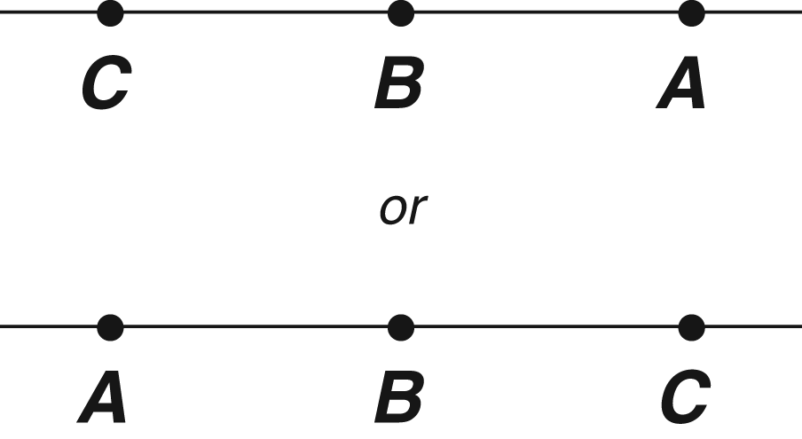
Diagram should include or illustrate the idea that B is halfway between A and C.

Scoring Rubric
1 - Correct
Correct response. Both correct diagrams are given
OR
If correct diagram is clearly indicated either by circling and/or the incorrect ones are crossed out.
0 - Incorrect
Any incorrect reason OR if there is no indication of which diagram is correct (by circling or crossing out incorrect one).
NOTE: Points need to be indicated by some mark, such as a dot or tick mark. A response in which points are indicated by letters only is an automatic incorrect.

In Mr. Bell’s classes, the students voted for their favorite shape for a symbol.
Here are the results.

 | Class 1 | Class 2 | Class 3
Shape N | 9 | 14 | 11
Shape P | 1 | 9 | 17
Shape Q | 22 | 7 | 2

Using the information in the chart, Mr. Bell must select one of the shapes to be the symbol. Which one should he select and why?

The shape Mr. Bell should select: _________________

Explain:

Source: 1996 NAEP (grades 4 and 8) Percent correct: 31 (grade 4); 58 (grade 8)

Scoring Guide
Scoring Rubric
1 - Correct
N, because more students chose it.
OR
N, because it was first choice in one class and second choice in the other classes.
“Majority” is acceptable (taken to mean most). If student says most classes, do not accept.
0 - Incorrect
Shape Q chosen, with an explanation that refers to a number of votes
OR
Shape N chosen, but explanation not given or is inadequate with incorrect computation.
OR
Any other incorrect response.

Appendix C
NAEP Mathematics Project Staff and Committees

NAEP Mathematics Project

CCSSO Staff
Rolf Blank
Director of Indicators Project
State Education Assessment Center
Council of Chief State School Officers
Washington, D.C.
Wayne Martin
Director
State Education Assessment Center
Council of Chief State School Officers
Washington, D.C.
John Olson
Director of Assessment
State Education Assessment Center
Council of Chief State School Officers
Washington, D.C.
Frank Philip
Senior Project Associate
State Education Assessment Center
Council of Chief State School Officers
Washington, D.C.
Linda D. Wilson
Consensus Coordinator Consultant
Council of Chief State School Officers
Washington, D.C.
Phoebe Winter
Project Director
State Education Assessment Center
Council of Chief State School Officers
Richmond, Virginia

Subcontractors and Consultants
Christopher Cross
President (Former)
Council for Basic Education
Washington, D.C.
Kim Gattis
President, Association of State Supervisors
of Mathematics
Education Program Consultant, Kansas Department of Education
Topeka, Kansas
Patricia Kenney
Senior Research Associate
University of Michigan
Ann Arbor, Michigan
Rebecca Kopriva
Director
Center for the Study of Assessment Validity in Education
Department of Measurement & Statistics
University of Maryland
College Park, Maryland
Linda Plattner
Director of Policy, Standards & Instruction
Council for Basic Education
Washington, D.C.

NAGB Staff
Mary Crovo
Project Officer
National Assessment Governing Board
Washington, D.C.
Sharif Shakrani
Contracting Officer
National Assessment Governing Board
Washington, D.C.
Roy Truby
Executive Director
National Assessment Governing Board
Washington, D.C.
Steering Committee
Eileen Ahearn
Project Director
National Association of State Directors
of Special Education
Alexandria, Virginia
Charles Allan
Mathematics Education Consultant
Michigan Department of Education
Lansing, Michigan
B. Marie Byers
National School Boards Association
Hagerstown, Maryland
Randy DeHoff
Colorado State Board of Education
6th Congressional District–Littleton
Denver, Colorado
M.B. “Sonny” Donaldson
Superintendent
Aldine ISD
Houston, Texas
Janice Earle
Senior Program Director
National Science Foundation
Arlington, Virginia
Lou Fabrizio
Director
Division of Accountability Services
North Carolina Department of Public Instruction
Raleigh, North Carolina
Bettye Forte
Mathematics Consultant
Arlington, Texas
Matt Gandal
Vice President
Achieve, Inc.
Washington, D.C.
Alice Gill
Associate Director
Educational Issues
American Federation of Teachers
Washington, D.C.
M. Kathleen Heid
The Pennsylvania State University
University Park, Pennsylvania
Audrey Jackson
Assistant Principal
Claymont Elementary School
Parkway City Schools
Fenton, Missouri
James M. Landwehr
Director
Data Analysis Research Department
Avaya Labs
Basking Ridge, New Jersey

Sharon Lewis
Research Director
Council of the Great City Schools
Washington, D.C.
Dane Linn
Policy Studies Director
National Governors’ Association
Washington, D.C.
Eddie Lucero
Principal
Griegos Elementary School
Albuquerque, New Mexico
Lee McCaskill
Principal
Brooklyn Technical High School
Brooklyn, New York
Barbara Montalto
Assistant Director of Mathematics
Texas Education Agency
Austin, Texas
Judy Rohde
Mathematics Instructor
John Glenn Middle School
Maplewood, Minnesota
Wilfried Schmid
Professor of Mathematics
Harvard Department of Mathematics
Cambridge, Massachusetts
Sr. Mary Frances Taymans
Executive Director
Secondary Schools Department
National Catholic Education Association
Washington, D.C.
Zalman Usiskin
Professor of Education
Director, University of Chicago School Mathematics Project
Chicago, Illinois
Judy Walter
Association for Supervision & Curriculum Development
Alexandria, Virginia
Diana Wearne
Associate Professor
School of Education
University of Delaware
Newark, Delaware
Hung-Hsi Wu
Professor of Mathematics
Department of Mathematics
University of California–Berkeley
Berkeley, California
Planning Committee
Dayo Akinsheye
Mathematics Resource Teacher
Seaton Elementary School
Washington, D.C.
Geri Anderson-Nielsen
Mathematics Specialist
Georgetown Day School
Washington, D.C.
Cindy Chapman
Elementary Teacher
Albuquerque Public Schools
Albuquerque, New Mexico
Herbert Clemens
Professor of Mathematics
Department of Mathematics
University of Utah
Salt Lake City, Utah
Carl Cowen
Professor of Mathematics
Purdue University
West Lafayette, Indiana
Jim Ellingson
Assistant Professor
Concordia College
Moorhead, Minnesota
Joan Ferrini-Mundy
Associate Dean/Director of Science and Mathematics
College of Natural Science
Michigan State University
East Lansing, Michigan
Kim Gattis
Education Program Consultant
Kansas Department of Education
Association of State Supervisors of Mathematics
Topeka, Kansas
Anne Gonzales
Middle School Mathematics Teacher
South Gate Middle School
South Gate, California
Jeremy Kilpatrick
Professor of Mathematics Education
University of Georgia
Athens, Georgia
Gerald Kulm
Curtis D. Robert Professor
of Mathematics Education
Texas A & M University
College Station, Texas
Mary Lindquist
Fuller E. Callaway Professor
of Mathematics Education
Columbus State University
Columbus, Georgia
Mary Jo Messenger
High School Mathematics Teacher
River Hill High School
Clarksville, Maryland
Marjorie Petit
Senior Associate
National Center for the Improvement of Educational Assessment
(The Center for Assessment)
Portsmouth, New Hampshire
Edward Silver
Professor
School of Education
University of Michigan
Ann Arbor, Michigan
Debra Vitale
Mathematics Specialist
Arlington Public Schools
Fairfax, Virginia
Frank Wang
President/CEO
Saxon Publishing, Inc.
Norman, Oklahoma
Norman Webb
Senior Research Scientist
Wisconsin Center for Education Research
Madison, Wisconsin
John Wisthoff
Member, Maryland State Board of Education and Mathematics Professor
Anne Arundel Community College
Pasadena, Maryland
Technical Advisory Panel
Fen Chou
Psychometrician
Louisiana Department of Education
Baton Rouge, Louisiana
Eugene Johnson
Chief Psychometrician
American Institutes for Research
Washington, D.C.
Edward Kifer
Professor and Chairperson
Department of Educational Policy Studies and Evaluation
College of Education
University of Kentucky
Lexington, Kentucky
Ina Mullis
Co-Director
International Study Center
Boston College
Chestnut Hill, Massachusetts
Barbara Plake
Director
Buros Center for Testing
University of Nebraska–Lincoln
Lincoln, Nebraska
Roger Trent
Ohio State Assessment Director (Emeritus)
Ohio Department of Education
Columbus, Ohio
Committee Representation
Policy Organizations
Achieve, Inc.
American Association of School Administrators (AASA)
American Federation of Teachers (AFT)
American Mathematical Society (AMA)
American Statistical Association (ASA)
Association for Supervision and Curriculum Development (ASCD)
Association of State Assessment Programs (ASAP)
Association of State Supervisors of Mathematics (ASSM)
Business Roundtable/National Alliance of Business
Council of the Great City Schools
Education Leaders Council (ELC)
National Association of Elementary School Principals (NAESP)
National Association of Secondary School Principals (NASSP)
National Association of State Boards of Education (NASBE)
National Association of State Directors of Special Education (NASDE)
National Catholic Education Association (NCEA)
National Education Association (NEA)
National Governors’ Association (NGA)
National School Boards Association (NSBA)
National Science Foundation (NSF)
Representative from national textbook publisher
Mathematics Associations and Groups
Mathematically Correct
Mathematics Association of America (MAA)
National Council of Teachers of Mathematics (NCTM)
Third International Mathematics and Science Study (TIMSS)

Educators
Classroom mathematics teachers from public and non-public schools
District and state mathematics specialists
Mathematics and mathematics education professors from public and private universities, colleges, and community colleges
Principals

Technical Experts
State testing specialists
Representatives from private research organizations
University professors

Acknowledgments
The following people were the primary authors of the introductions to the content areas:
Roger Howe, Yale University (Number Properties and Operations, Geometry, and Algebra)
Richard Scheaffer, University of Florida (Data Analysis and Probability)
Mary Lindquist, Columbus State University (Measurement)
Frank Philip and Arthur Halbrook, Council of Chief State School Officers, designed the layout and edited the document. Natalie Dubois provided word processing support.

